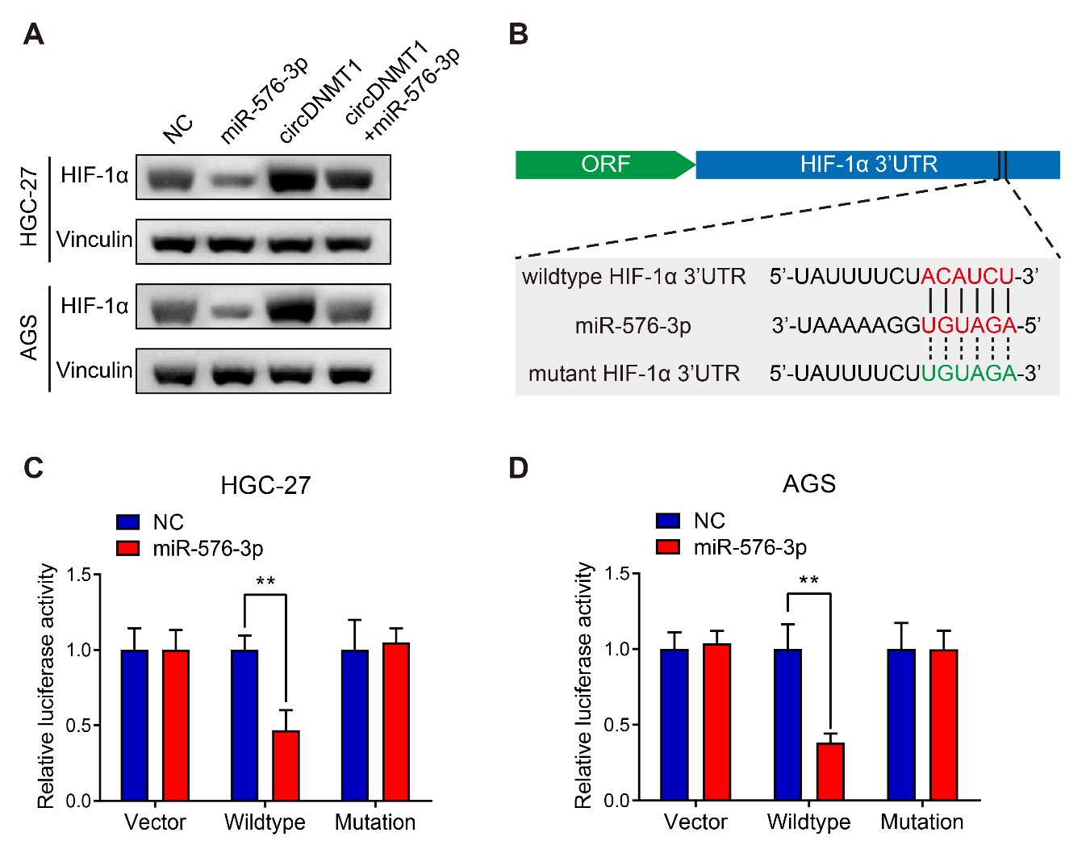

**Supplementary Figure 3.** miR-576-3p suppresses HIF-1α expression by directly binding to its mRNA 3’UTR. (A) WB analysis to show the expression of HIF-1α in HGC-27 and AGS cells stably carrying lentivirus with vectors or circDNMT1 overexpression plasmids and additionally transfected with NC or miR-576-3p mimics. Vinculin served as the internal control. (B) The schematic illustration of wildtype (red) and mutant (green) sequences of binding sites of 3’UTR of HIF-1α mRNA and miR-576-3p. (C, D) Luciferase reporter assay to show the relative luciferase activities in HGC-27 (C) and AGS (D) cells that were cotransfected with empty luciferase reporter plasmids (vector) or plasmids inserted with wildtype or mutant sequences and NC and miR-567-3p mimics. **P < 0.01.