Supplementary Materials
Table S1. Demographic and clinical characteristics of all participants
Characteristics | MDD (122) | HC (119) | Statistics | P value
Gender (female/male) | 82/40 | 82/37 | χ² = 0.080 | 0.778
Age (years) | 42.77 ± 11.50  (18 - 62) | 43.81 ± 13.85  (21 - 65) | t = -0.641 | 0.522
Education (years) | 8.86 ± 3.64  (0 - 16) | 11.52 ± 4.69  (0 - 20) | t = -4.902 | < 0.001
BMI (kg/m² ) | 22.91 ± 3.80  (13.93 - 34.60) | 23.23 ± 2.76  (15.98 - 31.56) | t = -0.752 | 0.453
HAMD | 28.87 ± 11.31  (1 - 55) | 1.13 ± 2.54  (0 - 19) | t = 26.418 | < 0.001
HAMA | 19.88 ± 7.38  (2 - 35) | 1.41 ± 2.86  (0 - 21) | t = 25.729 | < 0.001
EBPM | 2.66 ± 2.81  (0 - 8) | 5.71 ± 2.71  (0 - 8) | t = -8.561 | < 0.001
TBPM | 2.17 ± 2.24  (0 - 6) | 5.37 ± 1.35  (0 - 6) | t = -13.435 | < 0.001
CPT-IP-2 | 2.23 ± 1.03  (-0.12 - 4.24) | 3.14 ± 0.97  (0.27 - 4.24) | t = -7.087 | < 0.001
CPT-IP-3 | 1.68 ± 0.95  (-0.26 - 4.24) | 2.38 ± 1.13  (-0.11 - 4.24) | t = -5.268 | < 0.001
CPT-IP-4 | 0.93 ± 0.73  (-0.41 - 3.12) | 1.34 ± 0.87  (-0.44 - 3.62) | t = -3.933 | < 0.001
SCVD (nmol/L) | 42.62 ± 14.38  (15.95 - 96.34) | 52.70 ± 16.92  (21.50 - 105.75) | t = -4.986 | < 0.001
FD (mm) | 0.13 ± 0.09  (0.04 - 0.60) | 0.14 ± 0.08  (0.05 - 0.40) | t = -0.995 | 0.321
Illness duration (months) | 63.18 ± 71.33  (0.30 - 306) | - | - | -
Onset age (years) | 37.16 ± 11. 29  (12 - 55) | - | - | -
Episode number | 2.53 ± 2.23  (1 - 21) | - | - | -
Antidepressant medications
SSRIs | 82 | - | - | -
SNRIs | 33 | - | - | -
NaSSA | 7 | - | - | -
Except for gender designation, data are expressed as means ± standard deviations. Numbers in parentheses are the range. Abbreviations: MDD, major depressive disorder; HC, healthy controls; BMI, body mass index; HAMD, Hamilton Rating Scale for Depression; HAMA, Hamilton Rating Scale for Anxiety; EBPM, event-based prospective memory; TBPM, time-based prospective memory; CPT-IP, Continuous Performance Task-Identical Pairs; SCVD, serum concentration of vitamin D; FD, frame-wise displacement; SSRIs, selective serotonin reuptake inhibitors; SNRIs, serotonin norepinephrine reuptake inhibitors; NaSSA, noradrenergic and specific serotonergic antidepressant.
Table S2. Correlations between SCVD and clinical variables in females
Clinical variables | SCVD (nmol/L)
Clinical variables | pr | P
EBPM | 0.267 | < 0.001#
TBPM | 0.355 | < 0.001#
CPT-IP-2 | 0.215 | 0.006#
CPT-IP-3 | 0.121 | 0.126
CPT-IP-4 | 0.087 | 0.273
HAMD* | -0.074 | 0.516
HAMA* | -0.071 | 0.529
Abbreviations: SCVD, serum concentration of vitamin D; EBPM, event-based prospective memory; TBPM, time-based prospective memory; CPT-IP, Continuous Performance Task-Identical Pairs; HAMD, Hamilton Rating Scale for Depression; HAMA, Hamilton Rating Scale for Anxiety; pr, partial correlation coefficient.
# means P < 0.05 with false discovery rate correction for multiple comparisons.
* Correlation analyses were performed in 82 female patients with major depressive disorder.
Table S3. Correlations between functional network connectivity and clinical variables in females
Functional network connectivity | EBPM | TBPM | CPT-IP-2 | CPT-IP-3 | CPT-IP-4 | HAMD* | HAMA*
Right aANG | -0.194# | -0.234# | -0.095 | 0.035 | 0.100 | -0.045 | 0.025
Right pANG | -0.154 | -0.195# | -0.066 | -0.001 | 0.106 | 0.125 | 0.166
Right LPC | -0.288# | -0.334# | -0.281# | -0.046 | 0.041 | -0.150 | -0.097
Right CAL | -0.234# | -0.160 | -0.136 | -0.102 | -0.056 | -0.098 | -0.049
Right IPG | -0.188# | -0.244# | -0.118 | -0.061 | -0.052 | -0.126 | -0.104
Left MCC | -0.126 | -0.148 | -0.125 | -0.132 | -0.103 | -0.052 | -0.051
VAN-SMN | -0.148 | -0.165 | -0.221# | -0.047 | 0.011 | -0.231 | -0.232
Abbreviations: aANG, anterior angular gyrus; pANG, posterior angular gyrus; LPC, lateral parietal cortex; CAL, calcarine sulcus; IPG, inferior parietal gyrus; MCC, middle cingulate cortex; VAN, ventral attention network; SMN, sensorimotor network; EBPM, event-based prospective memory; TBPM, time-based prospective memory; CPT-IP, Continuous Performance Task-Identical Pairs; HAMD, Hamilton Rating Scale for Depression; HAMA, Hamilton Rating Scale for Anxiety.
# means P < 0.05 with false discovery rate correction for multiple comparisons.
* Correlation analyses were performed in 82 female patients with major depressive disorder.
Table S4. Correlations between SCVD and clinical variables in females after additionally controlling for BMI
Clinical variables | SCVD (nmol/L)
Clinical variables | pr | P
EBPM | 0.267 | < 0.001#
TBPM | 0.355 | < 0.001#
CPT-IP-2 | 0.215 | 0.006#
CPT-IP-3 | 0.121 | 0.127
CPT-IP-4 | 0.087 | 0.272
HAMD* | -0.080 | 0.486
HAMA* | -0.079 | 0.490
Abbreviations: SCVD, serum concentration of vitamin D; BMI, body mass index; EBPM, event-based prospective memory; TBPM, time-based prospective memory; CPT-IP, Continuous Performance Task-Identical Pairs; HAMD, Hamilton Rating Scale for Depression; HAMA, Hamilton Rating Scale for Anxiety; pr, partial correlation coefficient.
# means P < 0.05 with false discovery rate correction for multiple comparisons.
* Correlation analyses were performed in 82 female patients with major depressive disorder.
Table S5. Correlations between SCVD and functional network connectivity in females after additionally controlling for BMI
Functional network connectivity | SCVD (nmol/L)
Functional network connectivity | pr | P
Right aANG | -0.257 | 0.001#
Right pANG | -0.184 | 0.020#
Right LPC | -0.276 | < 0.001#
Right CAL | -0.168 | 0.034#
Right IPG | -0.180 | 0.023#
Left MCC | -0.183 | 0.020#
VAN-SMN | -0.273 | < 0.001#
Abbreviations: SCVD, serum concentration of vitamin D; BMI, body mass index; aANG, anterior angular gyrus; pANG, posterior angular gyrus; LPC, lateral parietal cortex; CAL, calcarine sulcus; IPG, inferior parietal gyrus; MCC, middle cingulate cortex; VAN, ventral attention network; SMN, sensorimotor network; pr, partial correlation coefficient.
# means P < 0.05 with false discovery rate correction for multiple comparisons.
Table S6. Correlations between SCVD and clinical variables in males
Clinical variables | SCVD (nmol/L)
Clinical variables | pr | P
EBPM | -0.008 | 0.946
TBPM | 0.133 | 0.256
CPT-IP-2 | 0.048 | 0.684
CPT-IP-3 | 0.034 | 0.769
CPT-IP-4 | 0.208 | 0.073
HAMD* | -0.092 | 0.581
HAMA* | -0.043 | 0.799
Abbreviations: SCVD, serum concentration of vitamin D; EBPM, event-based prospective memory; TBPM, time-based prospective memory; CPT-IP, Continuous Performance Task-Identical Pairs; HAMD, Hamilton Rating Scale for Depression; HAMA, Hamilton Rating Scale for Anxiety; pr, partial correlation coefficient.
* Correlation analyses were performed in 40 male patients with major depressive disorder.
Table S7. Correlations between SCVD and functional network connectivity in males
Functional network connectivity | SCVD (nmol/L)
Functional network connectivity | pr | P
Right aANG | -0.057 | 0.629
Right pANG | -0.001 | 0.995
Right LPC | 0.061 | 0.603
Right CAL | 0.237 | 0.042
Right IPG | -0.101 | 0.392
Left MCC | -0.090 | 0.446
VAN-SMN | 0.341 | 0.003
Abbreviations: SCVD, serum concentration of vitamin D; aANG, anterior angular gyrus; pANG, posterior angular gyrus; LPC, lateral parietal cortex; CAL, calcarine sulcus; IPG, inferior parietal gyrus; MCC, middle cingulate cortex; VAN, ventral attention network; SMN, sensorimotor network; pr, partial correlation coefficient.
Table S8. Correlations between functional network connectivity and clinical variables in males
Functional network connectivity | EBPM |  | TBPM |  | CPT-IP-2 |  | CPT-IP-3 |  | CPT-IP-4 |  | HAMD* |  | HAMA*
Right aANG |  | -0.142 |  | -0.252 |  | -0.227 |  | 0.042 |  | 0.093 |  | 0.177 |  | 0.123
Right pANG |  | -0.121 |  | -0.067 |  | 0.007 |  | 0.062 |  | 0.082 |  | 0.170 |  | 0.191
Right LPC |  | -0.334# |  | -0.416# |  | -0.315# |  | -0.046 |  | -0.064 |  | 0.290 |  | 0.201
Right CAL |  | -0.081 |  | -0.113 |  | -0.054 |  | -0.029 |  | -0.104 |  | 0.042 |  | 0.174
Right IPG |  | 0.060 |  | 0.005 |  | 0.052 |  | -0.001 |  | -0.042 |  | 0.269 |  | 0.096
Left MCC |  | 0.002 |  | -0.129 |  | < 0.001 |  | 0.072 |  | 0.071 |  | 0.096 |  | 0.074
VAN-SMN |  | -0.018 |  | -0.096 |  | 0.095 |  | 0.158 |  | 0.063 |  | 0.070 |  | -0.037
Abbreviations: aANG, anterior angular gyrus; pANG, posterior angular gyrus; LPC, lateral parietal cortex; CAL, calcarine sulcus; IPG, inferior parietal gyrus; MCC, middle cingulate cortex; VAN, ventral attention network; SMN, sensorimotor network; EBPM, event-based prospective memory; TBPM, time-based prospective memory; CPT-IP, Continuous Performance Task-Identical Pairs; HAMD, Hamilton Rating Scale for Depression; HAMA, Hamilton Rating Scale for Anxiety.
# means P < 0.05 with false discovery rate correction for multiple comparisons.
* Correlation analyses were performed in 40 male patients with major depressive disorder.
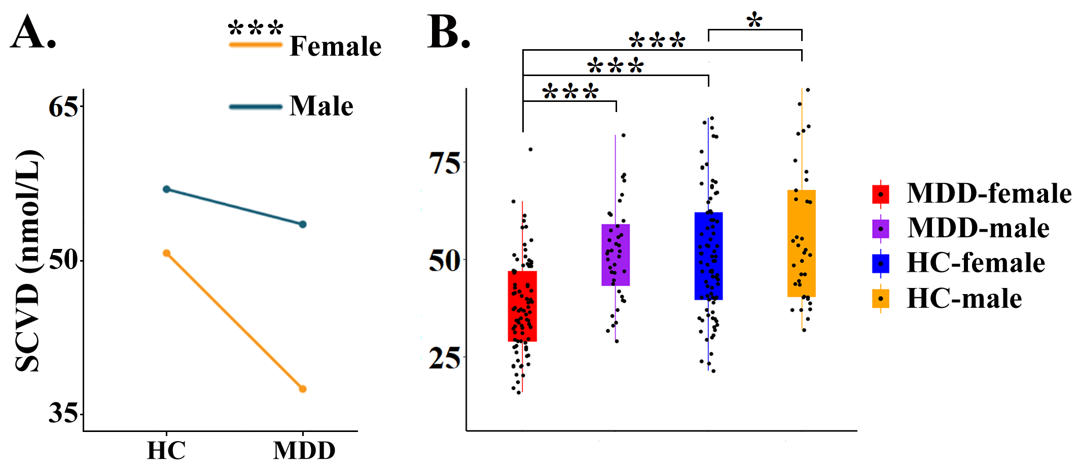
Figure S1. Interaction effect of group × gender on SCVD. (A) and (B) Significant group differences in females but not males. * P < 0.05; *** P < 0.001. Abbreviations: SCVD, serum concentration of vitamin D; MDD, major depressive disorder; HC, healthy controls.
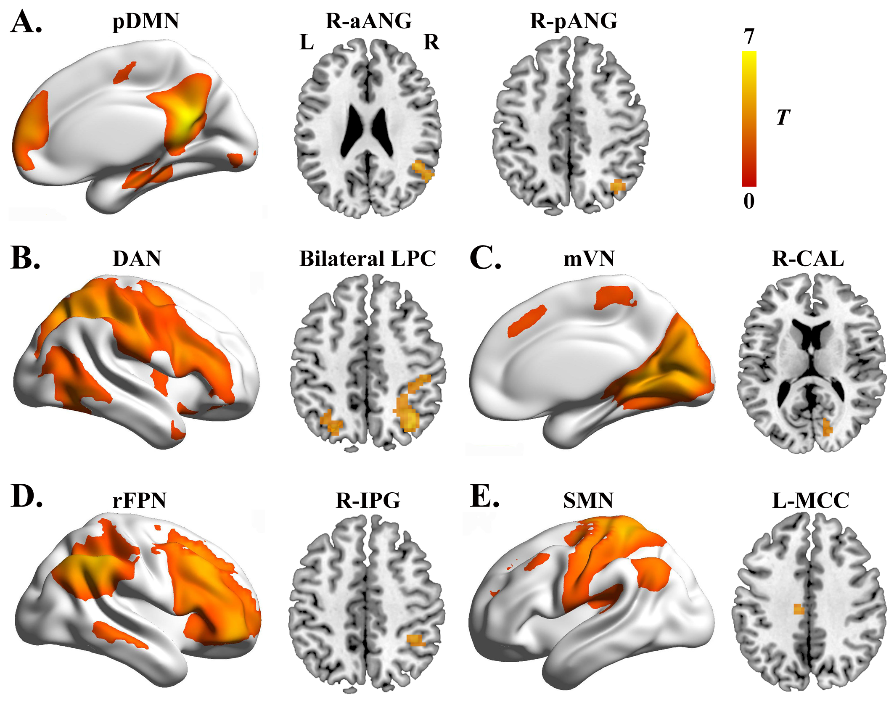
Figure S2. Brain regions showing increased intranetwork functional connectivity in female MDD patients relative to female HC. Abbreviations: pDMN, posterior default mode network; aANG, anterior angular gyrus; pANG, posterior angular gyrus; DAN, dorsal attention network; LPC, lateral parietal cortex; mVN, medial visual network; CAL, calcarine sulcus; rFPN, right frontoparietal network; IPG, inferior parietal gyrus; SMN, sensorimotor network; MCC, middle cingulate cortex; MDD, major depressive disorder; HC, healthy controls; L, left; R, right.

