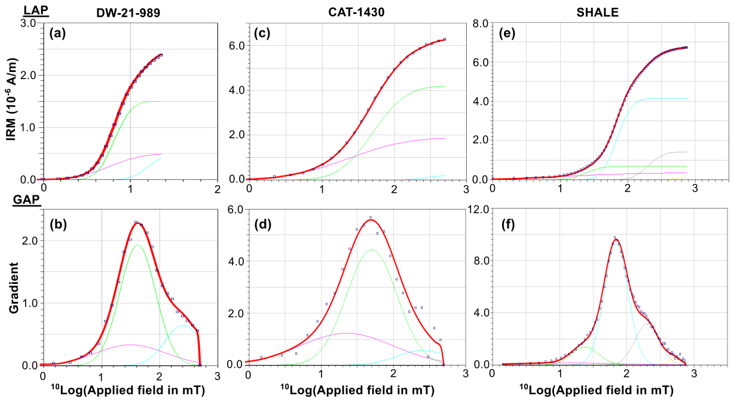

Figure S1: Linear acquisition plots (LAP) and gradient acquisition plot (GAP) respectively for a representative (a, b) background sample (c, d) hydrocarbon reservoir sandstone sample (e, f) shale sample obtained via cumulative log Gaussian analysis (Kruiver et al., 2001). Coercivity values, isothermal remanent magnetization (IRM) contributions, and S-ratio for these background, hydrocarbon reservoir and shale samples in Table S1.

Table S1: Coercivity values, isothermal remanent magnetization (IRM) contributions, and S-ratio for other background and hydrocarbon reservoir samples. B1/2 also known as median destructive field (MDF) stands for the field at which half of the SIRM is reached, DP stand for the dispersion parameter and LAP, GAP and SAP quote the sum of squared residuals for the linear acquisition plots, gradient acquisition plot, and standardization acquisition plot respectively

**Table S2:** Mössbauer parameters for the background samples and the hydrocarbon reservoir samples. IS stands for isomer shift, QS stands for quadrupole shift and Bhf stands for the magnetic hyperfine field.

*Table S1*

|  |  |  |  |  |  |  |  |  |
| --- | --- | --- | --- | --- | --- | --- | --- | --- |
| SAMPLE | Component | B1/2 (mT) | DP | IRM Cont. (%) | S-ratio | LAP | GAP | SAP |
| DW-21-989 | 1 | 30 | 0.60 | 20 | 0.83 | 1.20 × 10-14 | 5.48 × 10-14 | 9.59 × 10-2  1 |
| 2 | 40 | 0.31 | 60 |
| 3 | 250 | 0.31 | 20 |
| CAT-1430 | 1 | 20 | 0.65 | 30 | 0.91 | 5.92 × 10-16 | 2.70 × 10-14 | 7.30 × 10-2 |
| 2 | 50 | 0.35 | 65 |
| 3 | 250 | 0.35 | 5 |
| SHALE | 1 | 10 | 0.80 | 5 | 0.89 | 1.59 × 10-13 | 1.23 × 10-5 | 2.85 × 100 |
| 2 | 20 | 0.20 | 10 |
| 3 | 70 | 0.18 | 62 |
| 4 | 200 | 0.18 | 21 |
| 5 | 510 | 0.10 | 2 |

*Table S2*

|  |  |  |  |  |  |  |  |
| --- | --- | --- | --- | --- | --- | --- | --- |
| sample name | sample group |  | temp (K) | IS  (mm/s) | QS (mm/s) | Bhf  (T) | mineral interpretation |
| BON-1201 | high paramagnetic response – oil pay zone | doublet I  doublet II | 295k | 1.23  0.27 | 1.85  0.71 |  | siderite  silicates or pyrite |
| CAT-1429 | low paramagnetic response – oil pay zone | doublet I  doublet II | 295k | 0.28  1.39 | 0.76  2.41 |  | silicates or pyrite  silicates |
| BON-1190 | oil-water transition region | doublet I  doublet II | 295k | 1.23  1.30 | 1.84  3.55 |  | siderite  vivianite? |
| DW-21-991 | background | doublet I  doublet II | 295k | 0.30  1.31 | 0.81  2.41 |  | silicates or pyrite  silicates |
| BON-1190 | oil-water transition region | sextet I  sextet II  doublet I | 5-10k | 0.41  1.34  1.46 | 0.06  2.05  3.50 | 48.4  17.9 | Lepidocrocite? Ferrihydrite?  siderite  vivianite? |
| BON-1201 | high paramagnetic response – oil pay zone | sextet I  doublet III | 5-10k | 1.37  0.38 | 2.06  0.68 | 17.7 | siderite  silicates or pyrite |