*Supplementary Information*

**Identify Promising Mycobacterium tuberculosis FabH Inhibitors**

Niranjan Kumar1, Rakesh Srivastava1, Raj Kumar Mongre2,3, Chandra Bhushan Mishra4, Amit Kumar5,7, Rosy Khatoon6, Atanu Banerjee6, Harpreet Singh5, Andrew. M. Lynn1, Myeong-Sok Lee2* and Amresh Prakash7*

1School of Computational & Integrative Sciences, Jawaharlal Nehru University, New Delhi-110067, India.

2 Molecular Cancer Biology Laboratory, Cellular Heterogeneity Research Center, Department of Biosystem, Sookmyung Women's University, Hyochangwon gil-52, Yongsan-Gu, Seoul 140-742, Republic of Korea.

3Department of Microbiology & Immunology, David H. Smith Center for Vaccine Biology and Immunology, University of Rochester Medical Center, 601 Elmwood Avenue, Box 609, Rochester, NY 14642.

4 Department of Pharmacology & Chemical Biology, Baylor College of Medicine, Baylor Plaza, Houston, Texas 77030.

5Indian Council of Medical Research - Computational Genomics Centre, All India Institute of Medical Research, New Delhi, India.

6Amity Institute of Biotechnology, Amity University, Haryana, Gurgaon- 122413, India.

7Amity Institute of Integrative Sciences and Health, Amity University, Haryana, Gurgaon- 122413, India.

*\*Address for Correspondence*

Amresh Prakash, PhD

Assistant Professor

Amity Institute of Integrative Sciences and Health (AIISH),

Amity University Haryana, Gurgaon-122413, India

Email: [amreshprakash@jnu.ac.in](mailto:amreshprakash@jnu.ac.in); [aprakash@ggn.amity.edu](mailto:aprakash@ggn.amity.edu)

Myeong-Sok Lee, Ph.D

Professor

Molecular Cancer Biology Laboratory, Cellular Heterogeneity Research Center, Department of Biosystem, Sookmyung Women's University, Hyochangwon gil-52, Yongsan-Gu, Seoul 140-742, Republic of Korea. Tel.: +8227109418

E-mail: [mslee@sookmyung.ac.kr](mailto:mslee@sookmyung.ac.kr)

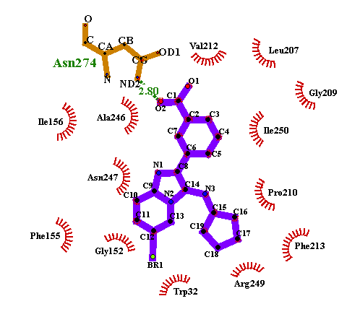 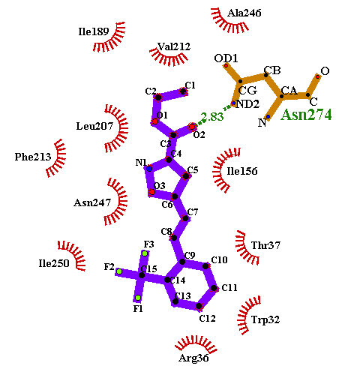

**CHEMBL549989 CHEMBL565500**

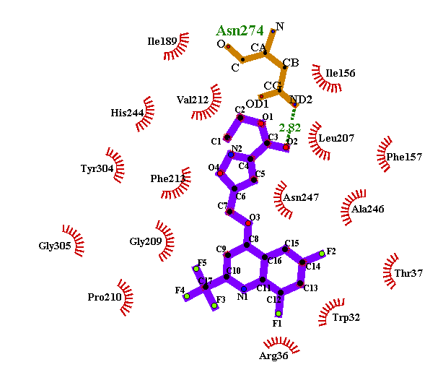 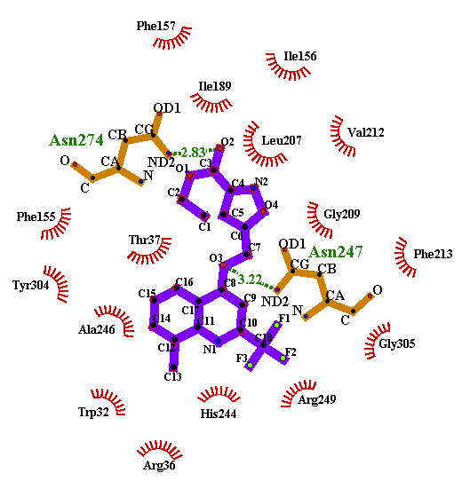

**CHEMBL515441 CHEMBL475041**

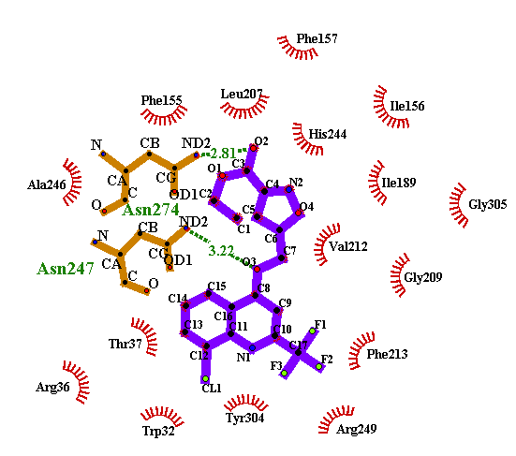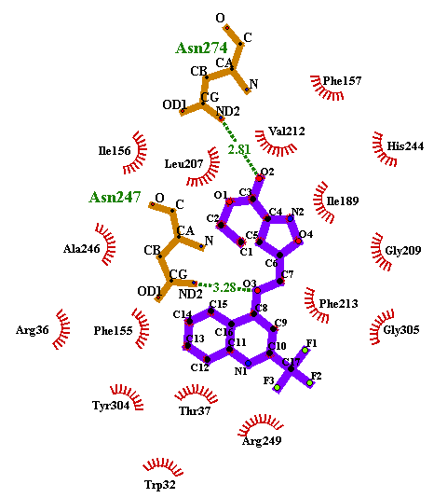

**CHEMBL474052 CHEMBL475851**

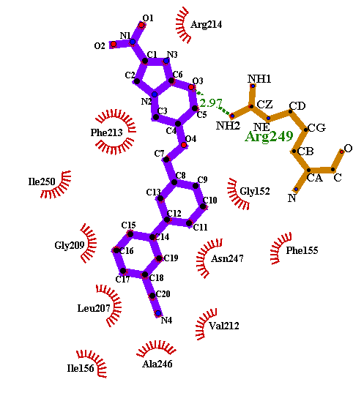 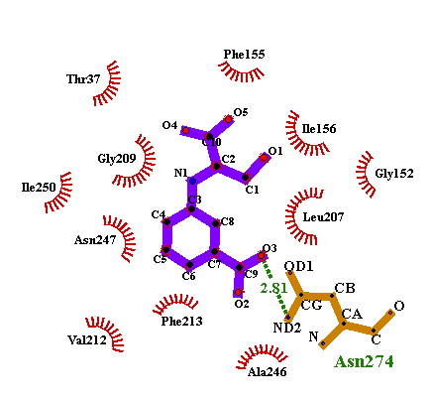

**CHEMBL572316 CHEMBL495223**

**Supplementary Figure S1:** LigPlot (2D) representation of top CHEMBL hit compounds**.**