**Supplementary material**

SOC changes were simulated under future weather scenario ﻿METO-HC-HadRM3Q0-HadCM3Q0 (Figure S1-S3). The fixed amount of manure applications leads to a steady increase in SOC in the first 12 years from the start of the experiment as measured in the LT1 sites. In the following 18 years a slight decrease in SOC can be observed in Figure S1. In LT2, keeping a constant input a different trend is observed compared to LT1. The SOC shows a steady increase in SOC over the whole simulation period, even under CT (Figure S2). In the Boreal site LT7 the SOC trend shows a similar pattern to the one observed in the past 22 years with the current weather (Figure S3). These long-term projections confirm the idea that in SOC depleting soil the use of diverse cropping systems, no tillage and exhogenous organic input (especially green manure) can represent a valid strategy to increase SOC stocks.

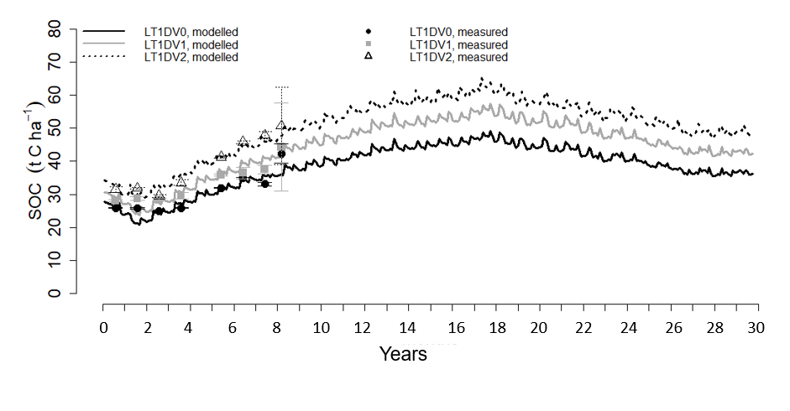  
Figure S1 Measured (point) and modelled (line) SOC in Spain (Murcia) Horticulture site, LT1 under conventional (LT1DV0, organic (LT1DV1) and diversified management (LT1DV2) for the period 2010-2039 at 0-30 cm depth using future weather scenario METO-HC-HadRM3Q0-HadCM3Q0 for the years 2019-2039. The error bar indicates standard deviation of the measured SOC.

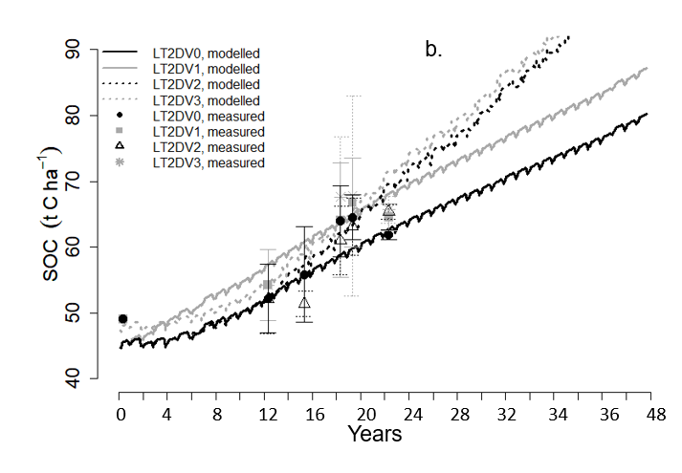  
Figure S2 Measured (point) and modelled (line) SOC in Foggia (Italy) arable cropland site, LT2 under conventional (LT2DV0), diversification 1 (LT2DV1), diversification 2 (LT2DV2) and diversification 3 (LT2DV3) for the period 1996-2039 at 0-30 cm depth using future weather scenario METO-HC-HadRM3Q0-HadCM3Q0 for the years 2019-2039. The error bar indicates standard deviation of the measured SOC.

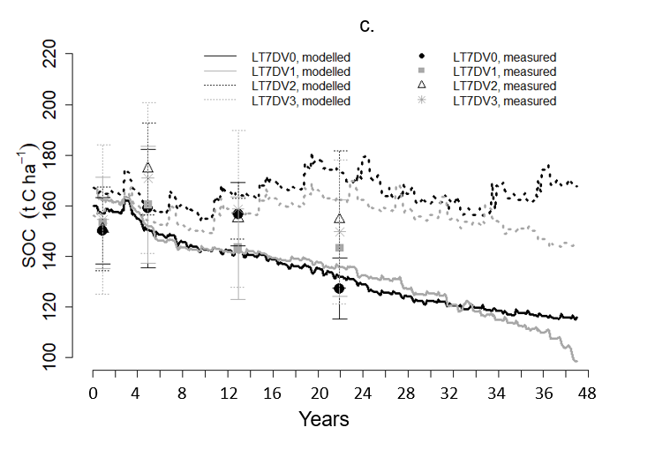

Figure S3 Measured (point) and modelled (line) LT7 SOC under conventional (LT7DV0) and diversification 1 (LT7DV1), Diversification 2 (LT7DV2), Diversification 3 (LT7DV3) management Toholampi (Finland) fodder cropland site, for the period 2010-2039 at 0-30 cm depth using future weather scenario METO-HC-HadRM3Q0-HadCM3Q0 for the years 2019-2039. The error bar indicates standard deviation of the measured SOC.

Table S1: Management Input in the European arable cropland test sites

|  |  |  |  |  |  |  |
| --- | --- | --- | --- | --- | --- | --- |
| Site | Management | Organic amendment | Amount  (t ha-1 yr-1) | N fertilizer  (kg N ha-1 yr-1) | Tillage | Crop |
| LT1 | Conventional (LT1DV0) | Sheep manure | 12-15 | 6.18 | CT | Leafy vegetables |
| Organic  (LT1DV1) | Sheep manure | 15 | 1.23 | CT | Leafy vegetables |
| Biodynamic (LT1DV2) | Sheep compost, tea compost | 10, 140 mg/L C (fertigation) | 1.23 | CT | Leafy vegetables |
| LT2 | Conventional (LT2DV0) | N/A |  | 36 | CT | Wheat |
| Diversification 1 (LT2DV1) |  |  | 36 | NT | Wheat |
| Diversification 2 (LT2DV2) |  |  | 36 | CT | Wheat-tick bean |
| Diversification 3 (LT2DV3) |  |  | 36 | NT | Wheat-tick bean |
| LT4 | Conventional (LT4DV0) | N/A |  | 75 | RT | Barley |
| Diversification 1 (LT4DV1) |  |  | 75 | NT | Barley |
| 1LT7 | Conventional (LT2DV0),  Chemical fertilizer | Fox manure | 14.2 | N/A  50-110 | RT/MT/NT  RT/MT | Barley-clover/grass ley- clover/grass ley- vetch/oats  Barley-barley-rye-oats |
| Diversification 1 (LT7DV1) | No fertilization  Cow slurry | 0-42, not applied every year | N/A  N/A | RT/MT/NT  RT/MT/NT | Barley-clover/grass ley- clover/grass ley- vetch/oats  Barley-clover/grass ley-rye-oats |
| Diversification 2 (LT7DV2) | Cow farmyard manure,  Cow slurry | 48  23-59 | 44-200  0-125 | RT/MT/NT  RT/MT/NT | Barley-grass-grass-barley |
| Diversification 3 (LT7DV3) | Composted farmyard manure,  Cow slurry | 62  14-50 | N/A | RT/MT/NT | Barley-clover/grass ley- clover/grass ley- vetch/oats |

1The amount and time of the manure application varies among treatments. In ECOSSE CT (conventional tillage) represents cultivation depth 20-30cm, RT (reduced tillage) represents cultivation depth 15-20cm, and MT (minimum tillage) represents cultivation depth 5-10cm (Smith et al., 2011).