Supplementary Material

Supplementary Figures
A
B
Supplementary Figure 1. (A) Relative expression levels of NtMYB330 in the flowers of pink-flowered Yunyan 87 (wild-type) and white-flowered Yunyan 87 (mutant). Data are the mean of three replicates with error bars indicating ± SD. Asterisks indicate statistically significant differences from wild-type according to paired t-test (*, P < 0.05; **, P < 0.01). (B) Exon/intron structures of NtMYB330 gene. Blue boxes and dash lines represent exons and introns, respectively, with numbers indicate the length. The inverted triangle indicates the PAM position for CRISPR/Cas9 system.
A
B
C |  | D
Supplementary Figure 2. Quantitative analyses of transcript levels of flavonoid-related EBGs, NtAn1b and NtAn11-1 in tobacco flowers. Relative expression levels of (A) NtCHS3, NtCHS4, NtCHI1, NtCHI2, (B) NtF3H1, NtF3H2, NtFLS1, NtFLS2, (C) NtAn1b, and (D) NtAn11-1 in the flower petals of WT, VC, NtMYB330-OE lines and ntmyb330 mutant plants. Data are the mean of three replicates with error bars indicating $±$SD.
A | 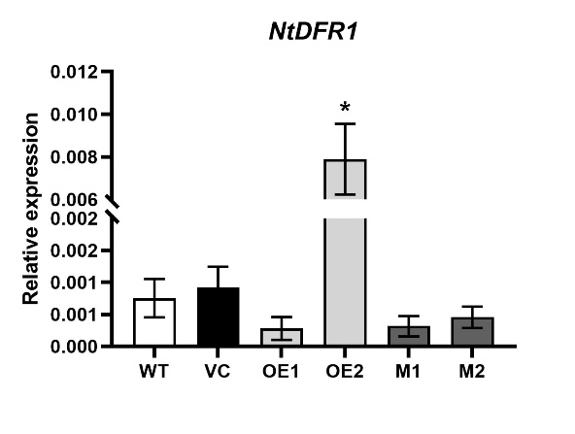 | B | 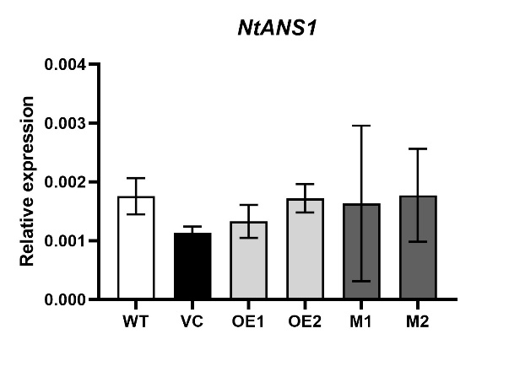
C | 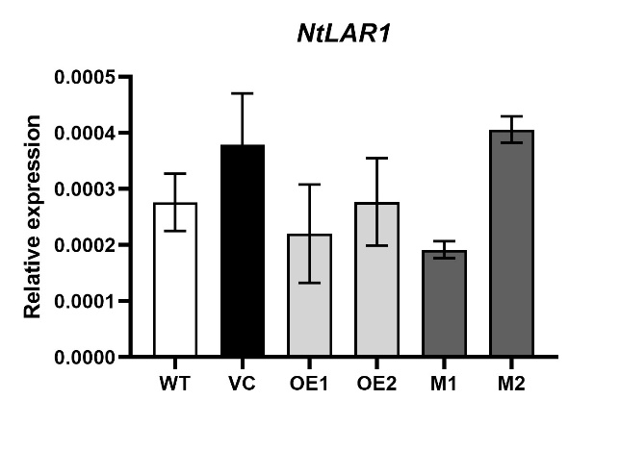 | D | 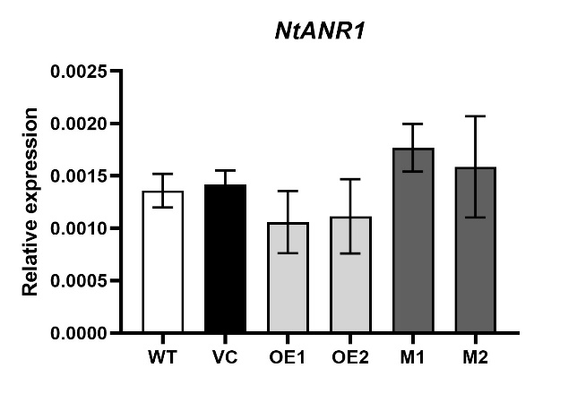
Supplementary Figure 3. Quantitative transcript analyses of LBGs in PA pathway in tobacco leaves. Analyses of expressions of (A) NtDFR1, (B) NtANS1, (C) NtLAR1and (D) NtANR1 in the leaves of WT, VC, NtMYB330-OE lines and ntmyb330 mutants. Data are the mean of three replicates with error bars indicating $±$SD. Asterisks indicate statistically significant differences from WT according to paired t-test (*, P < 0.05; **, P < 0.01).
A | 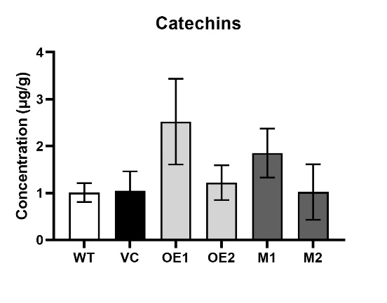 | B | 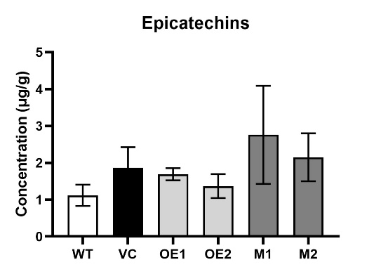
Supplementary Figure 4. Concentrations of (A) catechins and (B) epicatechins in the leaves of WT, VC, NtMYB330-OE lines and ntmyb330 mutant plants. Data are the mean of three replicates with error bars indicating $±$SD.
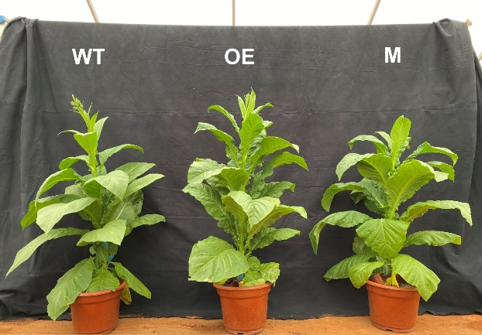
Supplementary Figure 5. WT, NtMYB330-OE and ntmyb330 mutant plants at the flowering stage.
A | 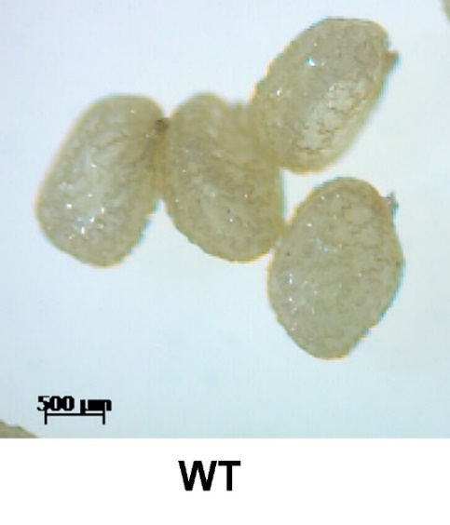 | B | 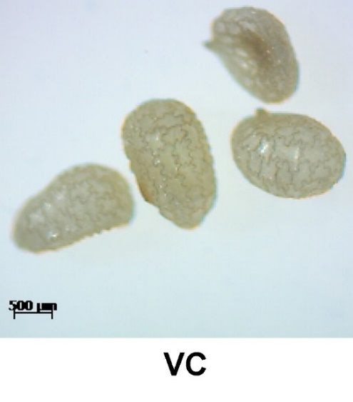
C | 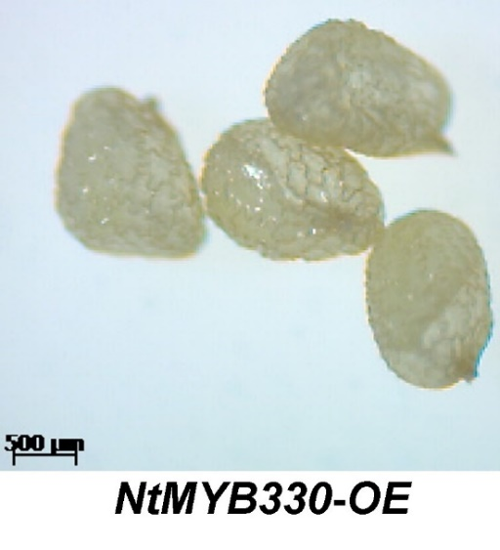 | D | 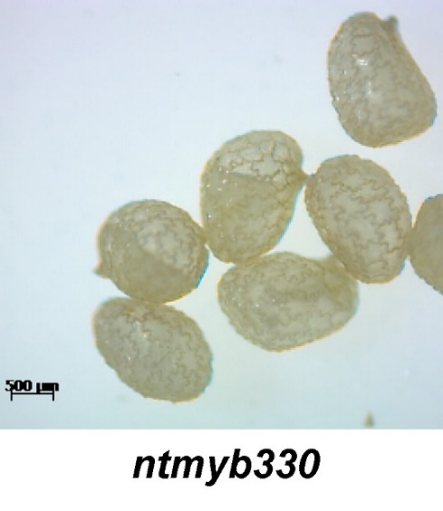
Supplementary Figure 6. Immature seeds of different lines without DMACA staining. (A) WT, (B) VC, (C) NtMYB330-OE, and (D) ntmyb330. Scale bar: 500 μm.

A |  | B
C |  | D
E |  | F
Supplementary Figure 7. Analyses of catechins and epicatechins in the flower samples of (A) WT, (B) VC, (C) OE1, (D) OE2, (E) M1, (F) M2. Peak identities: (1) catechin; (2) epicatechin. Experiment was repeated three times, representative data from one experimental replicate presented here.

