**Supplementary materials**

**Figure S1**: OTUs venn diagram in different sample groups.

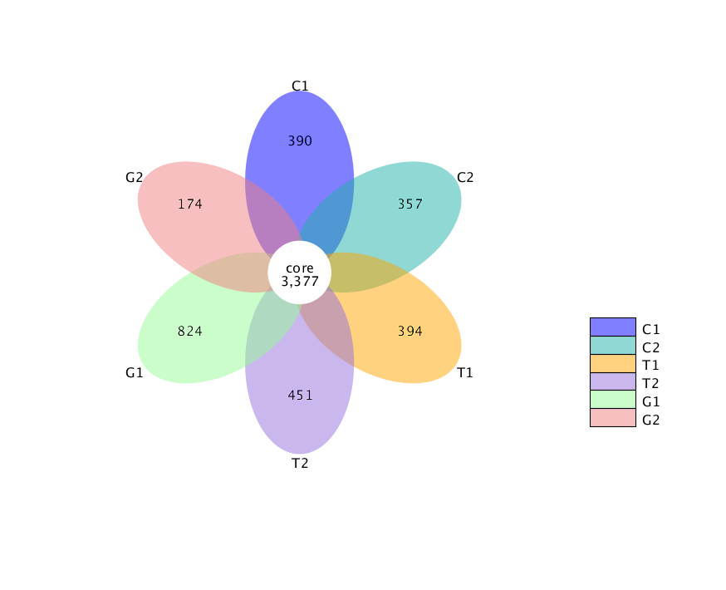

**Figure S1.** OTUs venn diagram in different sample groups.