Supplemental Figures and Tables
Supplemental Figure 1 1
Supplemental Figure 2 2
Supplemental Figure 3 3
Supplemental Table S1 4
Supplemental Table S2 4
Supplemental Table S3 4
Supplemental Table S4 4
Supplemental Table S5 4
Supplemental Table S6 4

Supplemental Figure 1
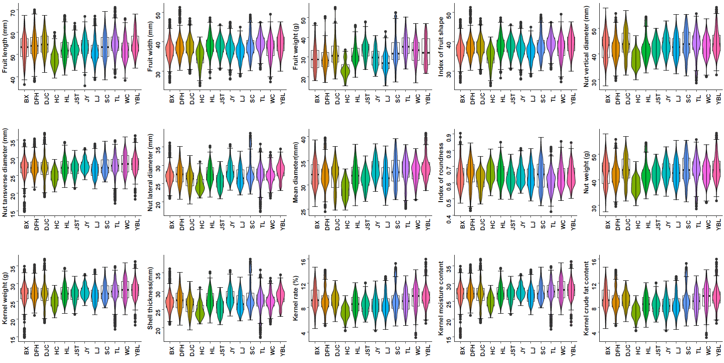
Figure S1. Distribution of fruit morphological traits.

Supplemental Figure 2
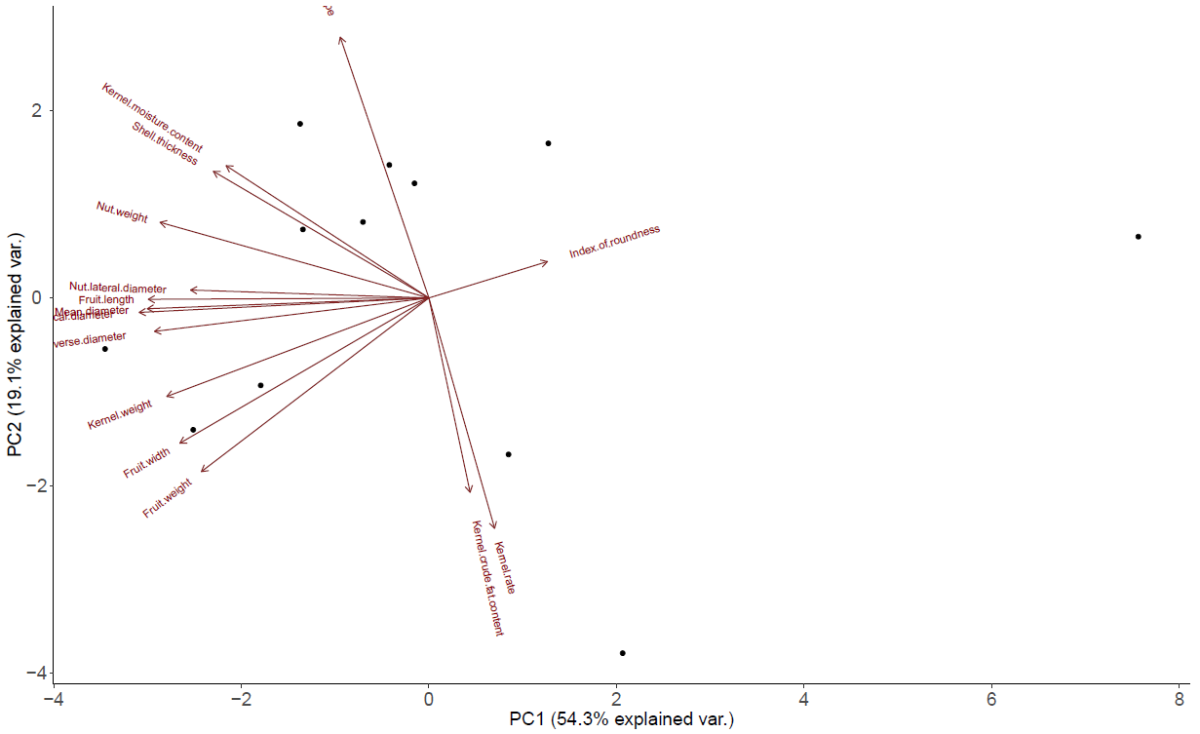
Figure S2. Principle component analysis using fruit morphology

Supplemental Figure 3
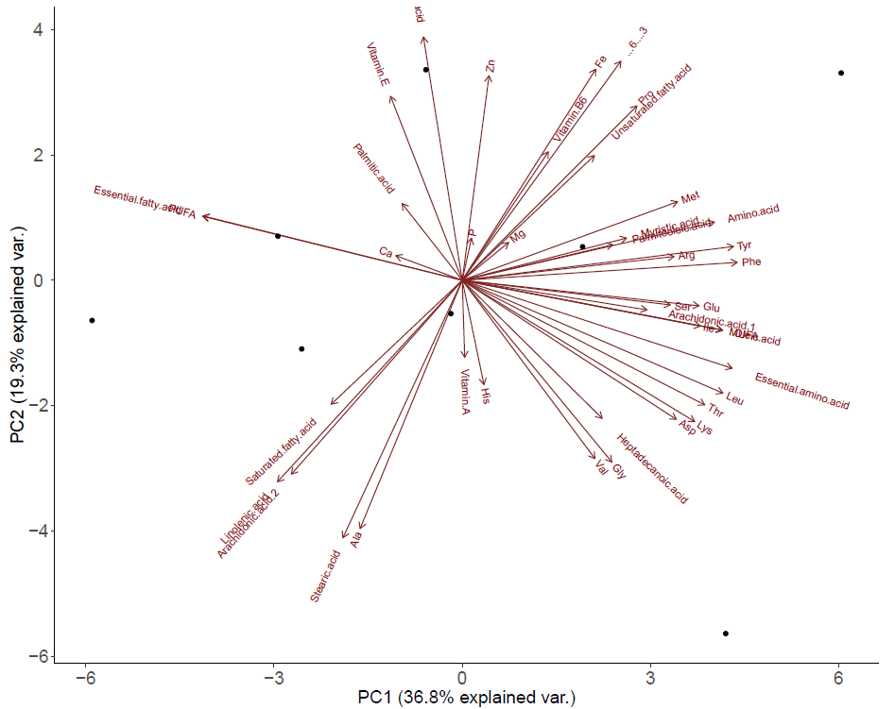
Figure S3. Principle component analysis using kernel nutritional composition

