Table S2 Secondary fragmentation of potential biomarkers in the urine of dampness-heat jaundice model rats
NO | Rt | m/z determined | Proposed Composition | Postulated Identity | MS/MS | Structural Formula
1 | 0.82 | 173.0084 | C₆H₆O₆ | Cis-Aconitic acid | 173.0458[M-H]⁻, 129.0578[M-H-CO₂]⁻, 111.0492[M-H-CH₂O₃]⁻, 85.0714[M-H-C₂O₄]⁻ | 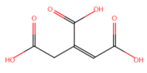
2 | 1.02 | 267.1098 | C₅H₁₀O₄ | 2,3-Dihydroxyvaleric acid | 267.1389[2M-H]⁻, 187.1087[2M-H-CH₄O₄]⁻ | 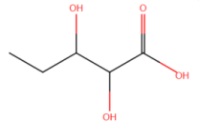
3 | 1.51 | 299.1665 | C₁₉H₂₄O₃ | 2-Methoxyestrone | 299.1602[M-H]⁻, 251.1118[M-H-C₂H₈O]⁻ | 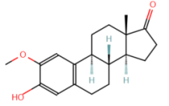
4 | 1.58 | 139.0509 | C₆H₆N₂O₂ | Urocanic acid | 139.0513[M+H]⁺,122.0280[M+H-NH₃]⁺, 96.0481[M+H-C₂H₅N]⁺ | 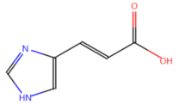
5 | 1.78 | 292.1054 | C₁₀H₁₇NO₆ | Malonylcarnitine | 292.1316[M+FA-H]⁻, 188.0419[M+FA-H-C₃H₄O₄]⁻, 156.1086[M+FA-H-C₅H₁₄O₃N]⁻ | 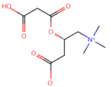
6 | 2.06 | 312.1089 | C₁₁H₂₁NO₇S | N-(1-Deoxy-1-fructosyl)methionine | 312.1133[M+H]⁺,276.1470[M+H-2H₂O]⁺, 229.1613[M+H-2H₂O-CH₃S]⁺ | 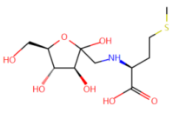
7 | 3.15 | 165.0559 | C₉H₈O₃ | Phenylpyruvic acid | 165.0565[M+H]⁺, 137.0597[M+H-C₂H₄]+ | 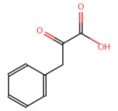
8 | 3.18 | 180.0883 | C₆H₁₃NO₅ | Glucosamine | 180.0923[M+H]⁺,162.0623[M+H-H₂O]⁺, 144.0488[M+H-2H₂O]⁺ | 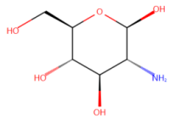
9 | 3.95 | 224.0560 | C₉H₉NO₃ | Adrenochrome | 224.0872[M+FA-H]⁻, 193.0758[M+FA-H-CH₃O]⁻ | 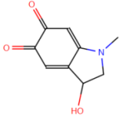
10 | 5.16 | 338.0888 | C₁₅H₁₇NO₈ | 5-Hydroxy-6-methoxyindole glucuronide | 338.0869[M-H]⁻,175.0228[M-H-C₉H₉NO₂]⁻, 162.0543[M-H-C₆H₈O₆]⁻ | 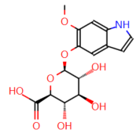
11 | 5.22 | 250.0717 | C₁₁H₁₁NO₃ | 5-Methoxyindoleacetate | 250.0707[M+FA-H]⁻, 206.0789[M+FA-H-CO₂]⁻ | 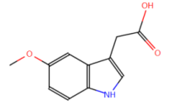
12 | 5.93 | 146.0607 | C₉H₇NO | 1H-Indole-3-carboxaldehyde | 146.0629[M+H]⁺, 119.0891[M+H-CHN]⁺ | 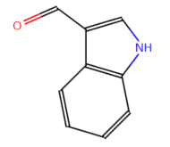
13 | 6.04 | 245.1749 | C₁₂H₂₄O₂ | Dodecanoic acid | 245.1747[M+FA-H]⁻, 201.1508[M+FA-H-CO₂]⁻, 173.1205[M+FA-H-C₃H₄O₂]⁻ | 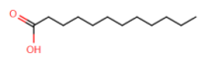
14 | 6.73 | 333.1129 | C₈H₉NO₃ | Pyridoxal | 333.1052[2M-H]⁻,297.1392[2M-H-2H₂O]⁻, 283.0883[2M-H-CH₆O₂]⁻ | 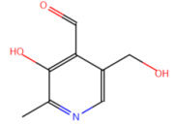
15 | 7.19 | 321.1579 | C₁₀H₁₁NO | Tryptophanol | 321.1779[2M-H]⁻,285.1422[2M-H-2H₂O]⁻, 245.1678[2M-H-C₃H₈O₂]⁻ | 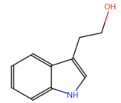
16 | 7.37 | 263.1119 | C₁₀H₁₆N₄O₃ | Homocarnosine | 263.1129[M+Na]⁺,245.1223[M+Na-H₂O]⁺, 133.0670[M+Na-C₅H₈NO₃]⁺ | 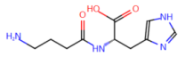
17 | 7.43 | 243.1600 | C₁₂H₂₂O₂ | Trans-Dodec-2-enoic acid | 243.1411[M+FA-H]⁻, 113.0649[M+FA-H-C₇H₁₄O₂]⁻ | 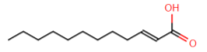
18 | 7.47 | 593.3384 | C₃₃H₄₄N₄O₆ | Mesobilirubinogen | 593.8547[M+H]⁺, 533.3176[M+H-C₂H₄O₂]⁺ | 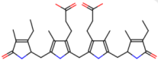
19 | 7.49 | 245.1383 | C₁₂H₂₂O₅ | 3-Hydroxydodecanedioic acid | 245.1678[M-H]⁻,199.1365[M-H-CH₂O₂]⁻, 155.1497[M-H-C₂H₂O₄]⁻ | 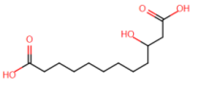
20 | 7.80 | 377.0771 | C₁₀H₇NO₃ | Kynurenic acid | 377.0891[2M-H]⁻, 243.0661[2M-H-C₇H₄NO₂]⁻, 233.1867[2M-H-C₉H₆NO]⁻ | 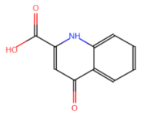
21 | 8.09 | 595.3488 | C₃₃H₄6N₄O₆ | L-Urobilin | 595.3667[M+H]⁺, 410.1938[M+H-C₉H₁₅O₃N]⁺, | 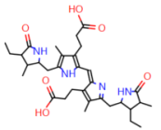
22 | 8.66 | 327.2318 | C₂₀H₃₂O₂ | Arachidonic acid | 327.2346[M+Na]⁺,291.1256[M+Na-2H₂O]⁺, 267.1656[M+Na-C₂H₄O₂]⁺ | 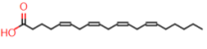
23 | 8.99 | 407.2786 | C₂₄H₃₈O₅ | 7-Ketodeoxycholic acid | 407.2189[M+H]⁺,345.2566[M+H-C₂H₆O₂]⁺, 315.2454[M+H-C₃H₈O₃]⁺ | 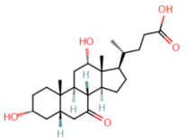
24 | 9.02 | 503.2353 | C₂₃H₃₈O₇S | 3-Sulfodeoxycholic acid | 503.2355[M+FA-H]⁻,441.1827[M+FA-H-CH₂O₃]⁻, 401.1044[M+FA-H₆O₄S]⁻ | 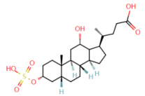
25 | 9.17 | 405.2635 | C₂₄H₃₆O₅ | 7a,12a-Dihydroxy-3-oxo-4-cholenoic acid | 405.2651[M+H]⁺, 290.2769[M+H-C₆H₁₁O₂]⁺ | 