Supplementary Figures

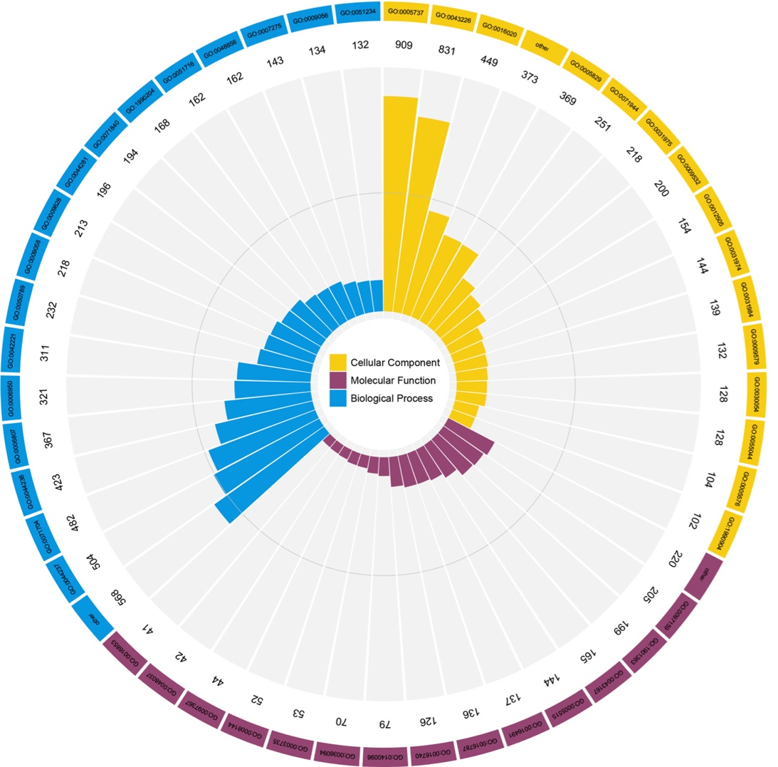
Supplementary Figure 1 GO classification of the crotonylated proteins based on biology process, cellular components and molecular functional

According to the p value of Fisher's exact test obtained by enrichment analysis, the related functions in different groups are clustered together by hierarchical clustering method and drawn as heat map. The horizontal direction of heat map represents the enrichment test results of different groups, and the vertical direction is the description of differentially expressed enrichment related functions (GO, KEGG pathway, protein domain).
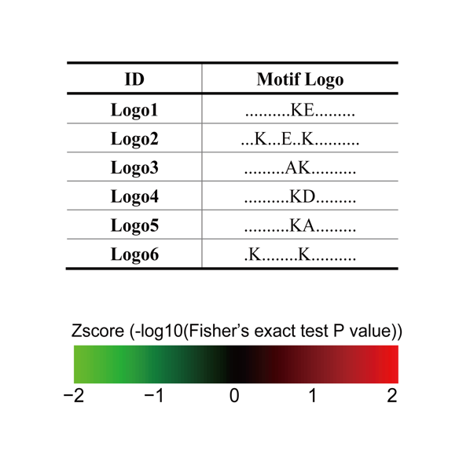
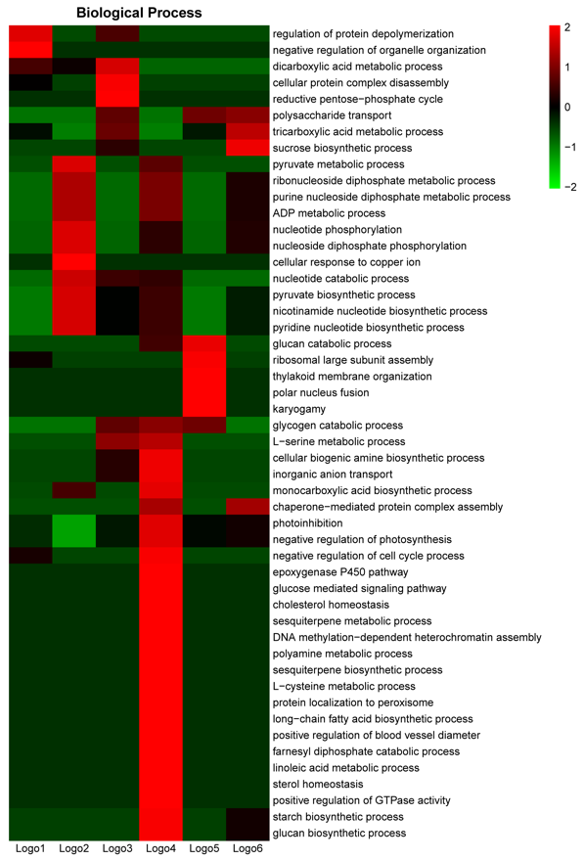
Supplementary Figure 2 Biological Process enrichment analysis of the first six significant motifs
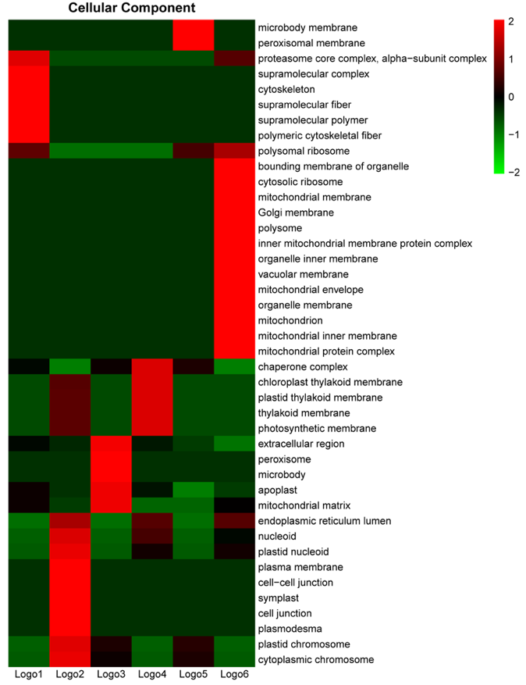
Supplementary Figure 3 Cellular Component enrichment analysis of the first six significant motifs

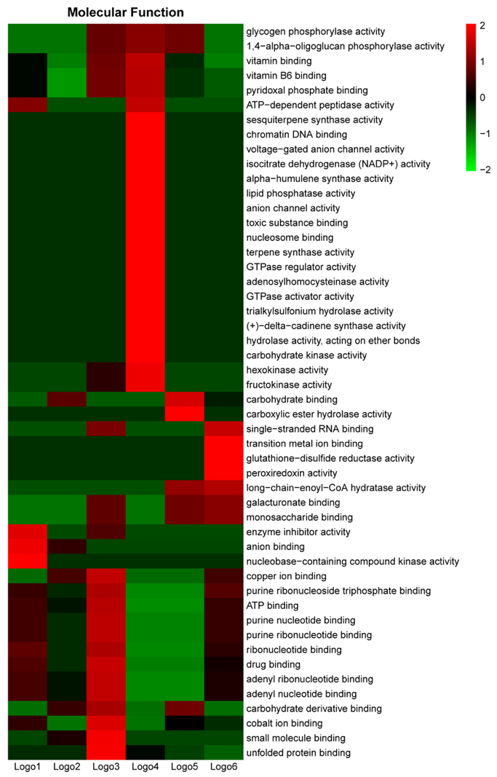
Supplementary Figure 4 Molecular Function enrichment analysis of the first six significant motifs
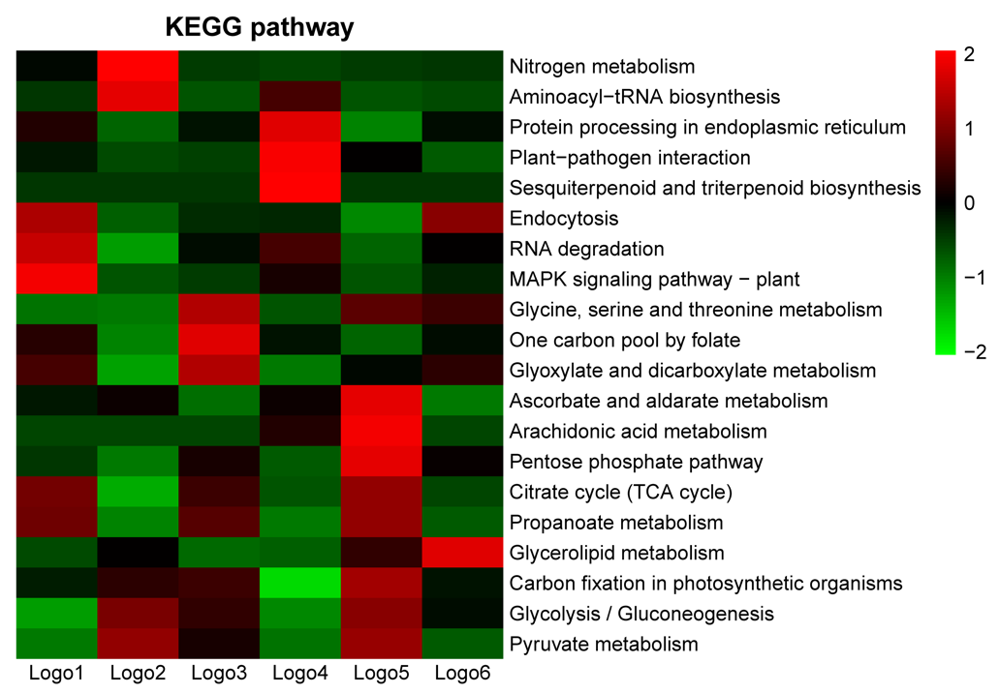
Supplementary Figure 5 KEGG pathway enrichment analysis of the first six significant motifs
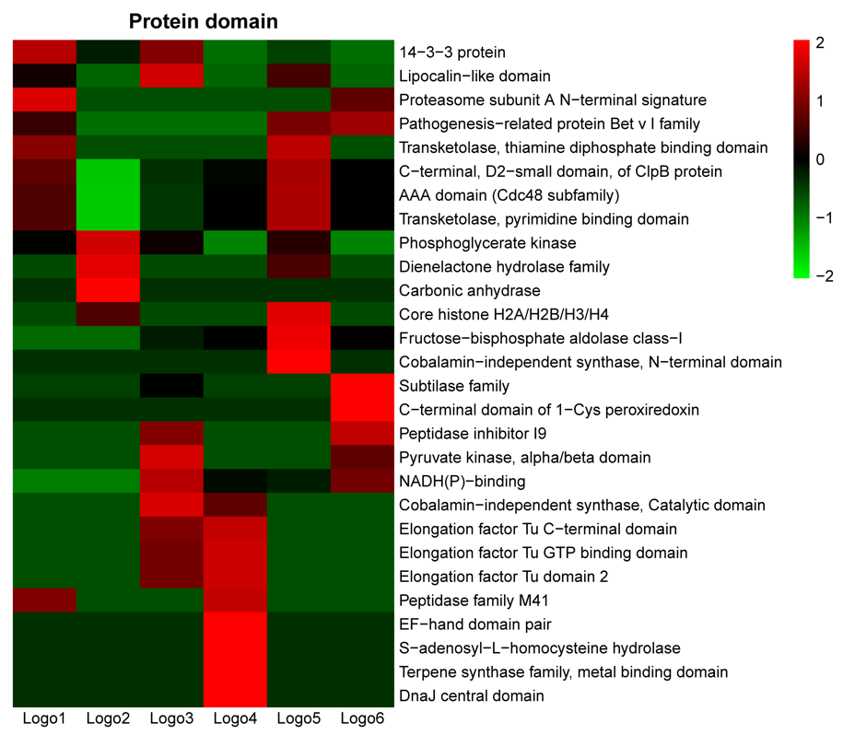
Supplementary Figure 6 Protein Domain enrichment analysis of the first six significant motifs

