Supplemental materials:

Fig. 1S Olmstead-Tukey test for association of abundance of amphipod families and frequency of appearance (%) for Canyon (●) and non-canyon (●) transects in the NGoM.

The lines dividing the quadrants correspond to the median values of the axes.

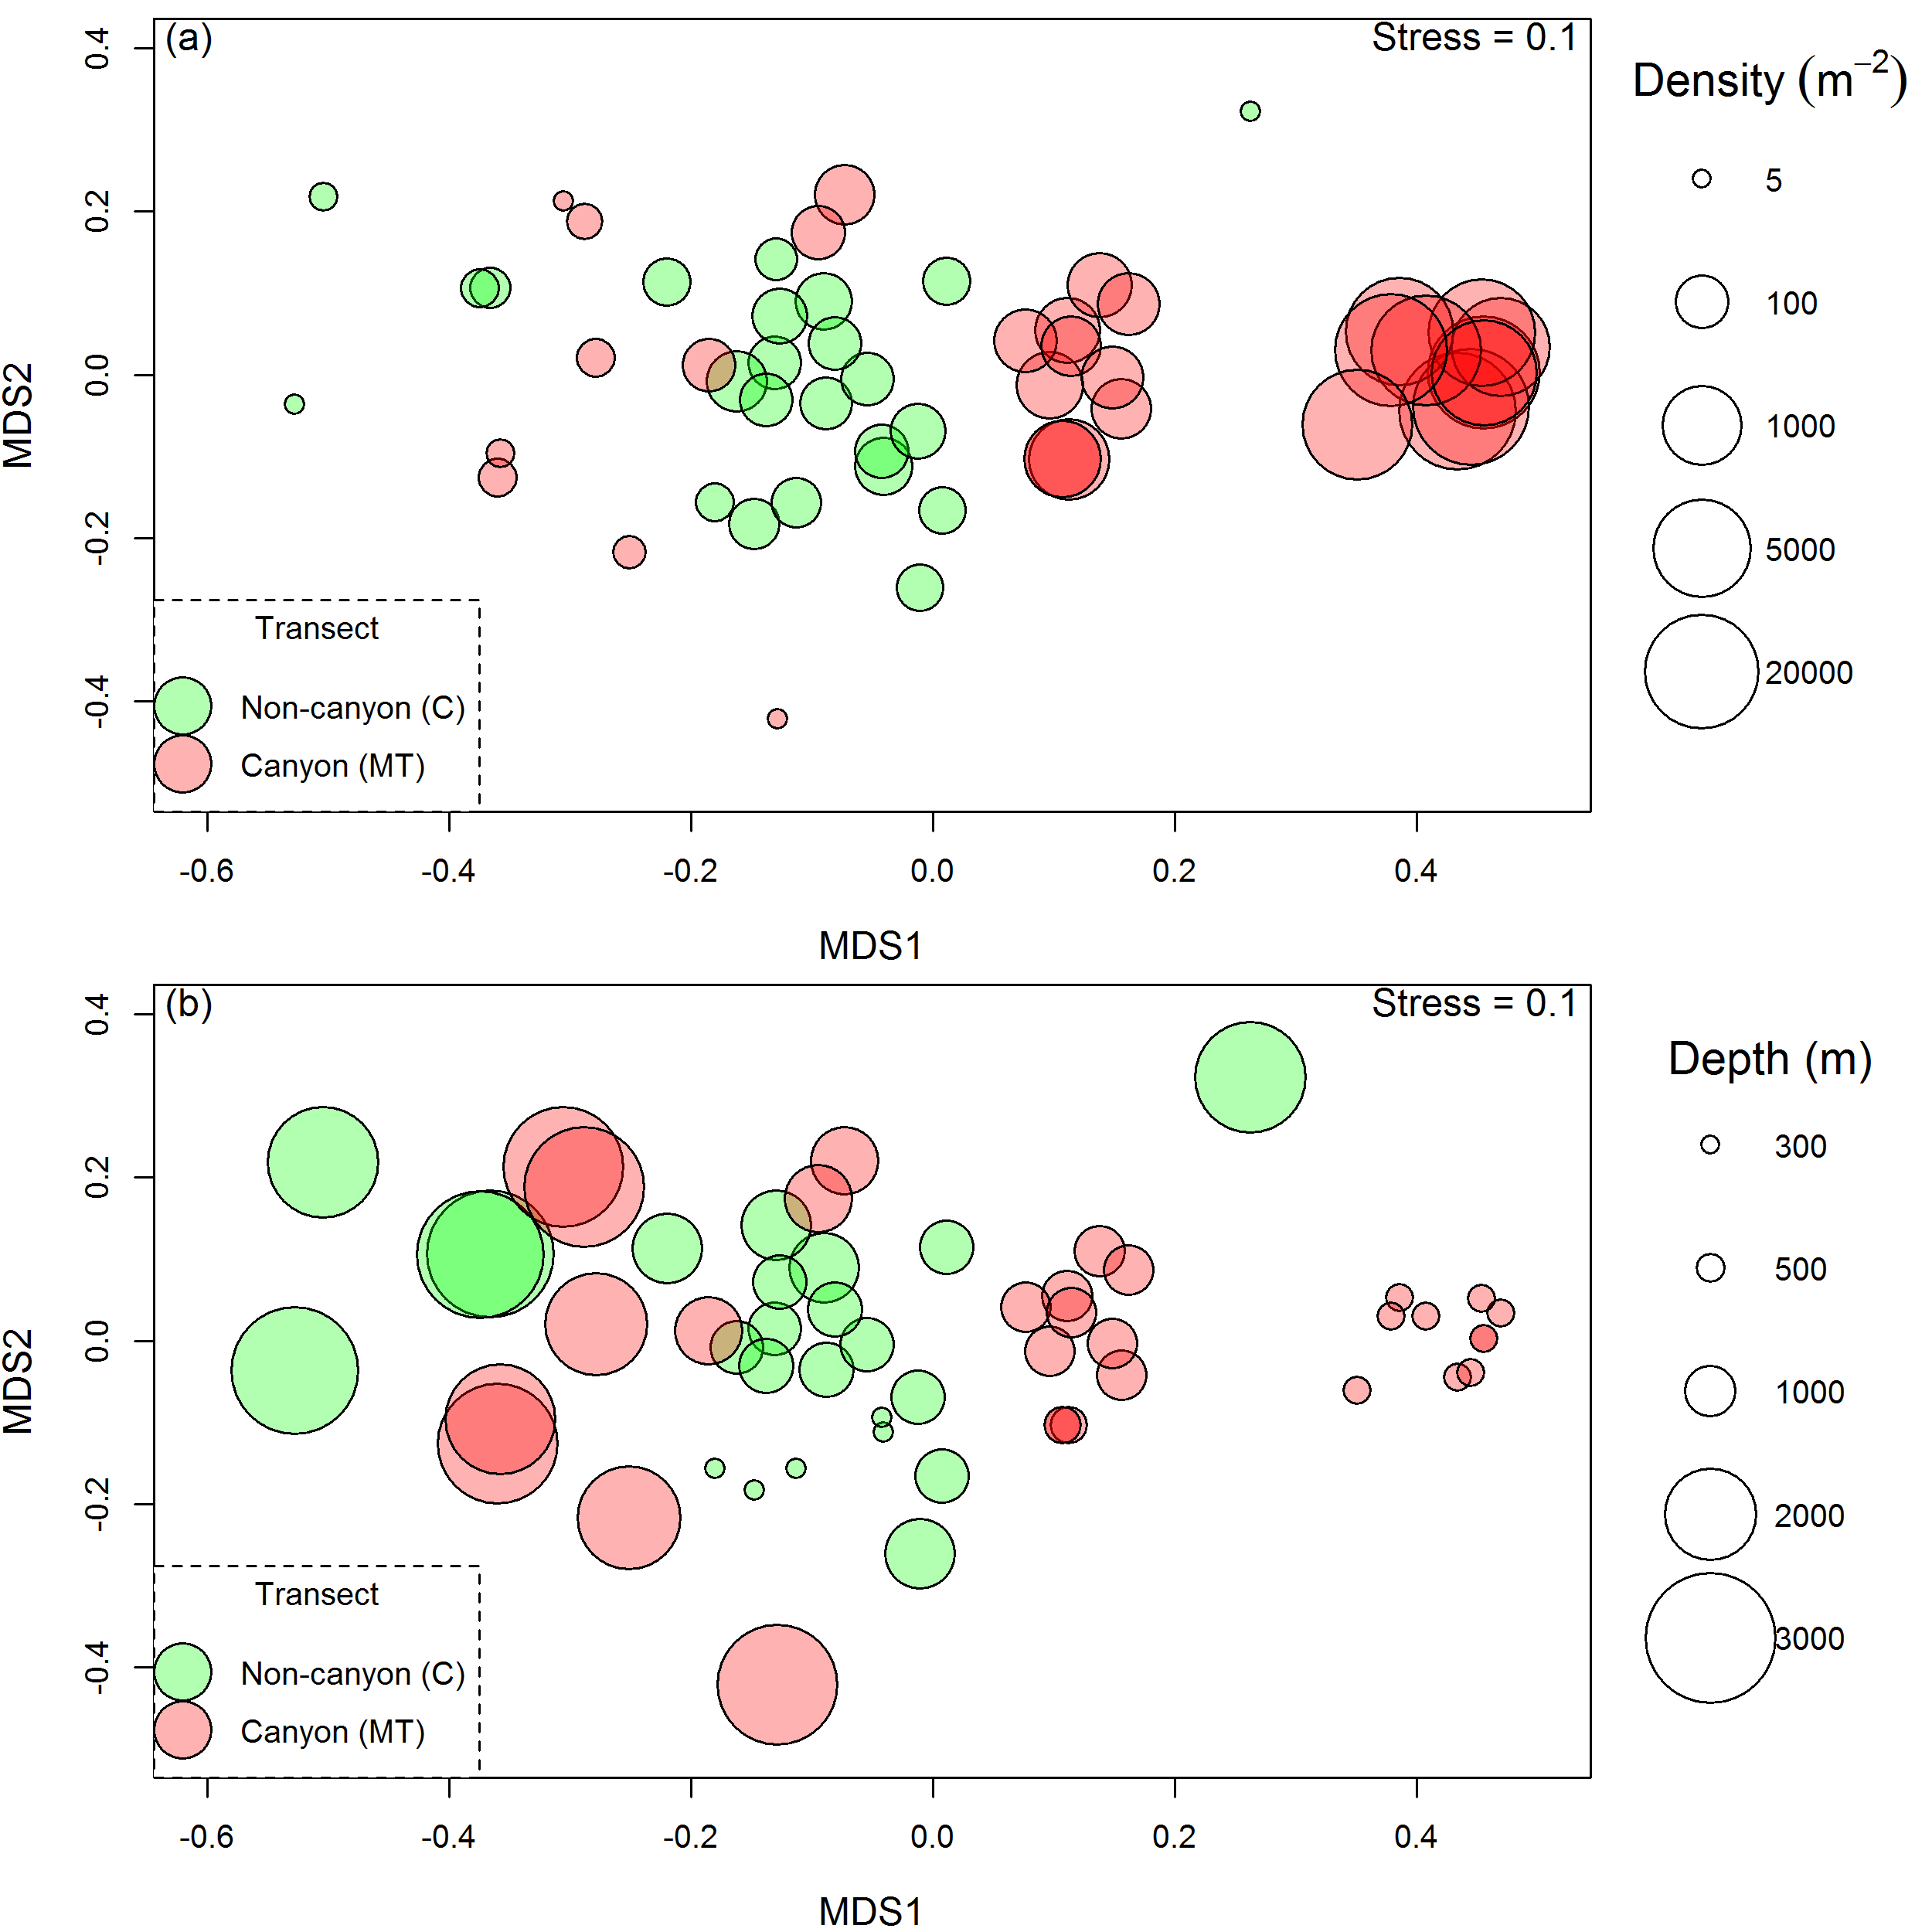

Fig. 2S. MDS ordination of DGOMB stations, based on Bray–Curtis similarity (4th root transformation) of amphipod species abundance data. Bubble size equals relative amphipod (a) density per square meter and (b) water depth (m).

Table 1S. Sampling stations and their geographical locations in the Mississippi Canyon (MT) and central transect (C), Northern Gulf of Mexico.

|  |  |  |  |  |  |  |
| --- | --- | --- | --- | --- | --- | --- |
| **Cruise** | **STATION** | **Replicate** | **Depth** | **Date** | **Latitude** | **Longitude** |
| 1 | C1 | 1 | 336 | 5/30/2000 | 28.05964 | -90.2491 |
| 1 | C1 | 2 | 336 | 5/30/2000 | 28.05938 | -90.2492 |
| 1 | C1 | 3 | 336 | 5/30/2000 | 28.05979 | -90.2494 |
| 1 | C1 | 4 | 336 | 5/30/2000 | 28.05984 | -90.2499 |
| 1 | C1 | 5 | 334 | 5/30/2000 | 28.06008 | -90.2489 |
| 1 | C12 | 1 | 2922 | 6/2/2000 | 26.37942 | -89.2414 |
| 1 | C12 | 2 | 2920 | 6/2/2000 | 26.38292 | -89.2414 |
| 1 | C12 | 3 | 2918 | 6/2/2000 | 26.37336 | -89.2376 |
| 1 | C12 | 4 | 2920 | 6/3/2000 | 26.37973 | -89.2403 |
| 1 | C12 | 5 | 2924 | 6/2/2000 | 26.37496 | -89.2431 |
| 1 | C14 | 1 | 2487 | 6/1/2000 | 26.92995 | -89.5704 |
| 1 | C14 | 2 | 2495 | 6/1/2000 | 26.92983 | -89.5645 |
| 1 | C14 | 3 | 2487 | 6/1/2000 | 26.92989 | -89.5709 |
| 1 | C14 | 4 | 2478 | 6/1/2000 | 26.93824 | -89.5725 |
| 1 | C14 | 5 | 2487 | 6/1/2000 | 26.92956 | -89.5714 |
| 1 | C4 | 1 | 1472 | 5/31/2000 | 27.45315 | -89.7631 |
| 1 | C4 | 2 | 1455 | 5/31/2000 | 27.4594 | -89.7857 |
| 1 | C4 | 3 | 1452 | 5/31/2000 | 27.46017 | -89.7795 |
| 1 | C4 | 4 | 1463 | 5/31/2000 | 27.45242 | -89.776 |
| 1 | C4 | 5 | 1476 | 5/31/2000 | 27.45054 | -89.7619 |
| 1 | C7 | 1 | 1080 | 5/30/2000 | 27.72828 | -89.9796 |
| 1 | C7 | 2 | 1070 | 5/30/2000 | 27.73286 | -89.9772 |
| 1 | C7 | 3 | 1066 | 5/30/2000 | 27.73152 | -89.9835 |
| 1 | C7 | 4 | 1070 | 5/30/2000 | 27.73015 | -89.9854 |
| 1 | C7 | 5 | 1072 | 5/30/2000 | 27.73044 | -89.982 |
| 1 | MT1 | 1 | 480 | 6/17/2000 | 28.54188 | -89.8289 |
| 1 | MT1 | 2 | 482 | 6/17/2000 | 28.53951 | -89.8289 |
| 1 | MT1 | 3 | 482 | 6/17/2000 | 28.54114 | -89.8271 |
| 1 | MT1 | 4 | 481 | 6/17/2000 | 28.54059 | -89.8288 |
| 1 | MT1 | 5 | 481 | 6/17/2000 | 28.54111 | -89.825 |
| 1 | MT2 | 1 | 676 | 6/17/2000 | 28.45108 | -89.6726 |
| 1 | MT2 | 2 | 677 | 6/17/2000 | 28.45121 | -89.6703 |
| 1 | MT2 | 3 | 676 | 6/17/2000 | 28.45055 | -89.6727 |
| 1 | MT2 | 4 | 677 | 6/17/2000 | 28.45028 | -89.6733 |
| 1 | MT2 | 5 | 680 | 6/17/2000 | 28.44793 | -89.6719 |
| 1 | MT3 | 1 | 983 | 6/16/2000 | 28.22041 | -89.4961 |
| 1 | MT3 | 2 | 987 | 6/16/2000 | 28.21922 | -89.4964 |
| 1 | MT3 | 3 | 990 | 6/16/2000 | 28.21904 | -89.4918 |
| 1 | MT3 | 4 | 988 | 6/16/2000 | 28.2176 | -89.4938 |
| 1 | MT3 | 5 | 985 | 6/16/2000 | 28.22151 | -89.494 |
| 1 | MT4 | 1 | 1401 | 6/15/2000 | 27.827 | -89.1659 |
| 1 | MT4 | 2 | 1401 | 6/15/2000 | 27.82836 | -89.1647 |
| 1 | MT4 | 3 | 1402 | 6/16/2000 | 27.83348 | -89.1658 |
| 1 | MT4 | 4 | 1402 | 6/16/2000 | 27.82761 | -89.1661 |
| 1 | MT4 | 5 | 1401 | 6/16/2000 | 27.82802 | -89.1679 |
| 1 | MT5 | 1 | 2290 | 6/3/2000 | 27.32635 | -88.6696 |
| Table 1, continued. | | | | | | |
| **Cruise** | **STATION** | **Replicate** | **Depth** | **Date** | **Latitude** | **Longitude** |
| 1 | MT5 | 3 | 2267 | 6/4/2000 | 27.3346 | -88.6622 |
| 1 | MT5 | 4 | 2263 | 6/4/2000 | 27.33652 | -88.6595 |
| 1 | MT5 | 5 | 2280 | 6/4/2000 | 27.33284 | -88.6561 |
| 1 | MT6 | 1 | 2745 | 6/4/2000 | 27.00011 | -87.9978 |
| 1 | MT6 | 2 | 2750 | 6/5/2000 | 27.00149 | -87.9882 |
| 1 | MT6 | 3 | 2745 | 6/5/2000 | 26.99651 | -87.9987 |
| 1 | MT6 | 4 | 2745 | 6/5/2000 | 26.99948 | -87.9962 |
| 1 | MT6 | 5 | 2743 | 6/5/2000 | 27.00165 | -87.9991 |
| 2 | MT1 | 1 | 487 | 6/2/2001 | 28.53808 | -89.8277 |
| 2 | MT1 | 2 | 490 | 6/2/2001 | 28.53517 | -89.8256 |
| 2 | MT1 | 3 | 485 | 6/3/2001 | 28.53883 | -89.8303 |
| 2 | MT1 | 4 | 480 | 6/3/2001 | 28.54105 | -89.8308 |
| 2 | MT1 | 5 | 478 | 6/3/2001 | 28.54185 | -89.8294 |
| 2 | MT3 | 1 | 980 | 6/4/2001 | 28.22455 | -89.5126 |
| 2 | MT3 | 2 | 982 | 6/4/2001 | 28.22443 | -89.5066 |
| 2 | MT3 | 3 | 984 | 6/4/2001 | 28.22263 | -89.5058 |
| 2 | MT3 | 4 | 984 | 6/4/2001 | 28.22083 | -89.5054 |
| 2 | MT3 | 5 | 985 | 6/4/2001 | 28.22104 | -89.5092 |
| 2 | MT6 | 1 | 2740 | 6/13/2001 | 26.99068 | -88.014 |
| 2 | MT6 | 2 | 2733 | 6/13/2001 | 27.0034 | -88.0145 |
| 2 | MT6 | 3 | 2741 | 6/13/2001 | 26.98583 | -88.0113 |
| 2 | MT6 | 4 | 2737 | 6/13/2001 | 26.99441 | -88.0115 |
| 2 | MT6 | 5 | 2740 | 6/14/2001 | 26.98816 | -88.0142 |
| 3b | MT1 | 1 | 470 | 8/13/2002 | 28.55335 | -89.8218 |
| 3b | MT1 | 2 | 460 | 8/13/2002 | 28.56121 | -89.8286 |
| 3b | MT1 | 3 | 465 | 8/13/2002 | 28.55418 | -89.823 |
| 3b | MT1 | 4 | 465 | 8/13/2002 | 28.56112 | -89.8209 |
| 4 | MT1 | 1 | 485 | 08/04/2004 | 27.6291 | -89.4273 |

Table 2S. The average measurements for 20 environmental factors measured in the sediment and near bottom water in the 11 locations of the study area during the period 2000-2004.

|  |  |  |  |  |  |  |  |  |  |  |  |  |
| --- | --- | --- | --- | --- | --- | --- | --- | --- | --- | --- | --- | --- |
| **Station** | **MT1** | **MT2** | **MT3** | **MT4** | **MT5** | **MT6** | **C1** | **C2** | **C3** | **C4** | **C5** |  |
| Depth | 481 | 677 | 983 | 1401 | 2277 | 2746 | 335 | 1072 | 1457 | 2922 | 2489 |  |
| Longitude | -89.83 | -89.67 | -89.51 | -89.19 | -88.67 | -88 | -90.25 | -89.98 | -89.78 | -89.24 | -89.58 |  |
| Latitude | 28.54 | 28.45 | 28.22 | 27.83 | 27.33 | 27 | 28.06 | 27.73 | 27.45 | 26.38 | 26.93 |  |
| Temperature | 9.24 | 6.27 | 5.05 | 4.25 | 4.25 | 4.3 | 11.67 | 4.95 | 4.33 | 4.32 | 4.27 |  |
| CHL | 2.47 | 2.13 | 0.75 | 0.41 | 0.24 | 0.19 | 0.5 | 0.28 | 0.22 | 0.2 | 0.19 |  |
| POC | 18.4 | 28.5 | 19.3 | 8.2 | 5.4 | 23.9 | 48.9 | 19.1 | 18.6 | 8.8 | 25.7 |  |
| PON | 5.7 | 4.4 | 3.4 | 2 | 2.3 | 4.5 | 5.5 | 2.9 | 3 | 1.8 | 4 |  |
| C/N | 3.6 | 7.7 | 7.4 | 7.2 | 5.4 | 6.7 | 9.9 | 8.6 | 8 | 8.1 | 7.9 |  |
| DO (mg/L) | 2.46 | 3.05 | 4.13 | 4.31 | 5.54 | 4.39 | 2.53 | 3.71 | 4.21 | 4.45 | 4.39 |  |
| % Sand | 2 | 2.7 | 4.1 | 9 | 64.3 | 29.7 | 4.3 | 8 | 10.8 | 24.6 | 4.8 |  |
| % Silt | 33 | 40.1 | 40.7 | 45.5 | 15.3 | 26.9 | 35 | 40.5 | 36.3 | 40.7 | 22.8 |  |
| %/Clay | 65 | 57.1 | 55.2 | 45.5 | 20.4 | 43.4 | 60.7 | 51.5 | 52.9 | 34.7 | 72.4 |  |
| NO3 (µM) | 20.4 | 17.4 | 23.8 | 19.1 | 14.5 | 10.9 |  | 18.9 | 19.8 | 21.75 | 12.4 |  |
| NH4 (µM) | 27.5 | 26.8 | 10.3 | 24.5 | 33.1 | 10.2 | 15 | 20.4 | 21.5 | 18.3 | 8.9 |  |
| UREA (µM) | 4.4 | 2.7 | 3.8 | 2.6 | 3.3 | 3.5 | 3.2 | 3.3 | 3.6 | 3.8 | 3.5 |  |
| Be | 2.1 | 2 | 2 | 1.7 | 0.9 | 1.1 | 1.8 | 1.6 | 1.8 | 1.1 | 1.6 |  |
| Sn (µg/L) | 2.5 | 2.5 | 2.5 | 1.7 | 0.6 | 0.7 | 2.2 | 1.4 | 1.9 | 0.9 | 1.5 |  |
| Fe (µg/L) | 37650 | 35400 | 37200 | 29900 | 15800 | 25950 | 32700 | 26900 | 32250 | 20700 | 29900 |  |
| Cr (µg/L) | 70.5 | 68.2 | 67.4 | 57.3 | 30.4 | 49.6 | 63.5 | 54.2 | 59.6 | 44.2 | 61.2 |  |
| DOC (mM) | 0.953 | 1.803 | 2.234 | 2.718 | 2.374 | 3.063 | 2.178 | 1.919 | 1.34 | 1.923 | 3.188 |  |
| POC_µg/L | 38.3 | 28.5 | 43.8 | 8.2 | 5.4 | 12.9 | 48.9 | 18.6 | 22.5 | 8.8 | 25.7 |  |
| PON_µg/L | 2.55 | 4.43 | 5.105 | 1.99 | 2.29 | 3.45 | 5.48 |  | 3.93 | 1.79 | 3.99 |  |
|  |  |  |  |  |  |  |  |  |  |  |  |  |

Table 3S. Variable loads for the rotated (varimax ) factor for the metals PCA.

|  |  |  |  |  |
| --- | --- | --- | --- | --- |
| Metals | PC1 | PC2 | PC3 | PC4 |
| Ag | .029 | .661 | .713 | -.025 |
| Al | .967 | .201 | .001 | -.104 |
| As | .800 | -.452 | -.084 | .042 |
| Ba | .560 | -.442 | .093 | .512 |
| Be | .992 | .021 | .022 | -.054 |
| Ca | -.973 | .220 | -.019 | .056 |
| Cd | .496 | .248 | .476 | -.359 |
| Co | .800 | .240 | -.522 | .031 |
| Cr | .976 | .034 | -.154 | -.030 |
| Cu | -.102 | .814 | -.544 | .053 |
| Fe | .991 | -.001 | -.072 | -.038 |
| K | .971 | .126 | -.001 | -.136 |
| Mg | .833 | .368 | -.296 | .161 |
| Mn | .847 | -.473 | -.145 | .081 |
| Na | .895 | .104 | .217 | .327 |
| Ni | .740 | .575 | -.286 | .037 |
| P | .763 | .283 | .159 | -.116 |
| Pb | .936 | -.129 | .230 | .119 |
| S | .855 | -.017 | .234 | .439 |
| Sb | .831 | -.312 | .080 | .102 |
| Si | .485 | -.222 | .002 | -.739 |
| Sn | .980 | -.131 | .063 | -.035 |
| Sr | -.903 | .371 | -.106 | .167 |
| Ti | .946 | -.046 | -.215 | -.120 |
| Tl | .545 | .667 | .367 | .178 |
| V | .973 | .173 | -.136 | -.042 |
| Zn | .925 | .044 | .069 | -.175 |
| % of variance | | 67.5% | 12.2% | 7,2% | 5.4% |

Table 4S. Principal Component Analysis matrix containing variable loads for the component of the environmental parameters for the canyon transect.

|  |  |  |  |  |
| --- | --- | --- | --- | --- |
|  | PC1  53.56% | PC2  25.28% | PC3  14.16% | PC4  6.98% |
| TEMP | .725 | .670 | -.071 | -.146 |
| DO (mg/L) | -.837 | .457 | .261 | .148 |
| PAH (µg/g) | .682 | -.074 | -.692 | .226 |
| DOC (µM) | -.635 | -.696 | .181 | .282 |
| POC (µM) | .491 | .745 | -.449 | -.049 |
| NO3 (µM) | .793 | -.456 | -.319 | .245 |
| NH4 (µM) | -.577 | .784 | .218 | -.074 |
| UREA (µM) | .465 | .303 | -.821 | -.134 |
| Org-C% | .334 | .696 | .489 | .406 |
| Org-N% | .401 | .822 | .362 | .178 |
| %sand | -.965 | -.118 | -.221 | -.082 |
| % Silt | .676 | -.496 | .349 | .419 |
| % Clay | .963 | .014 | .215 | .163 |
| POC_µg/L | .912 | -.120 | -.261 | -.293 |
| PON_µg/L | .546 | -.590 | .094 | -.587 |
| C/N | .489 | -.814 | .311 | -.039 |
| TSPM_mg/L | .171 | .021 | .775 | -.608 |
| Chl a at bottom | .681 | .699 | .101 | -.193 |
| Fe | .983 | -.080 | .139 | .086 |
| Cr | .971 | -.033 | .218 | .095 |
| Sn | .975 | -.062 | .206 | -.061 |
| Be | .981 | -.020 | .163 | .104 |