**Supplementary material**

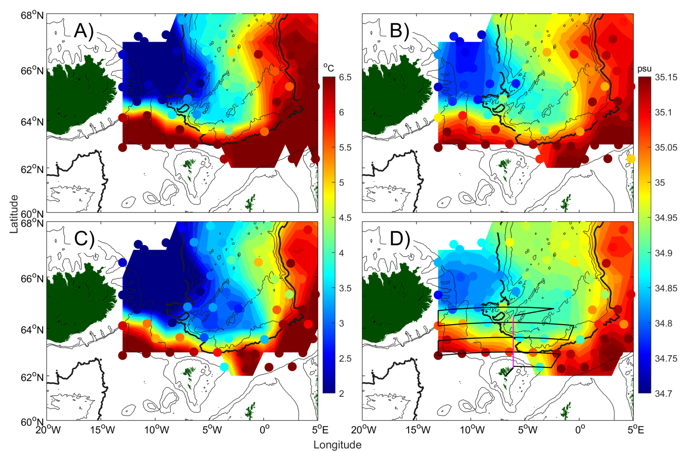

Figure S1. Oceanographic conditions in May 2020 during the IESNS survey. Temperature conditions at (A) 100 m and (C) 200 m depth and the associated salinity at (B) 100 m and (D) 200 m depth. The 2000 m isobath is shown in bold. The cruise track (black) and Section N (purple) are shown in (D).

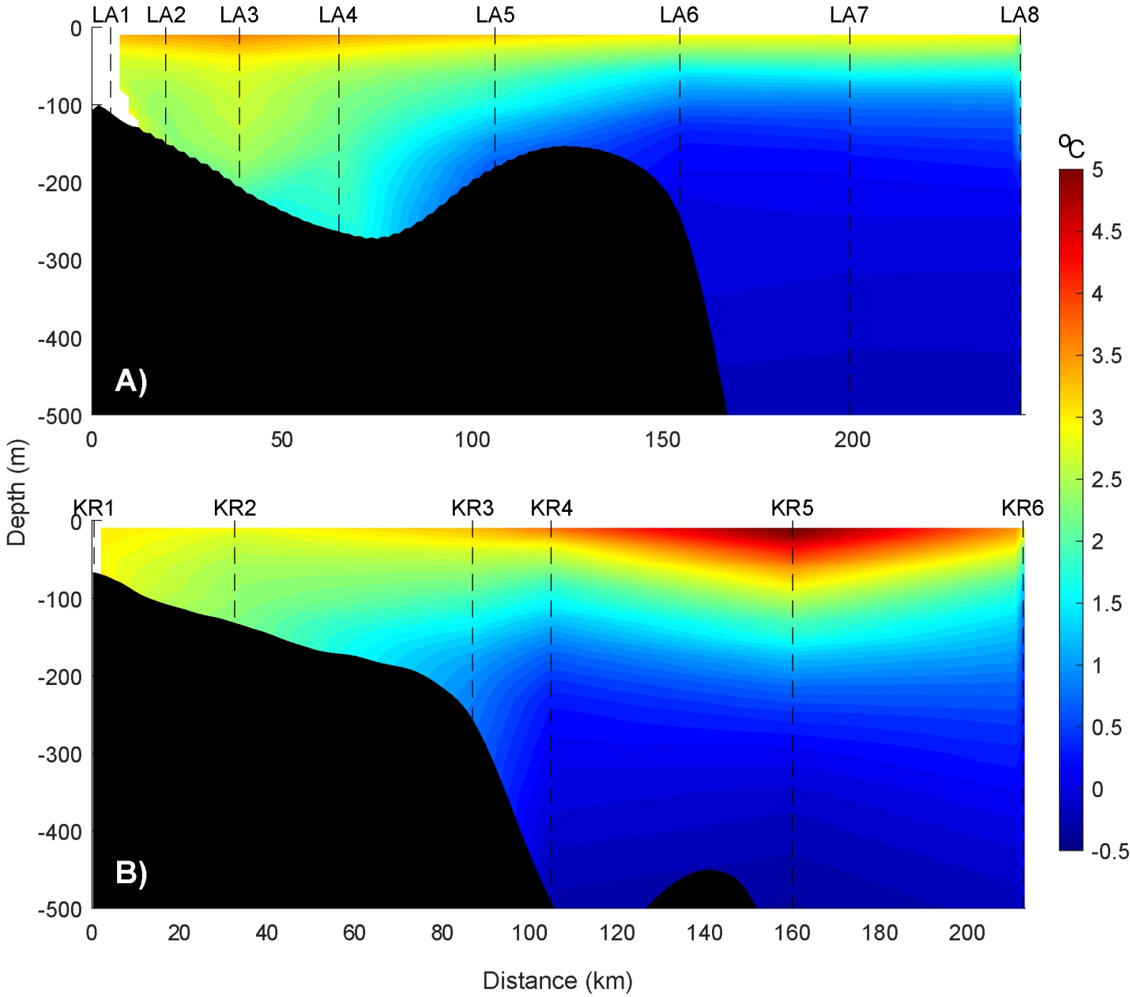

Figure S2. Mean temperature, in May, at two Icelandic sections, from 1991 to 2020. The name of each station is shown on the top of each plot, while the location is shown in Figure 1. Abbreviation: LA, Langanes East; KR, Krossanes.

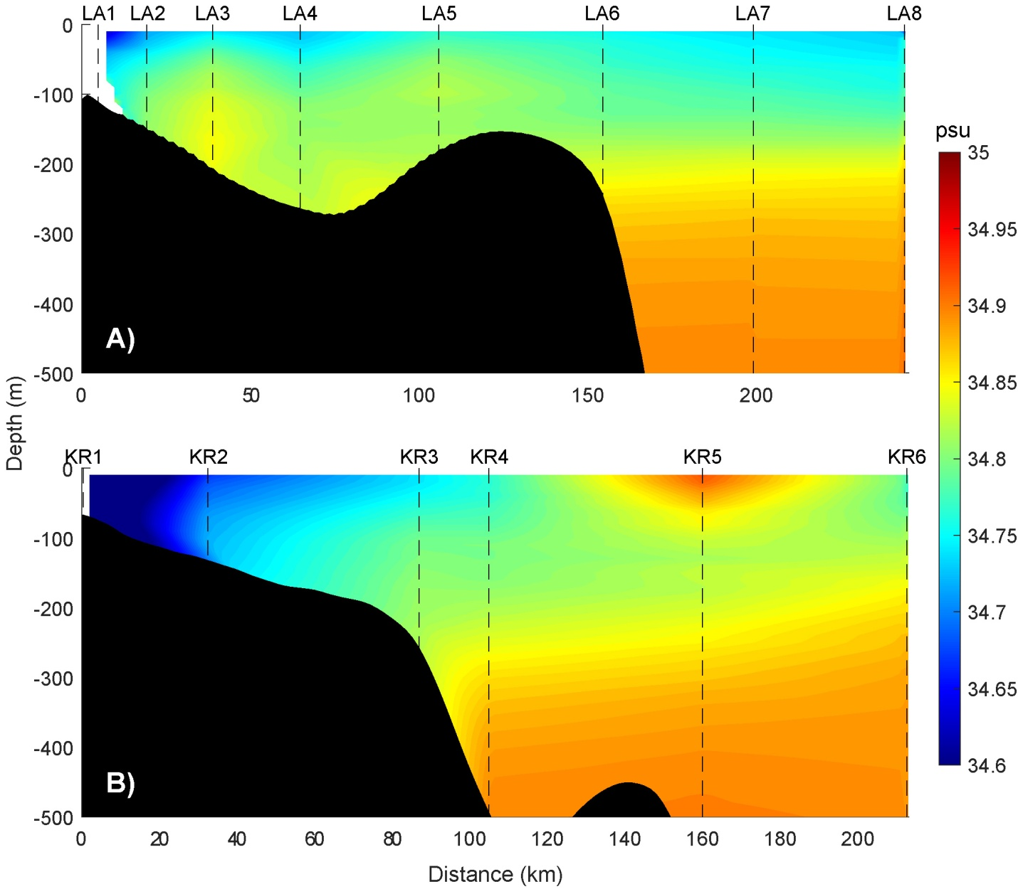

Figure S3. Mean salinity, in May, at two Icelandic sections, from 1991 to 2020. The name of each station is shown on the top of each plot (see Figure S2 for abbreviations), while the location is shown in Figure 1. Abbreviation: LA, Langanes East; KR, Krossanes.

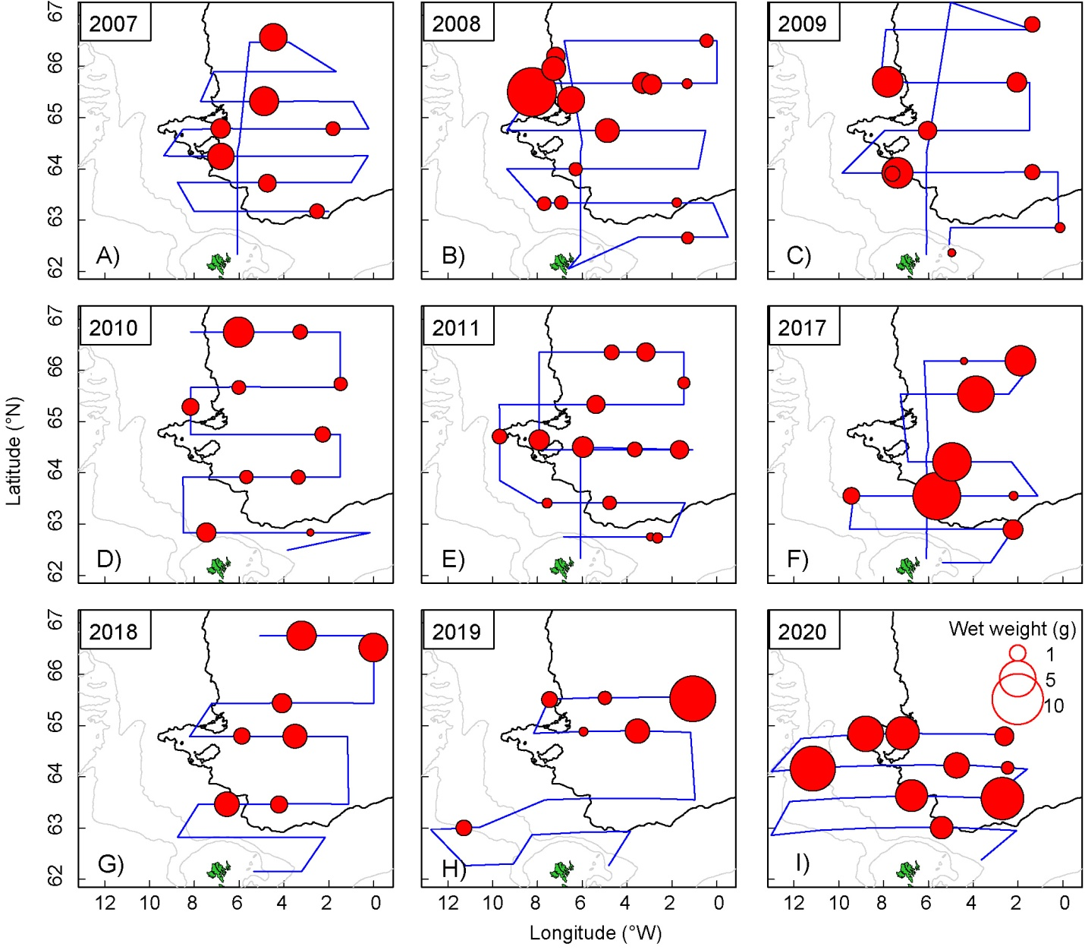

Figure S4. Wet weight (g) of ingested content in herring stomachs, in May, from 2007-2011 (low influx period) and 2017-2020 (high influx period).

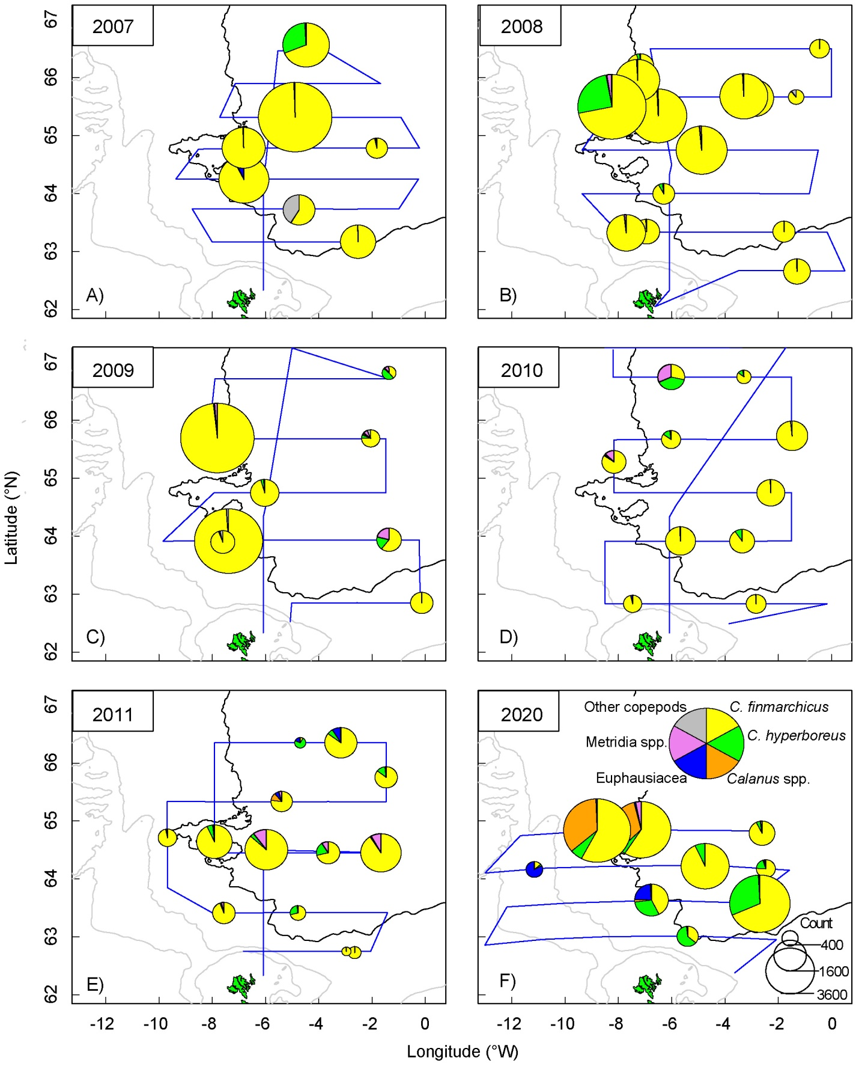

Figure S5. Spatial distribution of the encountered species, by number, in herring stomachs. Observations are from 2007 to 2011 and 2020. The blue line represents cruise tracks each year. The 2000 m depth contour is shown in bold. Refer to table S1 to see which copepods are included in the group ‘Other copepods’.

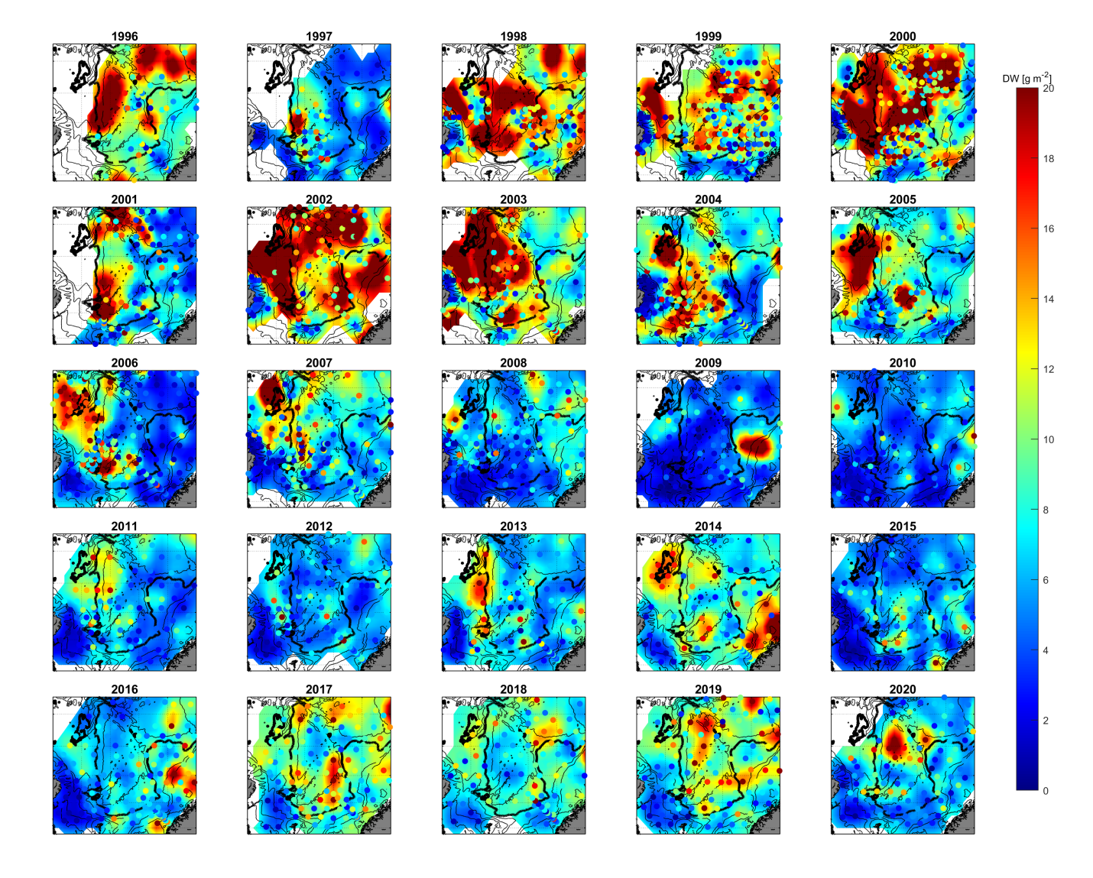

Figure S6. Zooplankton biomass in May, from 1996 to 2020, during the IESNS survey. The 2000 m depth contour is shown in bold.

Table S1. Coarse overview of identified species and the allocated groups for each species found during herring stomach content analysis in May, from 2007 to 2011 and 2020.

|  |  |  |
| --- | --- | --- |
| **Ingested species** | **Group ID** | **No. of occurrence (%)** |
| Calanus finmarchicus | C. finmarchicus | 85.6 |
| Calanus hyperboreus | C. hyperboreus | 6.6 |
| Unidentified Calanus spp. | Calanus spp. | 3.3 |
| Metridia | Metridia spp. | 1.6 |
| Acartia, Centropages, Euchaeta, Microcalanus, Oithona,  Paraeucheta, Pleuromamma robusta, Pseudocalanus,  Rhincalanus, Temora | Other copepods | 1.3 |
| Euphausiacea | Euphausiacea | 1.1 |
| Themisto | Amphipoda | 0.4 |
| Appendicularia, Decapoda, Evadne, Hydrozoa,  Indeterminatus, Myctophidae, Nematoda, Sagitta | Other | 0.2 |