**Supplementrary material (SM 1a)**

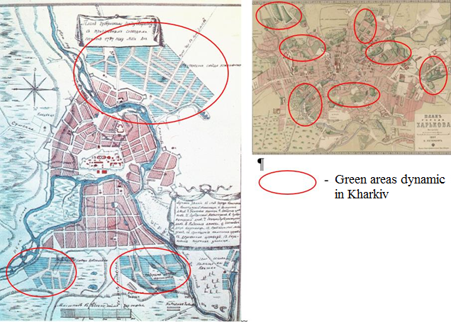

|  |  |
| --- | --- |
| Fig. 1a. Plan of Kharkiv 1787  (Bagaliy, Miller, 1993) | Fig. 1b. Plan of Kharkiv 1887 р. *(*Austrian military archive*)* |

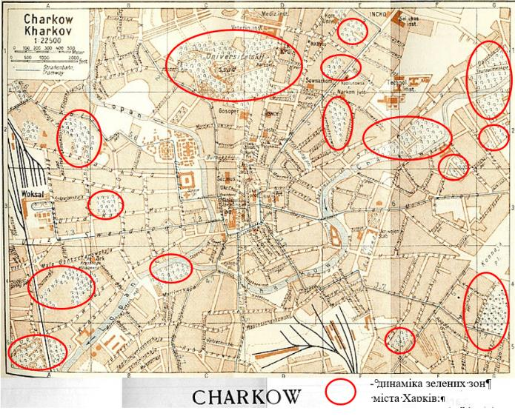

Fig. 2. Master plan of Kharkiv 1925 (Bagaliy, Miller, 1993)

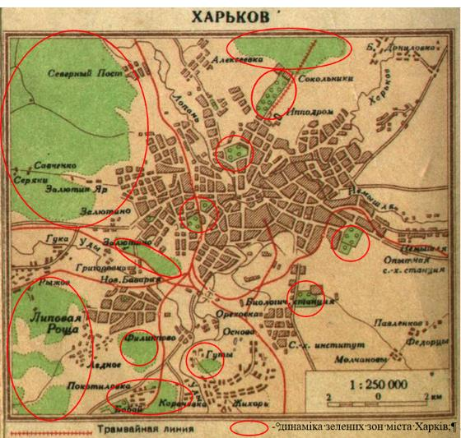

Fig. 3. Master plan of Kharkiv 1940

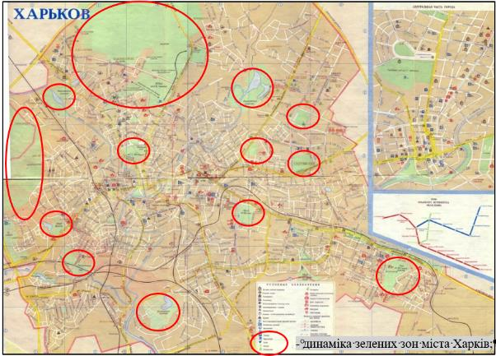

Fig. 4. Plan of Kharkiv 1990

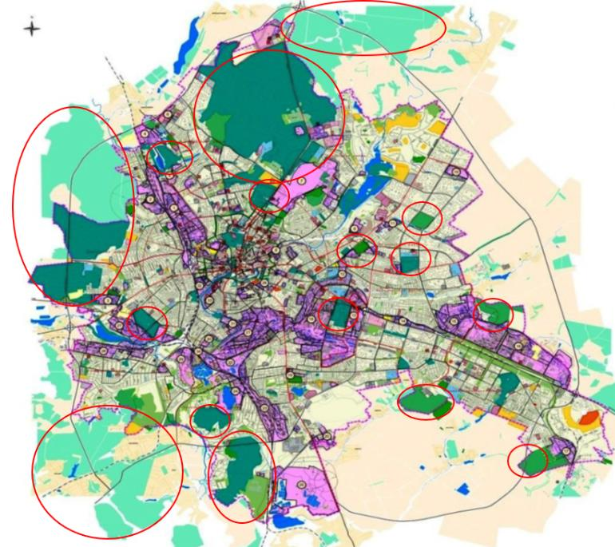

* dynamics of green areas of Kharkiv;

Fig. 5. Master plan of Kharkiv, 2004

*(Kharkiv substantive, 2021)*

This plan provided for the expansion of the recreational area in areas of new construction of the city:

* creation of a green and flooded recreation area along the Nemyshl River in the area of the Saltovsky residential area;
* further improvement of Oleksiyivsky Park;
* expansion and improvement of the water sports complex in the northern part of the city on the Kharkiv River;
* improvement and landscaping of the Uda River.
* creation of water-green diameters on the rivers: Kharkiv - Lopan - Nemyshlya - Udy, and their unification into a single recreational system with city parks and embankments.

The tradition formed in the recent past to periodically review the city limits, to expand its territory leads to the need to change and the territorial organization of the region masks the process of agglomeration.Thus, in accordance with the decisions of the sessions of the Kharkiv City Council of April 25, 2012 № 770/12 and the Kharkiv Regional Council of June 21, 2012 № 453 VI on the optimization of the boundaries of Kharkiv, approved by the Resolution of the Verkhovna Rada of Ukraine of September 16 2012 № 5215 VI. The territory of the city has increased in the total volume equal to 44.5 km². "Land management project to establish the border of Kharkiv" provides:

* • formation of the ecological network at the regional and local levels, especially in the near, most urbanized zone of the zone of influence, creation of a continuous and uniform system of open and green spaces in the south-western, deforested sector of the forest park zone;
* development of recreational sphere and tourism, placement of long-term recreation complexes for children and adults in resort and recreational areas: Merefa – Zidky, Lymanske – Taranovka, V. Prokhody – Lisove, M. Danylivka – Peresichne, Pechenizhke reservoir.

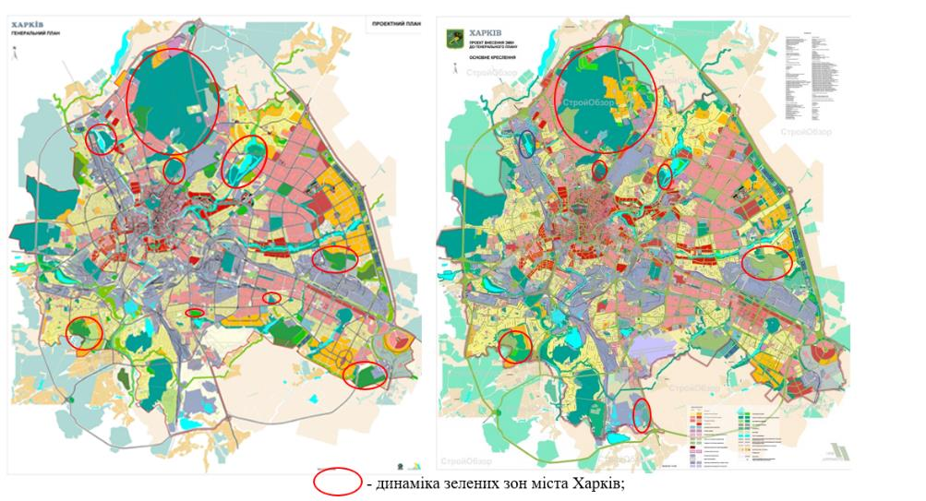

|  |  |
| --- | --- |
|  |  |
| Fig. 6.а Master plan of Kharkiv 2013 | Fig. 6b Master plan of Kharkiv 2019 (with changes and approved changes) (Master plan of the city of Kharkiv 2019, 2021) |

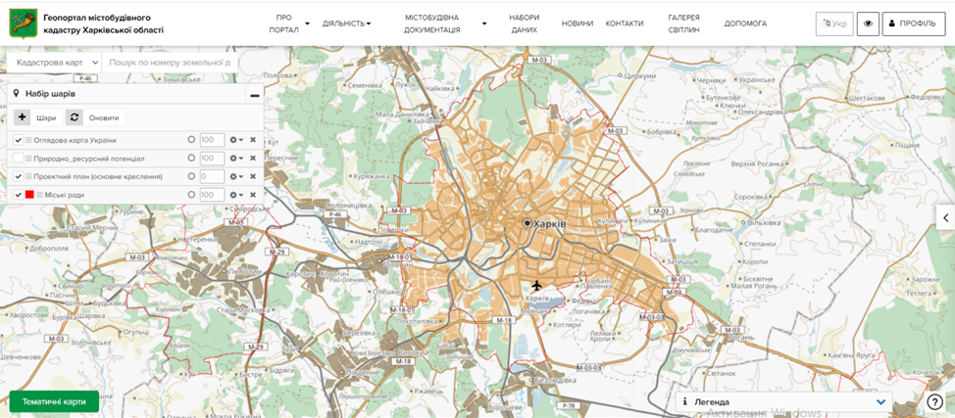

Fig. 7. Kharkiv in the aspect of urban cadastre of Kharkiv region, 2021

*(Geoportal of the urban cadaster, 2021)*