Supplementary materials 2а

Given the increasing density of urban development, much attention is paid to infrastructural changes in cities. City parks are an integral part of the general scheme of landscaping of the city. One of the oldest in Kharkiv is the Taras Shevchenko City Garden, which was founded in 1804-1805 by VN Karazin, reconstructed in the second decade of the XXI century. and is the modern urban landscape park (Famous Kharkiv residents’, 2021). On the territory of the Garden there are monuments, fountains, gazebos, ponds, children's playgrounds, restaurants, etc. The modern area of the botanical garden is 27 hectares. (fig. 1).

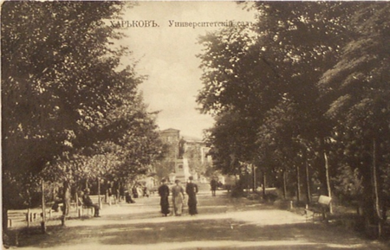 | 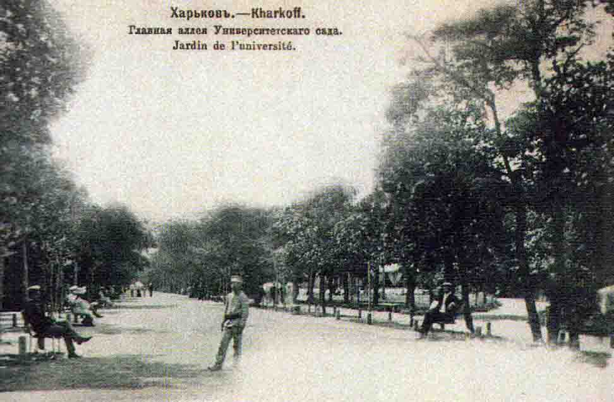
Fig. 2. Central Alley of the University Garden (1907-1917) (StroyObzor, 2021)
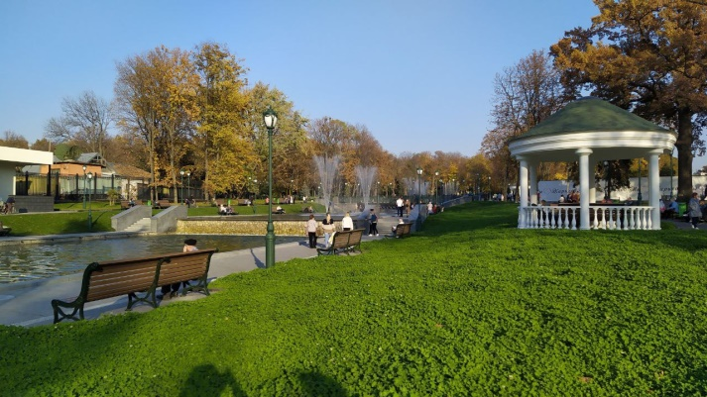 | 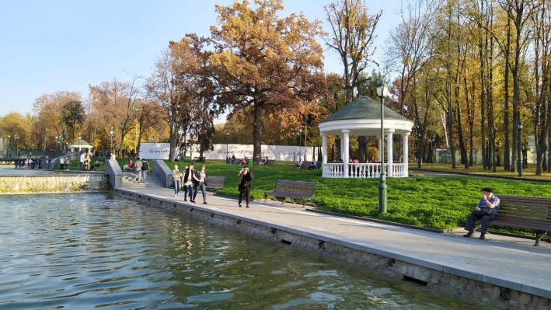
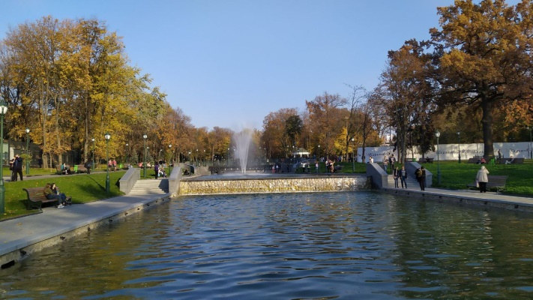 | 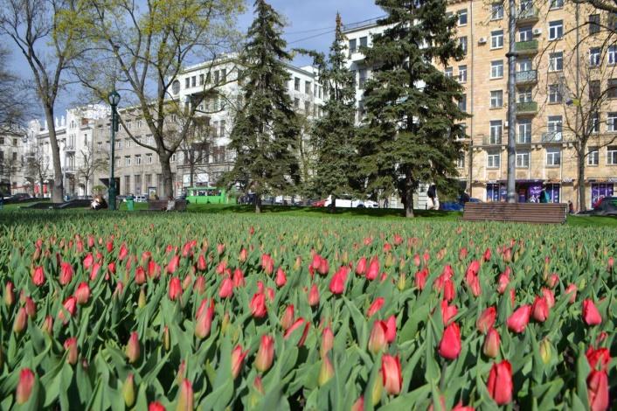
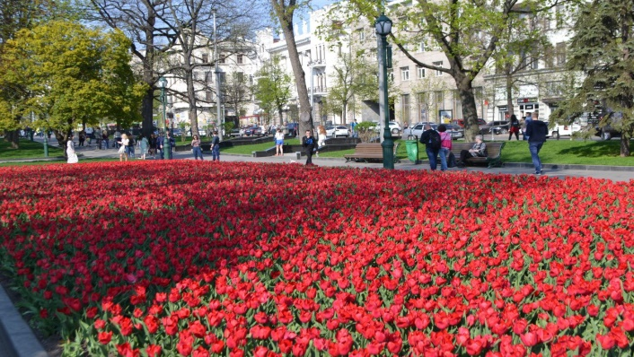 | 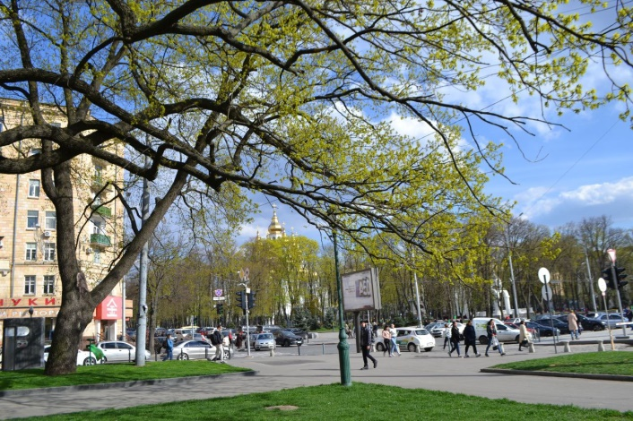
Fig. 3. Taras Shevchenko City Garden (now)

Kharkiv Zoo. Today Kharkiv Zoo is one of the best in Ukraine. The modern zoo has about 15 exposition zones, a system of food establishments, etc. Complies with international standards. The zoo has created conditions for visitors with special needs. Excursions are conducted, the educational component is supported - thematic lectures are held, a circle of young naturalists functions (Kharkiv Zoo, 2021). . Reconstruction of the zoo was carried out in accordance with European standards.
The Gorky Central Park of Culture and Recreation is interesting for its planning principle. The park was founded in 1893-1895 and was originally called a country Nikolaev park. At that time, the city authorities proposed to plant trees on an area of 20 to 40 acres on both sides of the Sumsʹkyy road. As the designated area was quite far from the city, the park was mostly intended for horseback riding. It was decided to build it on the model of the Boulogne Forest in France – with alleys for horseback riding and carriage rides (VGORODE, 2021). (fig.4).
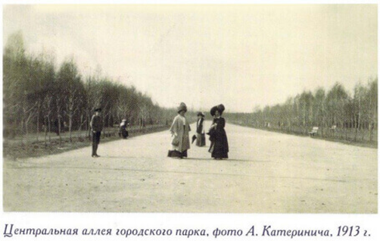 | 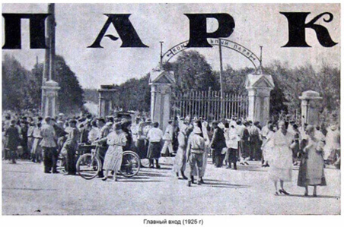
Fig. 4. City park in the early twentieth century

Professors of Kharkiv University were sent to France especially for this project, in order to thoroughly study all the features of the foreign park. Along with chestnut and lime alleys, the plan was to create a so-called "crew" alley. By the time it was opened to the public in 1907, the area of the park had grown almost 2.5 times. In the 1930s, the park underwent significant changes and renovations. This is due to the fact that the tram line was extended to the Forest Park, the trolleybus line was opened and the Children’s Railway was built. During its existence, the park was renamed several times.
During World War II, the park was completely destroyed and completely rebuilt after its end. Before the war, the park had the only cedar alley in the city, which was destroyed during the war in 1943. In the postwar years, from 1943 to 1953, squares and parks began to be actively revived in Kharkiv, almost three million trees and shrubs were planted (Maxim Gorkiy Central park of culture and leisure, 2021).
The global reconstruction of the park took place in 2010-2012. The special concept and design of the park was awarded the Golden Pony Awards by the IAPPA (The International Association of Amusement Parks and Attractions). Gorky Park regularly receives "Traveler's Choice " awards from the international travel portal Trip Advisor. This is the only amusement park of this level in Ukraine (Official site of Kharkiv City Council, 2021). Gorky Central Park of Culture and Recreation is one of the TOP-25 amusement parks in Europe. (Maxim Gorkiy Central park of culture and leisure, 2021). He received an award in the All-Ukrainian tourist competition "SafeTravels". The certificate makes it possible to use a specially designed sign "SafeTravels", which shows tourists safe locations, attractions and companies that comply with global protocols of health and hygiene, ie adapted and ready to work during the COVID-19 pandemic. The modern park area covers an area of 130 hectares. The infrastructure of the park includes 9 quest rooms; attractions; mini attractions; thematic areas; slot machines; party rooms; sports grounds (football, basketball, volleyball fields, playgrounds. roller skating rink, etc.; the first inclusive children's complex in Kharkov; cable car, etc.. Services provided in the park for visitors are excursions; organization of children's holidays; laser tag; wedding gazebo; After the reconstruction, the Gorky Central Park of Culture and Recreation was visited by more than 15 million people. more than 1.8 million guests. Infrastructure facilities of the park are aimed at all categories of the population.

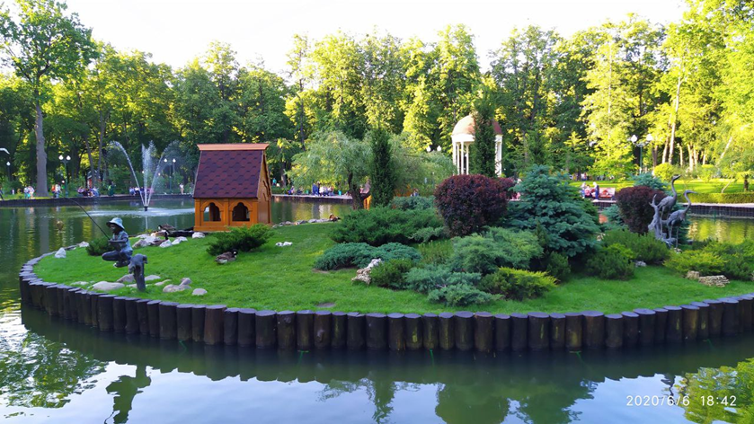

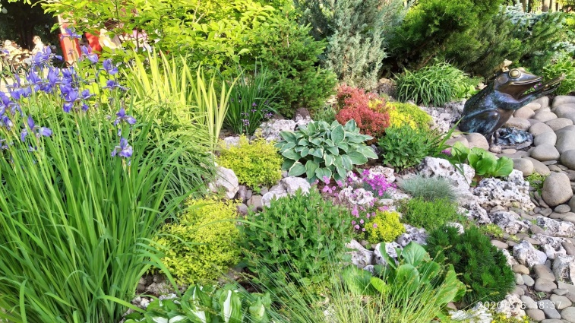 | 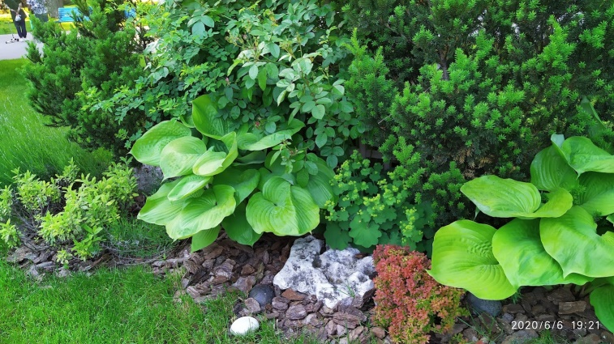
Fig. 5. Decorative elements in the Gorky Central Park of Culture and Recreation

The largest green area of the city is the Lisopark, which covers 2,092 hectares. The territory of the Lisopark consists of six tracts located in five districts of the city. Proximity to residential areas, convenient transport links to the city center, a large area of the park, the availability of rental bicycles, rollers and other accessories and equipment create favorable conditions for mass recreation and recreation, sports, active leisure (fig.6).

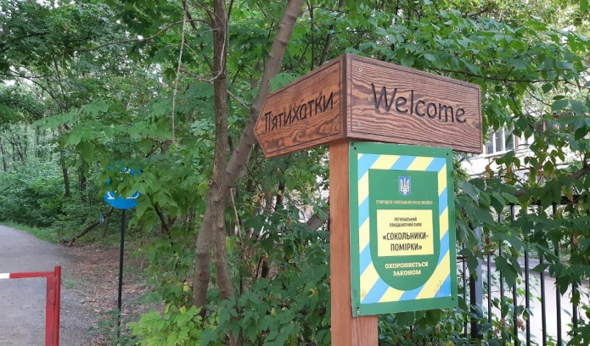 | 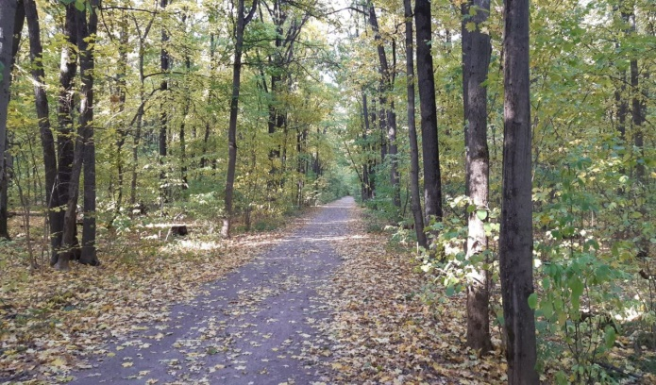
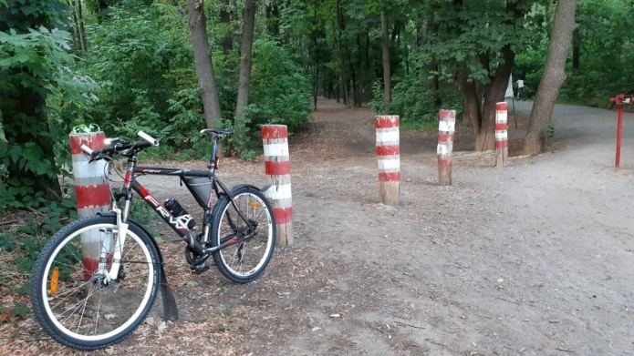 | 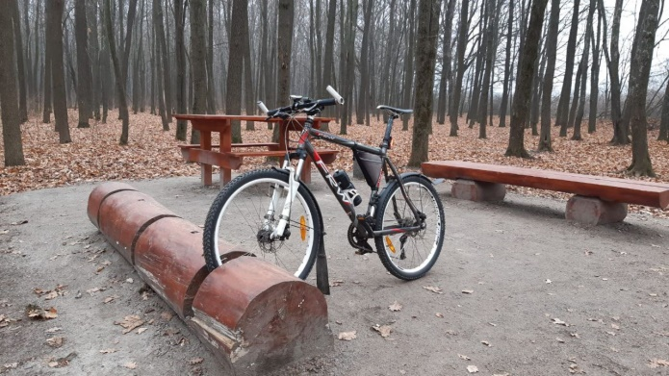
Fig. 6. Lisopark

Among the most unusual park green areas of Kharkiv is Sarzhyn Yar, which was reconstructed in 2018. Sarzhin Yar is a natural monument of local significance. Represents a beam with gentle slopes 12 km long. A source of mineral water is located in the beam. Specialists of the «SBMstudio» architecture and design studio developed the project of reconstruction of the territory of the recreation area from the dam to the territory of the mineral water source. In 2020, the "Sarzhyn Yar Water and Landscape Park project" won the Grand Prix of the First National Award for Landscape Architecture and Garden Design in the category "Renovation and Revitalization of Territories" in the category "Renovation and Revitalization of Territories" (KharkivTimes, 2021). One of the main criteria for the reconstruction was the maximum preservation of the existing landscape and nature, the use of environmental solutions. During the reconstruction, the territory was improved, seven lakes were created, located on three different levels, different recreation areas were created (Fig. 7), sports and children's playgrounds were arranged, a bicycle overpass was built, pump rooms and fonts were repaired, elements of existing architecture etc. The territory has been significantly landscaped, many trees and shrubs have been planted according to European standards: oaks, willows, thuja, maples, junipers, roses, etc.

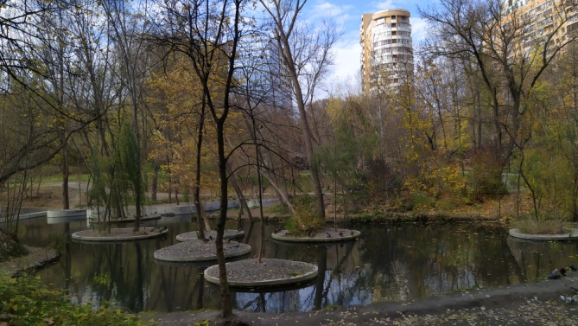 | 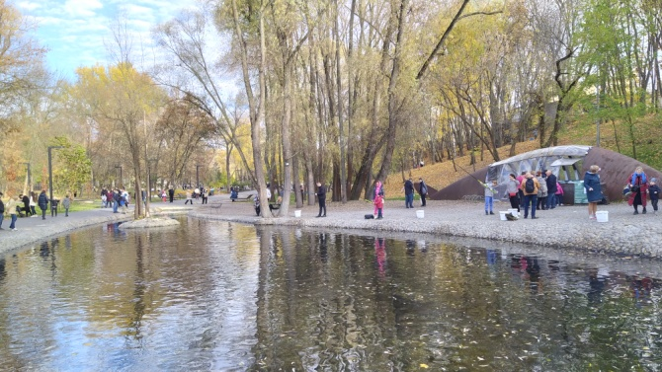
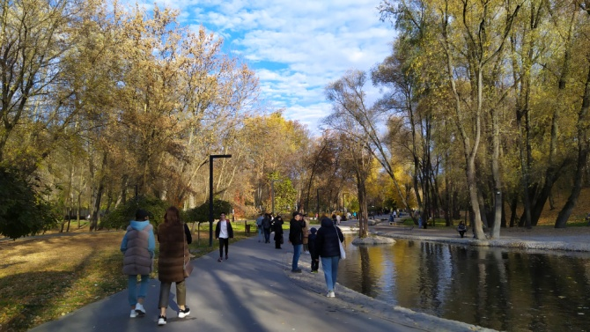 | 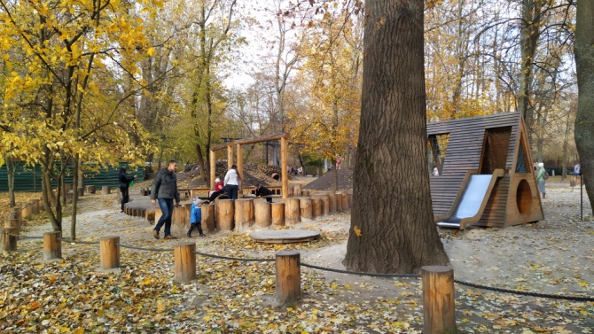
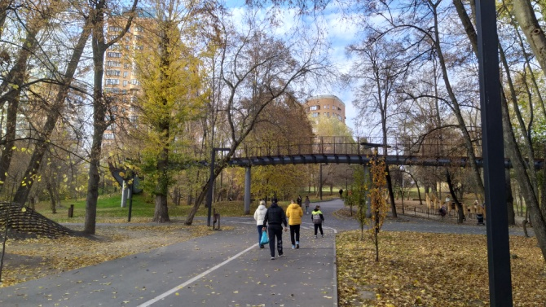 | 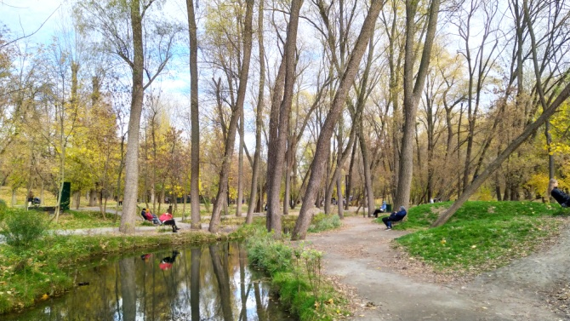
Fig. 7. Recreation areas of Sarzhyn Yar

The object of the nature reserve fund of Kharkiv of national importance is the Botanical Garden of V. N. Karazin Kharkiv National University, which is the oldest botanical garden in Ukraine. The garden was founded in 1804. The total area of the garden is 41.9 hectares. It consists of two parts: the "old" on the street. Klochkivska, the area of which is 5.1 hectares, and the "new" on the street. Otakara Yarosha (36.8 hectares). The garden is based on the botanical-geographical principle and includes expositions: "North America", "Europe", "Mediterranean", "Siberia", "Far East", "China and Japan". "Central Asia" (Botanical Garden, 2021). The collection of the Botanical Garden has more than 2,000 species of flora, includes relics, rare species of local and world flora, exotic plants.
In addition to central parks and gardens, which have an extensive infrastructure that meets the modern needs of the population for recreation and recreation, sports and walks with children, noteworthy are the district gardens and parks located in residential areas of the city. Until recently, most district squares and parks were in an abandoned state, almost all infrastructure facilities were physically and morally obsolete, and did not meet the aesthetic or functional needs of the residents of the districts. However, over the past 10 years, large-scale reconstructions and modernization of both the greenest areas of the city and their infrastructure have taken place. Different levels of lighting have been made, paths have been laid or replaced, new sports and children's playgrounds, recreation areas, etc. have been reconstructed or installed.
In the summer of 2021, the reconstruction of the central alley of the Victory City Park, which is located in the eastern part of the city in the largest residential district in Ukraine, was completed. The park was founded in 1985 and covers an area of about 45 hectares. Next year, the park plans to overhaul the fountain, open an urban park, restore all paths and recreation areas, and complete landscaping work. In addition to the urban park, the park is planned to provide Wi-Fi coverage, restore gazebos for recreation and install a speaker system. (KHARKOVGO, 2021a; News portal GorodKh, 2021).
An interesting location in Kharkiv is the Strilka Square, which is located in the central part of the city at the intersection of two rivers: the Kharkiv River and the Lopan River, located along the embankment. The territory of the park is well landscaped, equipped with infrastructure: a playground, a boat station, small cafes, benches, etc. The favorable atmosphere for rest is created (KHARKOVGO, 2021b).
New and unique for Kharkiv are the created urban parks and urban yards, which significantly contributes to the promotion of street sports and a healthy lifestyle. This is a new format of activities with a constant cycle of life, a place of creative self-expression, which combines a complex of playgrounds for street sports, urban cultures and active family recreation. It is also a place for various cultural and sports events and active recreation of local residents of different ages. Urban park projects are implemented by the “Streetculture team” together with “Uniquebuild” (RightPark, 2021). With their participation, five urban parks were created in Kharkiv: Kholodnohirsky Park (2019), Molodizhny Park (2019), Park on Yuriev Boulevard (2020), Youth Park (2021), Heroes of Labor Park. (2021) (RightPark, 2021). The urban park on Yuriev Boulevard, which is considered the largest in Ukraine, includes seven locations: Streetball, Street football, Street workout spot, Panna football, Pump track spot, Skate Park spot, Parkour spot (Successful city, 2021; Unique Build Сompany, 2021). An important feature of all urban parks is that they are well integrated into the urban landscape of the city, surrounded by greenery, due to the renovation of previous parks, modern urban parks have received a "second" life and new breath, meet modern demands not only young but also people of different ages, are actively involved in the processes of community life. In the future, the city leadership will create similar urban parks in almost all districts of Kharkiv.
After the reconstruction of the park, which began in 2018, in October 2021, Fantasy Park was opened near the House of Culture Metalist (Plekhanovskaya Street). This creative location will be the first open air exhibition park in Ukraine. Young artists, designers, sculptors, architects, musicians and performers will be able to embody their creative ideas on the territory of the creative space (Newsroom, 2021). A stage and a large playground were installed in the park, recreation areas with benches were arranged, a fountain was reconstructed, and decorative lighting and sound systems were installed. Figures of fantastic characters are installed on the lawns. All this is successfully combined with the greenery that existed before.

