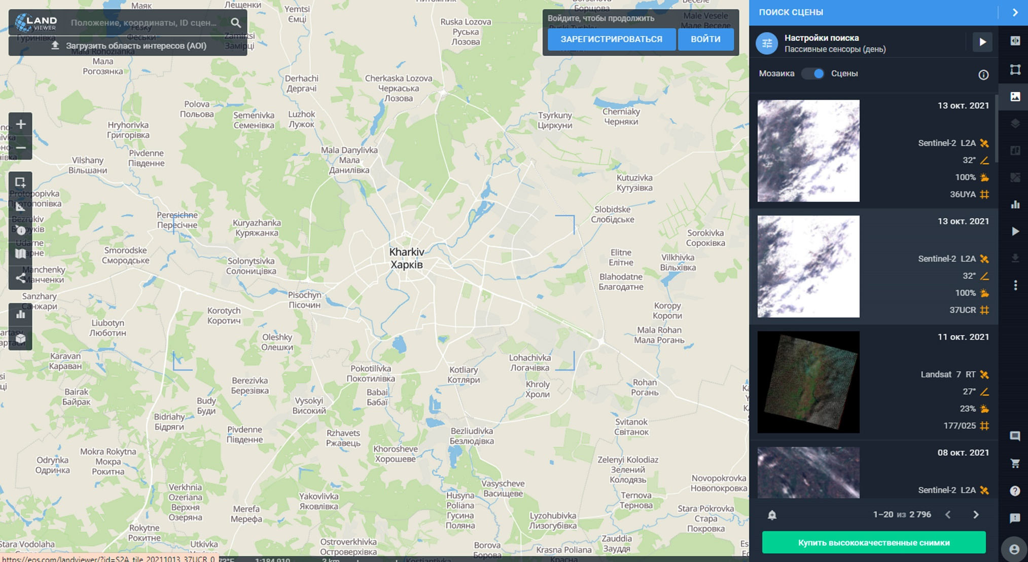
Supplementary Figure 1. The web-interface of the EOS satellite image repository


Supplementary Figure 2. The web-interface of signing up for the EOS Forest Monitoring web-service

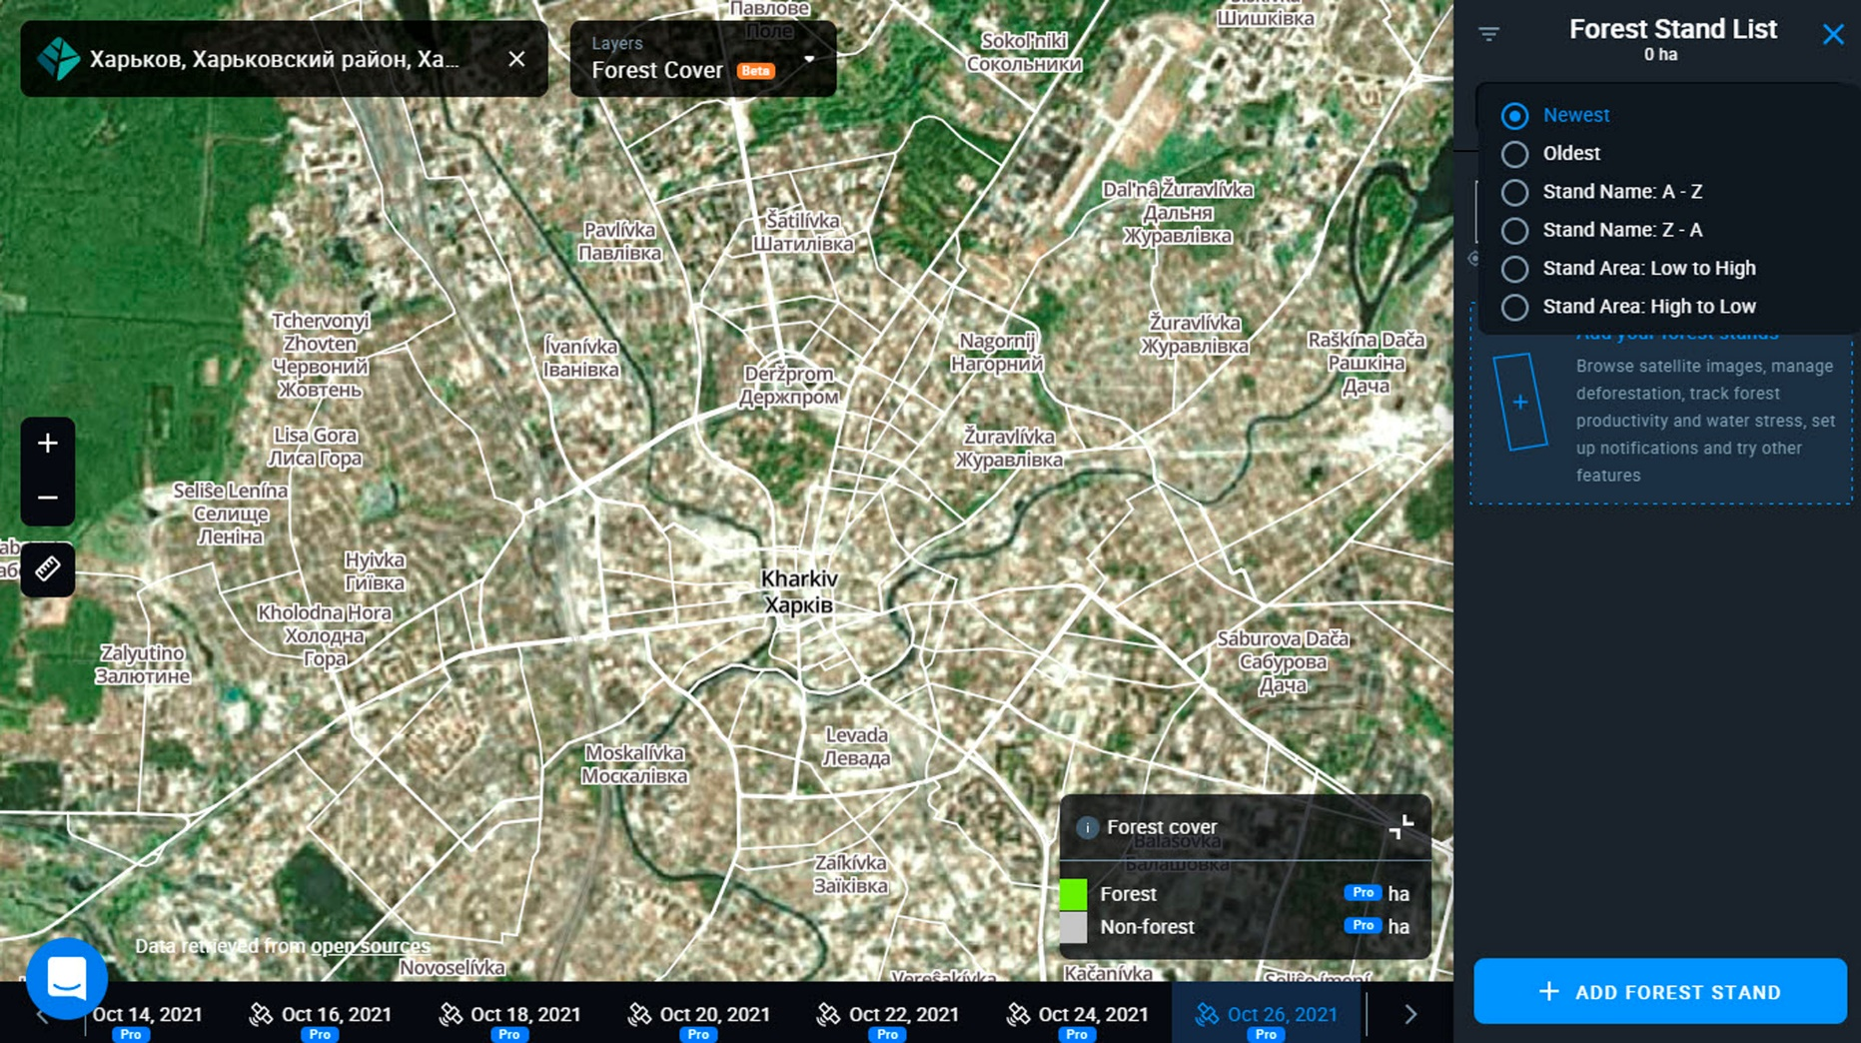
Supplementary Figure 3. The selected AOI of Kharkiv-City in the EOS Forest Monitoring web-service (https://forest-monitoring.eos.com/main-map)

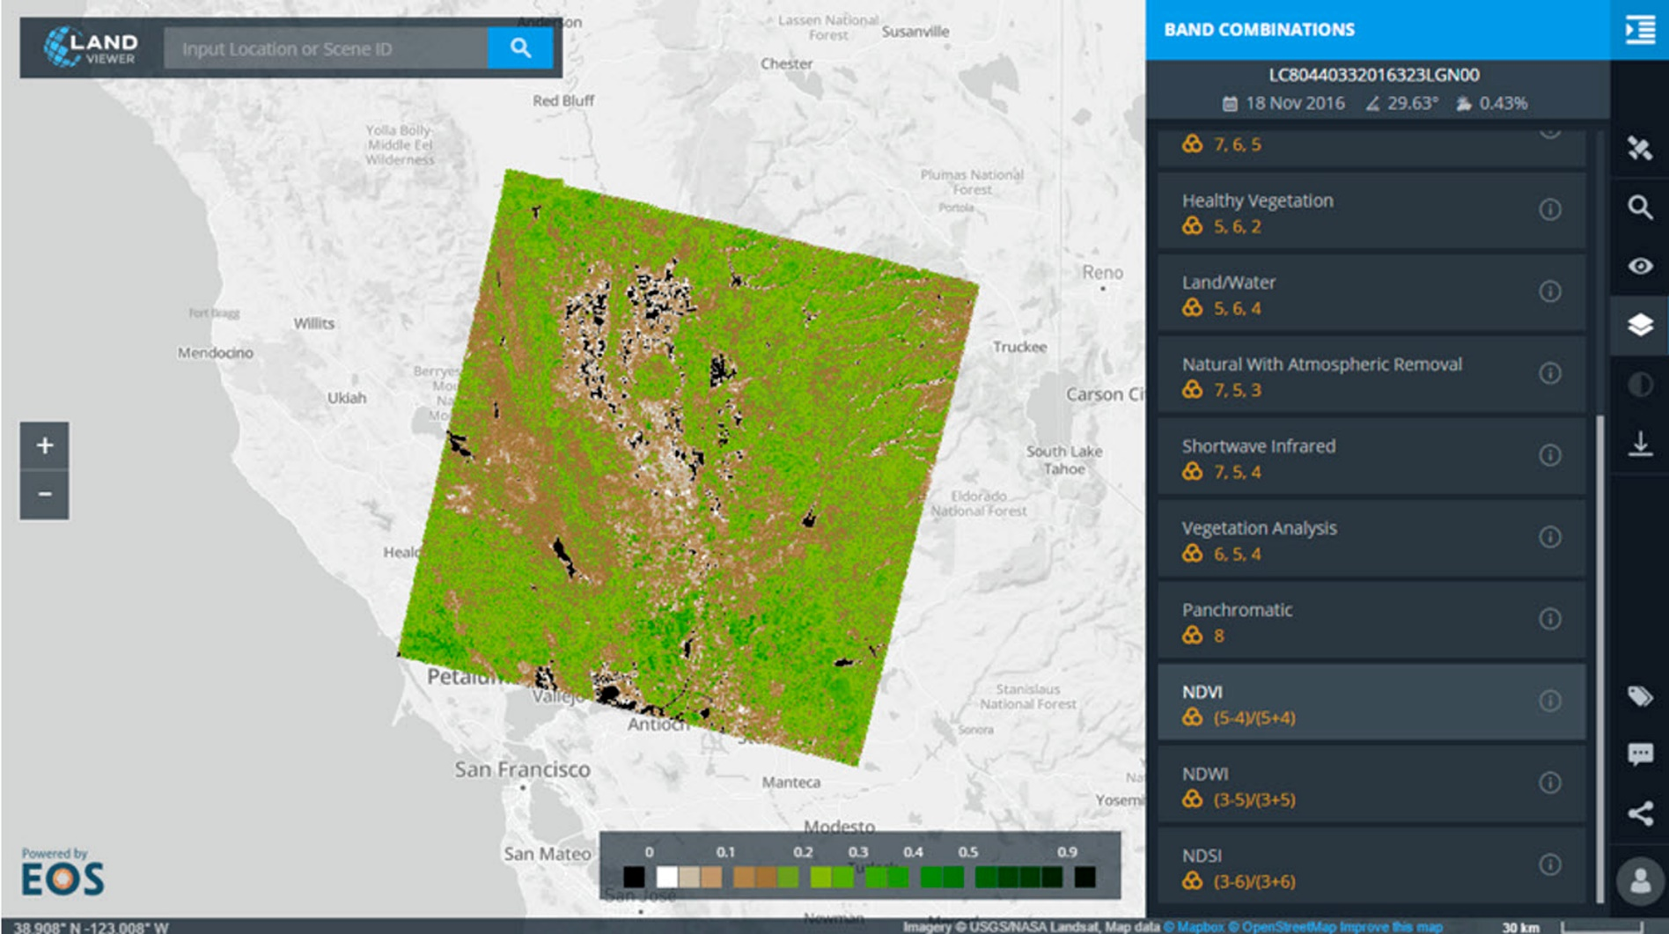
Supplementary Figure 4. Customization of the LV image browser functionality in its web-interface according to a task prescribed to a certain AOI

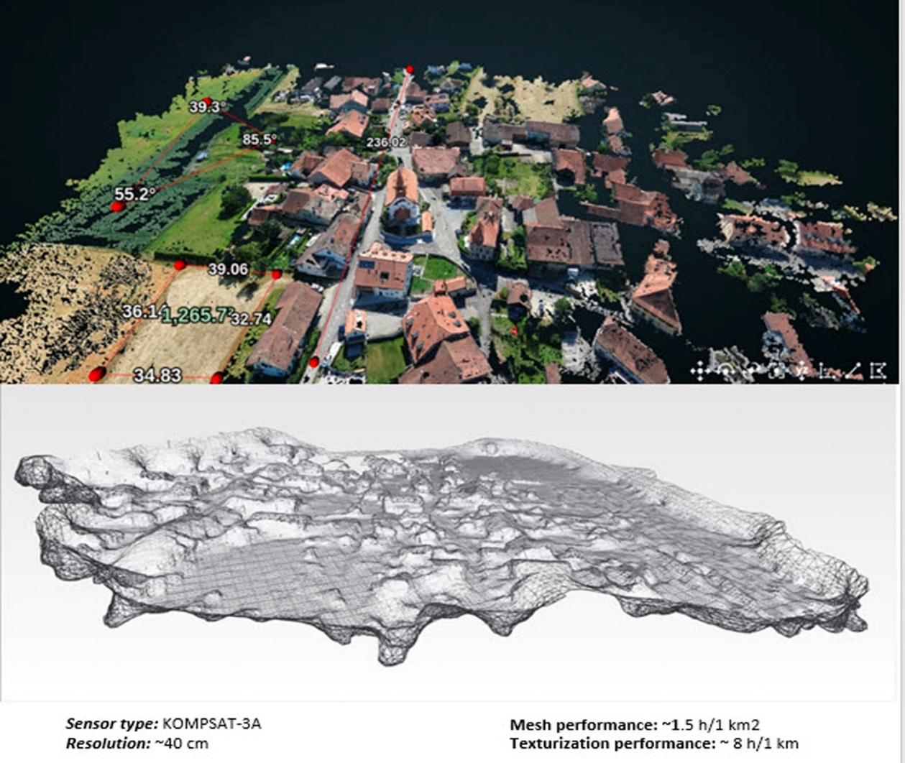
Supplementary Figure 5. A small parcel (around 2,5 ha) located in the northern part of our AOI visualized in the customized EOS platform web-interface. It illustrates in a large scale the photo-cloud based classification mapping for yearly change detection in UGA

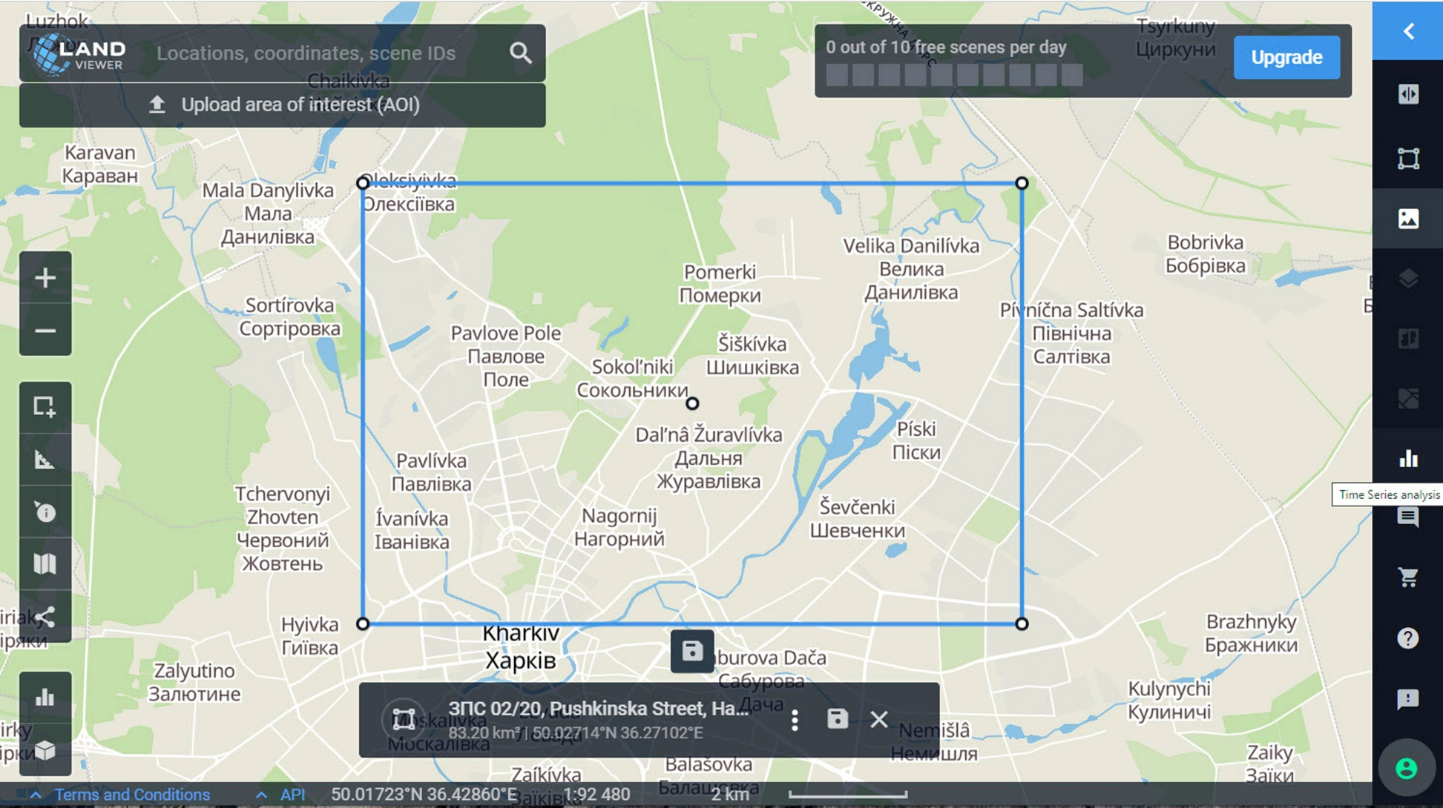
Supplementary Figure 6. The northern part (not more than 100 km²) of Kharkiv AOI selected for calculating aggregated NDVI values in long time interval (2000-2020)

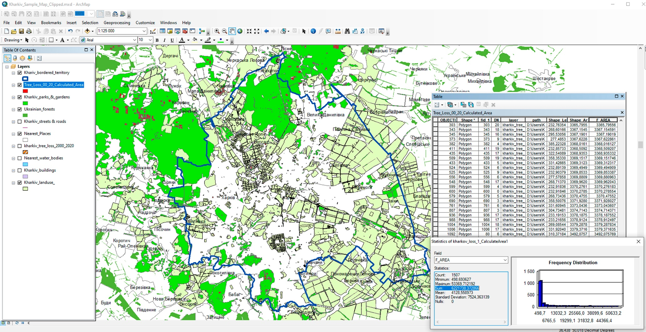

Supplementary Figure 7. Calculated areas of 622 ha due to the total USL values within the city and beyond its official border – in the nearest suburbs (GIS-project GDK-2)

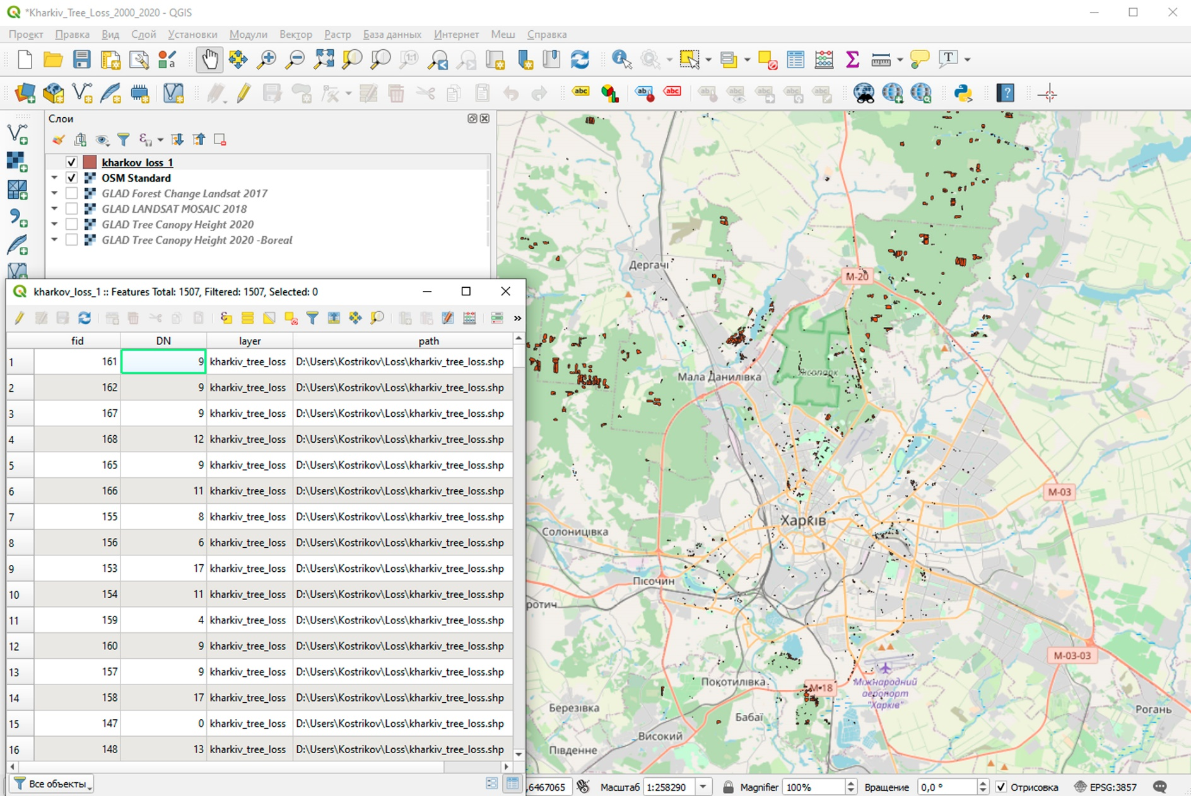

Supplementary Figure 8. The attribute table of the USL polygonal feature layer in QGIS interface, where a year of loss could be distinguished in the DN (Distinguishing Number) column, in which one- and two-digit integers corresponded to a certain year in 2000-2020 range

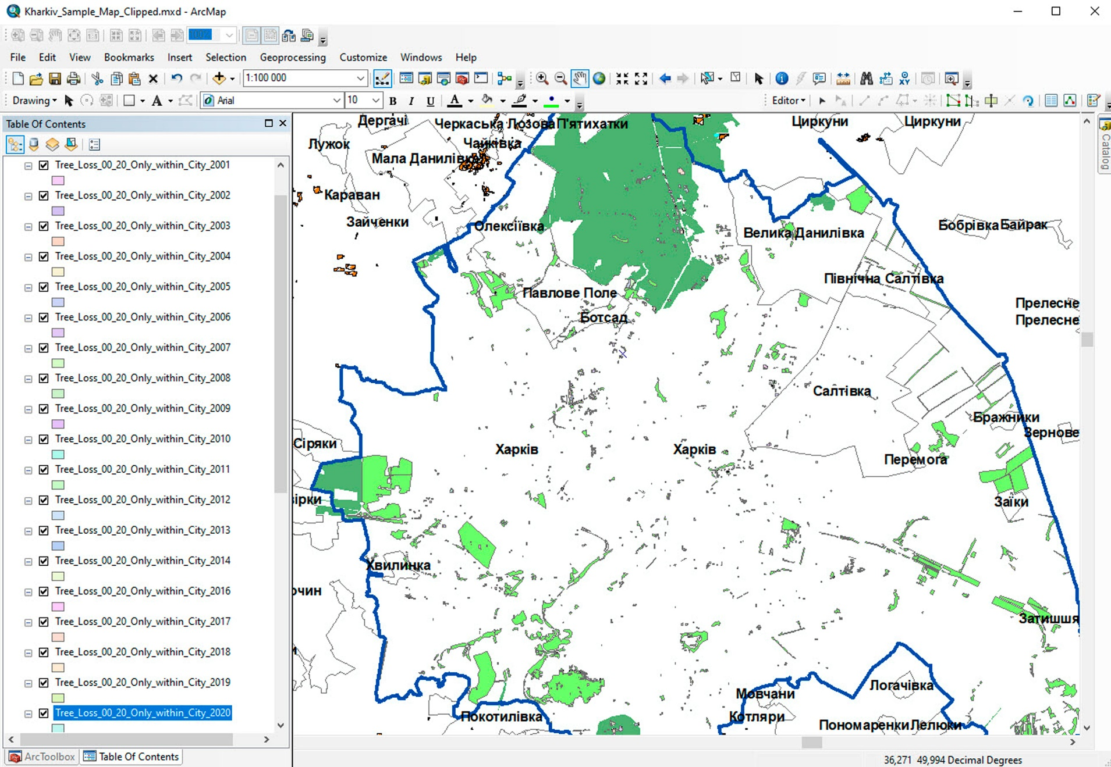
Supplementary Figure 9. The USL layer was partitioned for 21 layers on the base of 21 selection sets of the Year attribute (GDK-2)

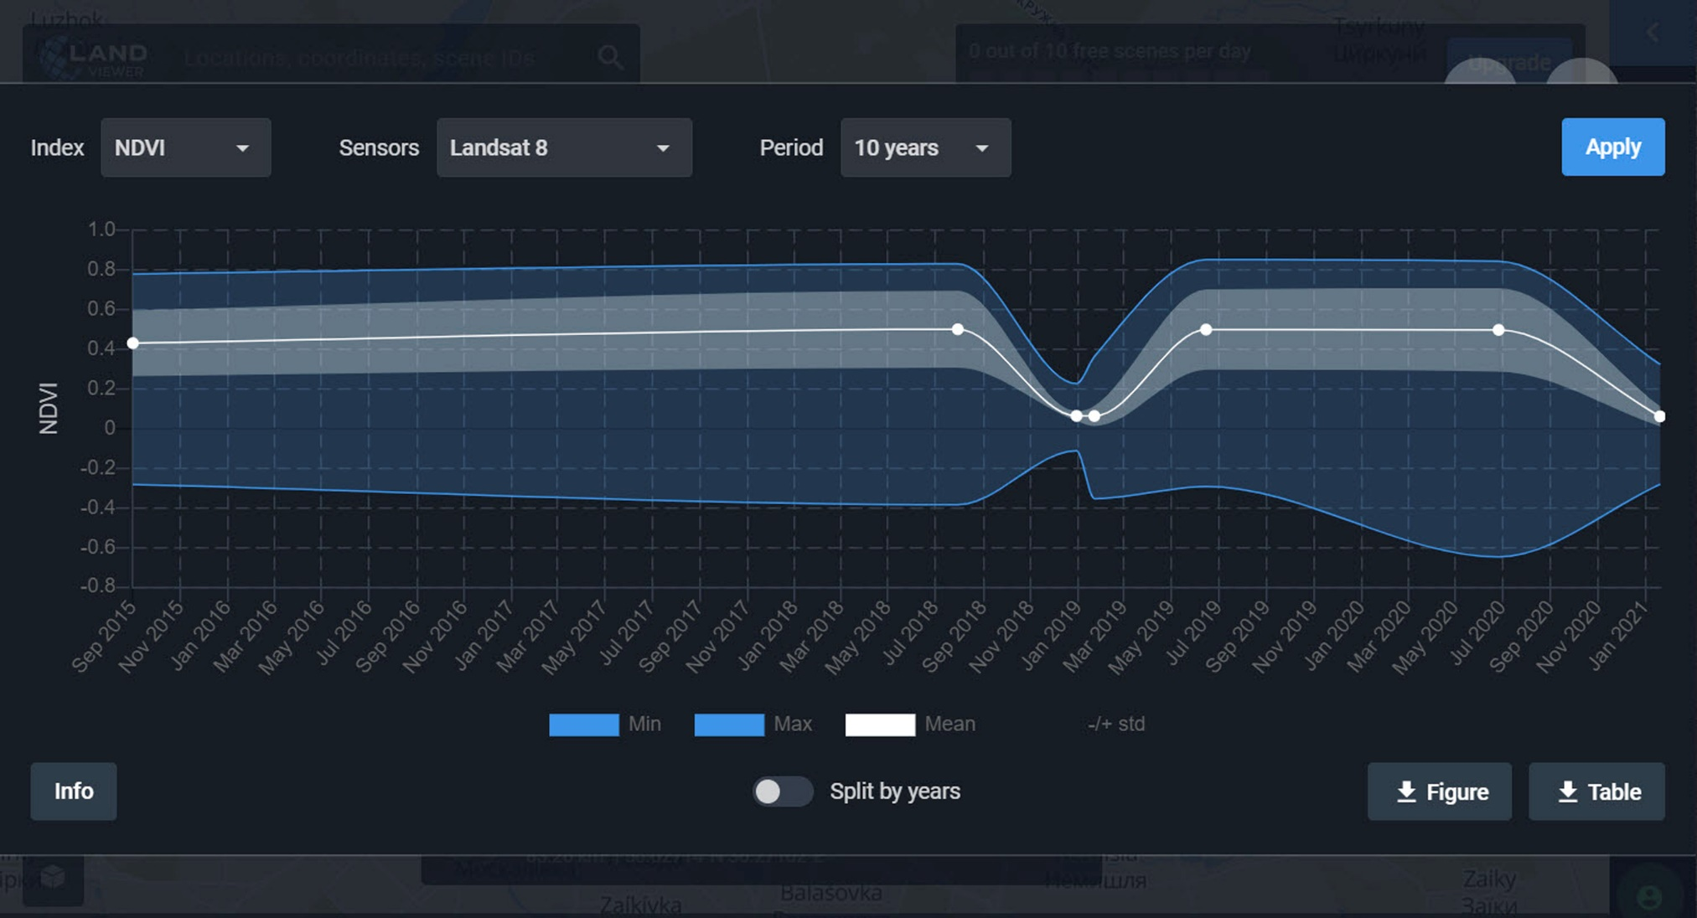
Supplementary Figure 10. The aggregated NDVI progress schedule in July 2015 -July 2020 for the northern part (Supplementary Figure 6) of Kharkiv urban area. The graph is presented in the LandViewer image browser interface

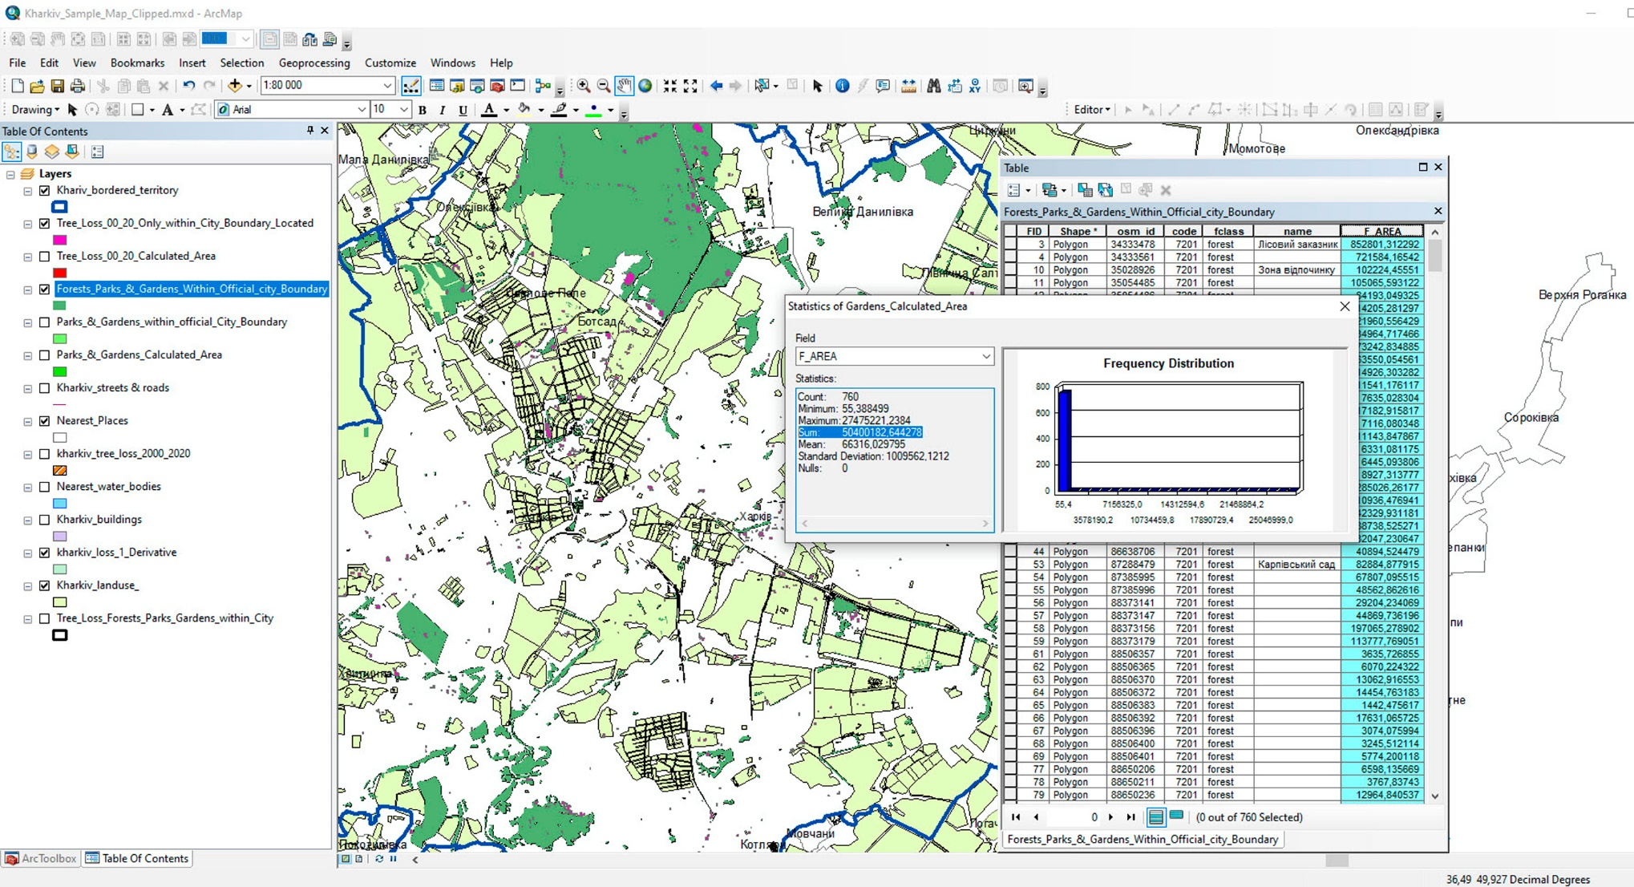
Supplementary Figure 11. Calculated areas of 5040 ha due to the total UGAs in Kharkiv including urban forests, parks, gardens, and other green classes (GDK-2)

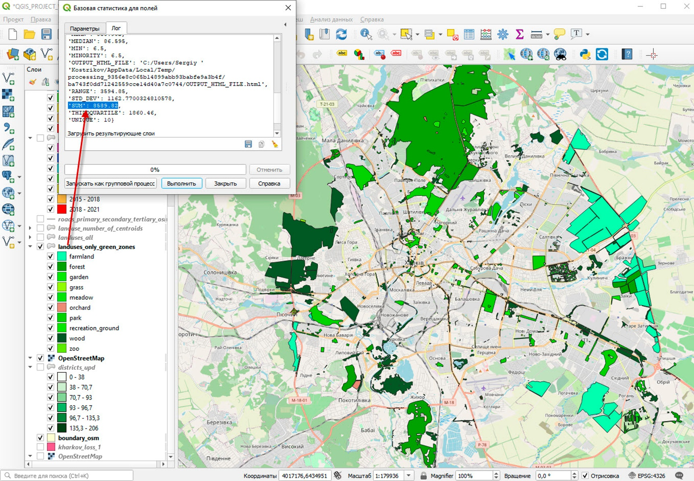

Supplementary Figure 12. A total area of the UGAs (with tree stand and without it) in Kharkiv calculated on the base of OSM sources - 8589 ha (GDK-1)

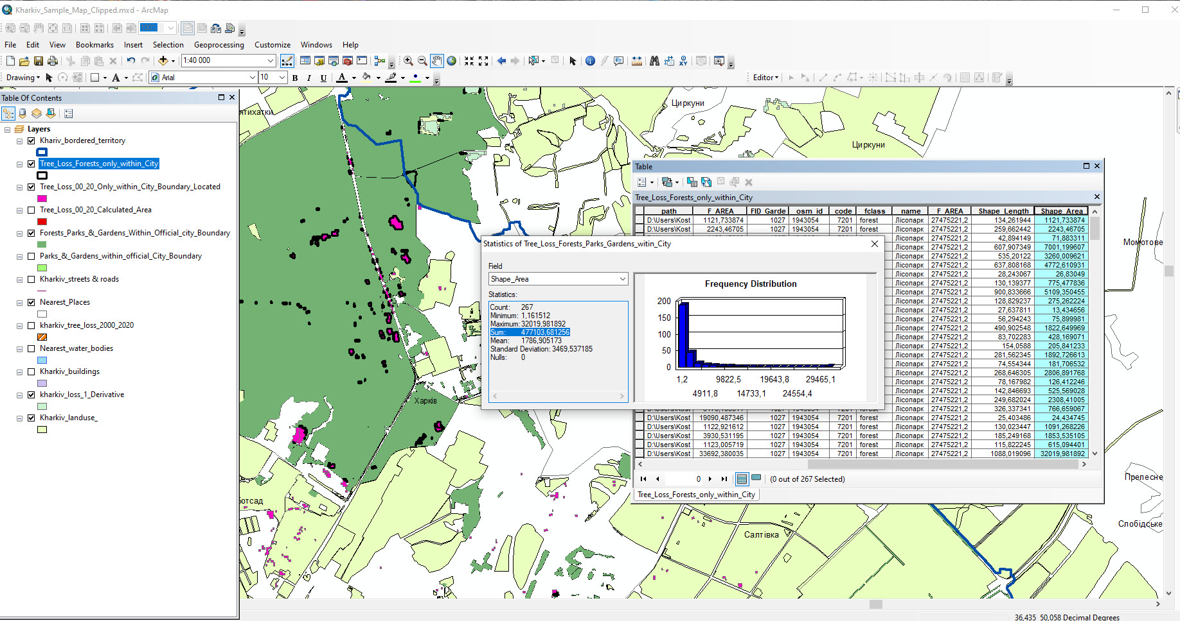
Supplementary Figure 13. Calculated areas of 48 ha due to the total USL values within the city in urban forests only (GDK-2)

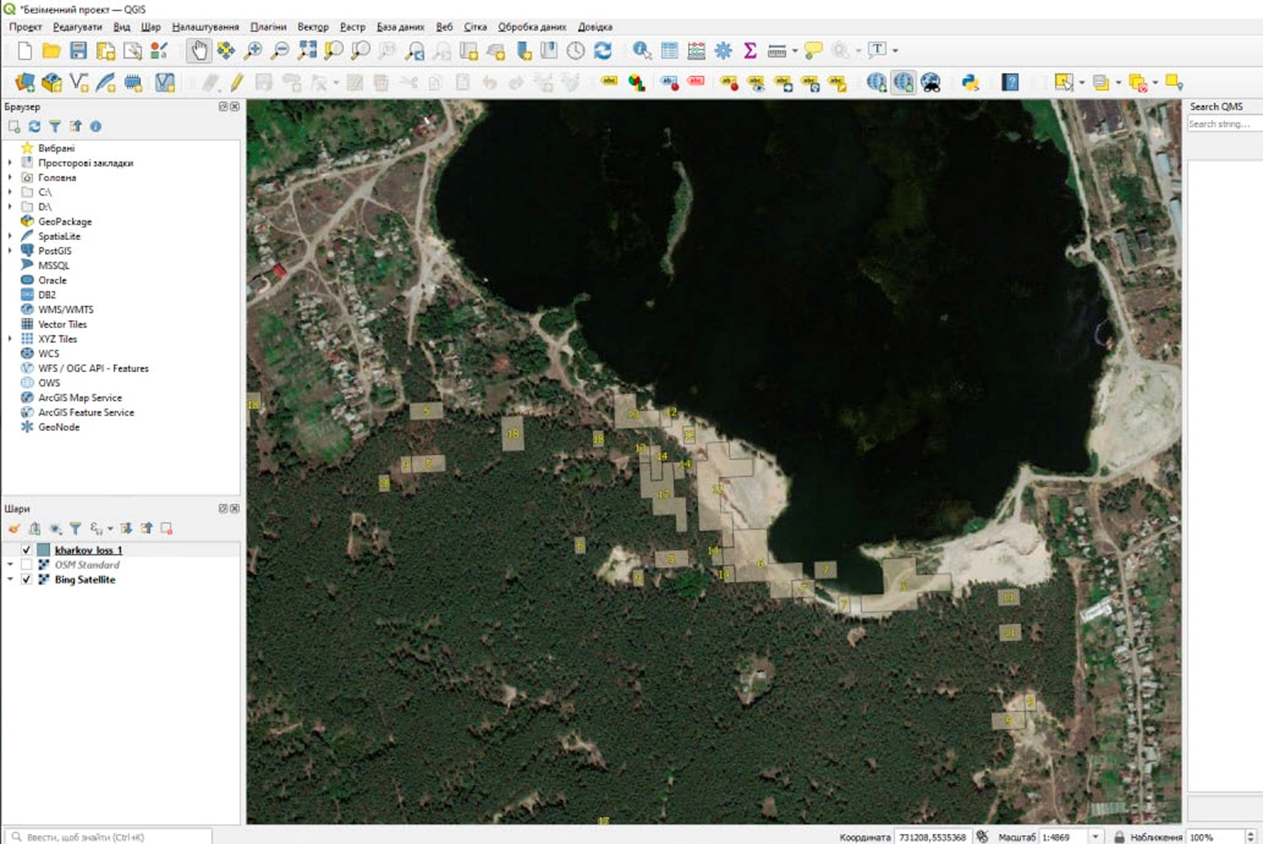
Supplementary Figure 14. Construction of a building material factory on an urban lake bank with a huge sandpit built in the former urban forest. Several USL vector polygons as the results of 1.5 block unit (Figure 2) market in that visual by yellow digits – identifiers of these polygons. The southern-western part of the AOI of our study.
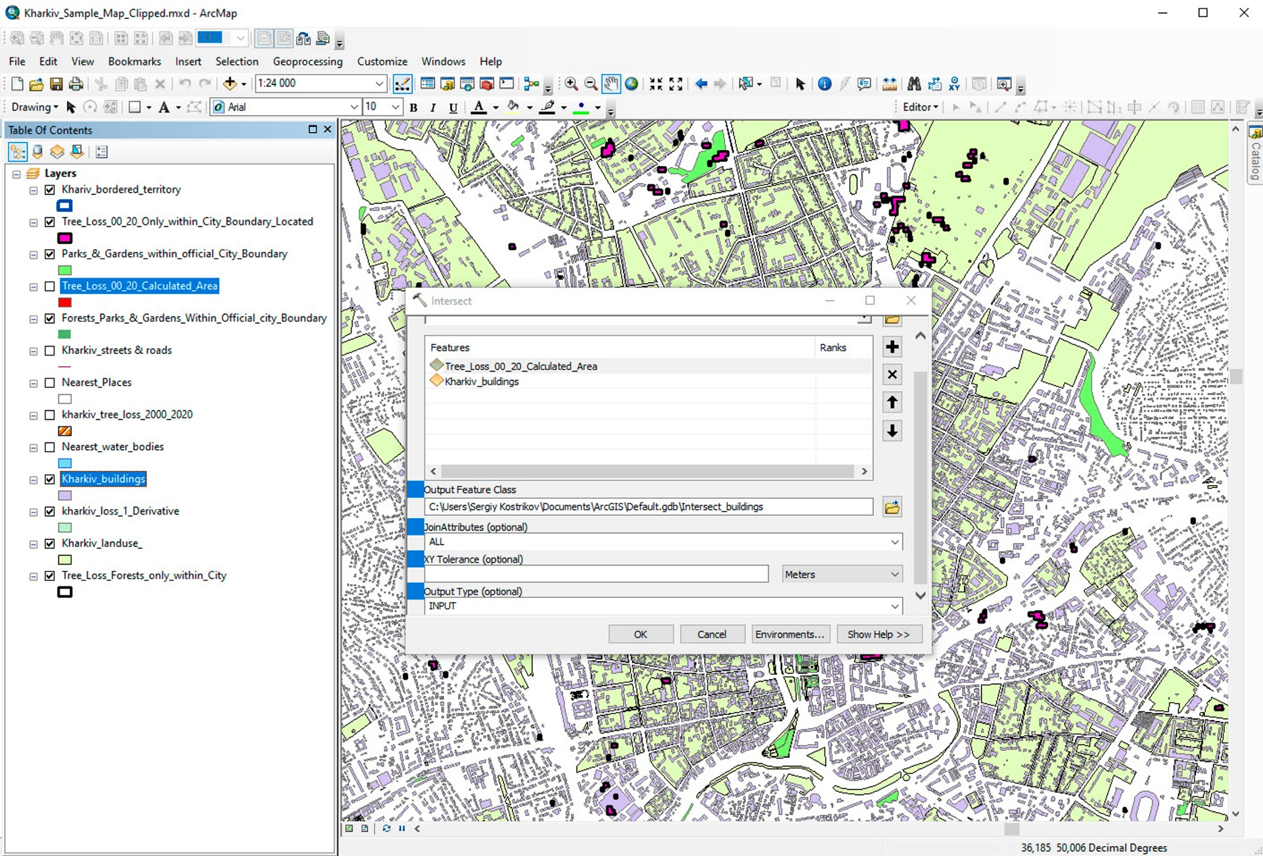
Supplementary Figure 15. Application of the Overlay Analysis Intersect tool (a geometric intersection of the aggregated USL layer with the Buildings layer as with the input feature class) (GDK-2)

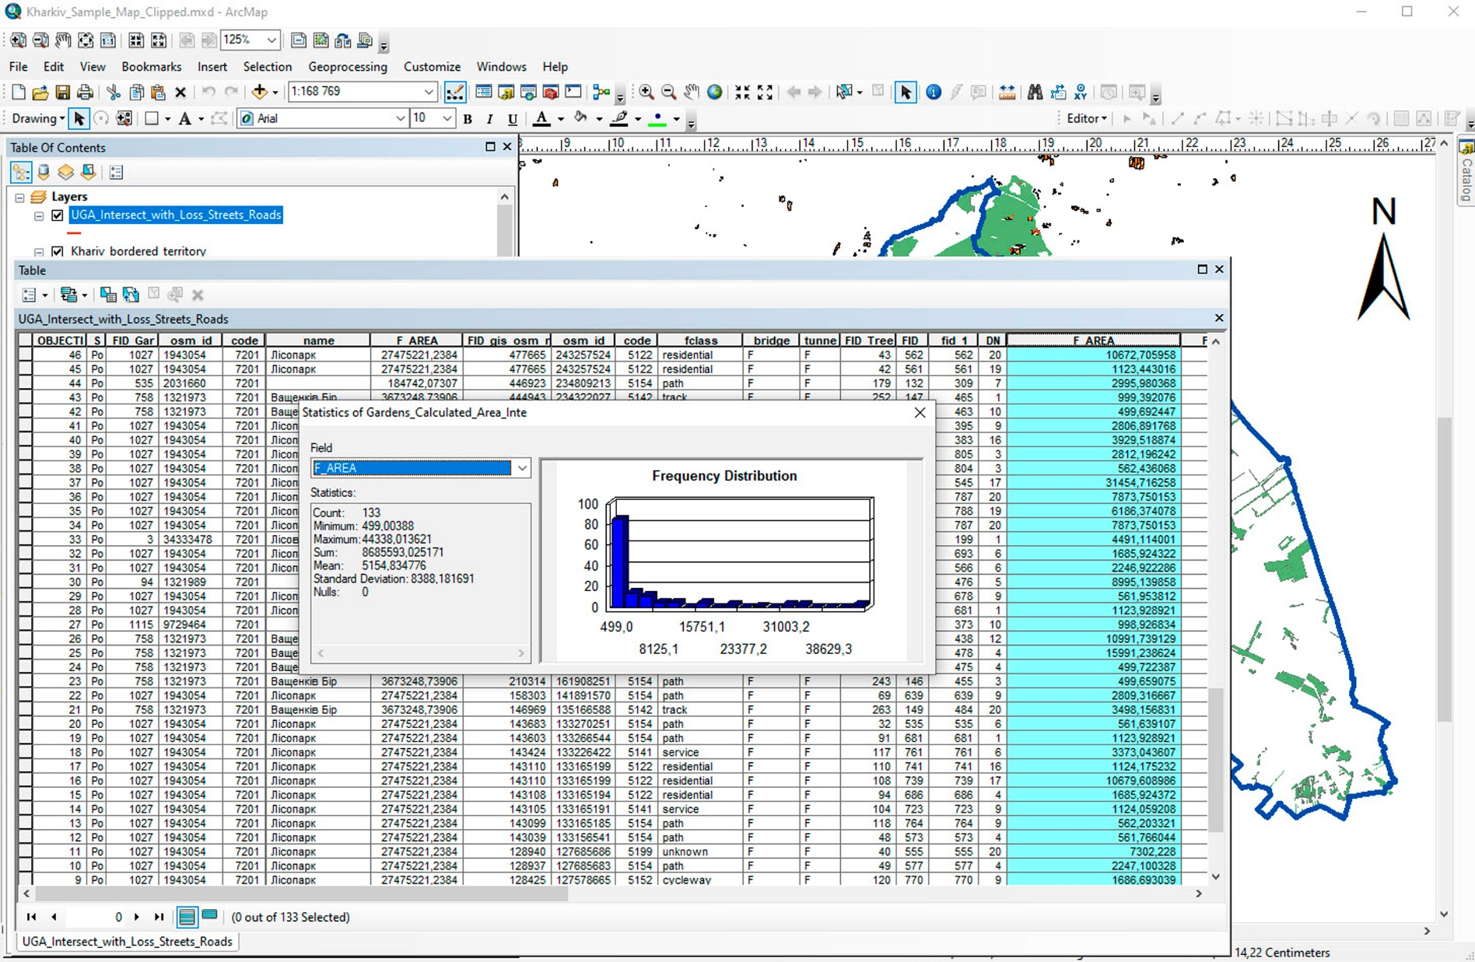
Supplementary Figure 16. The result of intersection of the USL layer with the Streets and Roads layers reported an overlapped area of 86 ha (GDK-2)
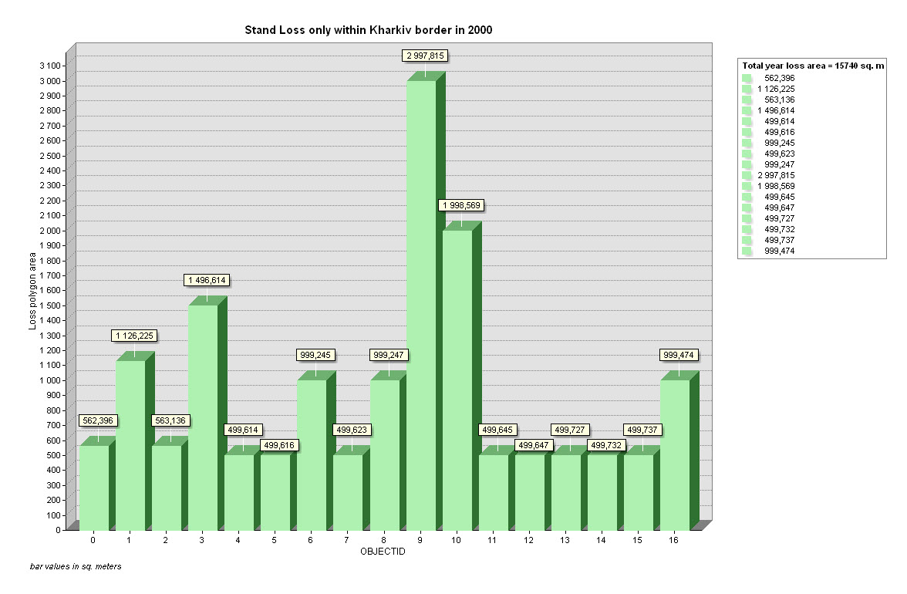
A
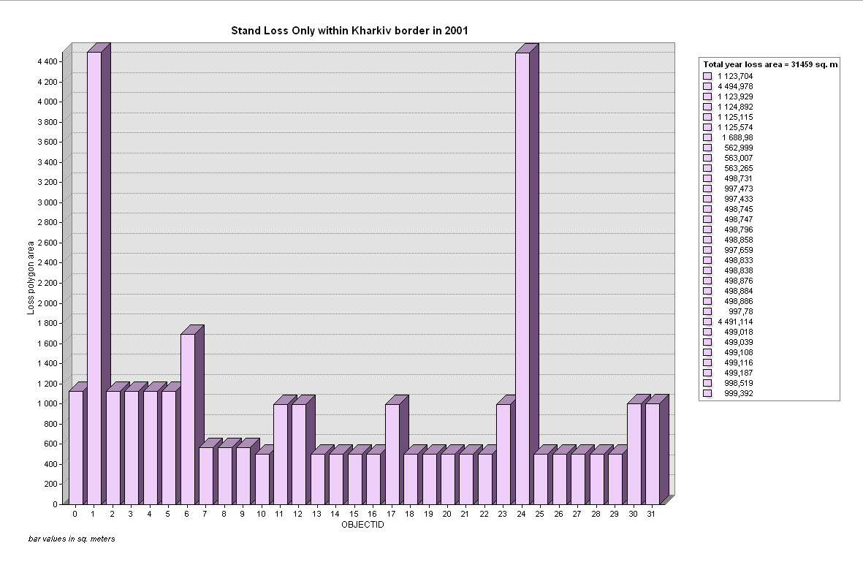
B
Supplementary Figure 17. Vector polygon areas of USL distributions per a Year: A – 2000; B – 2001. A Graph View in the ArcGIS interface (GDK-2)
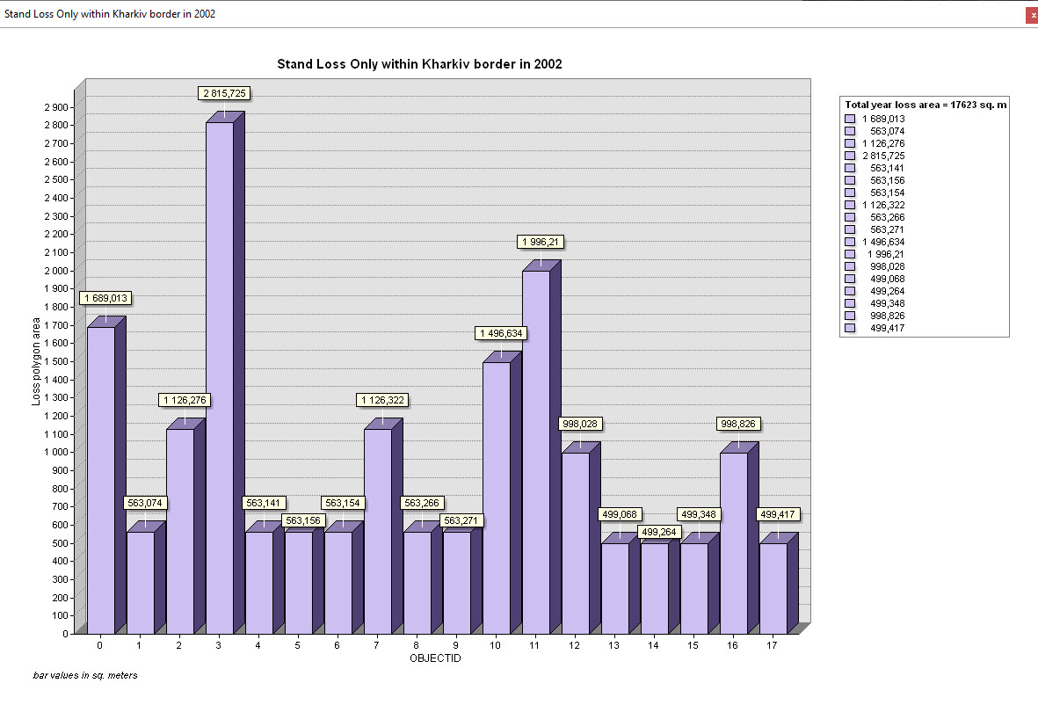
C
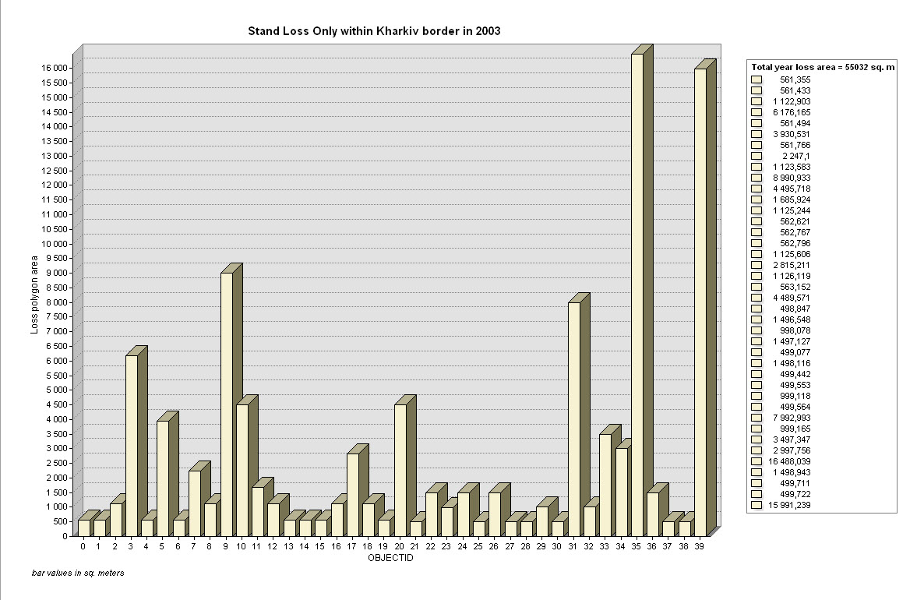
D
Supplementary Figure 17. Vector polygon areas of USL distributions per a Year: C – 2002; D – 2003. A Graph View in the ArcGIS interface (GDK-2)
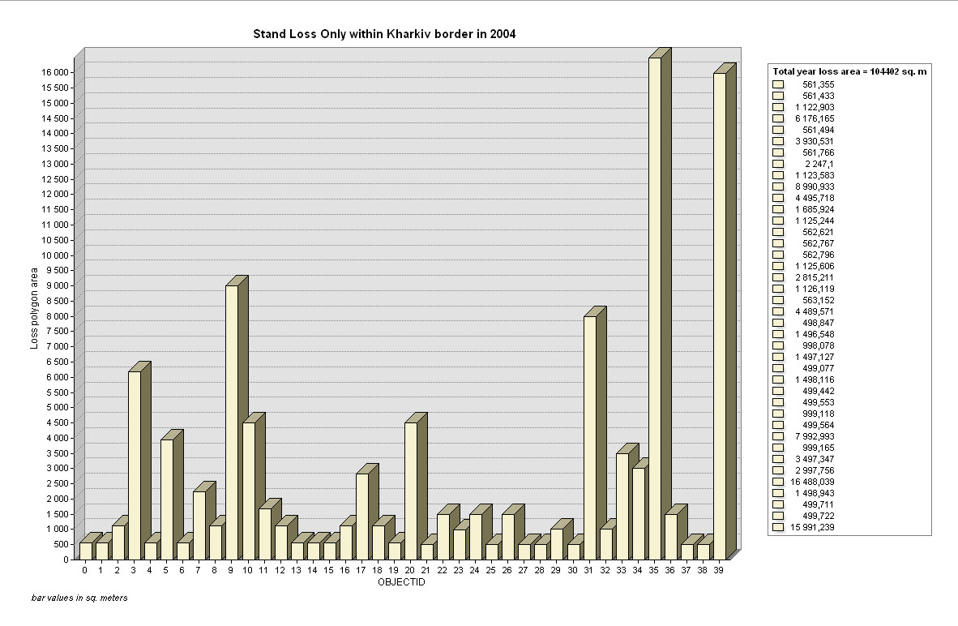
E
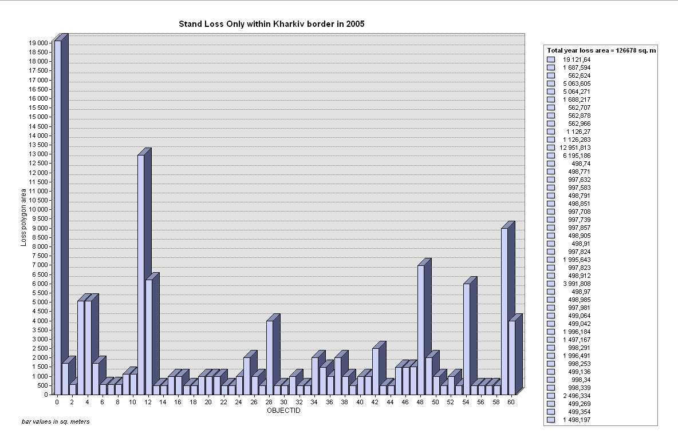
F
Supplementary Figure 17. Vector polygon areas of USL distributions per a Year: E – 2004; F – 2005. A Graph View in the ArcGIS interface (GDK-2)
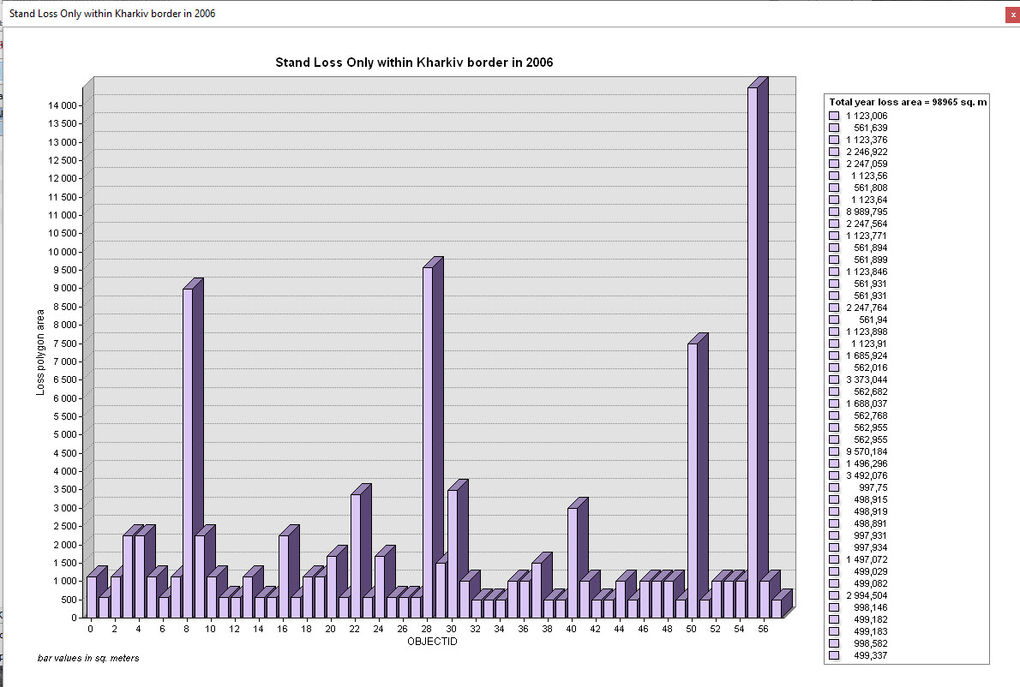
G
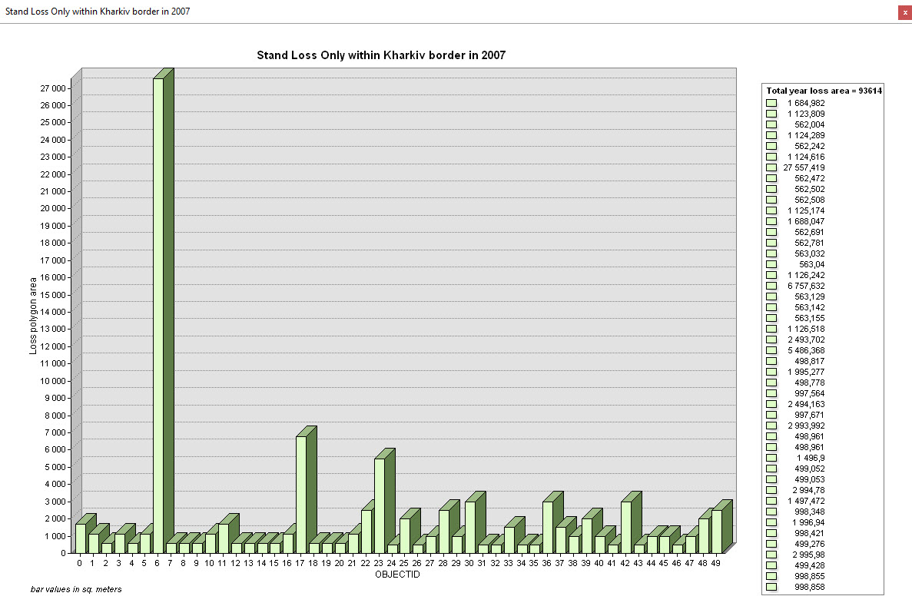
H
Supplementary Figure 17. Vector polygon areas of USL distributions per a Year: G – 2006; H – 2007. A Graph View in the ArcGIS interface (GDK-2)
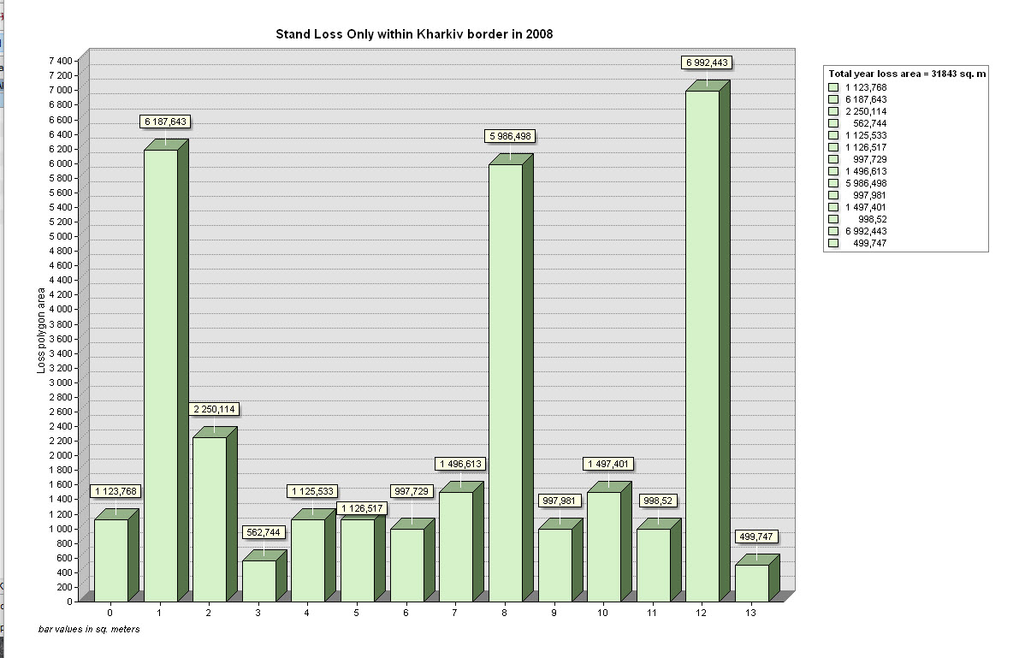
I
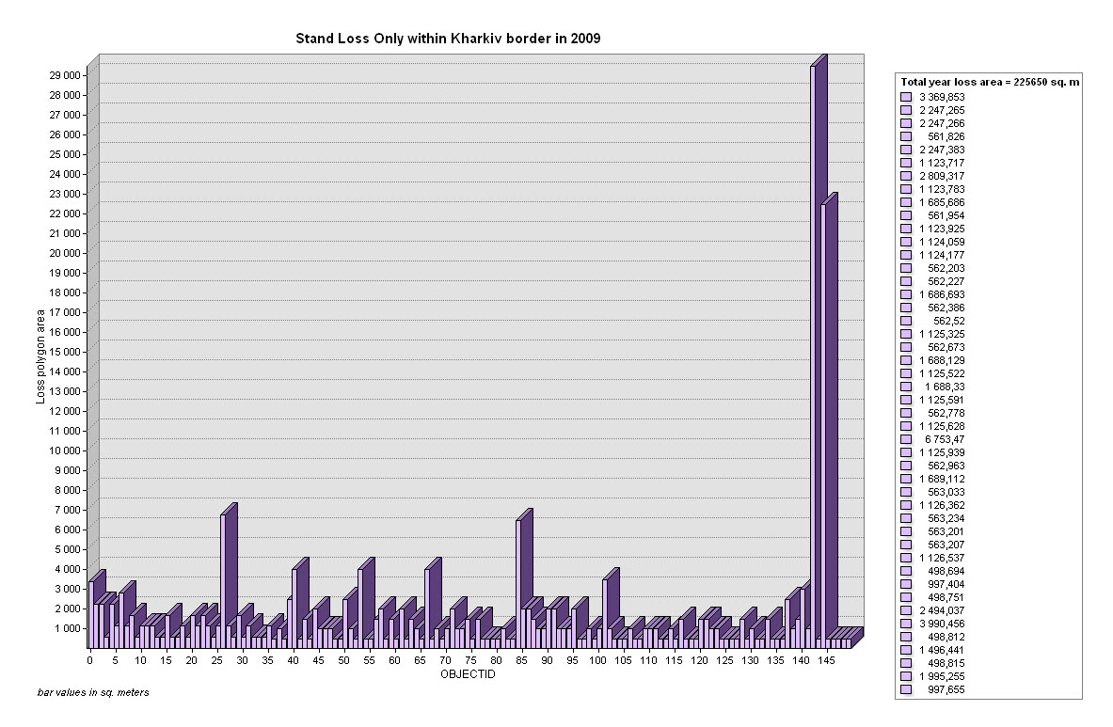
J
Supplementary Figure 17. Vector polygon areas of USL distributions per a Year: I – 2008; J – 2009. A Graph View in the ArcGIS interface (GDK-2)
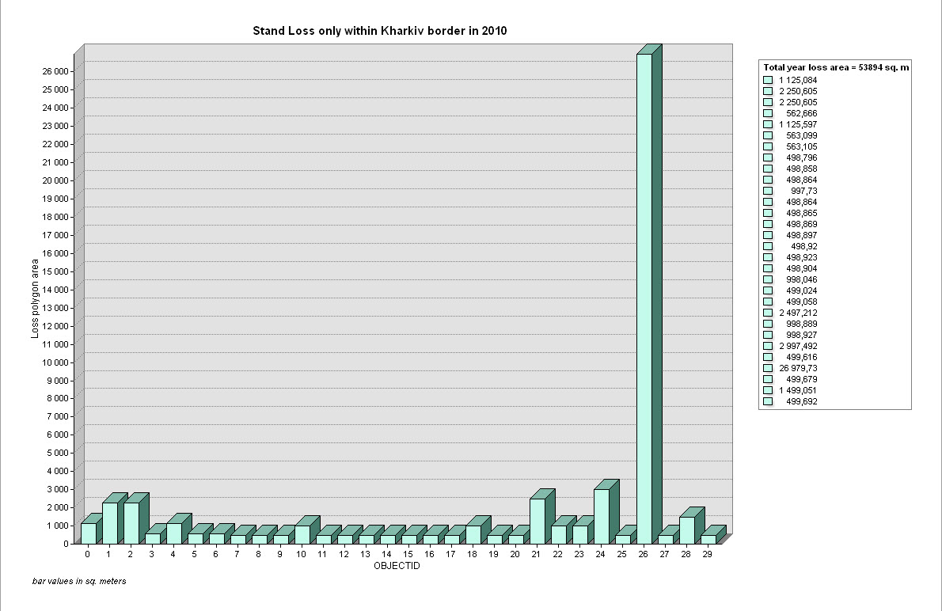
K
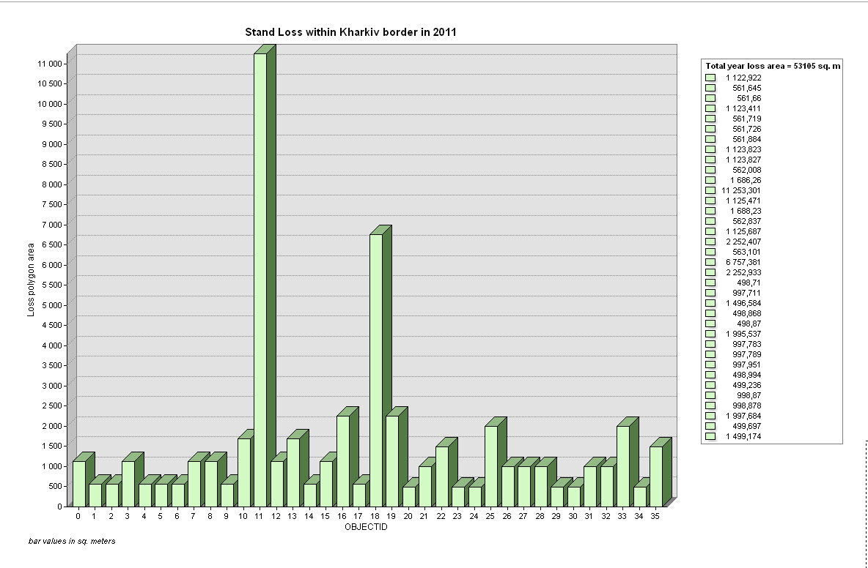
L
Supplementary Figure 17. Vector polygon areas of USL distributions per a Year: K – 2010; L – 2011. A Graph View in the ArcGIS interface (GDK-2)
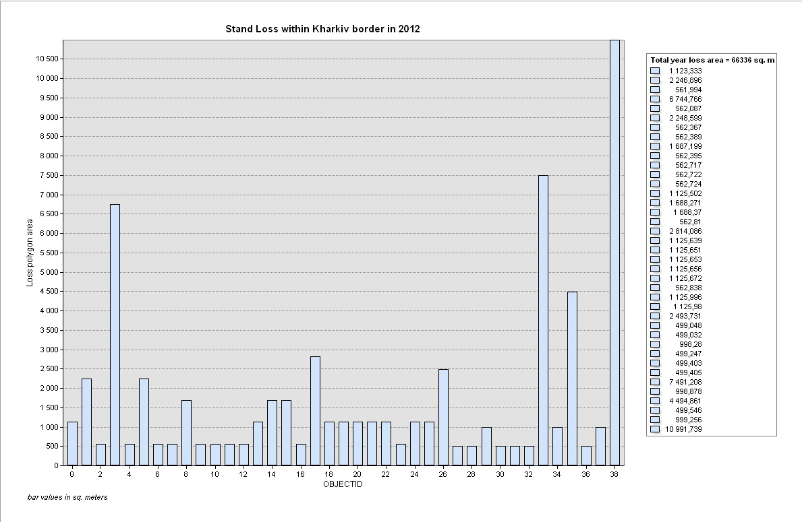
M
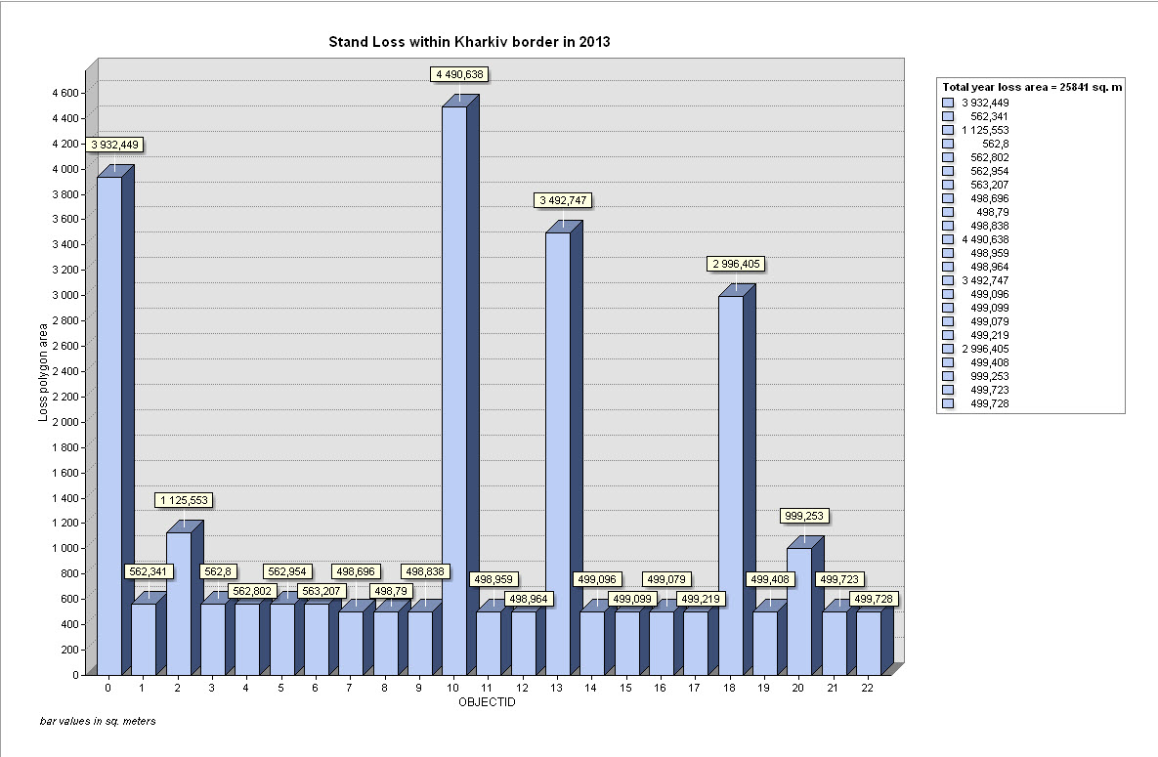
N
Supplementary Figure 17. Vector polygon areas of USL distributions per a Year: M – 2012; N – 2013. A Graph View in the ArcGIS interface (GDK-2)
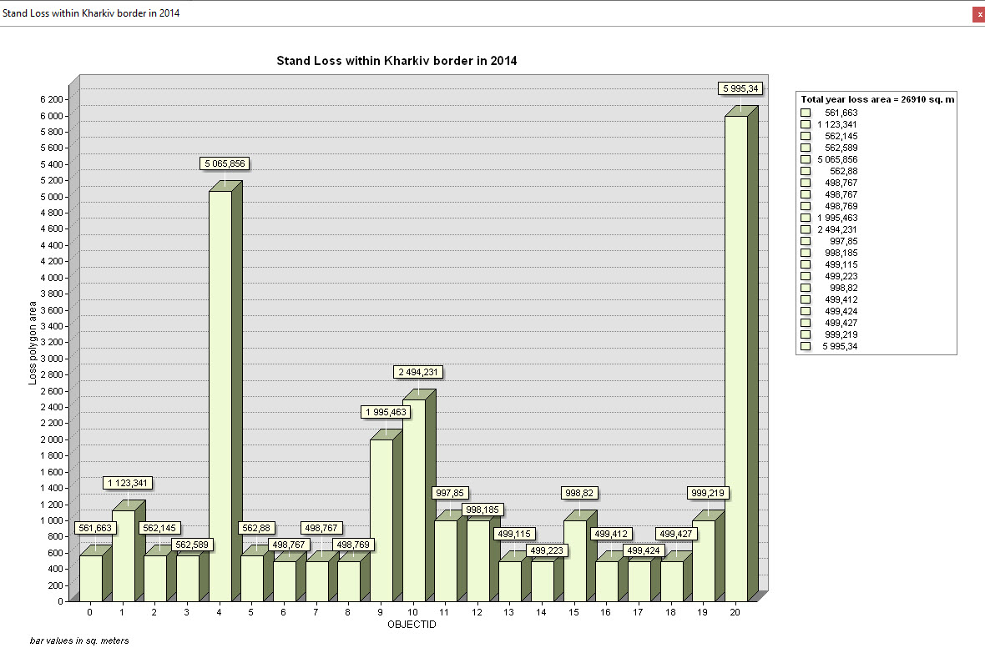
O
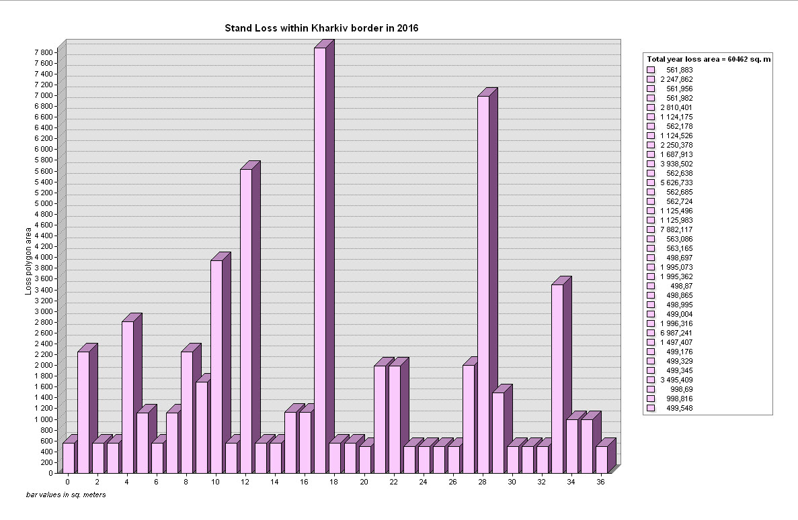
P
Supplementary Figure 17. Vector polygon areas of USL distributions per a Year: O – 2014; P – 2016. A Graph View in the ArcGIS interface (GDK-2)
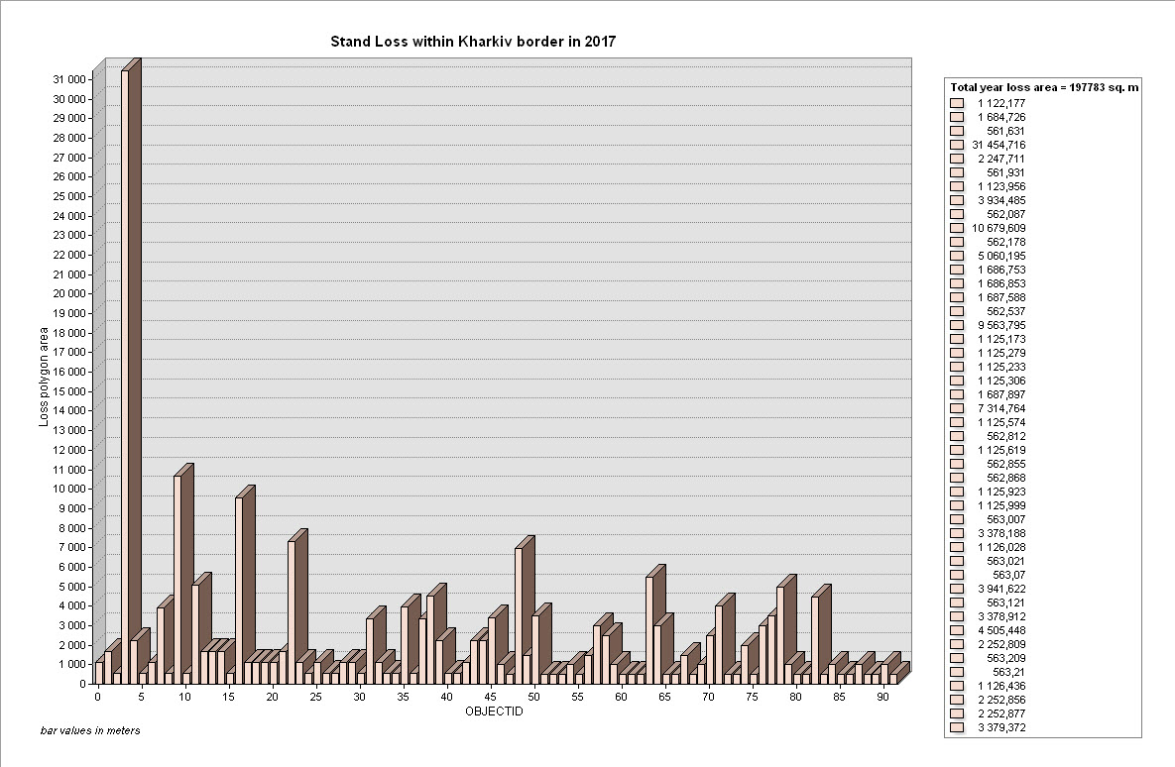
Q
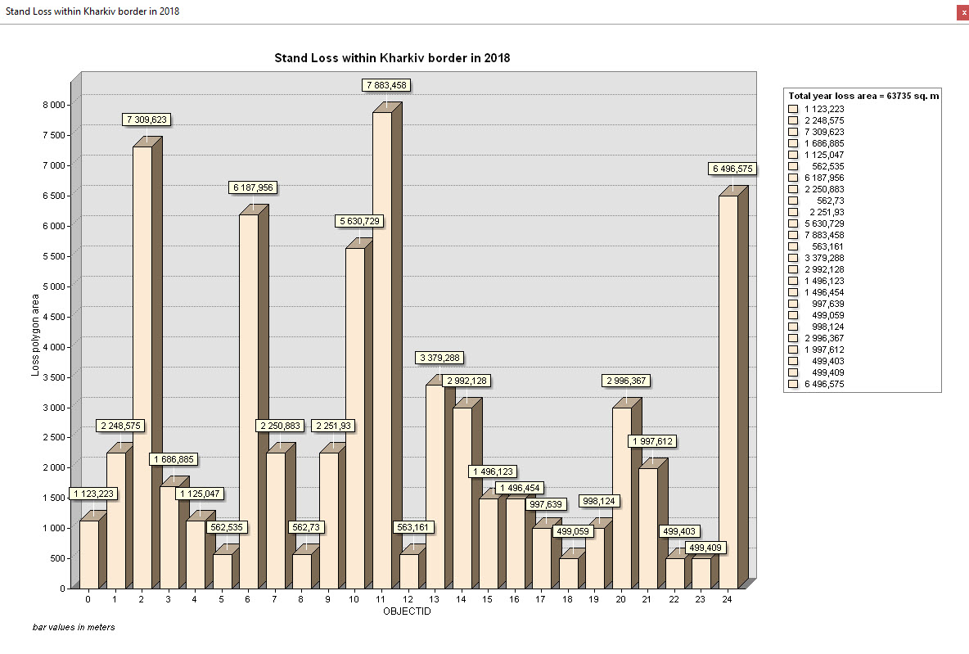
R
Supplementary Figure 17. Vector polygon areas of USL distributions per a Year: Q – 2017; R – 2018. A Graph View in the ArcGIS interface (GDK-2)
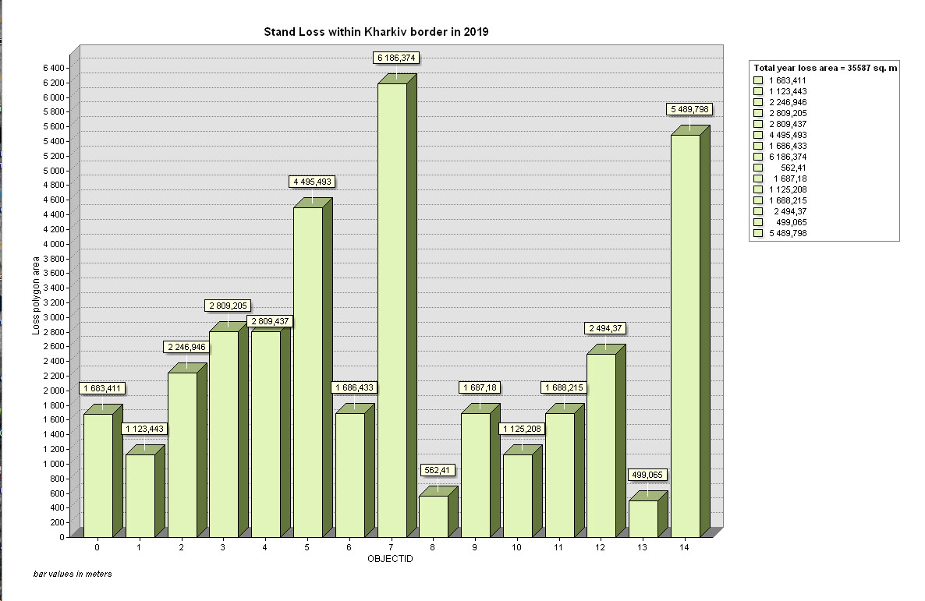
S
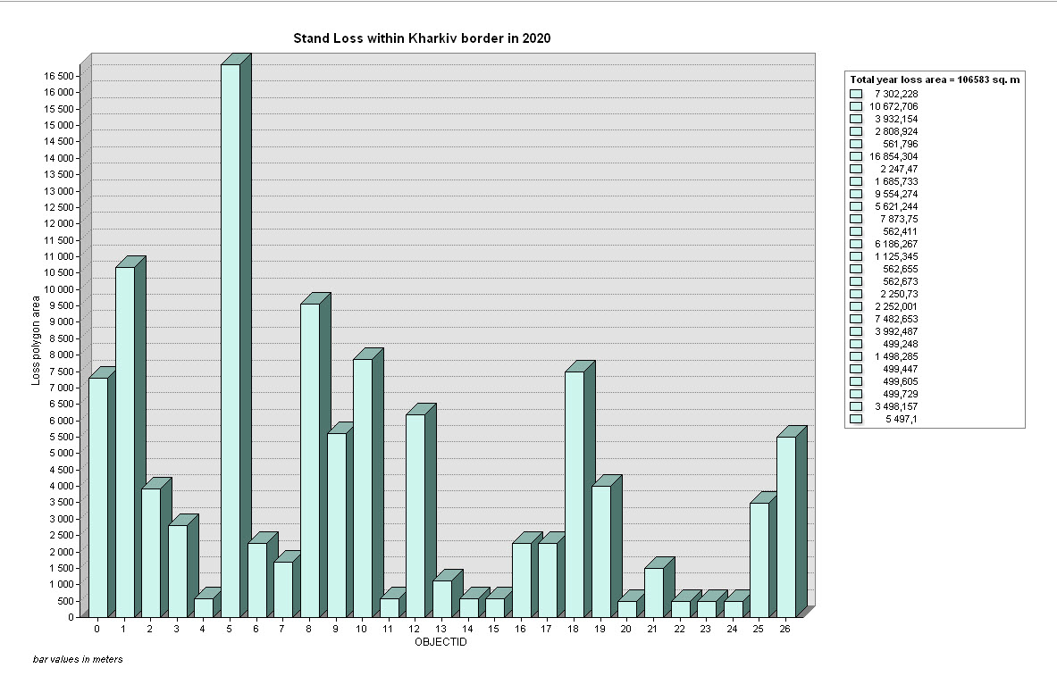
T
Supplementary Figure 17. Vector polygon areas of USL distributions per a Year: S – 2019; T – 2020. A Graph View in the ArcGIS interface (GDK-2)

