Table S1: Table showing disease modifying anti-rheumatic drugs (DMARDs) prescribed to EIA patients at first visit, short-term follow-up, and long-term follow-up timepoints. NA = details unavailable.
ERA ID | First prescribed | Short term  follow-up | Long-term  follow-up
04 | etanercept | NA | NA
07 | methotrexate + hydroxychloroquine | NA | NA
08 | etanercept | NA | NA
ERA 03 | etanercept | methotrexate + etanercept | adalimumab + methotrexate
ERA 25 | methotrexate | methotrexate | leflunomide
ERA 82 | methotrexate | methotrexate + leflunomide | etanercept
ERA 95 | sulfasalazine | methotrexate | methotrexate + sulfasalazine
ERA 110 | methotrexate | methotrexate + sulfasalazine + hydroxychloroquine | adalimumab
ERA 115 | methotrexate + sulfasalazine | Methotrexate | methotrexate + certolizumab
ERA 116 | methotrexate + sulfasalazine | methotrexate + sulfasalazine | methotrexate
ERA123 | methotrexate | Methotrexate | methotrexate
ERA 133 | NA | Methotrexate | adalimumab
ERA 135 | methotrexate | Methotrexate | methotrexate
ERA 143 | NA | methotrexate + infliximab | methotrexate
ERA 144 | NA | NA | NA
ERA 154 | NA | rituximab + methotrexate + hydroxychloroquine | methotrexate + sulfasalazine + hydroxychloroquine
ERA 165 | NA | methotrexate + sulfasalazine + hydroxychloroquine | etanercept + methotrexate + sulfasalazine + hydroxychloroquine

Table S2: Table showing differential expression of gene transcripts between ERA and RA patients. Data was analyzed by Student t test and corrected for false-discovery rate.
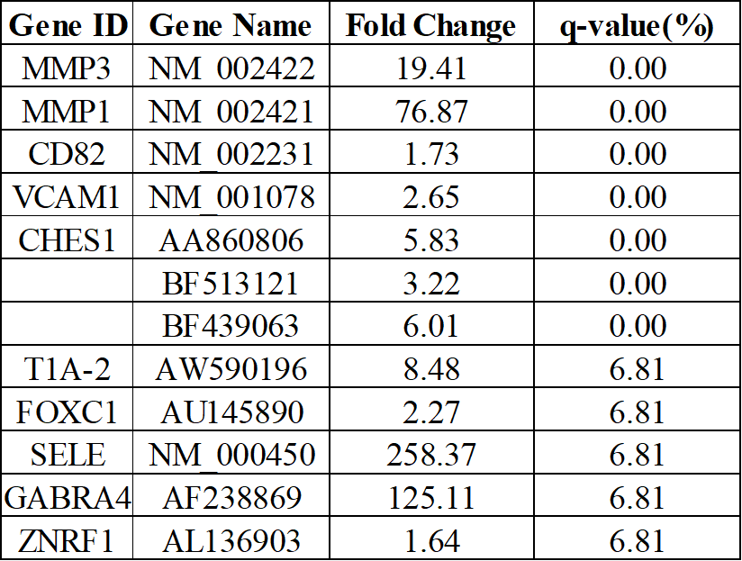

Fig S1: Violin plot showing the transcript abundance of various MMPs in ERA patients
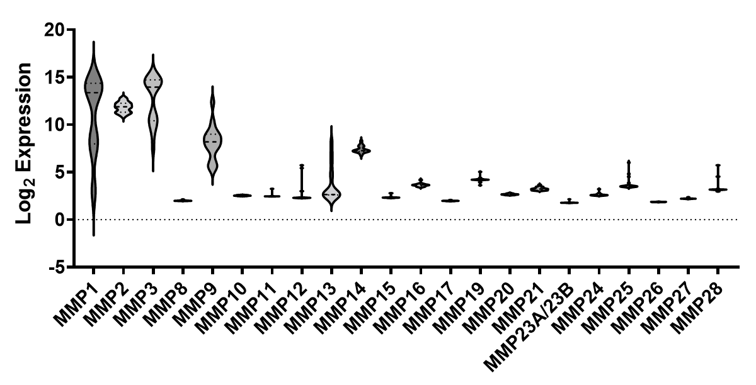
Table S3: Table showing the mRNA abundance of MMPs and TIMPs in MMP-high and MMP-low groups. Data is represented as log2-normalized values and was analyzed by independent samples T test.
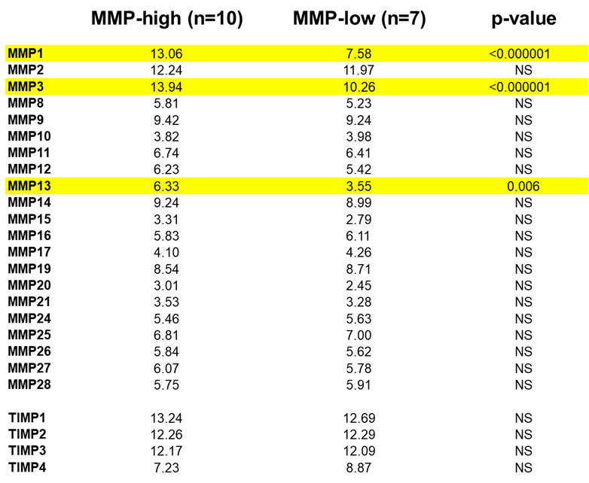

FigS2: Spearman rank correlation analysis between MMP-1 and MMP-3 mRNA levels in ERA patients (open circles = MMP-high; close circles = MMP-low)
Fig S3: (A) Box-whiskers plot showing the expression of MMP-1 and MMP-3 in the serum of MMP-high and MMP-low ERA subjects. Data was analyzed by Mann-Whitney U test; ns = non-significant. (B) Spearman rank correlation analysis between serum MMP-1 and MMP-3 levels in ERA patients (open circles = MMP-high; close circles = MMP-low) (C & D) Spearman rank correlation analysis between serum MMP levels and hs-CRP in ERA patients (open circles = MMP-high; close circles = MMP-low)

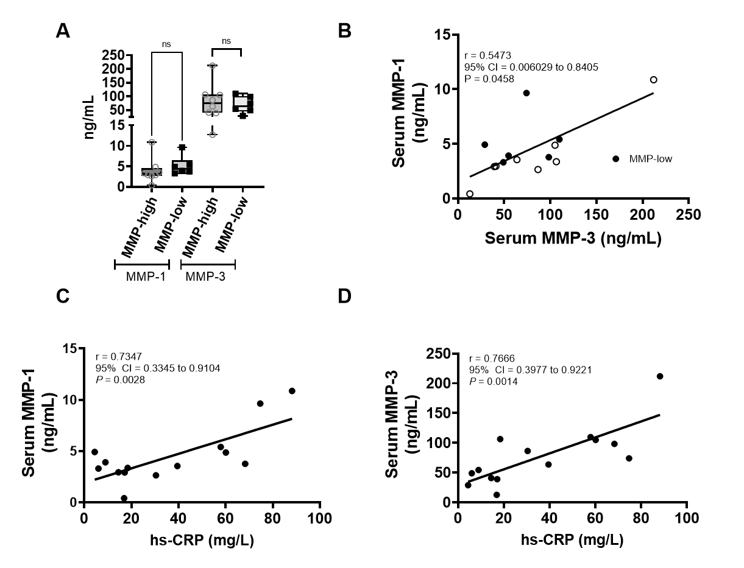

Table S4: List of genes that are differentially expressed between MMP-high and MMP-low ERA patients. Data was analyzed using independent samples T test and corrected for multiple comparison using Bonferroni correction

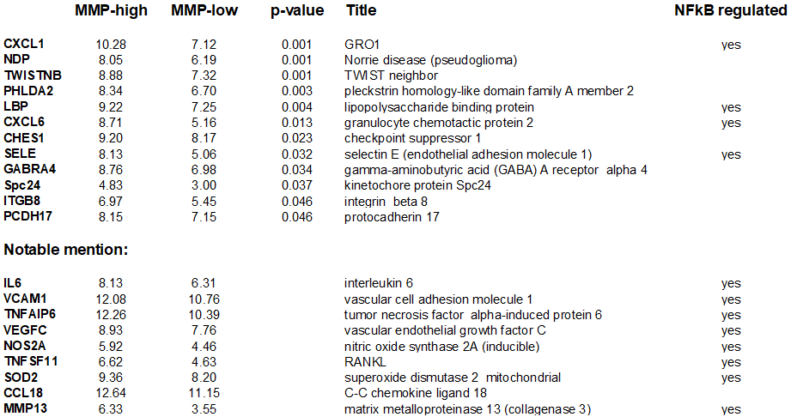

Table S5: Table showing baseline clinical features between MMP-high and MMP-low ERA patients. CRP = C-reactive protein, RF = rheumatoid factor, ESR = erythrocyte sedimentation rate, DAS = disease activity score. Data is represented either as mean (standard deviation, SD), n (%) or median (range), as required. Analyzed using either Mann-Whitney test or $Chi-square test.

