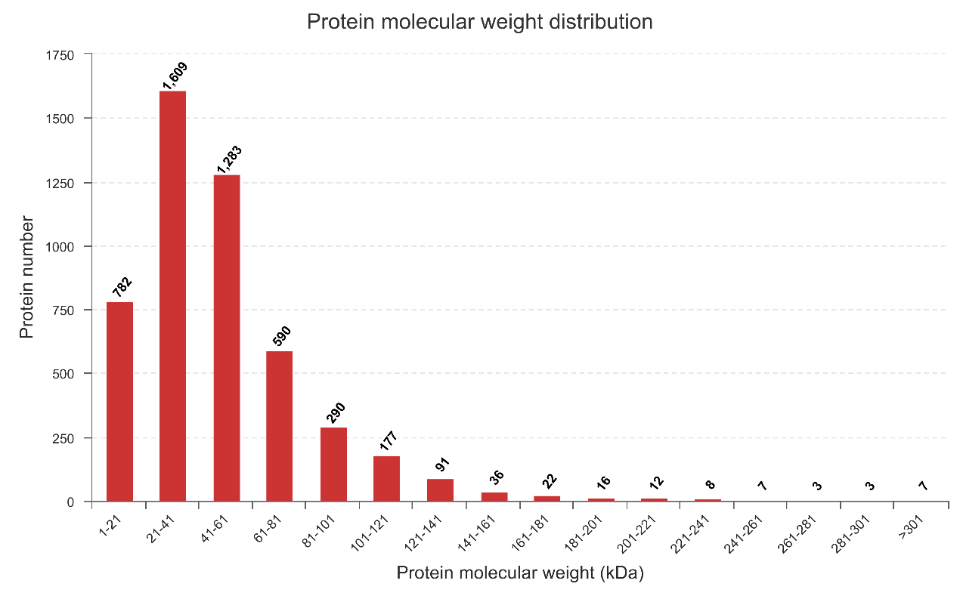 **Supplementary Figure 1A.** Molecular weight distribution of identified proteins.

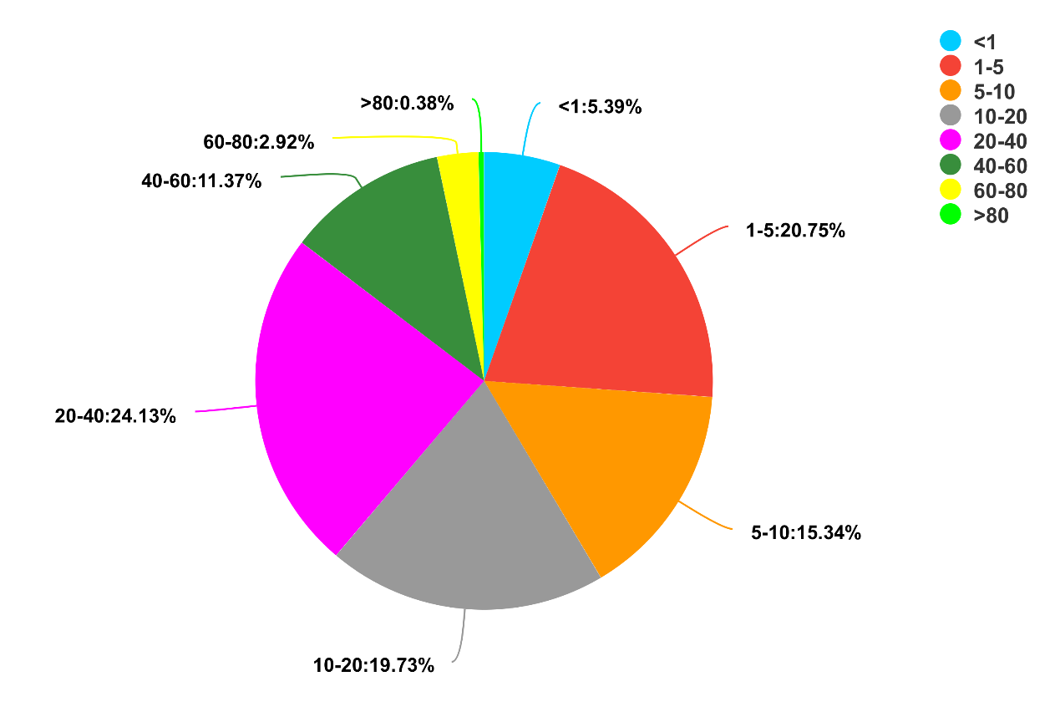 **Supplementary Figure 1B.** Distribution of identified proteins’ sequences coverage.

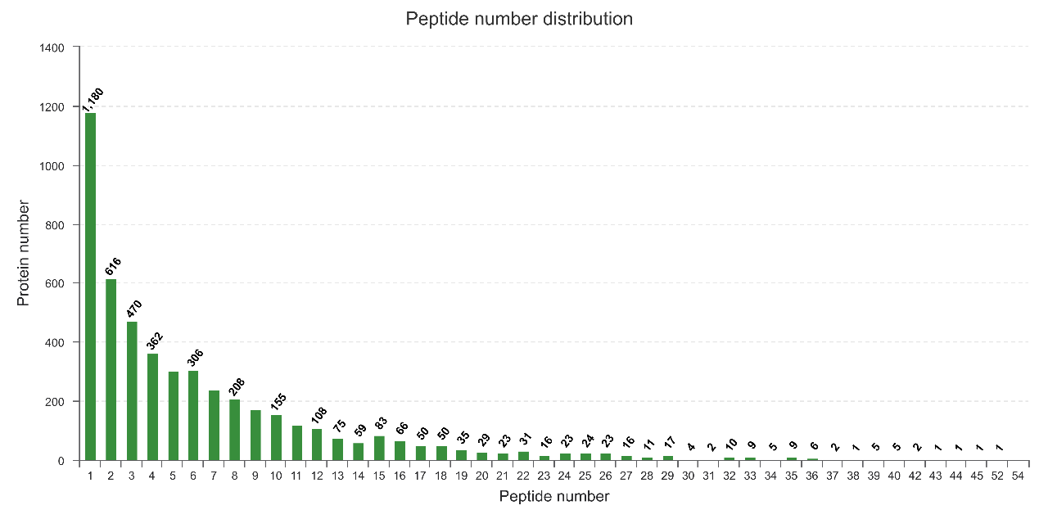**Supplementary Figure 1C.** Number distribution of identified proteins.

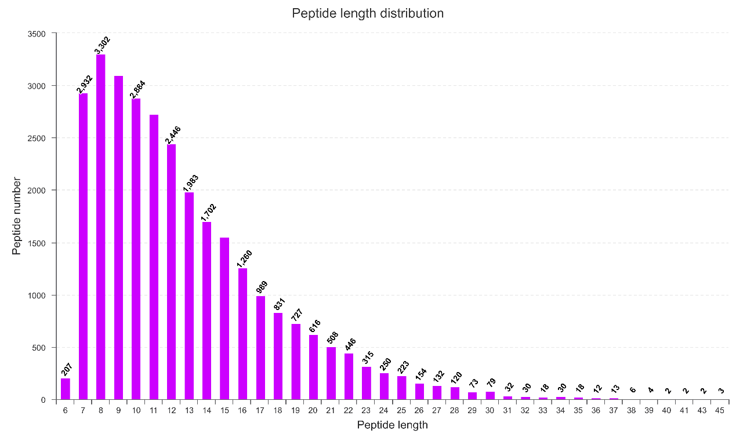**Supplementary Figure 1D.** Length distribution of peptide.

**Supplementary Figure 1E.** Principal components analysis (PCA) of proteome samples