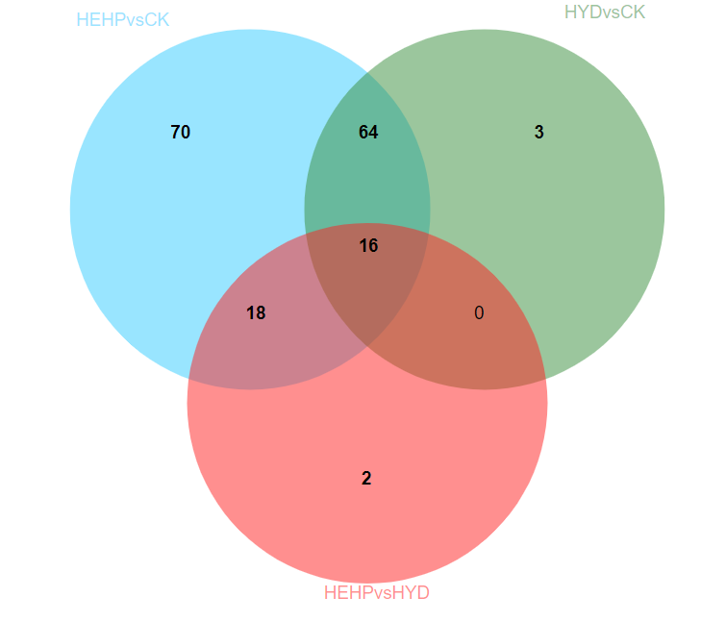 **Supplementary Figure 2.** Venn diagram showing specific and overlapping DAPs involved in carbohydrate metabolism among the three groups.