# 

**Supplementary Figure S1** Linear regression of the exogenous organic matter treatments (T1 to T6) and control treatments (T0) of the long-term experimental sites. Black spots indicate measured soil organic carbon (SOC) stocks and red solid lines indicate the predicted linear regression.

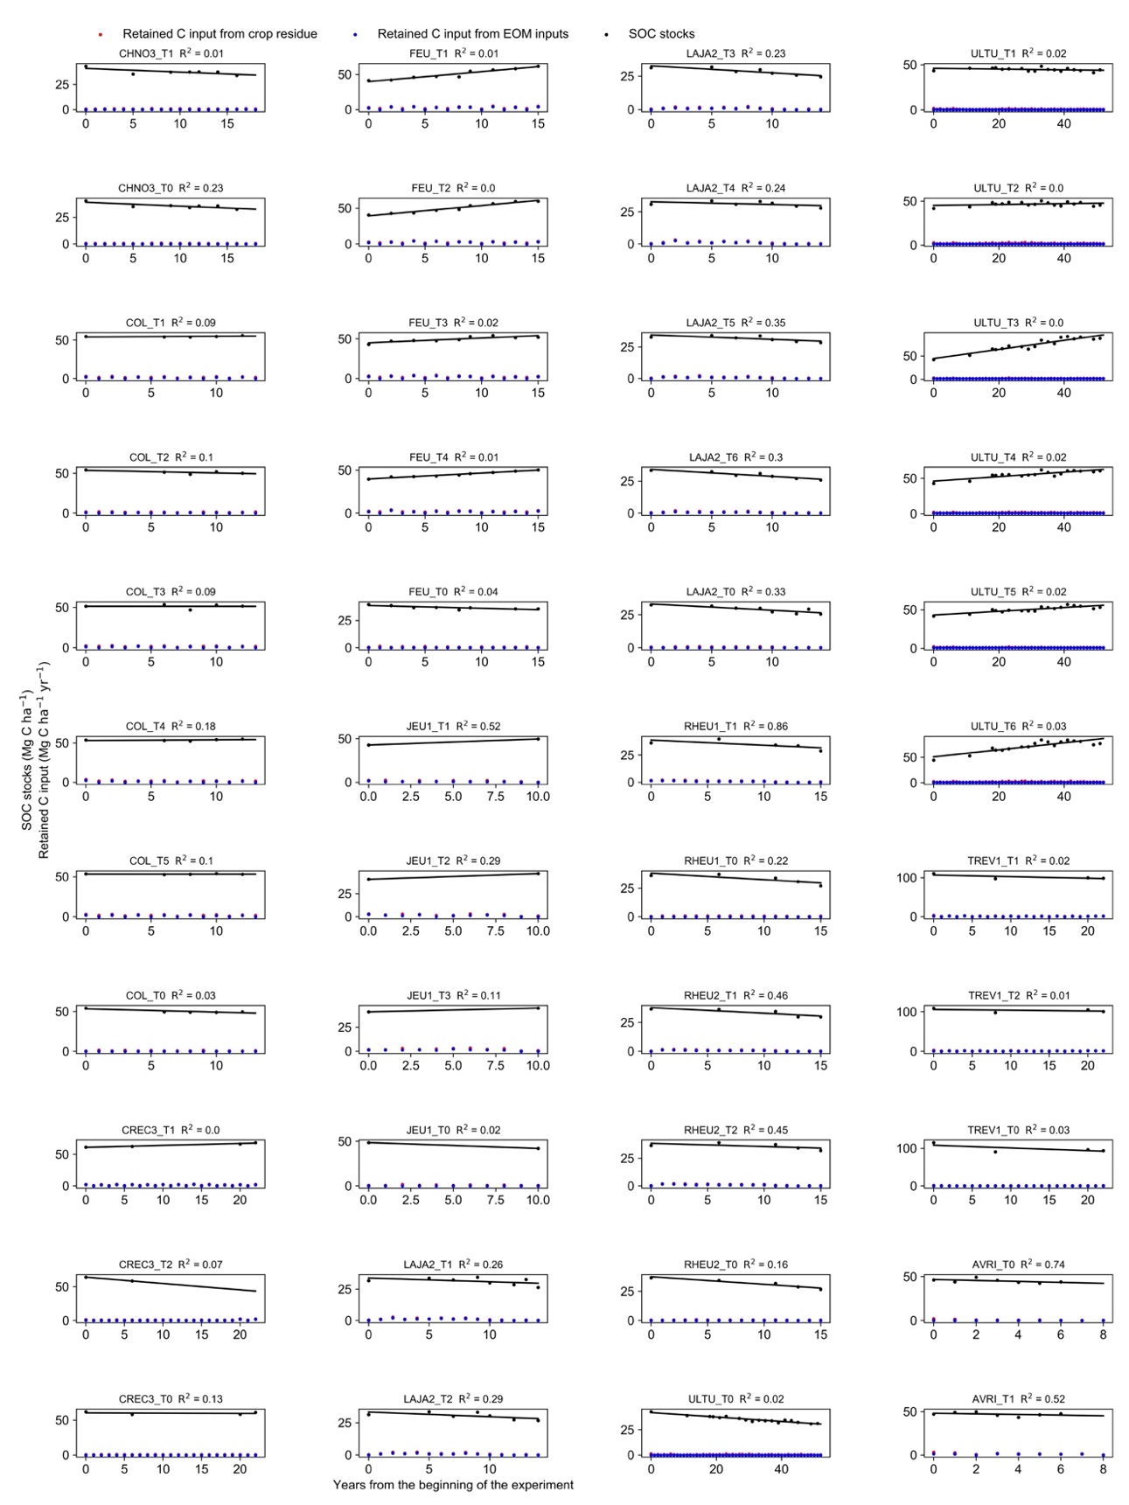

**Supplementary Figure S2**Measured and predicted soil organic carbon (SOC) stocks over time, and retained carbon (C) input over time, for each treatment throughout the experiments’ duration. Retained C inputs (from crop residues and exogenous organic matter (EOM) were calculated as the amount of C input, multiplied by its C retention coefficient (**Supplementary Table 1**).

**Supplementary Table S1** Agronomic information on the experiments.

|  |  |  |  |  |  |  |  |  |  |  |  |
| --- | --- | --- | --- | --- | --- | --- | --- | --- | --- | --- | --- |
| **Site** | **Treatment name** | **Plot size** | **Control/EOM type** | **Species name** | **Crop rotations1** | **Crops botanical names** | **Percentage of experiments' duration for which straw residue was exported** | **Maximal tillage depth2** | **Carbon retention coefficient aboveground crop** | **Carbon retention coefficient belowground crop** | **Carbon retention coefficient EOM inputs** |
|  |  | m2 |  |  |  |  | % | cm |  |  |  |
| Champ Noel 3 (CHNO3) | T0 | 150 | Control |  | sM | *Zea mays* | 100 | 25 | 0.23 | 0.40 |  |
|  | T1 | 150 | Pig slurry | *Sus domesticus* | sM | *Zea mays* | 100 | 25 | 0.23 | 0.40 | 0.15 |
| Colmar (COL) | T0 | 90 | Control |  | wW/Mg/sB/S | *Triticum aestivum, Zea mays, Hordeum vulgare, Beta vulgaris* | 0 | 28 | 0.24 | 0.40 |  |
|  | T1 | 90 | Green waste and biowaste compost |  | wW/Mg/sB/S | *Triticum aestivum, Zea mays, Hordeum vulgare, Beta vulgaris* | 0 | 28 | 0.24 | 0.40 | 0.83 |
|  | T2 | 90 | Urban sludges |  | wW/Mg/sB/S | *Triticum aestivum, Zea mays, Hordeum vulgare, Beta vulgaris* | 0 | 28 | 0.24 | 0.40 | 0.54 |
|  | T3 | 90 | Composted Cattle manure | *Bos taurus* | wW/Mg/sB/S | *Triticum aestivum, Zea mays, Hordeum vulgare, Beta vulgaris* | 0 | 28 | 0.24 | 0.40 | 0.61 |
|  | T4 | 90 | Green waste compost |  | wW/Mg/sB/S | *Triticum aestivum, Zea mays, Hordeum vulgare, Beta vulgaris* | 0 | 28 | 0.24 | 0.40 | 0.65 |
|  | T5 | 90 | Cattle manure | *Bos taurus* | wW/Mg/sB/S | *Triticum aestivum, Zea mays, Hordeum vulgare, Beta vulgaris* | 0 | 28 | 0.24 | 0.40 | 0.65 |
| Crécom (CREC3) | T0 | 130 | Control |  | wW/sM | *Triticum aestivum, Zea mays* | 100 | 30 | 0.22 | 0.40 |  |
|  | T1 | 130 | Cattle manure | *Bos taurus* | wW/sM | *Triticum aestivum, Zea mays* | 100 | 30 | 0.22 | 0.40 | 0.52 |
|  | T2 | 130 | Poultry manure | *Gallus gallus domesticus* | wW/sM | *Triticum aestivum, Zea mays* | 100 | 30 | 0.22 | 0.40 | 0.40 |
| Feucherolles (FEU) | T0 | 450 | Control |  | wW/Mg/wB | *Triticum aestivum, Zea mays, Hordeum vulgare3* | 56 | 29 | 0.22 | 0.40 |  |
|  | T1 | 450 | Biowaste and green waste compost |  | wW/Mg/ wB | *Triticum aestivum, Zea mays, Hordeum vulgare3* | 56 | 29 | 0.22 | 0.40 | 0.83 |
|  | T2 | 450 | Green waste compost |  | wW/Mg/ wB | *Triticum aestivum, Zea mays, Hordeum vulgare3* | 56 | 29 | 0.22 | 0.40 | 0.65 |
|  | T3 | 450 | Cattle manure | *Bos taurus* | wW/Mg/ wB | *Triticum aestivum, Zea mays, Hordeum vulgare3* | 56 | 29 | 0.22 | 0.40 | 0.65 |
|  | T4 | 450 | Municipal solid waste compost |  | wW/Mg/ wB | *Triticum aestivum, Zea mays, Hordeum vulgare3* | 56 | 29 | 0.22 | 0.40 | 0.53 |
| Jeu-les-Bois (JEU1) | T0 | 72 | Control |  | wB/R/wW | *Triticum aestivum, Brassica napus L., Hordeum vulgare* | 55 | 30 | 0.22 | 0.40 |  |
|  | T1 | 144 | Composted Cattle manure | *Bos taurus* | wB/R/wW | *Triticum aestivum, Brassica napus L., Hordeum vulgare* | 55 | 30 | 0.22 | 0.40 | 0.61 |
|  | T2 | 144 | Composted Cattle manure | *Bos taurus* | wB/R/wW | *Triticum aestivum, Brassica napus L., Hordeum vulgare* | 55 | 30 | 0.22 | 0.40 | 0.61 |
|  | T3 | 144 | Cattle manure | *Bos taurus* | wB/R/wW | *Triticum aestivum, Brassica napus L., Hordeum vulgare* | 55 | 30 | 0.22 | 0.40 | 0.52 |
| La Jaillère 2 (LAJA2) | T0 | 70 | Control |  | sM/wW | *Triticum aestivum, Zea mays, Brassica napus L.* | 93 | 22 | 0.23 | 0.40 |  |
|  | T1 | 70 | Composted Cattle manure | *Bos taurus* | sM/wW | *Triticum aestivum, Zea mays, Brassica napus L.* | 93 | 22 | 0.23 | 0.40 | 0.61 |
|  | T2 | 70 | Composted Pig manure | *Sus domesticus* | sM/wW | *Triticum aestivum, Zea mays, Brassica napus L.* | 93 | 22 | 0.23 | 0.40 | 0.61 |
|  | T3 | 70 | Composted Poultry manure | *Gallus gallus domesticus* | sM/wW | *Triticum aestivum, Zea mays, Brassica napus L.* | 93 | 22 | 0.23 | 0.40 | 0.61 |
|  | T4 | 70 | Cattle manure | *Bos taurus* | sM/wW | *Triticum aestivum, Zea mays, Brassica napus L.* | 93 | 22 | 0.23 | 0.40 | 0.52 |
|  | T5 | 70 | Pig manure | *Sus domesticus* | sM/wW | *Triticum aestivum, Zea mays, Brassica napus L.* | 93 | 22 | 0.23 | 0.40 | 0.53 |
|  | T6 | 70 | Poultry manure | *Gallus gallus domesticus* | sM/wW | *Triticum aestivum, Zea mays, Brassica napus L.* | 93 | 22 | 0.23 | 0.40 | 0.40 |
| Le Rheu 1 (RHEU1) | T0 | 60 | Control |  | sM | *Zea mays* | 100 | 30 | 0.23 | 0.40 |  |
|  | T1 | 60 | Composted Cattle manure | *Bos taurus* | sM | *Zea mays* | 100 | 30 | 0.23 | 0.40 | 0.61 |
| Le Rheu 2 (RHEU2) | T0 | 60 | control |  | sM | Zea mays | 100 | 30 | 0.23 | 0.40 |  |
|  | T1 | 60 | Composted Pig manure | *Sus domesticus* | sM | Zea mays | 100 | 30 | 0.23 | 0.40 | 0.61 |
|  | T2 | 60 | Pig manure | *Sus domesticus* | sM | Zea mays | 100 | 30 | 0.23 | 0.40 | 0.40 |
| Ultuna (ULTU) | T0 | 4 | Control |  | O/sT/Mu/sW/sB/Fb/OsR/FR/M | *Avena sativa, Brassica napus, Sinapis alba and Brassica nigra mixture4, Triticum aestivum, Hordeum vulgare, Beta vulgaris, Zea Mays5* | 100 | 20 | 0.23 | 0.40 |  |
|  | T1 | 4 | Straw residue | Cereal straw | O/sT/Mu/sW/sB/Fb/OsR/FR/M | *Avena sativa, Brassica napus, Sinapis alba and Brassica nigra mixture4, Triticum aestivum, Hordeum vulgare, Beta vulgaris, Zea Mays5* | 100 | 20 | 0.23 | 0.40 | 0.23 |
|  | T2 | 4 | Green manure | Grass hay (different species) | O/sT/Mu/sW/sB/Fb/OsR/FR/M | *Avena sativa, Brassica napus, Sinapis alba and Brassica nigra mixture4, Triticum aestivum, Hordeum vulgare, Beta vulgaris, Zea Mays5* | 100 | 20 | 0.23 | 0.40 | 0.76 |
|  | T3 | 4 | Peat |  | O/sT/Mu/sW/sB/Fb/OsR/FR/M | *Avena sativa, Brassica napus, Sinapis alba and Brassica nigra mixture4, Triticum aestivum, Hordeum vulgare, Beta vulgaris, Zea Mays5* | 100 | 20 | 0.23 | 0.40 | 0.93 |
|  | T4 | 4 | Farmyard manure | Bos taurus and straw residue | O/sT/Mu/sW/sB/Fb/OsR/FR/M | *Avena sativa, Brassica napus, Sinapis alba and Brassica nigra mixture4, Triticum aestivum, Hordeum vulgare, Beta vulgaris, Zea Mays5* | 100 | 20 | 0.23 | 0.40 | 0.52 |
|  | T5 | 4 | Sawdust | Tree secies (not specified) | O/sT/Mu/sW/sB/Fb/OsR/FR/M | *Avena sativa, Brassica napus, Sinapis alba and Brassica nigra mixture4, Triticum aestivum, Hordeum vulgare, Beta vulgaris, Zea Mays5* | 100 | 20 | 0.23 | 0.40 | 0.45 |
|  | T6 | 4 | Sewage sludge |  | O/sT/Mu/sW/sB/Fb/OsR/FR/M | *Avena sativa, Brassica napus, Sinapis alba and Brassica nigra mixture4, Triticum aestivum, Hordeum vulgare, Beta vulgaris, Zea Mays5* | 100 | 20 | 0.23 | 0.40 | 0.54 |
| Trévarez (TREV1) | T0 | 156 | Control |  | RG/Mg/wW/sM | *Triticum aestivum, Zea mays, Lolium perenne L.* | 100 | 30 | 0.23 | 0.40 |  |
|  | T1 | 156 | Cattle manure | Bos taurus | RG/Mg/wW/sM | *Triticum aestivum, Zea mays, Lolium perenne L.* | 100 | 30 | 0.23 | 0.40 | 0.52 |
|  | T2 | 156 | Pig manure | Sus domesticus | RG/Mg/wW/sM | *Triticum aestivum, Zea mays, Lolium perenne L.* | 100 | 30 | 0.23 | 0.40 | 0.53 |
| Avrillé (AVRI) | T0 | 360 | Control |  | wW/sM | *Triticum aestivum, Zea mays, Lolium perenne L.* | 78 | 30 | 0.23 | 0.40 |  |
|  | T1 | 360 | Cattle manure | Bos taurus | wW/sM | *Triticum aestivum, Zea mays* | 78 | 25 | 0.23 | 0.40 | 0.52 |
| 1Rotations legend: M = maize / wM = winter maize / sM = silage maize / Mg = maize grain / gM = green maize / W = wheat / wW = winter wheat / sW = spring wheat / B = barley / wB = winter barley / sB = spring barley / O = Oats / P = potato / S = sugar beet / R = rapeseed / Sf = sunflower / sT = Swedish turnip / Mu = mustard / Fb = fodder beet / OsR = oilseed rape / FR = fodder rape / RG = ray grass / wR = winter rye / Oflax = oil flax / fPea = fodder peas / Pea = peas | | | | | | | | | | | |
| 2For Ultuna, tillage depth (cm) | | | | | | | | | | | |
| 3 Winter Barley (*Hordeum vulgare*) only in 2007 | | | | | | | | | | | |
| 4 Most likely hypothesis on the crop species for mustard | | | | | | | | | | | |
| 5 Zea mays grown every year since 2000 to get a 13C signal in SOM | | | | | | | | | | | |

**Supplementary Table S2** Annual average CO2 fluxes (Mg CO2eq ha-1 yr-1), calculated from the annual average soil organic carbon (SOC) stock variation in the control treatments, and potential annual average CO2 fluxes if the SOC stock increase targets (0.1% T0, 0.1% B, 0.4% T0, and 0.4% B) are reached implementing CO2 storing practices. Negative values represent net CO2 emissions from the soil to the atmosphere, while positive values represent potential CO2 storage.

|  |  |  |  |  |  |
| --- | --- | --- | --- | --- | --- |
|  | Annual average CO2 fluxes | | | | |
|  | Mg CO2eq ha-1 yr-1 | | | | |
|  | Control treatment | Target T0 0.1% | Target B 0.1% | Target T0 0.4% | Target B 0.4% |
| CHNO3 | -1.33 | 0.14 | -1.18 | 0.57 | -0.75 |
| COL | -1.53 | 0.20 | -1.33 | 0.78 | -0.75 |
| CREC3 | -0.14 | 0.22 | 0.08 | 0.89 | 0.74 |
| FEU | -0.94 | 0.14 | -0.79 | 0.57 | -0.37 |
| JEU1 | -2.37 | 0.18 | -2.19 | 0.71 | -1.66 |
| LAJA2 | -1.73 | 0.12 | -1.61 | 0.49 | -1.25 |
| RHEU1 | -2.11 | 0.14 | -1.97 | 0.56 | -1.55 |
| RHEU2 | -2.36 | 0.14 | -2.23 | 0.55 | -1.81 |
| ULTU | -0.80 | 0.15 | -0.65 | 0.62 | -0.18 |
| TREV1 | -2.61 | 0.40 | -2.21 | 1.59 | -1.02 |
| AVRI | -2.01 | 0.17 | -1.84 | 0.69 | -1.33 |
| Mean $±$ SD | -1.63 $±$ 0.73 | 0.18 $±$ 0.07 | -1.45 $±$ 0.72 | 0.73 $±$ 0.29 | -0.90 $±$ 0.72 |