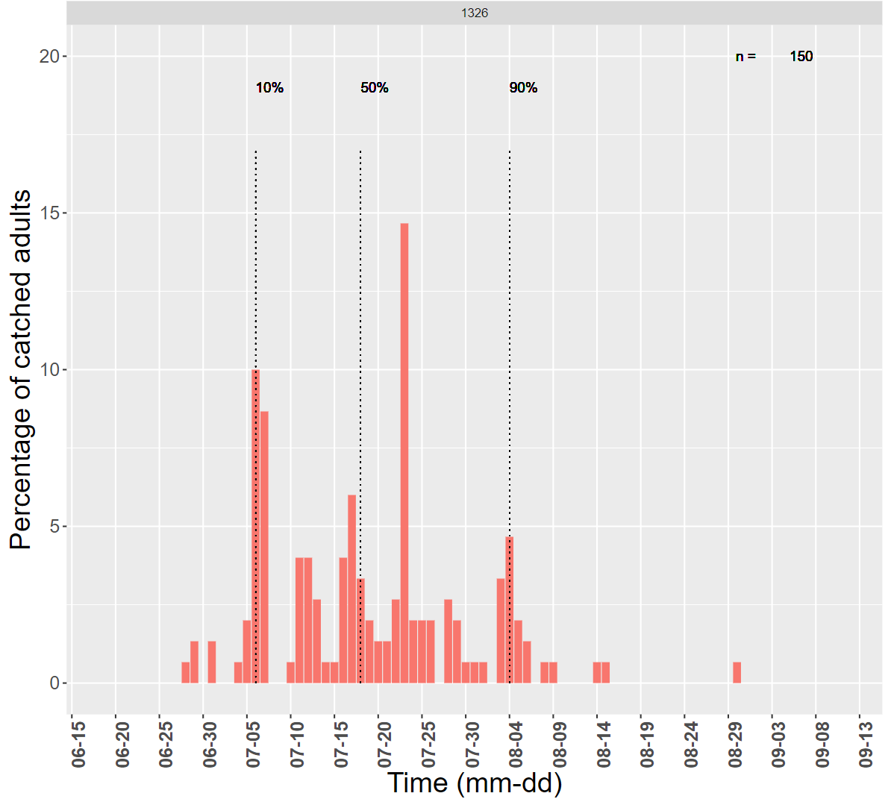

**Supplementary Figure 1.** Flight curve of Orléans population in 2019. Dashed lines represent dates with 10, 50 and 90% of cumulated adult catches. *n* isthe total number of catches.

**Supplementary Protocol 1.** Number of larvae counted per tent and stage determination.

To determine how many larvae should be counted to have a good estimation of proportion of each stage present in tent, 18 tents were opened, all larvae were counted and their life stage identified. To find at which stage larvae are, head capsule width, body colour and number of setae were observed and compared to a referential (larvae per stage in different alcohol tubes) and literature data [1]. Calculations were made on R version 3.5.0 [2]. Firstly, the probability of each stage occurrence was calculated. Secondly, a random draw of counted larvae was simulated with *i*, the number of larvae counted. *i* varied between 15 to 105 by 15. A binomial law was applied to simulate the proportion of each stage for every *i* with the probability calculated before. Thirdly, the variance of stage proportion was calculated for every *i*. The variance as a function of *i* was graphically represented and slope between *i* values was determined (15-30, 30-45, 45-60, 60-75 and 75-90). Fourthly, graphic of slope according to *i* was made and permitted to determine the value of slope from which the variance, in each tent, is the lowest. Fifth, determination of i value that corresponded to the maximum percentage of opened tents with a slope superior to the threshold. Finally, after the comparison between each stage, we found a threshold of 1e-4 and *i* = 60 larvae.

1. Martin J-C (2005) La processionnaire du pin *Thaumetopoea pityocampa*, biologie et protection des forêts. 62

2. R Core Team (2018). R: A language and environment for statistical computing. R Foundation for Statistical Computing, Vienna, Austria. Available online at https://www.R-project.org/.

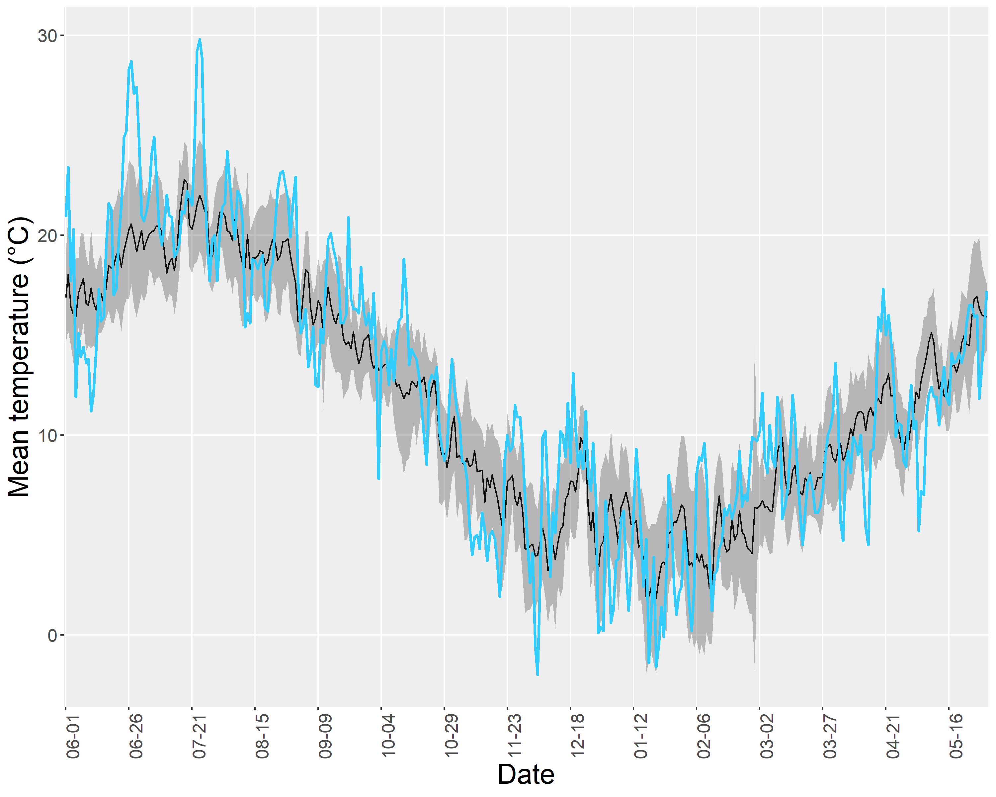

**Supplementary Figure 2.** Daily mean temperature recorded in Orléans in 2019 compared to 2012-2020 average with 95% range. Daily mean temperature in 2019 (blue line) and 2012-2020 average (black line) with 95% range (grey area).

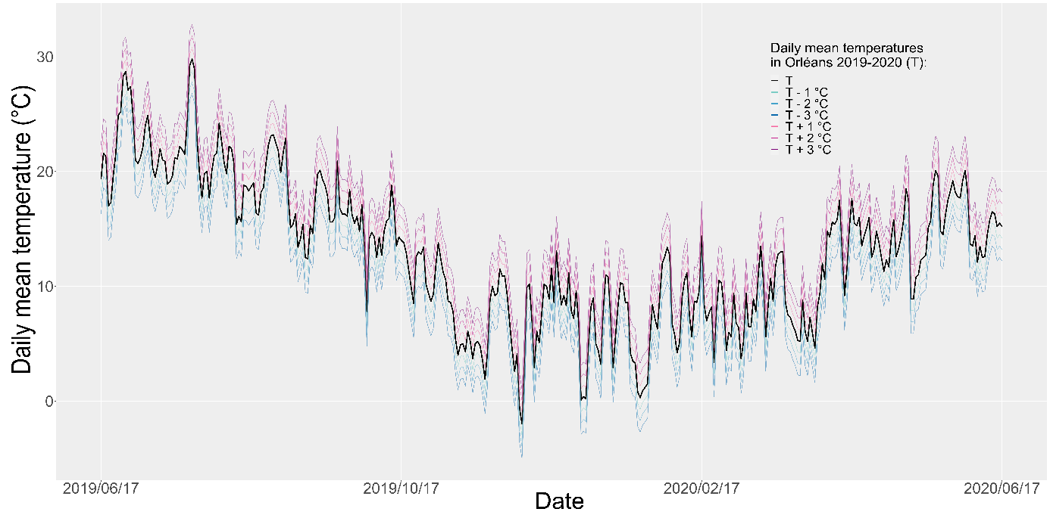

**Supplementary Figure 3.** Simulated change in Orléans daily mean temperature.

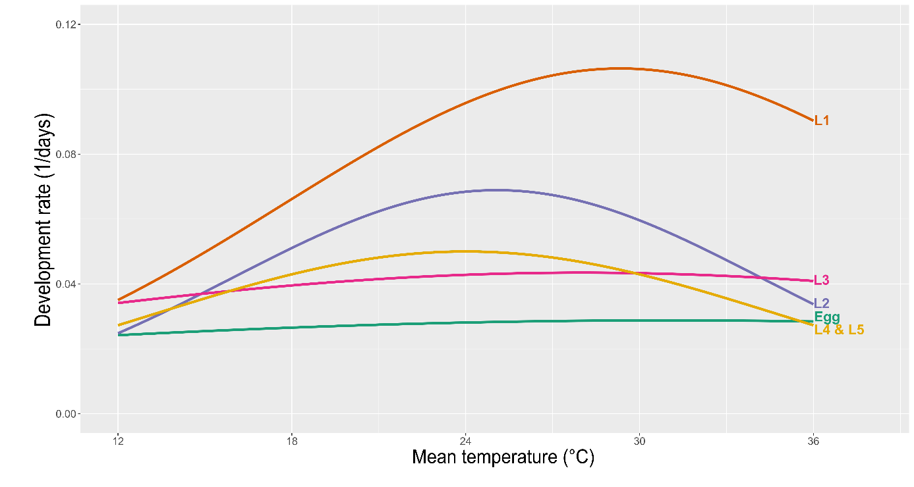

**Supplementary Figure 4.** Thermal performance curves obtained with Taylor‘s equation from egg to the last larval stage

**Supplementary Table 1.** Difference between predicted and observed percentage of individuals

|  |  |  |  |  |
| --- | --- | --- | --- | --- |
| Date | Stage | Predicted percentage | Observed percentage | Absolute difference |
| 02/10/2019 | Egg | 0.65789474 | NA | NA |
| 29/10/2019 | Egg | 0 | NA | NA |
| 18/11/2019 | Egg | 0 | NA | NA |
| 02/12/2019 | Egg | 0 | NA | NA |
| 16/12/2019 | Egg | 0 | NA | NA |
| 03/01/2020 | Egg | 0 | NA | NA |
| 16/01/2020 | Egg | 0 | NA | NA |
| 04/02/2020 | Egg | 0 | NA | NA |
| 02/10/2019 | L1 | 3.94736842 | 0 | 3.94736842 |
| 29/10/2019 | L1 | 0.64102564 | 0 | 0.64102564 |
| 18/11/2019 | L1 | 0 | 0.96618358 | 0.96618358 |
| 02/12/2019 | L1 | 0 | 0 | 0 |
| 16/12/2019 | L1 | 0 | 0 | 0 |
| 03/01/2020 | L1 | 0 | 0 | 0 |
| 16/01/2020 | L1 | 0 | 0 | 0 |
| 04/02/2020 | L1 | 0 | 0 | 0 |
| 02/10/2019 | L2 | 48.6842105 | 3 | 45.6842105 |
| 29/10/2019 | L2 | 13.4615385 | 0 | 13.4615385 |
| 18/11/2019 | L2 | 3.31125828 | 0 | 3.31125828 |
| 02/12/2019 | L2 | 1.98675497 | 0 | 1.98675497 |
| 16/12/2019 | L2 | 2 | 0 | 2 |
| 03/01/2020 | L2 | 0.66666667 | 0 | 0.66666667 |
| 16/01/2020 | L2 | 0.64935065 | 0 | 0.64935065 |
| 04/02/2020 | L2 | 0.68493151 | 0 | 0.68493151 |
| 02/10/2019 | L3 | 46.7105263 | 88.3333333 | 41.622807 |
| 29/10/2019 | L3 | 46.1538462 | 11.0780781 | 35.0757681 |
| 18/11/2019 | L3 | 19.8675497 | 2.11111111 | 17.7564386 |
| 02/12/2019 | L3 | 13.2450331 | 0.71428571 | 12.5307474 |
| 16/12/2019 | L3 | 1.33333333 | 3.33333333 | 2 |
| 03/01/2020 | L3 | 1.33333333 | 0 | 1.33333333 |
| 16/01/2020 | L3 | 1.2987013 | 0 | 1.2987013 |
| 04/02/2020 | L3 | 0.68493151 | 0 | 0.68493151 |
| 02/10/2019 | L4 | 0 | 8.66666667 | 8.66666667 |
| 29/10/2019 | L4 | 39.7435897 | 81.8108108 | 42.0672211 |
| 18/11/2019 | L4 | 76.1589404 | 96.7919864 | 20.633046 |
| 02/12/2019 | L4 | 81.4569536 | 93.2502838 | 11.7933302 |
| 16/12/2019 | L4 | 72 | 85.981855 | 13.981855 |
| 03/01/2020 | L4 | 50.6666667 | 96.3857442 | 45.7190776 |
| 16/01/2020 | L4 | 41.5584416 | 78.194626 | 36.6361844 |
| 04/02/2020 | L4 | 15.0684932 | 46.5451852 | 31.476692 |
| 02/10/2019 | L5 | 0 | 0 | 0 |
| 29/10/2019 | L5 | 0 | 7.11111111 | 7.11111111 |
| 18/11/2019 | L5 | 0.66225166 | 0.13071895 | 0.5315327 |
| 02/12/2019 | L5 | 3.31125828 | 6.03543045 | 2.72417217 |
| 16/12/2019 | L5 | 24.6666667 | 10.6848117 | 13.981855 |
| 03/01/2020 | L5 | 47.3333333 | 3.61425577 | 43.7190776 |
| 16/01/2020 | L5 | 56.4935065 | 21.805374 | 34.6881325 |
| 04/02/2020 | L5 | 83.5616438 | 53.4548148 | 30.106829 |

**Supplementary Supporting information 1.** Sensitivity and uncertainty analyses.A sensitivity analysis was made to determine which parameters have the most influence on the model outputs. The effect of an increase and a decrease of 10% of *Rm*, *Tm* and *To* on predicted mean duration of every instars was calculated:

|  |  |  |  |  |  |
| --- | --- | --- | --- | --- | --- |
|  | **Initial Value (IV)** | **IV + 10%** | **IV - 10%** | **Mean duration variation with IV + 10% in days** | **Mean duration variation with IV - 10% in days** |
| **EGG** |  |  |  |  |  |
| **Rm** | 0.0288 | 0.0317 | 0.0259 | - 3 | 4 |
| **Tm** | 30.9852 | 34.0838 | 27.8868 | 2 | - 1 |
| **To** | 32.3145 | 35.5460 | 29.0831 | 0 | 1 |
| **L1** |  |  |  |  |  |
| **Rm** | 0.1064 | 0.1170 | 0.09576 | - 2 | 3 |
| **Tm** | 29.3348 | 32.2683 | 26.40132 | 6 | - 3 |
| **To** | 11.6322 | 12.7954 | 10.46898 | - 1 | 2 |
| **L2** |  |  |  |  |  |
| **Rm** | 0.0689 | 0.0758 | 0.0620 | - 4 | 9 |
| **Tm** | 25.0753 | 27.5828 | 22.5678 | 31 | - 7 |
| **To** | 11.6322 | 10.0613 | 8.2320 | - 3 | 10 |
| **L3** |  |  |  |  |  |
| **Rm** | 0.0435 | 0.0479 | 0.0391 | - 4 | 6 |
| **To** | 28 | 30.8 | 25.2 | 7 | - 3 |
| **Tm** | 23 | 25.3 | 20.7 | - 2 | 4 |
| **L4** |  |  |  |  |  |
| **Rm** | 0.05 | 0.055 | 0.045 | - 11 | 9 |
| **Tm** | 24 | 26.4 | 21.6 | 20 | - 19 |
| **To** | 10.9 | 11.99 | 9.81 | - 10 | 17 |
| **L5** |  |  |  |  |  |
| **Rm** | 0.05 | 0.055 | 0.045 | - 2 | - 2 |
| **Tm** | 24 | 26.4 | 21.6 | - 7 | - 12 |
| **To** | 10.9 | 11.99 | 9.81 | - 7 | 2 |

Sensitivity analysis results showed that *Rm* and *Tm* were parameters with the most influence on predicted mean duration of stages. An uncertainty analysis was realized to observe the model behaviour at the confidence interval (CI) range of those parameters. CI range were obtained with *devRatePrint* function. The uncertainty analyses was made from egg to L2:

|  |  |  |  |  |  |
| --- | --- | --- | --- | --- | --- |
|  | **Initial Value (IV)** | **CI 2.5%** | **CI 97.5%** | **Mean duration variation with CI 2.5% in days** | **Mean duration variation with CI 97.5% in days** |
| **EGG** |  |  |  |  |  |
| **Rm** | 0.0289 | 0.0277 | 0.0299 | 2 | -1 |
| **Tm** | 30.9852 | 11.1854 | 50.7850 | 0 | 19 |
| **L1** |  |  |  |  |  |
| **Rm** | 0.1064 | 0.0997 | 0.1130 | 1 | -1 |
| **Tm** | 29.3348 | 26.9485 | 31.7210 | -3 | 11 |
| **L2** |  |  |  |  |  |
| **Rm** | 0.0689 | 0.0644 | 0.0734 | 5 | -2 |
| **Tm** | 25.0753 | 24.1385 | 26.0120 | -4 | 40 |