## Supplementary Figure 2

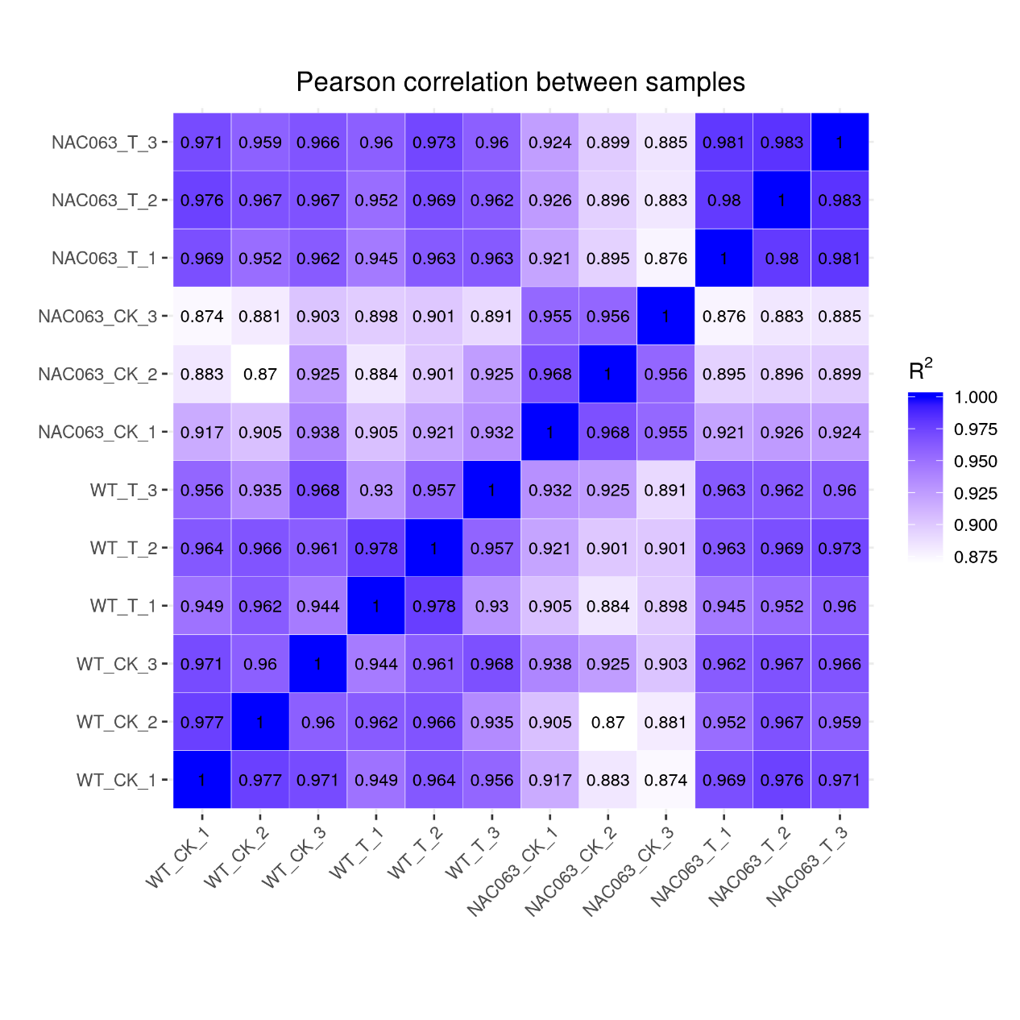

**Supplementary Figure 2.** The correlations of RNA-sequencing biological replicates of WT and *nac063* mutant.