Supplementary Material

**Potential impact on climate and humans**

The potential release of significant amounts of sulfur gases during the YTT supereruption and subsequent sulfate aerosol loading has been putatively associated with a major global climatic downturn (volcanic winter)(Ambrose, 1998). The latter has been also controversially associated with a human population bottleneck and dispersion occurring between *ca*. 100-50 ka BP (Ambrose, 1998). Geological, archeological, and ecological records in southeastern Africa seemingly show no evidence of abrupt climate and population disruption following the YTT supereruption (Jackson et al., 2015; Lane et al., 2013; Smith et al., 2018; Yost et al., 2018). Several genetic analyses have also failed to detect a human bottleneck coeval to the YTT eruption but rather have restricted this event at *ca*. 50 ka (Yost et al., 2018 and references therein). In addition, there is no clear evidence of a significant impact of the YTT eruption products on the human population in India (Clarkson et al., 2020; Singh and Srivastava, 2022). Nonetheless, these studies may not be entirely representative as they were focused on a region with complex ocean-atmosphere system interactions (Roberts et al., 2013). Moreover, new evidence is tilting the opinion back towards a significant climatic impact of the eruptions suggesting Africa was less affected by climate change in the world at the time following the YTT eruption (Black et al., 2021; Osipov et al., 2021). Although less studied from a climatic point of view, LCY has shown strong potential in forcing climate change, especially by previously unconsidered sulfur coupled to halogen loading to the atmosphere (Brenna et al., 2020; Brenna et al., 2021; Krüger et al., 2015; Kutterolf et al., 2015; Metzner et al., 2014).

**Methods**

To quantify the potential temporal clustering of large volcanic eruptions (>400 km3 bulk volume) we used the Large Magnitude Explosive Volcanic Eruptions database (LaMEVE) (Crosweller et al., 2012). The LaMEVE database provides the best global compilation of aerial volcanic eruption ages and magnitudes during the Quaternary (Brown et al., 2014; Crosweller et al., 2012). We choose a large volume range cutoff (typically corresponding to magnitude (M) >7 eruptions or Volcanic Explosivity Index (VEI) 7–8 eruptions) since the largest eruptions are most likely to be recorded in the geologic record. This conclusion is further supported by the observation that the cumulative number of eruptions through time (Figure 2, 28 eruptions total) has an approximately linear relationship in our dataset. Assuming the eruption rate is effectively time-invariant, strong decreases in the eruption recording probability back in time would show up as a convex non-linearity in this plot (Guttorp and Thompson, 1991; Rougier et al., 2018) and this is observed for less well preserved lower volume eruptions (Papale, 2018; Rougier et al., 2018). Nevertheless, there are some gaps in the LaMEVE eruption record (e.g., between 100–275 kyr, 1275–1500 kyr, Figure 2) which may either be indicative of unrecorded eruptions (more likely though there is no clear relationship with glacial-interglacial periods) or some episodic tectonic process. An analysis of the database biases is beyond the scope of our analysis and we refer the reader to the original LaMEVE papers (Brown et al., 2014; Crosweller et al., 2012) and Deligne et al. (2017) for a detailed discussion. We choose a lower volume threshold of 400 km3 to ensure that we have enough eruptions in the dataset to allow robust statistical analysis. Additionally, this threshold ensures that our dataset is very similar to the VEI-8 category dataset in Papale (2018) analysis of recurrence interval for large eruption dataset. We find that the main results of our analysis are not sensitive to the specific volume threshold and are valid as long as we are only considering large (typically a few hundred km3 bulk tephra volume eruptions).

We assess any temporal eruption clustering using the coefficient of variation (CV): the ratio of the standard deviation and the mean time interval between two successive volcanic eruptions. The CV (also called: relative standard deviation) is a commonly used statistical measure for analyzing the clustering of discrete events in time (e.g., earthquakes)(Hooker et al., 2018). Typically, CV values are close to 1 for randomly distributed data, >1 for clustered eruptions, and <1 for eruptions with a constant inter-eruption recurrence time (Hooker et al., 2018). Since some volcanic eruptions in the LaMEVE have a significantly large age uncertainty, we use a Monte-Carlo method to generate 50,000 different possible eruption histories by sampling from the reported eruption ages and their 1σ uncertainties. Using these eruption histories, we calculated the CV value as well as the mean and median recurrence time between large eruptions (inset Figure 2 and Figure S2). The median value of the CV distribution is ~1.035, indicating an approximately random distribution (Figure S2). Similarly, the median value of the mean time between eruptions is 76.28 kyr which is close to the value expected for a random distribution (28 eruptions in 2.054 Ma) as well as the results from (Papale, 2018) for VEI 8 eruptions (ca. 78 kyr. Finally, although the median value of time between LaMEVE eruptions has a large spread between different possible eruptive histories, the peak of the probability distribution is at ca. 35 kyr (Figure S4).

Since our eruption catalog only has a small number of data points (Nerupt = 28 eruptions) which can bias statistical interpretations, we generated synthetic random eruption sequences with the same number of eruptions and total sequence duration as our catalog. Using the CV values from these synthetic sequences, we find the LaMEVE distribution lies within the 5–95th percentile values for the random distribution (inset Figure 2; Figure S2). Thus, on the scale of the whole dataset, the LaMEVE >400 km3 eruptions do not have any significant non-randomness at the 95% confidence limit. This conclusion is further supported by the clear overlap between the mean time between eruptions for the synthetic random sequences and the LaMEVE dataset. However, some of the statistical properties of the LaMEVE dataset are not fully consistent with a purely random (or Poisson) eruption history. Specifically, the most likely value for the median temporal gap between individual eruptions does not closely match the expectations for random eruption histories (Figure S3-S4). However, based on our analysis of a variety of synthetic eruption histories (e.g., random, periodic, clustered; Figure S3) and their differences concerning the median parameter, we posit that the LaMEVE dataset likely has a few eruption groups. Since our LaMEVE dataset includes the potential YTT-LCY and Huckleberry Ridge Tuff (HRT)-Cerro Galán Ignimbrite (CGI) pairs, this conclusion is not unexpected.

As a test to illustrate that our statistical analysis is robust and compare CV for clustered and periodic eruption scenarios, we generated 50,000 synthetic eruptive histories with either 2/3/4 clustered eruptions or with periodic eruptions. For the clustered eruption cases, we chose the maximum spacing between individual eruption clusters to be 5% (as well as 40% for the 2-cluster case, this is close to a random case) of the mean time between eruption clusters. Individual eruptive histories are generated by first sampling a random eruptive history with Nerupt/2; Nerupt/3; or Nerupt/4 eruptions and then adding the clustered eruption pairs with random spacing between 1 yr and the maximum spacing (e.g., 5% of the spacing between eruption clusters). For the periodic eruption histories, we set Nerupt eruption ages equally spaced over the LaMEVE dataset duration (~2.054 Ma) and assign a 1σ age uncertainty equal to 5% or 30% of the eruption spacing. Then, we generated synthetic histories with the same number of eruptions (Nerupt = 28) as the LaMEVE dataset. As shown in Figure S2, the CV values for these eruptive histories are distinctive from the LaMEVE dataset with CV >1 for clustered eruptions and CV <1 for periodic eruptions as expected. Additionally, a random eruptive history with ~1000 eruptions has a CV ~1 as theoretically expected (Hooker et al., 2018). Among non-random histories, the closest match with the observed CV values is the 2-cluster case with maximum spacing between individual eruption clusters equal to 40% of the mean inter-cluster temporal spacing. We find the same qualitative result when comparing the median time between eruptions (Figure S3) where the random and 2-cluster (with 40% variation) is the closest match to the observations. Since the presence of very closely spaced eruption clusters decreases the median time between eruptions (see Figure S3), we posit that the most parsimonious explanation for the LaMEVE dataset is that it represents a combination of mostly randomly distributed eruptions along with a few closely spaced pairs (e.g., YTT-LCY, HRT-CGI). Given the significant uncertainties in eruption ages for many eruptions in the LaMEVE catalog as well as open questions regarding catalog completeness, it is challenging to presently make any stronger conclusions regarding eruption clustering of large volcanic eruptions.

Finally, we estimate how closely spaced two eruptions can be in a Nerupt (=28) random eruptive history. We also assign a bulk eruption volume to every volcanic eruption in each random eruptive history by randomly shuffling the volumes of the eruptions in our LaMEVE dataset. Thus, by construction, the probability density of eruption volumes in each synthetic history is the same as the observed dataset. We would note herein that we have assumed that there is no correlation between eruption volumes and when they erupt. Although this may not be exactly true in practice, this assumption provides a clear statistical end-member to compare against the observations. We use a similar methodology to assign a spatial location for each synthetic eruption by randomly shuffling the locations of our LaMEVE eruptions. Among the 50,000 synthetic histories, we find 2%, 10.15%, 16.392%, and 20% histories with a minimum time between two eruptions being < 80 years, 80–400, 400–1000, and 1000–2000 years, respectively (Fig. S5). However, if we also consider the volume of these eruption pairs, the joint probability of two eruptions spaced between 80 to 400 years and having ≥1000 km3 volumes are much lower (Fig. S6). Finally, we can consider a constraint that a close-in-time (80-400 yr) supereruption pair must have a small distance (<3,000 km) between the antipodal location of the first eruption in the pair and the location of the second eruption. This is motivated by the small similar distance between YTT-LCY (~2,200 km). With this additional constraint, the total probability is even lower (Figure S7). The probability is still less than 2% even if we use a homogeneous Poisson process (e.g., Papale, 2018) as the model for eruption temporal distribution instead of a random distribution.

In conclusion, for a randomly distributed eruption sequence, it is unlikely to observe close eruption pairs like YTT and LCY. As a final note, we acknowledge that our statistical results are weakly dependent on the choice of the underlying statistical model for eruption spacing (Papale, 2018; Rougier et al., 2018; Wang et al., 2020). For instance, a common model for eruption return times is the homogeneous Poisson process with exponential distribution of return times naturally leading to some long-time gaps (Papale et al., 1998). With this model, they find a very similar result for the mean recurrence time between eruptions (ca. 78 kyr) as our results as well as the probability of having a YTT-LCY eruption pair. It is noteworthy that Rougier *et al.* (2018), also using the LaMEVE database, but only for the last 100 kyr eruptions, find a much shorter (ca. 17 ka) recurrence time between M8 eruptions with their statistical model compared to other analyses. They argue for systematic biases in the volume estimates of very large explosive eruptions due to spatially widely distributed deposits for older eruptions. This illustrates that ultimately the accuracy of our conclusions is dependent on the veracity of the geologic constraints for large eruptions especially the accuracy of volume values reported in the LaMEVE database and the confidence in database completeness. To assess how a higher eruption recurrence rate (as argued by Rougier *et al.* (2018)) may affect our results, we repeated the statistical analysis with only eruptions in the last 100 kyr (n = 6 eruptions). Given the smaller number of eruptions, the statistical results for CV are less clear with a larger possible range from synthetic eruption histories. Nevertheless, CV from the 100 kyr LaMEVE dataset is consistent with random eruption distribution as a whole. Additionally, the likelihood of having two eruptions between 80 to 400 years and each having greater than 1000 km3 bulk tephra volume is still less than 5% (Fig. S6).

Overall, our results advanced previous work in showing that presently, there is no strong evidence for eruption clustering for >400 km3 bulk tephra volume eruptions in the LaMEVE database as a whole. Instead, the dataset identifies randomly distributed eruptions within only a few double eruption couplets. This result further highlights that the YTT-LCY eruption doublet is a unique circumstance.

Finally, we plotted published glass shards major and trace-element data for YTT and LCY (Cisneros de León et al., 2021; Pearce et al., 2020) in order to test whether both supereruptions can be easily discriminated against if tephra was to be found in ice-core records, which could provide the highest precision in age difference (Figure S9).

**Understanding the climate impacts of YTT and LCY supereruptions**

Synchronous large eruptions have been suggested before for the Altiplano Puna Volcanic Complex of the Andes and the Taupo Volcanic Zone of New Zealand (de Silva et al., 2006; Gravley et al., 2007), however, these are from coeval regional magmatic systems that reasonably could be expected to be linked because of their spatial proximity and thermomechanical connectivity. Other potential examples of synchroneity on a global scale may be represented by the Huckleberry Ridge Tuff (HRT) in the USA (2.0794 ± 0.0046 Ma; Rivera et al., 2014) and Cerro Galán Ignimbrite (CGI) in Chile (2.08 ± 0.02 Ma; Kay et al., 2011), but these lack the age precision to accurately constrain relative ages on a sub-kyr scale. They also lack the near antipodal positioning that stands out as a unique and compelling feature of the YTT-LCY connection (Figure 3).

Since both YTT and LCY eruptions are equatorial, the expected regional pattern of surface temperature and precipitation would be fairly similar. Several global climate model studies for YTT and LCY (Black et al., 2021; Brenna et al., 2020; Brenna et al., 2021; Osipov et al., 2021; Timmreck et al., 2012) show that the most severe climate impacts are in the Northern Hemisphere - North America, Europe, and Asia (excluding parts of the Indian and Arabian sub-continent) while the Southern Hemisphere and parts of the equatorial regions have reduced effects (partially due to reduced aerosol forcing and a larger ocean/land fraction). Thus, broadly, model results agree that the effects from LCY and YTT would be synergistic and the impact (or lack thereof) of the synchronous supereruptions on human populations needs additional work.

In a supereruption doublet scenario, the effects on climate are likely strongly dictated by the timelapse between eruptions. In particular, the short-term effects from the associated sulfur and halogens outputs (e.g., cooling, precipitation change). According to model results, the effects of these gases on climate will persist for a few decades after the eruption (e.g., Black et al., 2021; Brenna et al., 2020; Brenna et al., 2021; Osipov et al., 2021; Timmreck et al., 2012). Thus, even at the potential shortest time interval of ~87 years between YTT and LCY events, the direct effects are likely to be minimal. However, we envision two potential circumstances where a supereruption doublet can have a compounded effect. Ecological and societal impact of large volcanic perturbation as the result of sulfur and halogen release (lasting up to a decade) can be in the order of hundreds to a few thousand years (the exact timescale depends on the specific ecosystem affected). Thus, the natural environment impacted by the first supereruption may have been in a transient recovering state before the next supereruption started. Second, the response of ocean circulation to large eruptions can play an important role since ocean perturbations persist for hundreds to thousands of years given estimated timescales for whole-ocean overturn (Rousselet et al., 2021). Therefore, supereruptions a few hundred years apart can potentially have a synergistic effect modulated through atmosphere-ocean dynamics. However, the specific unfolding of such a scenario, and the resulting non-linear feedbacks are poorly understood since the majority of existing work has focused on analyzing the decadal-scale atmospheric effects of large eruptions. Overall, we expect that a few thousand years is a reasonable estimate for the maximum age difference between eruptions to trigger synergistic climate effects. Future work on global climate model calculations will be very useful in assessing the full combined effect of the LCY and YTT eruptions, especially with regards to long-term changes in ocean circulation and deep ocean temperatures as well as a relationship with GS-20 (Baldini et al., 2015).

**Supplementary Figure 1.** Correlation of sulfur isotope compositions (Δ33S) from ice core layers containing the sulfate anomalies that are potentially associated with YTT and LCY with records of oxygen (NGRIP) and sulfate from the NGRIP, EPICA Dronning Maud Land (EDML, Antarctica), and EPICA dome C (EDC, Antarctica) bipolar ice core records. Modified from Crick et al. (2021) and Svensson et al. (2013).

**Supplementary Figure 2.** Coefficient of variation (CV) Monte Carlo synthetic results. Analysis of the Coefficient of Variation for 50,000 synthetic eruptive histories with different statistical models - random, clustered, and periodic. We also plot the results from the LaMEVE dataset for comparison.

**Supplementary Figure 3.** Median value for the time between eruptions. Analysis of the median value of the time between individual eruptions for 50,000 synthetic eruptive histories with different statistical models - random, clustered, and periodic. We also plot the results from the LaMEVE dataset for comparison.

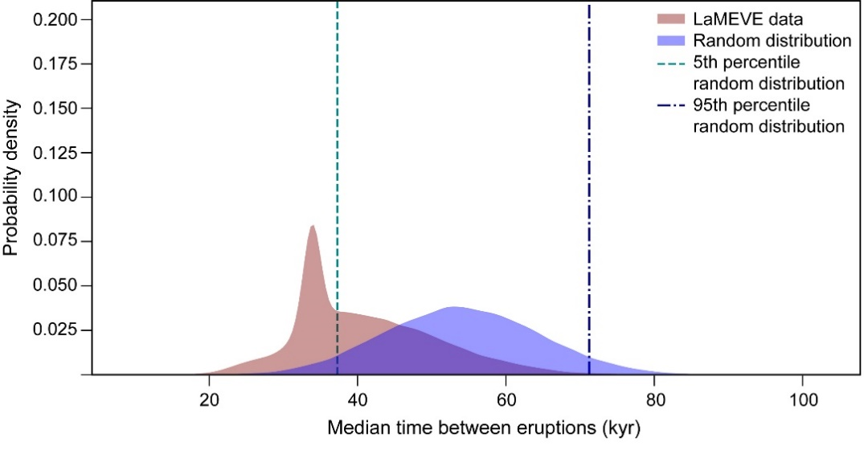

**Supplementary Figure 4.** Median time between eruptions (Monte Carlo results). Analysis of the Median value of the time between individual eruptions for the LaMEVE dataset and 50,000 synthetic eruptive histories wherein the eruptions (28 eruptions, same as LaMEVE dataset) are randomly distributed in time.

**Supplementary Figure 5.** Histogram of minimum time between subsequent eruptions for 50,000 synthetic eruptions histories assuming that eruptions are randomly distributed. The numbers on each histogram show the percentage probability of being in that bin based on the synthetic eruptive histories. We would note that here we are only considering the time between eruptions and not the volumes of each eruption which provides additional constraints on the likelihood of a large volume YTT-LCY pair.

**Supplementary Figure 6.** Histogram showing how many eruption histories (among 50,000 synthetic eruptions histories assuming that eruptions are randomly distributed) have two eruptions within 80-400 years and bulk tephra volumes ≥1000 km3 (supereruption). In contrast to inset in Fig. 2, we only use the eruption frequency estimates from eruptions over the past 100 kyr. A supereruption pair like YTT-LCY would be represented by the ‘2’ bin. On the other hand, if only one of the two closely spaced eruptions is a supereruption, it would be represented by the ‘1’ bin. The numbers on each histogram show the percentage probability of being in that bin based on the synthetic eruptive histories.

**Supplementary Figure 7.** Histogram showing number of eruption histories (among 50,000 synthetic eruptions histories assuming that eruptions are randomly distributed) that have two supereruptions within 80-400 years and a spatial relationship <3000 km distance between the antipodal location of the first eruption in the eruption pair and the second eruption's location. The numbers on each histogram show the percentage probability of being in that bin based on the synthetic eruptive histories.

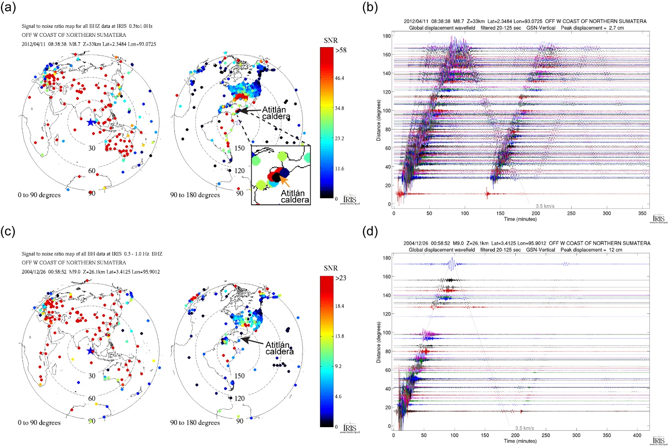

**Supplementary Figure 8.** Signal to noise ratios maps (showing station locations) from earthquakes generated at Sumatra and associated global displacement vertical displacement wavefield filtered between 20-125 seconds. (a,b) Data for an earthquake that occurred on 2012/04/11 with a magnitude M8.7. (c,d) Data for an earthquake that occurred on 2004/12/26 of magnitude M9.0.Modified figures fromthe Incorporated Research Institutions for Seismology (IRIS). Both the waveform panels show a clear near antipodal enhancement of displacement with similar observations for the traverse and radial displacement fields. In addition, the wavefield for the M8.7 EQ shows how surface wave interference between closely spaced seismic source (or a long seismic source) modifies the overall waveform structure and duration (potentially affecting its interaction with a magma reservoir).

**Supplementary Figure 9.** Major and trace elements compositions for YTT and LCY glass shards. a) Major element compositions and b) Trace element compositions for YTT and LCY glass shards. YTT data from Pearce *et al.* (2020) and LCY data from Cisneros de León *et al.* (2021).

**References:**

Ambrose, S. H., 1998, Late Pleistocene human population bottlenecks, volcanic winter, and differentiation of modern humans: Journal of Human Evolution, v. 34, no. 6, p. 623-651.

Black, B. A., Lamarque, J.-F., Marsh, D. R., Schmidt, A., and Bardeen, C. G., 2021, Global climate disruption and regional climate shelters after the Toba supereruption: Proceedings of the National Academy of Sciences, v. 118, no. 29.

Brenna, H., Kutterolf, S., Mills, M. J., and Krüger, K., 2020, The potential impacts of a sulfur- and halogen-rich supereruption such as Los Chocoyos on the atmosphere and climate: Atmos. Chem. Phys., v. 20, no. 11, p. 6521-6539.

Brenna, H., Kutterolf, S., Mills, M. J., Niemeier, U., Timmreck, C., and Krüger, K., 2021, Decadal Disruption of the QBO by Tropical Volcanic Supereruptions: Geophysical Research Letters, v. 48, no. 5, p. e2020GL089687.

Brown, S. K., Crosweller, H. S., Sparks, R. S. J., Cottrell, E., Deligne, N. I., Guerrero, N. O., Hobbs, L., Kiyosugi, K., Loughlin, S. C., and Siebert, L., 2014, Characterisation of the Quaternary eruption record: analysis of the Large Magnitude Explosive Volcanic Eruptions (LaMEVE) database: Journal of Applied Volcanology, v. 3, no. 1, p. 1-22.

Cisneros de León, A., Schindlbeck‐Belo, J. C., Kutterolf, S., Danišík, M., Schmitt, A. K., Freundt, A., Pérez, W., Harvey, J. C., Wang, K. L., and Lee, H. Y., 2021, A history of violence: magma incubation, timing and tephra distribution of the Los Chocoyos supereruption (Atitlán Caldera, Guatemala): Journal of Quaternary Science, v. 36, no. 2, p. 169-179.

Clarkson, C., Harris, C., Li, B., Neudorf, C. M., Roberts, R. G., Lane, C., Norman, K., Pal, J., Jones, S., and Shipton, C., 2020, Human occupation of northern India spans the Toba super-eruption~ 74,000 years ago: Nature communications, v. 11, no. 1, p. 1-10.

Crick, L., Burke, A., Hutchison, W., Kohno, M., Moore, K. A., Savarino, J., Doyle, E. A., Mahony, S., Kipfstuhl, S., Rae, J. W. B., Steele, R. C. J., Sparks, R. S. J., and Wolff, E. W., 2021, New insights into the ∼74 ka Toba eruption from sulfur isotopes of polar ice cores: Clim. Past, v. 17, no. 5, p. 2119-2137.

Crosweller, H. S., Arora, B., Brown, S. K., Cottrell, E., Deligne, N. I., Guerrero, N. O., Hobbs, L., Kiyosugi, K., Loughlin, S. C., and Lowndes, J., 2012, Global database on large magnitude explosive volcanic eruptions (LaMEVE): Journal of Applied Volcanology, v. 1, no. 1, p. 1-13.

de Silva, S., Zandt, G., Trumbull, R., Viramonte, J. G., Salas, G., and Jiménez, N., 2006, Large ignimbrite eruptions and volcano-tectonic depressions in the Central Andes: a thermomechanical perspective: Geological Society, London, Special Publications, v. 269, no. 1, p. 47-63.

Deligne, N. I., Sparks, R. S. J., and Brown, S. K., 2017, Report on potential sampling biases in the LaMEVE database of global volcanism: Journal of Applied Volcanology, v. 6, no. 1, p. 1-5.

Gravley, D., Wilson, C., Leonard, G., and Cole, J., 2007, Double trouble: Paired ignimbrite eruptions and collateral subsidence in the Taupo Volcanic Zone, New Zealand: Geological Society of America Bulletin, v. 119, no. 1-2, p. 18-30.

Guttorp, P., and Thompson, M. L., 1991, Estimating second-order parameters of volcanicity from historical data: Journal of the American Statistical Association, v. 86, no. 415, p. 578-583.

Hooker, J., Laubach, S., and Marrett, R., 2018, Microfracture spacing distributions and the evolution of fracture patterns in sandstones: Journal of Structural Geology, v. 108, p. 66-79.

Jackson, L. J., Stone, J. R., Cohen, A. S., and Yost, C. L., 2015, High-resolution paleoecological records from Lake Malawi show no significant cooling associated with the Mount Toba supereruption at ca. 75 ka: Geology, v. 43, no. 9, p. 823-826.

Kay, S. M., Coira, B., Wörner, G., Kay, R. W., and Singer, B. S., 2011, Geochemical, isotopic and single crystal 40 Ar/39 Ar age constraints on the evolution of the Cerro Galán ignimbrites: Bulletin of Volcanology, v. 73, no. 10, p. 1487-1511.

Krüger, K., Kutterolf, S., and Hansteen, T. H., 2015, Halogen release from Plinian eruptions and depletion of stratospheric ozone, *in* Schmidt, A., Fristad, K., and Elkins-Tanton, L., eds., Volcanism and Global Environmental Change: Cambridge, Cambridge University Press, p. 244-259.

Kutterolf, S., Hansteen, T. H., Freundt, A., Wehrmann, H., Appel, K., Krüger, K., and Perez, W., 2015, Bromine and chlorine emissions from Plinian eruptions along the Central American Volcanic Arc: From source to atmosphere: Earth and Planetary Science Letters, v. 429, p. 234-246.

Lane, C. S., Chorn, B. T., and Johnson, T. C., 2013, Ash from the Toba supereruption in Lake Malawi shows no volcanic winter in East Africa at 75 ka: Proceedings of the National Academy of Sciences, v. 110, no. 20, p. 8025-8029.

Metzner, D., Kutterolf, S., Toohey, M., Timmreck, C., Niemeier, U., Freundt, A., and Krüger, K., 2014, Radiative forcing and climate impact resulting from SO2 injections based on a 200,000-year record of Plinian eruptions along the Central American Volcanic Arc: International Journal of Earth Sciences, v. 103, no. 7, p. 2063-2079.

Osipov, S., Stenchikov, G., Tsigaridis, K., LeGrande, A. N., Bauer, S. E., Fnais, M., and Lelieveld, J., 2021, The Toba supervolcano eruption caused severe tropical stratospheric ozone depletion: Communications Earth & Environment, v. 2, no. 1, p. 1-7.

Papale, P., 2018, Global time-size distribution of volcanic eruptions on Earth: Scientific reports, v. 8, no. 1, p. 1-11.

Papale, P., Neri, A., and Macedonio, G., 1998, The role of magma composition and water content in explosive eruptions: 1. Conduit ascent dynamics: Journal of Volcanology and Geothermal Research, v. 87, no. 1-4, p. 75-93.

Pearce, N. J., Westgate, J. A., Gualda, G. A., Gatti, E., and Muhammad, R. F., 2020, Tephra glass chemistry provides storage and discharge details of five magma reservoirs which fed the 75 ka Youngest Toba Tuff eruption, northern Sumatra: Journal of Quaternary Science, v. 35, no. 1-2, p. 256-271.

Rivera, T. A., Schmitz, M. D., Crowley, J. L., and Storey, M., 2014, Rapid magma evolution constrained by zircon petrochronology and 40Ar/39Ar sanidine ages for the Huckleberry Ridge Tuff, Yellowstone, USA: Geology, v. 42, no. 8, p. 643-646.

Roberts, R. G., Storey, M., and Haslam, M., 2013, Toba supereruption: Age and impact on East African ecosystems: Proceedings of the National Academy of Sciences, v. 110, no. 33, p. E3047-E3047.

Rougier, J., Sparks, R. S. J., Cashman, K. V., and Brown, S. K., 2018, The global magnitude–frequency relationship for large explosive volcanic eruptions: Earth and Planetary Science Letters, v. 482, p. 621-629.

Singh, A., and Srivastava, A. K., 2022, Had Youngest Toba Tuff (YTT, ca. 75 ka) eruption really destroyed living media explicitly in entire Southeast Asia or just a theoretical debate? An extensive review of its catastrophic event: Journal of Asian Earth Sciences: X, v. 7, p. 100083.

Smith, E. I., Jacobs, Z., Johnsen, R., Ren, M., Fisher, E. C., Oestmo, S., Wilkins, J., Harris, J. A., Karkanas, P., and Fitch, S., 2018, Humans thrived in South Africa through the Toba eruption about 74,000 years ago: Nature, v. 555, no. 7697, p. 511-515.

Svensson, A., Bigler, M., Blunier, T., Clausen, H. B., Dahl-Jensen, D., Fischer, H., Fujita, S., Goto-Azuma, K., Johnsen, S., and Kawamura, K., 2013, Direct linking of Greenland and Antarctic ice cores at the Toba eruption (74 ka BP): Climate of the Past, v. 9, no. 2, p. 749-766.

Wang, T., Schofield, M., Bebbington, M., and Kiyosugi, K., 2020, Bayesian modelling of marked point processes with incomplete records: volcanic eruptions: Journal of the Royal Statistical Society: Series C (Applied Statistics), v. 69, no. 1, p. 109-130.

Yost, C. L., Jackson, L. J., Stone, J. R., and Cohen, A. S., 2018, Subdecadal phytolith and charcoal records from Lake Malawi, East Africa imply minimal effects on human evolution from the ∼74 ka Toba supereruption: Journal of Human Evolution, v. 116, p. 75-94.