Supplementary Material

This file includes:

* Table S1. Summary of regression lines fit to handling time data in Figure 3.
* Figure S1. Relationship between chain length (µm) and cells chain−1 in the four diatoms.
* Figure S2. Colony abundance and size distribution and ingestion clearance rate from video experiments with copepodites.

Table S1. Summary of regression lines fit to handling time data in Figure 3. Handling time per colony (HT) includes only ingested prey, handling time per cell (HT cell−1) includes both ingestions and rejections. ESD: equivalent spherical diameter. Asterisks indicate significance of the model fit. **: *p* < 0.01, ***: *p* < 0.001.

|  |  |  |
| --- | --- | --- |
| Species | Handling time (ms) | R2 |
| *C. affinis* | HT = 191.2 + 2.9 × Length (µm) | 0.55*** |
| HT cell−1 = 190.6 – 122.4 × log Cells | 0.59*** |
| *T. nordenskioeldii* | HT = 335.9 + 1.1 × Length (µm) | 0.45** |
| HT cell−1 = 195.6 – 142.7 × log Cells | 0.86*** |
| *S. marinoi* | HT = 189.6 + 3.3 × Length (µm) | 0.41*** |
| HT cell−1 = 188.4 – 155.5 × log Cells | 0.75*** |
| *P. globosa* | HT = 131.8 + 7.3 × ESD (µm) | 0.83*** |
| HT cell−1 = 16.8 – 5.8 × log Cells | 0.41*** |

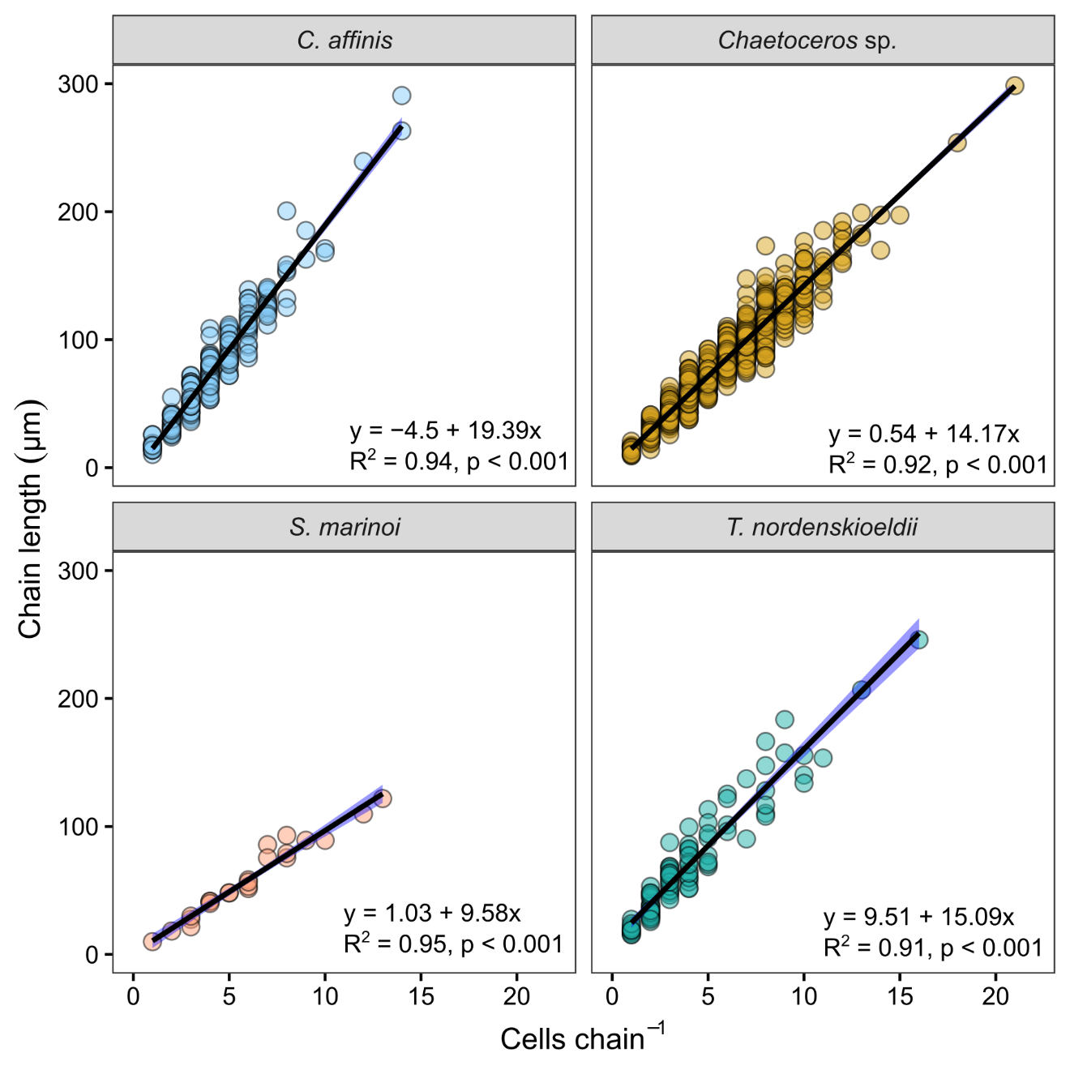

Figure S1. Relationship between chain length (µm) and cells chain−1 in the four diatoms. The shaded blue areas show 95% confidence intervals.

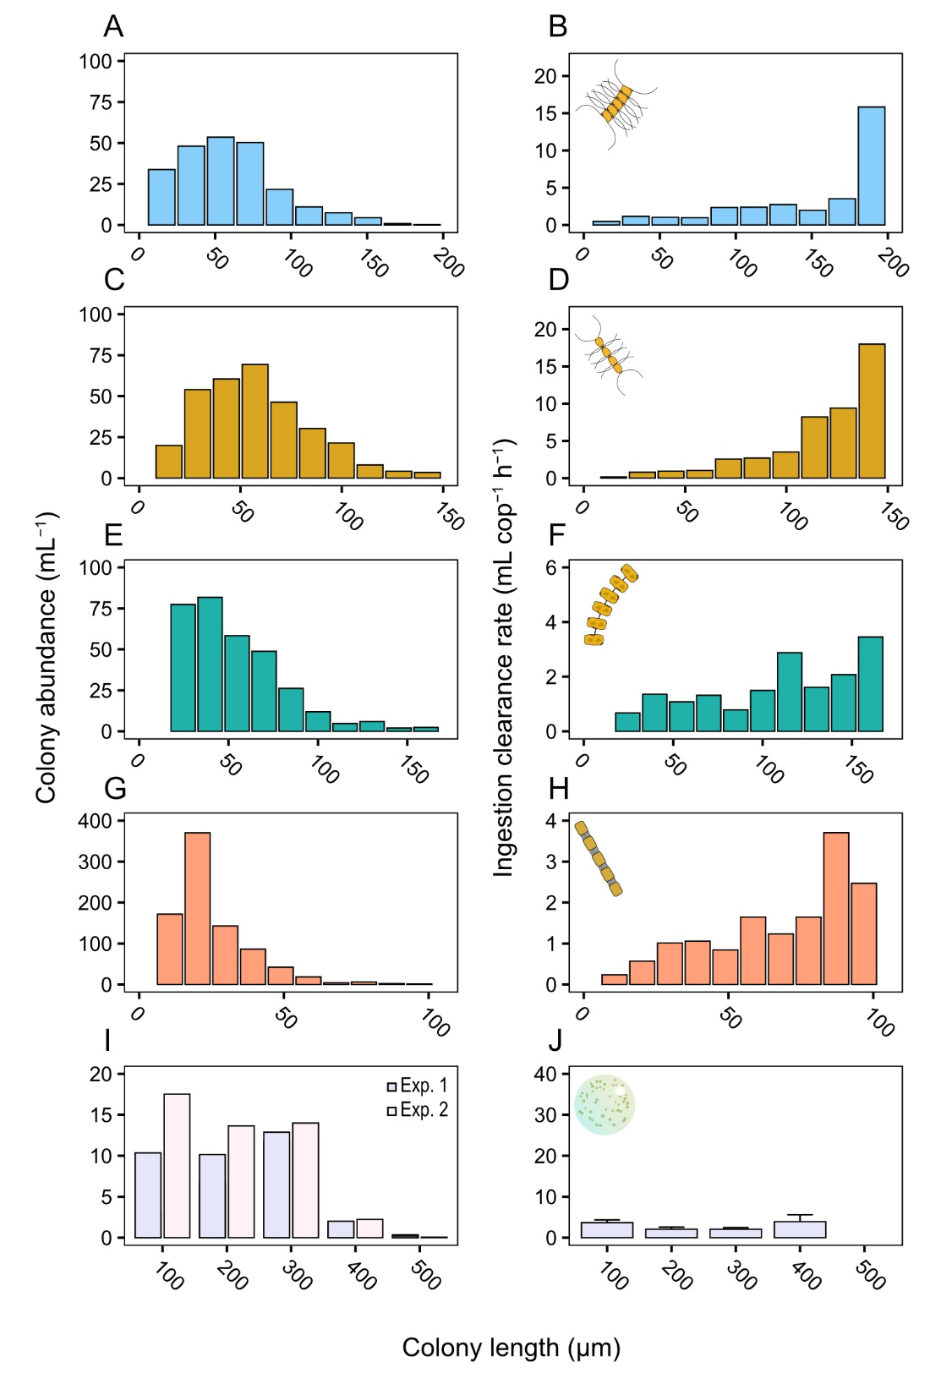

Figure S2. Colony abundance and size distribution of prey suspension in the aquarium (first column), and ingestion clearance rate (second column) from video experiments with copepodites. (A, B) *Chaetoceros affinis*, (C, D) *Chaetoceros* sp., (E, F) *Thalassiosira nordenskioeldii*, (G, H) *Skeletonema marinoi*, and (I, J) *Phaeocystis globosa*. The ingestion clearance rate is equivalent to that measured in bottle-incubation experiments (‘capture’ clearance rate multiplied by the fraction of ingested cells). J shows mean with SD from the two experiments.