Supplementary Material

# Supplementary tables and figures

**Table S1.** Estimated proportion (in percentage) of impervious surface in each 1 km2 plot around the central point of each study site.

|  |  |  |  |  |
| --- | --- | --- | --- | --- |
| **Site**  **Code** | **Site Name** | **Central point Coordinates** | | **Percentage of**  **impervious surface** |
| **Latitude** | **Longitude** |
| U1 | San Francisco | -16.499610 | -68.134536 | 86.25 |
| U2 | Sopocachi | -16.510293 | -68.128126 | 83.75 |
| U3 | Villa Fátima | -16.480889 | -68.120832 | 79 |
| E1 | Auquisamaña | -16.554830 | -68.071654 | 13.25 |
| E2 | Chicani | -16.488089 | -68.081664 | 14.25 |
| E3 | Apaña | -16.546619 | -68.012994 | 12.75 |
| E4 | Palca | -16.567740 | -67.954202 | 12.5 |

**Table S2.** Geographical information of the capture places of the Chiguanco Thrush in urban and extra-urban sites.

|  |  |  |  |  |
| --- | --- | --- | --- | --- |
| **Site Code** | **Site Name** | **Latitude** | **Longitude** | **Altitude** |
| U2 | “Bolivia” Square | -16.506902 | -68.126587 | 3540 |
| U2 | “Montículo” Square | -16.512461 | .68.127184 | 3556 |
| E1 | Auquisamaña | -16.554108 | -68.071603 | 3489 |
| E4 | Palca | -16.564782 | -67.954158 | 3447 |

**Table S3.** Shapiro-Wilk’s normality test values for FID, neophobia and problem-solving abilities data for urban (U) and extra-urban (E-u) Chiguanco Thrush individuals in the city of La Paz. N is the population size.

|  |  |  |  |
| --- | --- | --- | --- |
| **Task** | **Zone** | **N** | **Shapiro-Wilk test of normality (*p*-value)** |
| **Boldness (FID)** |  |  |  |
| Morning | U | 38 | 0.970 (= 0.421) |
|  | E-u | 19 | 0.971 (= 0.132) |
| Afternoon | U | 25 | 0.946 (= 0.205) |
|  | E-u | 21 | 0.983 (= 0.964) |
| **Neophobia** | U | 10 | 0.892 (= 0.179) |
|  | E-u | 10 | 0.960 (= 0.790) |
| **Drawer test** | U | 8 | 0.978 (= 0.942) |
|  | E-u | 5 | 0.984 (= 0.924) |
| **Tunnel test** | U | 4 | 0.988 (= 0.947) |
|  | E-u | 1 |  |

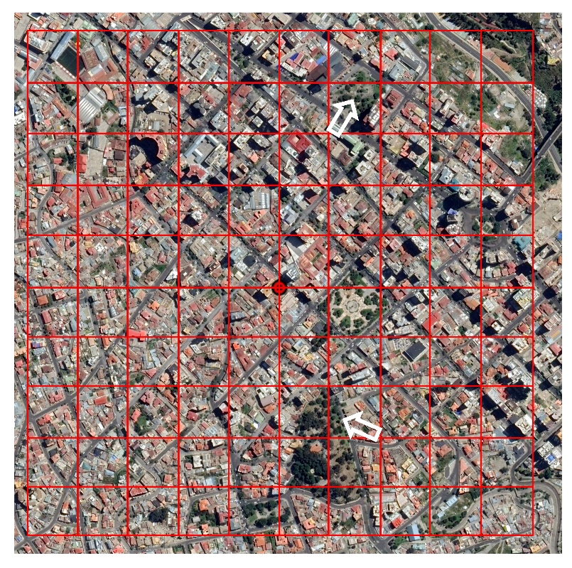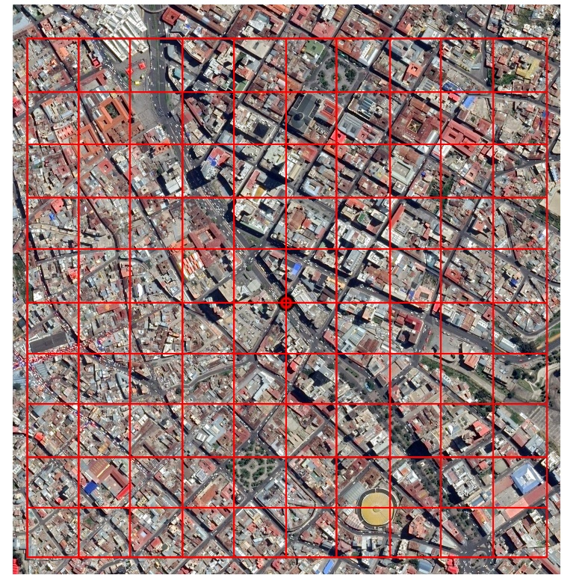

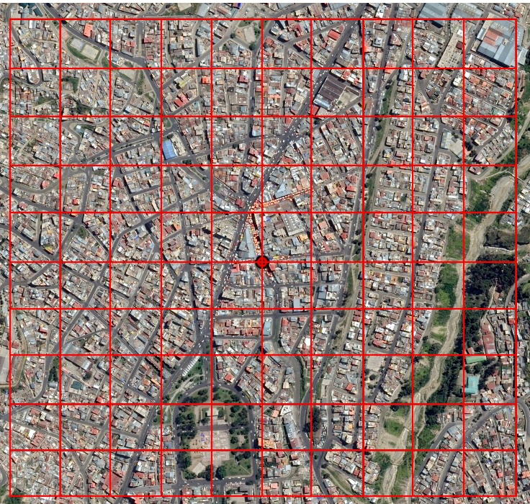

**Figure S1.** Satellite images of the 1 km2 plots for the evaluation of the level of urbanization as the percentage of impervious surface in urban sites. From top to bottom and left to right the sites are U1, U2 and U3. The central points are red dots, the grid of the 100 plots of one hectare is delimited by red lines and the places for the capture of adult individuals are pointed with white arrows. Satellite images from Google Earth Pro 7.3.2, 2019, (04/2014).

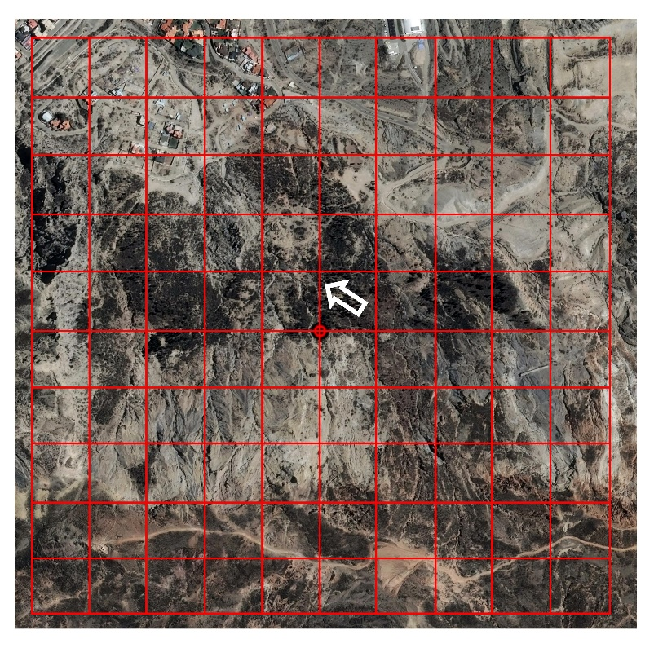

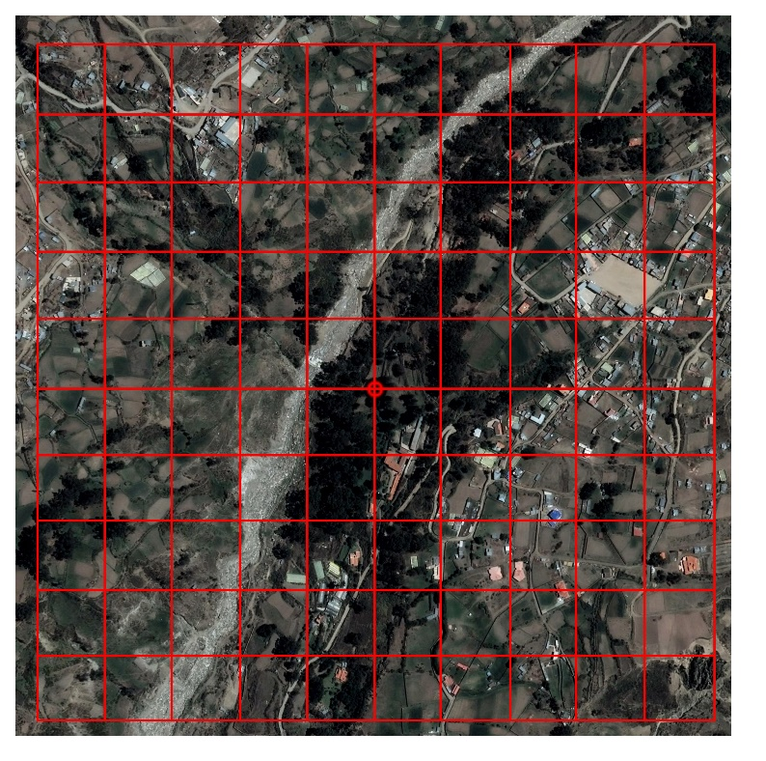

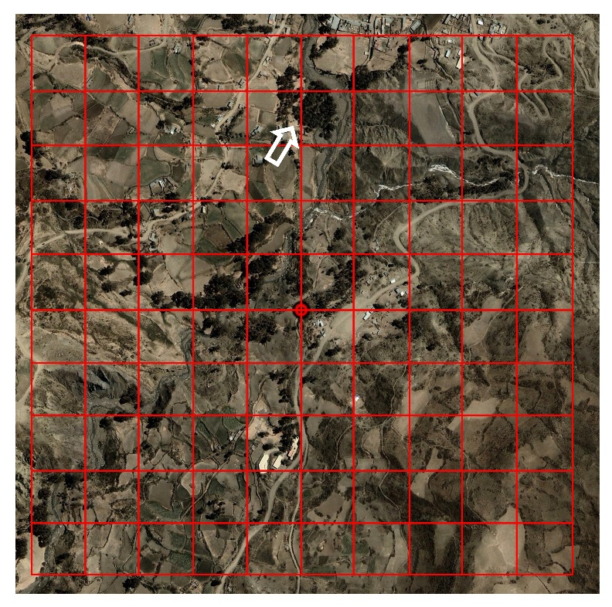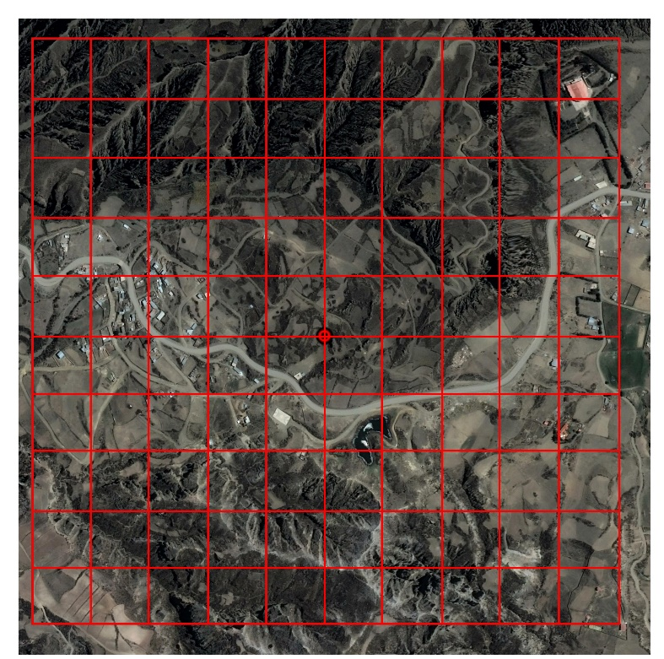

**Figure S2.** Satellite images of the 1 km2 plots for the evaluation of the level of urbanization as the percentage of impervious surface in extra-urban sites. From top to bottom and left to right the sites are E1, E2, E3 and E4. The central points are red dots, the grid of the 100 plots of one hectare is delimited by red lines and the places for the capture of adult individuals are pointed with white arrows. Satellite images from Google Earth Pro 7.3.2, 2019, (04/2014).

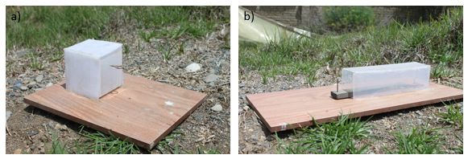

**Figure S3.** The two problem boxes used for the evaluation of the problem-solving abilities of adult Chiguanco Thrush individuals. The “drawer test” (a) was the simplest and the “tunnel test” (b) the most complex.