Supplementary Material

Supplementary Table S1. Patterns of pairwise genetic structure in Leavenworthia exigua. Pairwise FST values are shown above the diagonal, Pairwise Jost’s D values are shown below the diagonal.

|  |  |  |  |  |  |  |  |  |  |  |  |  |  |  |  |  |  |  |  |  |  |  |  |  |  |  |  |
| --- | --- | --- | --- | --- | --- | --- | --- | --- | --- | --- | --- | --- | --- | --- | --- | --- | --- | --- | --- | --- | --- | --- | --- | --- | --- | --- | --- |
| Obs. | lac 262 | lac 263 | lac 264 | lac 265 | lac 266 | lac 267 | lac 268 | lac 269 | lac 270 | lac 271 | lac 272 | lac 273 | lac 274 | lac 275 | lac 276 | lac 277 | lac 278 | lac 279 | Lac 280 | Lac 22A | Lac 35A | exi 01 | exi 02 | exi 03 | exi 04 | exi 05 | exi 06 |
| lac 262 | -- | 0.00 | 0.00 | 0.00 | 0.00 | 0.01 | 0.03 | 0.34 | 0.01 | 0.03 | 0.20 | 0.18 | 0.20 | 0.18 | 0.10 | 0.06 | 0.07 | 0.16 | 0.02 | 0.15 | 0.36 | 0.87 | 0.65 | 0.67 | 0.62 | 0.80 | 0.68 |
| lac 263 | 0.00 | -- | 0.00 | 0.00 | 0.00 | 0.00 | 0.02 | 0.34 | 0.00 | 0.02 | 0.19 | 0.17 | 0.19 | 0.17 | 0.08 | 0.04 | 0.06 | 0.13 | 0.01 | 0.14 | 0.35 | 0.87 | 0.64 | 0.67 | 0.61 | 0.80 | 0.67 |
| lac 264 | 0.00 | 0.00 | -- | 0.00 | 0.01 | 0.02 | 0.04 | 0.35 | 0.02 | 0.04 | 0.21 | 0.19 | 0.22 | 0.19 | 0.12 | 0.08 | 0.08 | 0.19 | 0.03 | 0.17 | 0.37 | 0.87 | 0.65 | 0.67 | 0.62 | 0.80 | 0.68 |
| lac 265 | 0.00 | 0.00 | 0.00 | -- | 0.00 | 0.01 | 0.03 | 0.34 | 0.01 | 0.02 | 0.19 | 0.18 | 0.20 | 0.17 | 0.09 | 0.05 | 0.07 | 0.15 | 0.02 | 0.15 | 0.36 | 0.87 | 0.65 | 0.67 | 0.62 | 0.81 | 0.68 |
| lac 266 | 0.00 | 0.00 | 0.00 | 0.00 | -- | 0.00 | 0.01 | 0.33 | 0.00 | 0.01 | 0.19 | 0.18 | 0.18 | 0.17 | 0.06 | 0.03 | 0.04 | 0.11 | 0.00 | 0.14 | 0.34 | 0.87 | 0.60 | 0.63 | 0.58 | 0.79 | 0.62 |
| lac 267 | 0.00 | 0.00 | 0.00 | 0.00 | 0.00 | -- | 0.01 | 0.33 | 0.00 | 0.01 | 0.18 | 0.17 | 0.17 | 0.17 | 0.05 | 0.02 | 0.04 | 0.10 | 0.00 | 0.13 | 0.34 | 0.87 | 0.61 | 0.65 | 0.59 | 0.79 | 0.64 |
| lac 268 | 0.00 | 0.00 | 0.00 | 0.00 | 0.00 | 0.00 | -- | 0.06 | 0.00 | 0.00 | 0.02 | 0.02 | 0.02 | 0.02 | 0.01 | 0.00 | 0.01 | 0.01 | 0.00 | 0.02 | 0.06 | 0.79 | 0.63 | 0.57 | 0.35 | 0.67 | 0.50 |
| lac 269 | 0.06 | 0.06 | 0.06 | 0.06 | 0.06 | 0.06 | 0.06 | -- | 0.33 | 0.34 | 0.45 | 0.45 | 0.43 | 0.44 | 0.34 | 0.33 | 0.32 | 0.39 | 0.33 | 0.40 | 0.48 | 0.86 | 0.60 | 0.64 | 0.61 | 0.78 | 0.66 |
| lac 270 | 0.00 | 0.00 | 0.00 | 0.00 | 0.00 | 0.00 | 0.00 | 0.06 | -- | 0.01 | 0.17 | 0.17 | 0.18 | 0.17 | 0.06 | 0.03 | 0.05 | 0.10 | 0.00 | 0.13 | 0.34 | 0.87 | 0.64 | 0.67 | 0.62 | 0.80 | 0.67 |
| lac 271 | 0.00 | 0.00 | 0.00 | 0.00 | 0.00 | 0.00 | 0.00 | 0.06 | 0.00 | -- | 0.10 | 0.09 | 0.10 | 0.09 | 0.04 | 0.03 | 0.05 | 0.09 | 0.01 | 0.12 | 0.35 | 0.87 | 0.65 | 0.67 | 0.62 | 0.81 | 0.67 |
| lac 272 | 0.02 | 0.02 | 0.02 | 0.02 | 0.02 | 0.02 | 0.02 | 0.07 | 0.02 | 0.01 | -- | 0.00 | 0.01 | 0.00 | 0.15 | 0.17 | 0.18 | 0.23 | 0.16 | 0.26 | 0.45 | 0.89 | 0.68 | 0.71 | 0.67 | 0.84 | 0.71 |
| lac 273 | 0.02 | 0.02 | 0.02 | 0.02 | 0.02 | 0.02 | 0.02 | 0.07 | 0.02 | 0.01 | 0.00 | -- | 0.02 | 0.00 | 0.16 | 0.18 | 0.18 | 0.25 | 0.16 | 0.27 | 0.45 | 0.89 | 0.68 | 0.70 | 0.67 | 0.83 | 0.71 |
| lac 274 | 0.02 | 0.02 | 0.02 | 0.02 | 0.02 | 0.02 | 0.02 | 0.08 | 0.02 | 0.01 | 0.00 | 0.00 | -- | 0.02 | 0.14 | 0.16 | 0.17 | 0.21 | 0.16 | 0.23 | 0.42 | 0.88 | 0.66 | 0.69 | 0.66 | 0.82 | 0.68 |
| lac 275 | 0.02 | 0.02 | 0.02 | 0.02 | 0.02 | 0.02 | 0.02 | 0.07 | 0.02 | 0.01 | 0.00 | 0.00 | 0.00 | -- | 0.16 | 0.18 | 0.18 | 0.25 | 0.16 | 0.27 | 0.44 | 0.89 | 0.67 | 0.70 | 0.66 | 0.83 | 0.70 |
| lac 276 | 0.01 | 0.01 | 0.01 | 0.01 | 0.01 | 0.01 | 0.01 | 0.06 | 0.01 | 0.00 | 0.01 | 0.02 | 0.02 | 0.02 | -- | 0.00 | 0.05 | 0.02 | 0.04 | 0.10 | 0.27 | 0.86 | 0.61 | 0.67 | 0.59 | 0.79 | 0.63 |
| lac 277 | 0.01 | 0.00 | 0.01 | 0.01 | 0.00 | 0.00 | 0.00 | 0.06 | 0.00 | 0.00 | 0.02 | 0.02 | 0.02 | 0.02 | 0.00 | -- | 0.04 | 0.03 | 0.02 | 0.08 | 0.27 | 0.86 | 0.63 | 0.68 | 0.60 | 0.79 | 0.64 |
| lac 278 | 0.01 | 0.01 | 0.01 | 0.01 | 0.01 | 0.01 | 0.01 | 0.06 | 0.01 | 0.01 | 0.02 | 0.02 | 0.02 | 0.02 | 0.01 | 0.01 | -- | 0.08 | 0.04 | 0.08 | 0.31 | 0.85 | 0.62 | 0.65 | 0.59 | 0.78 | 0.63 |
| lac 279 | 0.02 | 0.01 | 0.02 | 0.02 | 0.01 | 0.01 | 0.01 | 0.07 | 0.01 | 0.01 | 0.02 | 0.02 | 0.02 | 0.03 | 0.00 | 0.00 | 0.01 | -- | 0.07 | 0.10 | 0.32 | 0.87 | 0.65 | 0.69 | 0.63 | 0.81 | 0.67 |
| lac 280 | 0.00 | 0.00 | 0.00 | 0.00 | 0.00 | 0.00 | 0.00 | 0.06 | 0.00 | 0.00 | 0.02 | 0.02 | 0.02 | 0.02 | 0.00 | 0.00 | 0.00 | 0.01 | -- | 0.09 | 0.33 | 0.87 | 0.64 | 0.67 | 0.62 | 0.80 | 0.66 |
| 22A | 0.02 | 0.02 | 0.02 | 0.02 | 0.01 | 0.01 | 0.02 | 0.07 | 0.01 | 0.01 | 0.02 | 0.03 | 0.02 | 0.03 | 0.01 | 0.01 | 0.01 | 0.01 | 0.01 | -- | 0.35 | 0.88 | 0.61 | 0.67 | 0.62 | 0.79 | 0.61 |
| 35A | 0.06 | 0.06 | 0.06 | 0.06 | 0.06 | 0.06 | 0.06 | 0.11 | 0.06 | 0.06 | 0.07 | 0.07 | 0.07 | 0.07 | 0.04 | 0.05 | 0.06 | 0.05 | 0.05 | 0.06 | -- | 0.85 | 0.62 | 0.67 | 0.60 | 0.79 | 0.64 |
| exi 01 | 0.79 | 0.79 | 0.79 | 0.79 | 0.79 | 0.79 | 0.79 | 0.79 | 0.79 | 0.80 | 0.81 | 0.81 | 0.81 | 0.81 | 0.79 | 0.79 | 0.79 | 0.79 | 0.79 | 0.81 | 0.74 | -- | 0.68 | 0.72 | 0.78 | 0.81 | 0.75 |
| exi 02 | 0.63 | 0.63 | 0.63 | 0.63 | 0.63 | 0.63 | 0.63 | 0.63 | 0.63 | 0.64 | 0.66 | 0.66 | 0.66 | 0.66 | 0.63 | 0.63 | 0.62 | 0.63 | 0.63 | 0.63 | 0.62 | 0.77 | -- | 0.12 | 0.45 | 0.36 | 0.32 |
| exi 03 | 0.56 | 0.57 | 0.56 | 0.56 | 0.57 | 0.57 | 0.57 | 0.56 | 0.57 | 0.58 | 0.60 | 0.60 | 0.60 | 0.60 | 0.60 | 0.59 | 0.57 | 0.59 | 0.57 | 0.58 | 0.59 | 0.74 | 0.08 | -- | 0.48 | 0.37 | 0.36 |
| exi 04 | 0.34 | 0.35 | 0.34 | 0.34 | 0.34 | 0.35 | 0.35 | 0.40 | 0.35 | 0.35 | 0.38 | 0.38 | 0.39 | 0.38 | 0.35 | 0.34 | 0.34 | 0.36 | 0.35 | 0.37 | 0.35 | 0.81 | 0.46 | 0.40 | -- | 0.66 | 0.49 |
| exi 05 | 0.65 | 0.66 | 0.65 | 0.65 | 0.66 | 0.66 | 0.67 | 0.66 | 0.66 | 0.67 | 0.69 | 0.69 | 0.69 | 0.69 | 0.68 | 0.67 | 0.66 | 0.69 | 0.66 | 0.68 | 0.67 | 0.78 | 0.27 | 0.20 | 0.57 | -- | 0.52 |
| exi 06 | 0.50 | 0.50 | 0.50 | 0.50 | 0.49 | 0.49 | 0.50 | 0.56 | 0.50 | 0.50 | 0.52 | 0.52 | 0.51 | 0.52 | 0.47 | 0.47 | 0.49 | 0.48 | 0.49 | 0.48 | 0.48 | 0.78 | 0.31 | 0.29 | 0.42 | 0.39 | -- |

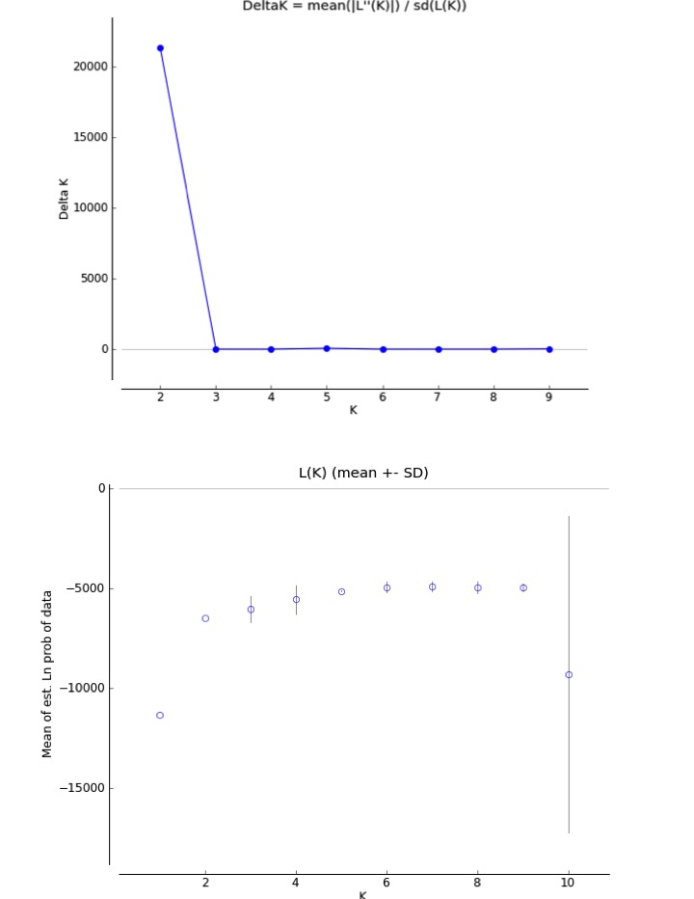

**Supplementary Figure 1.** Estimation of the number of clusters (K) for the STRUCTURE analysis of *Leavenworthia exigua*. (A) K estimation using the Evanno method shows that the optimal value of K =2. (B) K estimation using a graph of the average -ln probability of the data, which also selected K=2 as the optimal value of K