Supplementary Material

**Supplemental Table 1. Sequences of the primers and TaqMan® probes.**

|  |  |  |  |
| --- | --- | --- | --- |
| **Gene (GenBank accession)** | | **Oligonucleotide sequence (5’-3’)** | |
| *CCL2* (NM_002982) | |  |
| Forward | | GCTCATAGCAGCCACCTTCATT |
| Reverse | | TCTGCACTGAGATCTTCCTATTGGT |
| TaqMan® Probe | | FAM-TCGCTCAGCCAGATGCAATCAATGC-TAMRA |
| *COL1A1* (NM_000088.3) | |  | |
| Forward | | CTCCCGGGCCTCAAGGTAT | |
| Reverse | | TTGCTCCAGAGGGACCTTGTT | |
| TaqMan® Probe | | FAM-TCTTCCTGGCCCCTCTGGTGAACCT-TAMRA | |
| *COL4A3* (NM_000091.4) | |  | |
| Forward | | AGTGGATTGCCAGGATTTTCTG | |
| Reverse | | TGGTACACCGACCAGTCCGTAA | |
| TaqMan® Probe | | FAM-CCAGGCACCCCAGGCAATACCG-TAMRA | |
| *COL6A3* (NM_004369.3) | |  | |
| Forward | | GACGGAGATCTGGCTGATTTACA | |
| Reverse | | AGATGCATTAGCCGCTCCAA | |
| TaqMan® Probe | | FAM-AGAACCTCCGCCAAGAAGGAGTCCGT-TAMRA | |
| *CTSG* (NM_000501.4) | |  | |
| Forward | | ATGTTATTGCAGCTGAGCAGAAGA | |
| Reverse | | TCAGTCCCTCCTGGGCTCTAG | |
| TaqMan® Probe | | FAM-TCAGACGGAATCGAAACGTGAACCCA-TAMRA | |
| *ELN* (NM_000501.4) | |  | |
| Forward | | TGGAGGAGTGGCAGCAAGA | |
| Reverse | | CTTCCGGCCACAAGCTTTC | |
| TaqMan® Probe | | FAM-TCGGATTGTCTCCCATTTTCCCAGGT-TAMRA | |
| *HMGB1* (NM_001313893.1) | |  | |
| Forward | | GAAGTTCAAGGATCCCAATGCA | |
| Reverse | | CTCCTTTGATTTTTGGGCGATAC | |
| TaqMan® Probe | | FAM-CTCCTTCGGCCTTCTTCCTCTTCTGCTC-TAMRA | |
| *IL1A* (NM_000575) | |  | |
| Forward | | GTTCTGAAGAAGAGACGGTTGAGTTT | |
| Reverse | | AAGTTGTATTTCACATTGCTCAGGAA | |
| TaqMan® Probe | | FAM-CATCGCCAATGACTCAGAGGAAGAAATCA-TAMRA | |
| *IL1B* (NM_000576) | |  | |
| Forward | | CAGTGGCAATGAGGATGACTTG | |
| Reverse | | GTAGTGGTGGTCGGAGATTCGTA | |
| TaqMan® Probe | | FAM-TGGCCCTAAACAGATGAAGTGCTCCTTCC-TAMRA | |
| *IL6* (NM_000600) | |  | |
| Forward | | GCCCTGAGAAAGGAGACATGTAAC | |
| Reverse | | ATCCATCTTTTTCAGCCATCTTTG | |
| TaqMan® Probe | | FAM-AGGCACTGGCAGAAAACAACCTGAACC-TAMRA | |
| *IL8* (NM_000584.3) | |  | |
| Forward | | ACCTTTCCACCCCAAATTTATCA | |
| Reverse | | TTCTCAGCCCTCTTCAAAAACTTC | |
| TaqMan® Probe | | FAM-CCACACTGCGCCAACACAGAAATTATTGTA-TAMRA | |
| *IL17* (NM_002190) | |  | |
| Forward | | ACAACCGATCCACCTCACCTT | |
| Reverse | | CCTCCCAGATCACAGAGGGATAT | |
| TaqMan® Probe | | FAM-ATCTCCACCGCAATGAGGACCCTGA-TAMRA | |
| *IL32* (NM_001012631) | |  |
| Forward | | GAGACAGTGGCGGCTTATTATGA |
| Reverse | | GGCACCGTAATCCATCTCTTTCT |
| TaqMan® Probe | | FAM-CAGCACCCAGAGCTCACTCCTCTACTTGAA-TAMRA |
| *IL36* (NM_004530) | |  |
| Forward | | TGTGGGACTTCCACGAAGTG |
| Reverse | | CTTGCTCAAGAGCCTCTGGATAC |
| TaqMan® Probe | | FAM-ACCCCAGTCACTGTTGCTGTTATCACATGC-TAMRA |
| *IL36R* (NM_004530) | |  |
| Forward | | AGATTATGGCCTTCCTTTCATGT |
| Reverse | | GGCGATAAGCCCTCCTATCAA |
| TaqMan® Probe | | FAM-GACCTCCCAGCTCCGGA-TAMRA |
| *MMP2* (NM_004530) | |  |
| Forward | | CCATTTTGATGACGATGAGCTATG |
| Reverse | | GTTGTACTCCTTGCCATTGAACAA |
| TaqMan® Probe | | FAM-CTTGGGAGAAGGCCAAGTGGTCCGT-TAMRA |
| *MMP9* (NM_004994) | |  |
| Forward | | GCCCGGACCAAGGATACAGT |
| Reverse | | CCCCTCAGTGAAGCGGTACA |
| TaqMan® Probe | | FAM-ACGCGCTGGGCTTAGATCATTCCTCA-TAMRA |
| *NGAL* (NM_005564) | |  |
| Forward | | CCCAGCCCCACCTCTGA |
| Reverse | | CTTCCCCTGGAATTGGTTGTC |
| TaqMan® Probe | | FAM-CAAGGTCCCTCTGCAGCAGAACTTCCA-TAMRA |
| *S100A9* (NM_002965) | |  |
| Forward | | CTCAAGAAGGAGAATAAGAATGAAAAGG |
| Reverse | | TCAGCTGCTTGTCTGCATTTG |
| TaqMan® Probe | | FAM-CATAGAACACATCATGGAGGACCTGGAC-TAMRA |
| *SPP1* (NM_000582) | |  |
| Forward | | CATCCAGTACCCTGATGCTACAGA |
| Reverse | | GGCCTTGTATGCACCATTCAA |
| TaqMan® Probe | | FAM-ACATCACCTCACACATGGAAAGCGAGGA-TAMRA |
| *TGFB* (NM_000660) | |  |
| Forward | | GCCCAGCATCTGCAAAGC |
| Reverse | | TCCTTGCGGAAGTCAATGTACA |
| TaqMan® Probe | | FAM-CACCAACTATTGCTTCAGCTCCACGGA-TAMRA |
| *TNF* (NM_000594) | |  | |
| Forward | | CCCCAGGGACCTCTCTCTAATC | |
| Reverse | | ACATGGGCTACAGGCTTGTCA | |
| TaqMan® Probe | | FAM-CCTCTGGCCCAGGCAGTCAGATCAT-TAMRA | |
| Mouse *Il36g* (NM_000594) | |  | |
| Forward | | AGGCCCTTGTGACAGTTCCA | |
| Reverse | | AATCCCTTTGTCCTGTTCAAGAGA | |
| TaqMan® Probe | | FAM-AGCCACAGAGTAACCCCAGTCAGCGTG-TAMRA | |

*CCL2*,monocyte chemoattractant protein-1; *COL*,collagen; *CTSG*, cathepsin G; *HMGB1*, high mobility group box 1; *IL*, interleukin; *MMP*, matrix metalloproteinase; *NGAL*, lipocalin 2; S100A9, S100 calcium-binding A9; *SPP1*,osteopontin; *TGFB*, transforming growth factor-; *TNF*, tumor necrosis factor-.

**Supplemental Table 2. Effects of weight loss in obese patients after Roux-en-Y gastric bypass (RYGB).**

|  |  |  |
| --- | --- | --- |
|  | **Before WL** | **After WL** |
| **n (male, female)** | 31 (8, 23) | 31 (8, 23) |
| **Age (years)** | 47  2 | 48  2 |
| **BMI (kg/m2)** | 42.0  1.2 | 29.3  0.8*** |
| **Body fat (%)** | 52.3  1.2 | 35.5  1.7*** |
| **Waist-to-hip ratio** | 0.94  0.02 | 0.88  0.02** |
| **Fasting glucose (mg/dL)** | 104  4 | 86  2** |
| **Fasting insulin (U/mL)** | 20.6  2.7 | 6.9  0.8* |
| **HOMA** | 5.3  0.8 | 1.4  0.2*** |
| **QUICKI** | 0.313  0.008 | 0.377  0.010*** |
| **Triglycerides (mg/dL)** | 127  18 | 100  31*** |
| **Cholesterol (mg/dL)** | 191  7 | 157  7*** |
| **LDL-cholesterol (mg/dL)** | 116  6 | 87  6*** |
| **HDL-cholesterol (mg/dL)** | 49  3 | 54  2* |
| **Leptin (ng/mL)** | 50.6  3.6 | 12.8  1.7*** |

BMI, body mass index; HOMA, homeostatic model assessment; QUICKI, quantitative insulin sensitivity check index; WL, weight loss. Data are mean ± SEM. Differences between groups were analyzed by paired two-tailed Student’s *t* tests. \**P*<0.05, \*\**P*<0.01 and \*\*\**P*<0.001 *vs* before WL.

**Supplemental Table 3. Impact of IL-36 on ECM remodelling genes in visceral adipocytes.**

|  |  |  |  |
| --- | --- | --- | --- |
| **Gene** | **CTL** | **100 ng/mL** | **200 ng/mL** |
| ***COL4A3*** | 1.00  0.14 | 1.01  0.14 | 1.07  0.19 |
| ***COL6A3*** | 1.00  0.11 | 0.67  0.08 | 0.66  0.05 |
| ***ELN*** | 1.00  0.12 | 1.02  0.14 | 1.04  0.12 |
| ***MMP2*** | 1.00  0.10 | 1.30  0.11 | 1.35  0.04 |
| ***MMP9*** | 1.00  0.19 | 1.70  0.08 | 1.69  0.99 |

Analysis of mRNA levels in human visceral adipocytes after IL-36 treatment. Data represent the mean  SEM of the ratio between the gene expressionto *18S* rRNA. Differences between groups were analyzed by one-way ANOVA followed by Dunnett’s *post hoc* test. *COL*, collagen, ECN, extracellular matrix; *ELN*, elastin; MMP, matrix metalloproteinase.

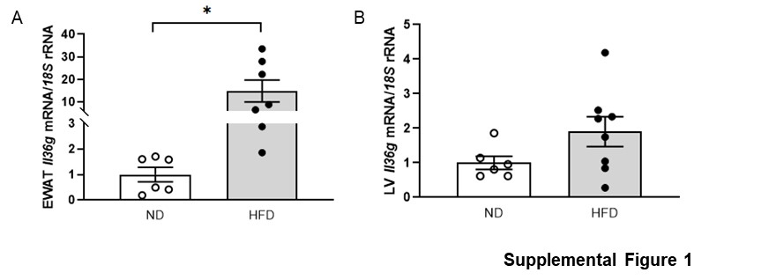

**Supplemental Figure 1**. Gene expression levels of *Il36g* in A) epididymal white adipose tissue (EWAT) and B) liver (LV) from mice submitted to normal (ND) and high-fat (HFD) diet. Bars represent the mean  SEM. Differences between groups were analyzed by unpaired two-tailed Student’s *t* test. \**P*<0.05.

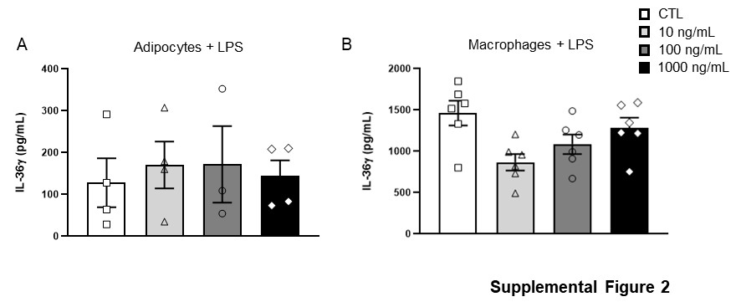

**Supplemental Figure 2.** Secreted levels of IL-36 after LPS treatment in A) human visceral adipocytes and B) monocyte-derived macrophages. Bars represent the mean  SEM. Differences between groups were analyzed by one-way ANOVA followed by Dunnetts’s *post hoc* test.

