**Supporting Information**

**(a)**

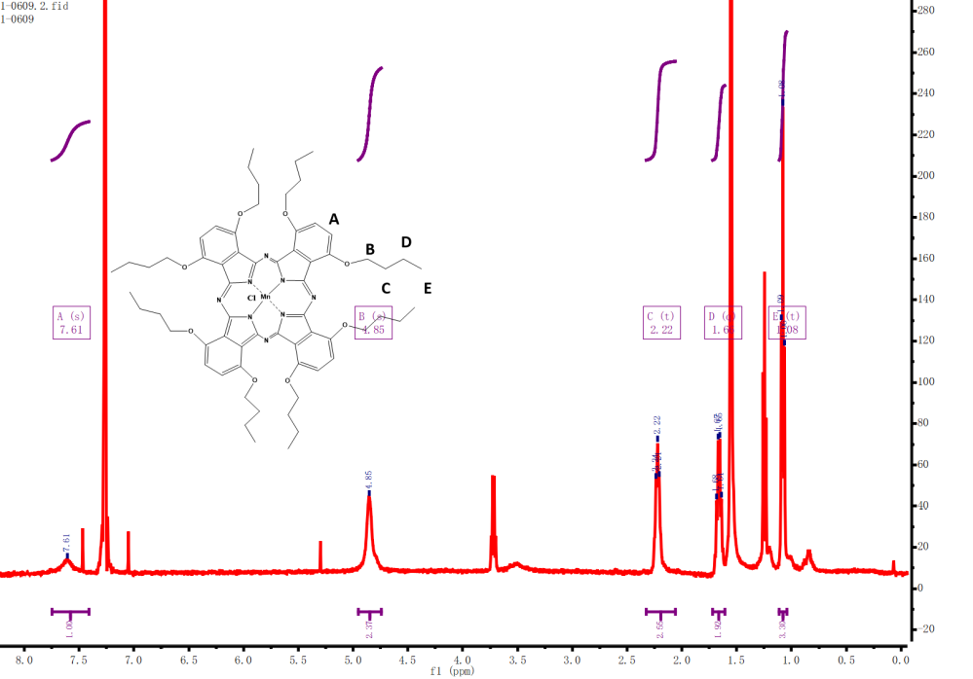

**(b)**

MnClPC-放大

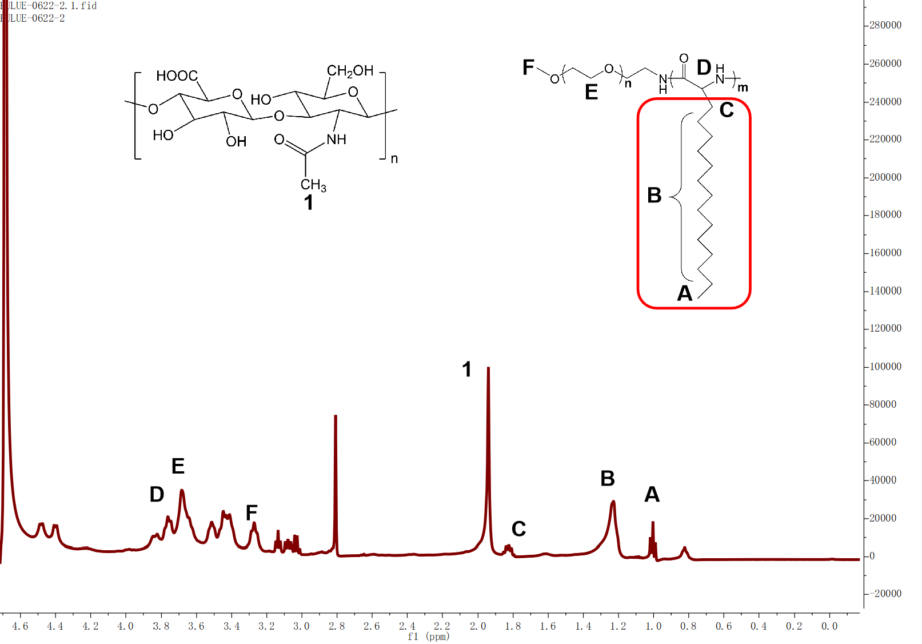

**(c)**

**Fig.S1 The 1H NMR spectrum (a) and mass spectrometry spectrum (b) of MnIIIPC. The 1H NMR spectrum (c) of HA@PLGA modified by HDA.**



**Fig. S2 Absorbance of MDPMH solutions with different concentrations (n=3)**



**Fig. S3 The standard curve of DTX detected by HPLC**

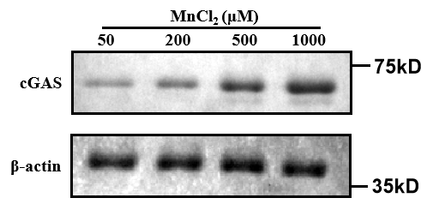

**Fig. S4 Western blot assay on the expression of cGAS with different concentration of MnCl2**