**Supplementary Data**

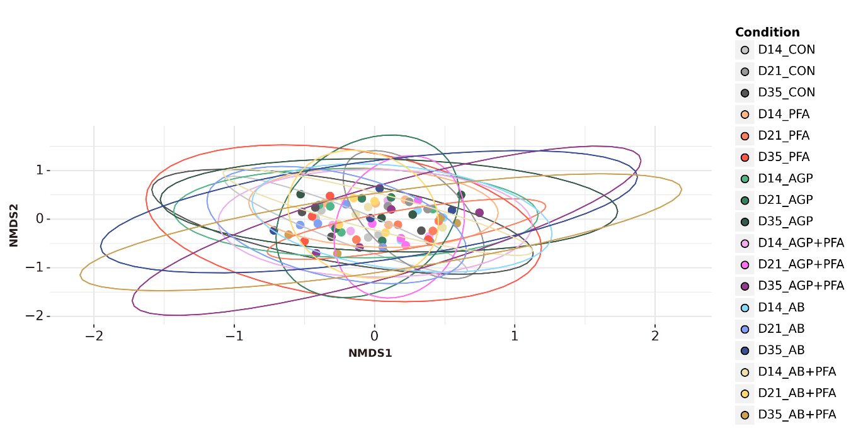

**Figure - S1** NMDS ordination based on Bray-Curtis dissimilarity metric represents ARGs compositional differences in treatments over sampling points

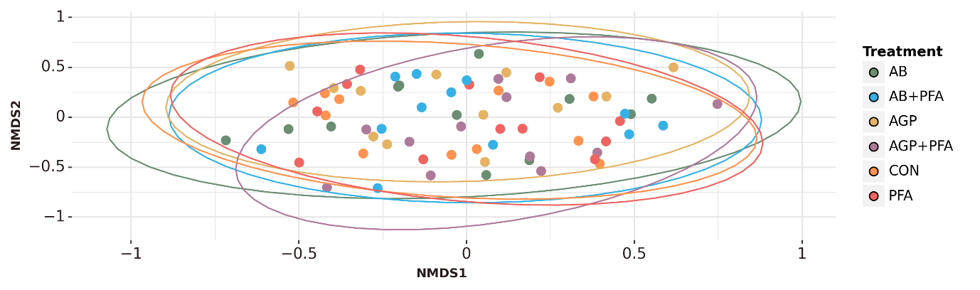

**Figure S2** - NMDS ordinations based on Bray–Curtis dissimilarity metric showing the changes in ARGs compositions between the treatments.

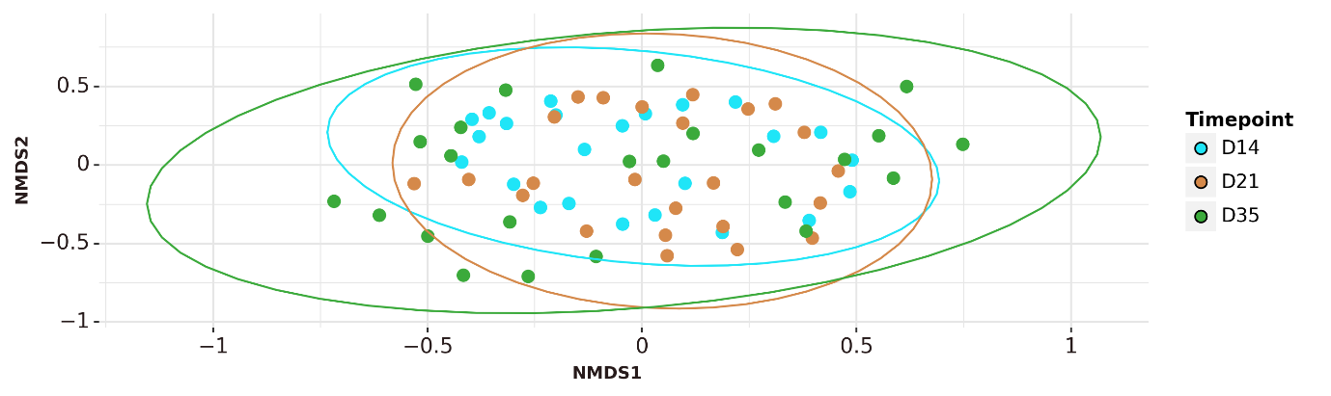

**Figure S3** - NMDS ordination based on Bray-Curtis dissimilarity metric represents ARGs compositional differences between the timepoints.

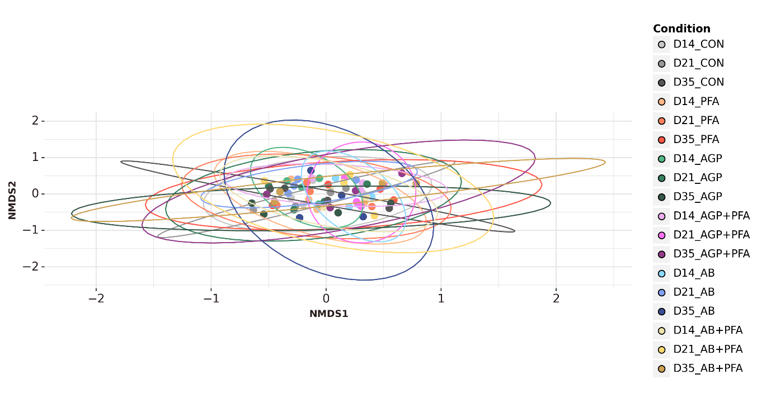

**Figure S4** - NMDS ordination based on Bray-Curtis dissimilarity metric represents bacterial compositional differences in treatments over time points

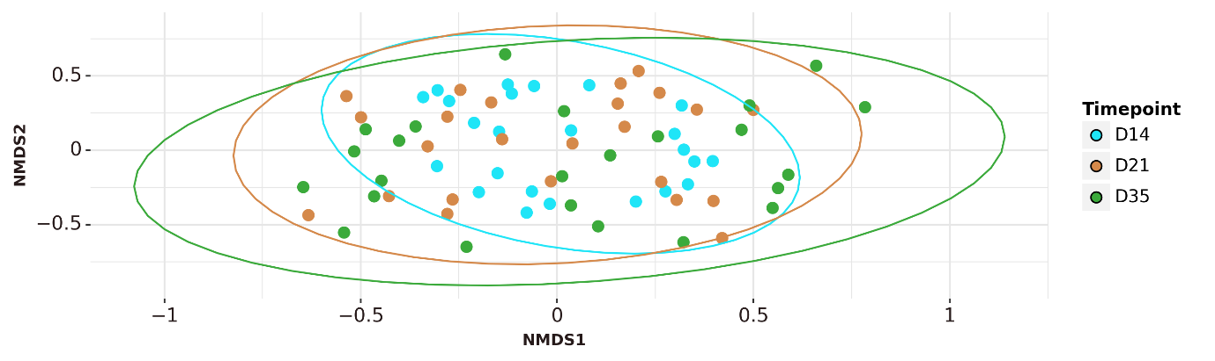

**Figure S5** - NMDS ordination based on Bray-Curtis dissimilarity metric represents bacterial compositional differences between the timepoints.