Supplementary Materials
Bt GS57 interacts with the gut microbiota to accelerate Spodoptera exigua mortality
Yazi Li^{1†}, Dan Zhao^{1†}, Han Wu¹, Yujie Ji², Zhaorui Liu¹, Xiaochang Guo¹, Wei Guo^{1,2#} and Yang Bi³
¹ College of Plant Protection, Hebei Agricultural University, Baoding, 071000, China.
² Graduate School of Chinese Academy of Agricultural Sciences, Beijing, 100081, China.
³ College of Bioscience and Resources Environment, Beijing University of Agriculture, Beijing, 102206, China.
# correspondence to guowei@hebau.edu.cn.
† These authors contributed equally to this work.

This file includes:
Supplementary Figures 1-7

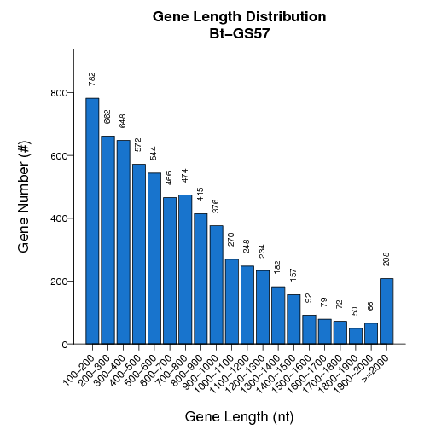
Supplementary Figure 1 Gene length distribution. The X-axis indicates the gene length and Y-axis indicates the number of gene of each gene length.

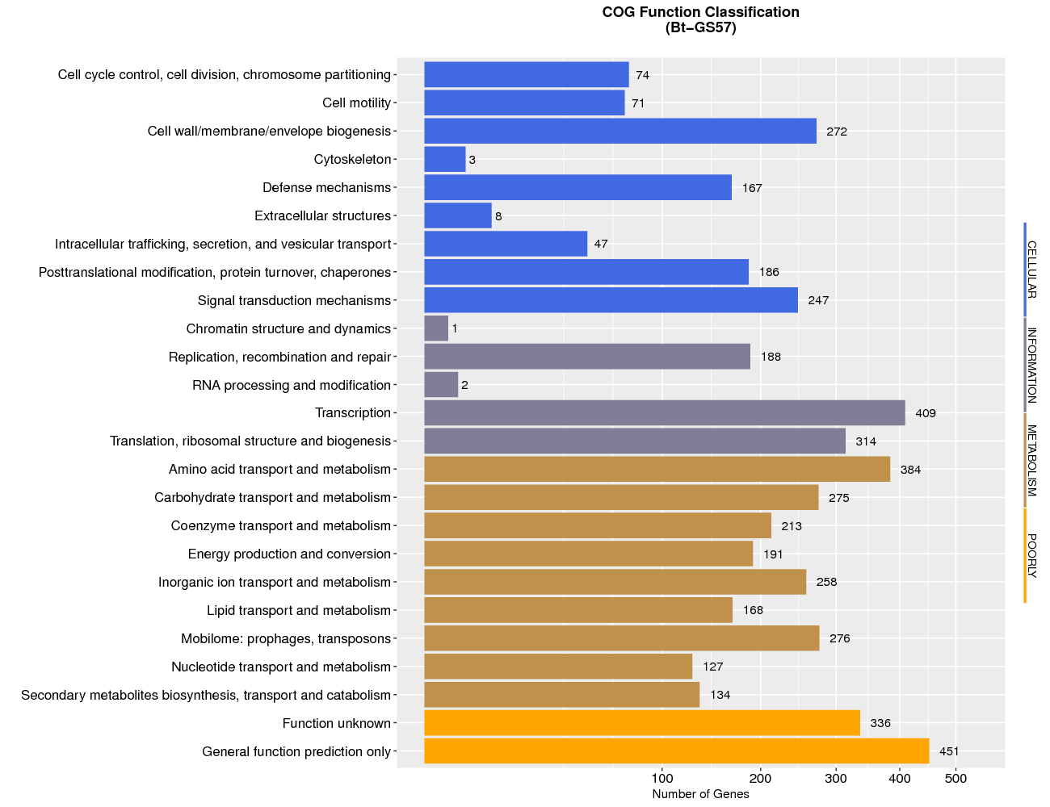

Supplementary Figure 2 The distribution of genes function against COG database. The X-axis indicates the number of genes and Y-axis indicates the comment entry.

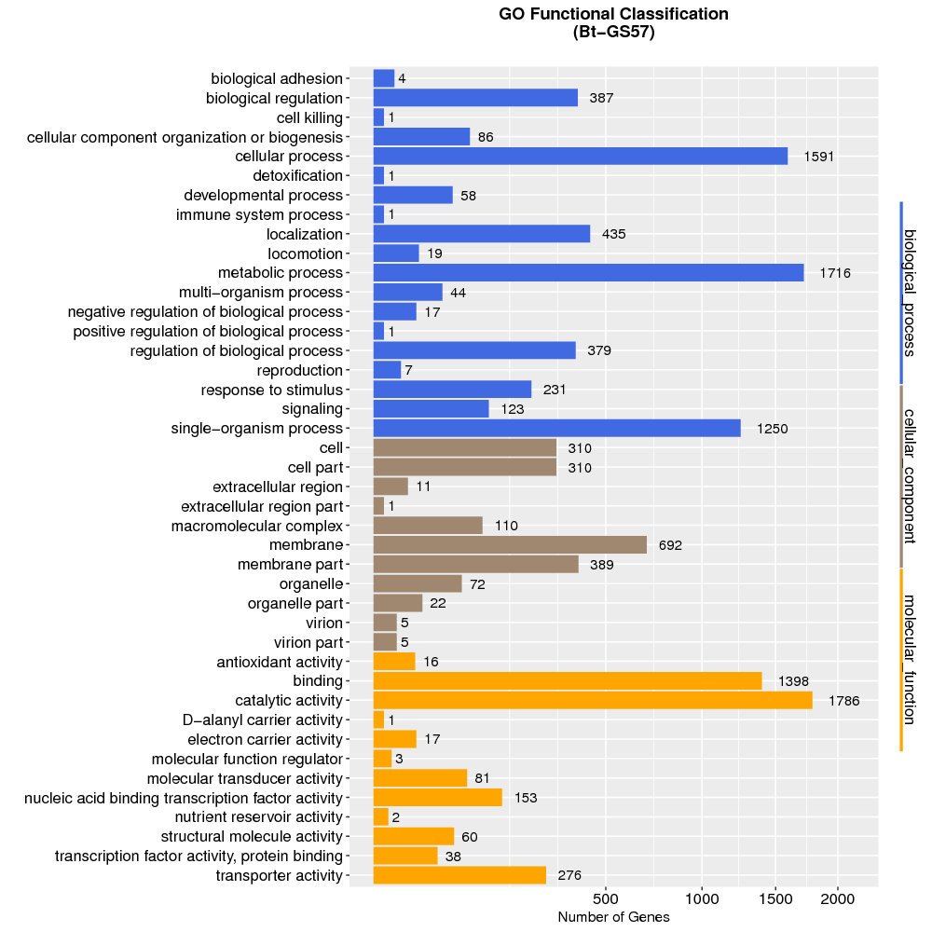

Supplementary Figure 3 The distribution of genes function classification against GO database. 3,324 genes were divided into three categories: "cellular component", "biological process" and "molecular function". The X-axis indicates the number of genes and Y-axis indicates the comment entry.

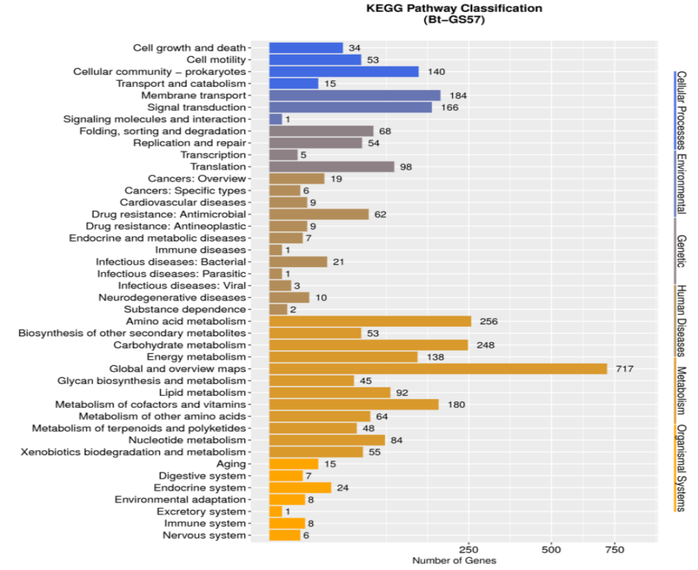

Supplementary Figure 4 KEGG categories of annotated genes function. 3,041 genes were divided into six categories: Cellular Processes, Environmental, Genetic, Human Disease, Metabolism and Organismal System. The X-axis indicates the number of genes and Y-axis indicates the comment entry.

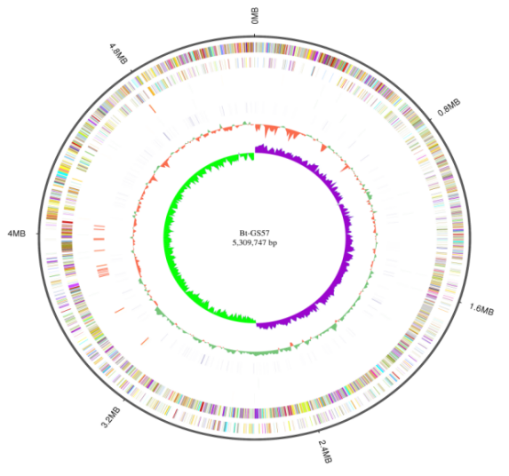
Supplementary Figure 5 Circular representation of chromosome of Bt GS57 performing relevant genome features. From outside to inner: Genome Size，Forward Strand Gene, colored according to cluster of orthologous groups (COG) classification, Reverse Strand Gene, colored according to cluster of orthologous groups (COG) classification, Forward Strand ncRNA, Reverse Strand ncRNA, repeat, GC, GC-SKEW.

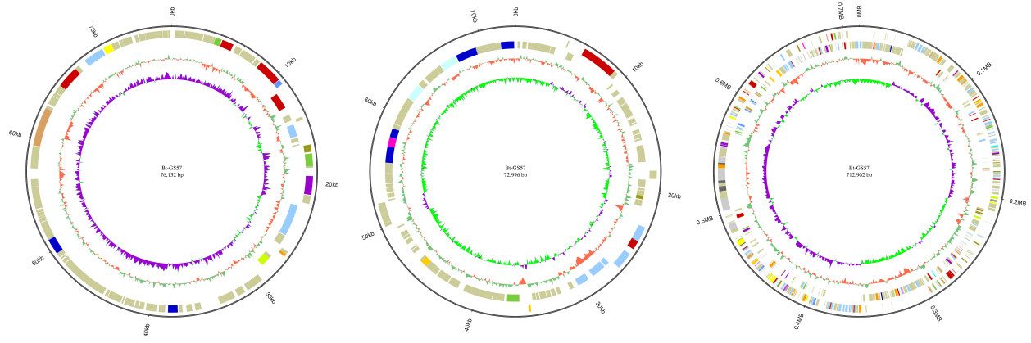
Supplementary Figure 6 Circular representation of plasmide of Bt GS57 performing relevant genome features. The plasmide 1-3 from outside to inner: Genome Size, Forward Strand Gene, colored according to cluster of orthologous groups (COG) classification, Reverse Strand Gene, colored according to cluster of orthologous groups (COG) classification, GC, GC-SKEW.

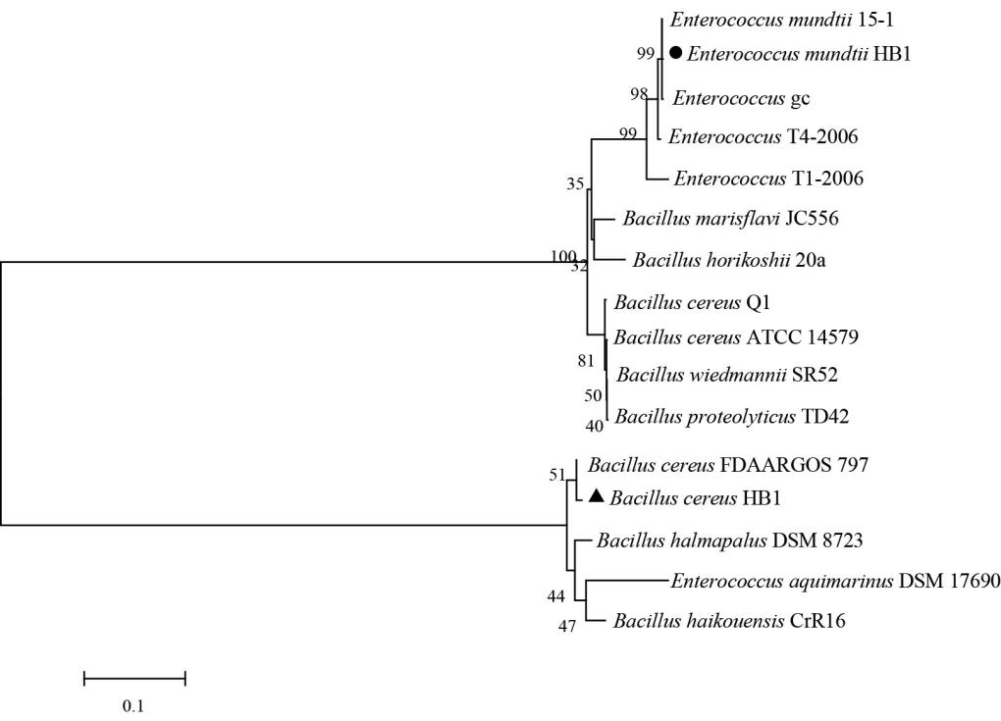
Supplementary Figure 7 Phylogenetic tree based on 16S rDNA sequences predominant cultivable bacterium with 14 related bacteria. The strains and their 16S rDNA corresponding to the GenBank accession numbers given below: E. mundtii 15-1 (NZ_AP019810.1); E. aquimarinus DSM 17690 (NZ_JXKD01000005.1); Enterococcus gc (DQ469876.1); Enterococcus T1-2006 (DQ462332.1); Enterococcus T4-2006 (DQ462331.1); B. cereus FDAARGOS_797 (NZ_CP053931.1); B. wiedmannii SR52 (NZ_CP032365.1); B. proteolyticus TD42 (NZ_MACH01000033.1); B. horikoshii 20a (NZ_CP020880.1); B. cereus Q1 (CP000227.1); B. cereus ATCC 14579 (NR_074540.1); B. marisflavi JC556 (LS974830.1); B. halmapalus DSM 8723 (NR_026144.1); B. haikouensis CrR16 (NZ_JABMCR010000501.1).

