***Supplementary Material***

**Antagonistic antibody targeting TNFR2 inhibits Regulatory T cell function to promote anti-tumor activity**

**Yonglin Chen, Manxue Jia, Sharon Wang, Sherry Xu, Nanhai He\***

**\*Corresponding Author: Nanhai He**

nathan.he@adlainortye.com

**Supplementary Figures**

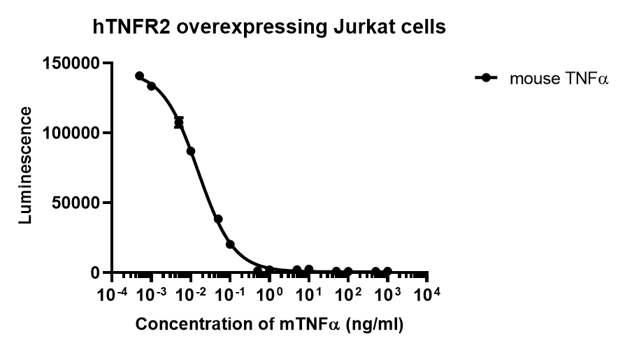

**Supplementary Figure 1. Mouse TNFα (mTNFα) induced cell death of hTNFR2 overexpressing Jurkat cells.** Gradient concentration of mouse TNFα (Invitrogen, RMTNFAI) was added to hTNFR2 overexpressing Jurkat cells. The cell viability after 24 hours culture was measured with Promega CellTiter-Glo® Luminescent Cell Viability Assay (Promega, G7570) according to the manufacturer’s instructions. Values were expressed as Mean ± SEM.

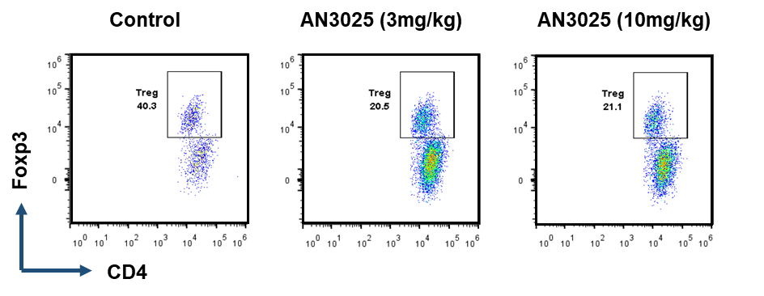

**Supplementary Figure 2. Representative images showing the Treg percentage in CD4+ T cells in the MC38 tumors of TNFR2 humanized mice after control or AN3025 administration.** Murine colon cancer MC38 cells (5E5) were implanted subcutaneously into homozygous TNFR2 humanized mice (female). MC38 tumor bearing TNFR2 humanized mice were treated with AN3025 at the dosage of 10mg/kg, 3mg/kg every 3 days intraperitoneally for 3 doses in total. Tregs (CD45+CD3+CD4+ Foxp3+) frequency in total CD4+ T cells in the MC38 tumors was quantified by flow cytometry (n=6 each group).

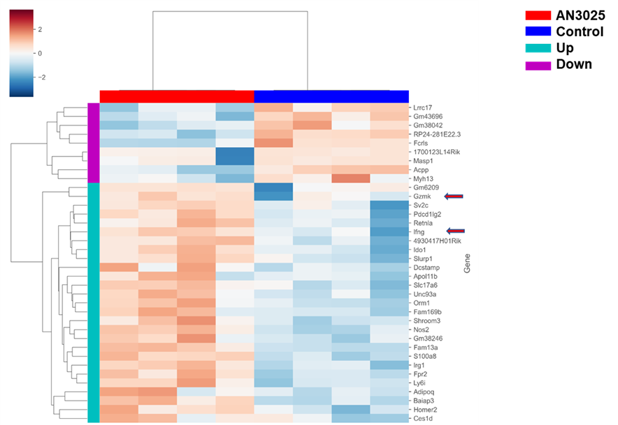

**Supplementary Figure 3. AN3025 increases expression of immune activation genes in the MC38 tumor tissue.** Murine colon cancer MC38 cells (5E5) were implanted subcutaneously into homozygous TNFR2 humanized mice (female). Mice were grouped when tumor volume reached approximately 100 mm3. MC38 tumor bearing TNFR2 humanized mice were treated with 10 mg/kg AN3025 every 3 days intraperitoneally for 7 doses in total. MC38 tumor tissues were collected for RNA seq analysis (n=4 each group). Immune activation genes such as Gzmk (gene for Granzyme K) and Ifng (gene for IFN-γ) were upregulated by AN3025 treatment.

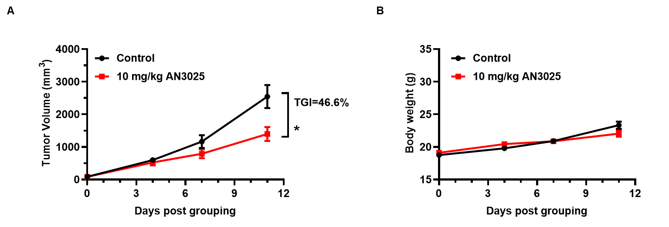

**Supplementary Figure 4. AN3025 significantly inhibits B16F10 tumor growth as a monotherapy in hTNFR2 mouse model.** Murine melanoma cell B16F10 cells were implanted subcutaneously into homozygous humanized TNFR2 mice (female, n=8 each group). Mice were grouped when tumor volume reached approximately 80 mm3. Then they were treated with control or 10 mg/kg AN3025 twice per week intraperitoneally for 4 doses in total. (A) Tumor volume measurement during the treatment (n=8 each group). (B) Body weight record during the treatments (n=8 each group). Values were expressed as Mean ± SEM. Statistical analysis of the tumor volumes on the final day of experiments was performed via t-test. *P<0.05.

**Supplementary Table 1 P values of two-way ANOVA analysis of tumor growth in TNFR2 humanized mouse cancer models（*P<0.05; ** P<0.01; ***P<0.001）.**

|  |  |  |
| --- | --- | --- |
|  | Groups | P value of Two-way ANOVA analysis |
| Figure 3A | 10mg/kg AN3025 v.s. Control | **P=0.007 |
| 3mg/kg AN3025 v.s. Control | **P=0.0042 |
| Figure 3D | 10mg/kg AN3025 v.s. Control | **P=0.007 |
| 10mg/kg AN3025 v.s. (10mg/kg AN3025+anti-CD4+ anti-CD8) | ***P=0.0001 |
| Figure 4A | 10mg/kg AN3025 v.s. Control | ***P<0.0001 |
| Figure 4G | 3mg/kg AN3025 v.s. Control | ***P<0.0001 |
| (3mg/kg AN3025+3mg/kg mPD1 Ab) v.s. Control | ***P<0.0001 |
| (3mg/kg AN3025+3mg/kg mPD1 Ab) v.s 3mg/kg mPD1 Ab | *P=0.019 |
| (3mg/kg AN3025+3mg/kg mPD1 Ab) v.s 3mg/kg AN3025 | **P=0.0079 |