Supplementary Material

Supplementary Data
Supplementary Data 1. Studies included for meta-analysis.
Supplementary Data 2. Dataset collected for meta-analysis.

Supplementary Figures and Tables

Supplementary Figures
Supplementary Figure 1. PRISMA 2020 flow diagram.
It was provided as a separate file.
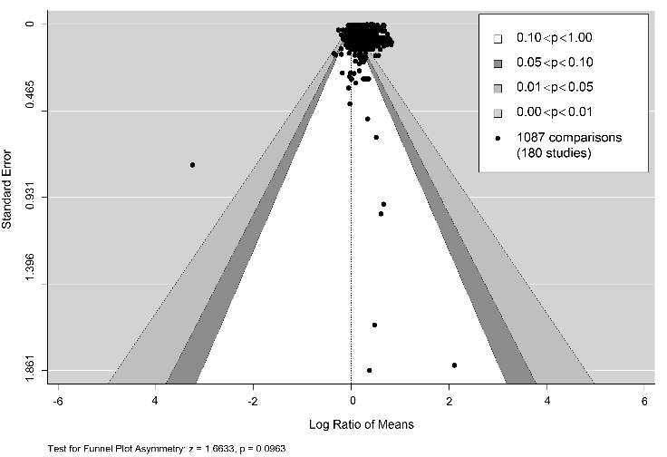
Supplementary Figure 2. Contour-enhanced funnel plot for publication bias based on the standard errors in the random-effect models of 187 studies used in this meta-analysis. Each point represents the standard error located in distinct levels of confidence limits for a single study. Asymmetry analysis of Egger's test is indicated at the bottom left, where p > 0.001 means there is no evidence for asymmetry.

Supplementary Figures and Tables
Supplementary Table 1. The biostimulant categories used in this meta-analysis according to the substance resources, adapted from (Du Jardin, 2015).
Biostimulant Category | Natural resources/substances | Bioactive compounds | Reference
Chitosan (Chi) | Shrimp or crab shells | Co-polymers of N-acetyl-d-glucosamine and d-glucosamine | Reviewed in (Pichyangkura and Chadchawan, 2015)
Humic and fulvic acids (HFA) | plant and animal matter, and microbial metabolism | humic acids and fulvic acids | Reviewed in (Canellas et al., 2015)
Protein hydrolysates (PHs) | Both animal and plant biomass | peptides and free amino acids | Reviewed in (Colla et al., 2015)
Phosphites (Phi) | P-containing nutrients | phosphite (Phi; H₂PO₃⁻) or its conjugate phosphorous acid (H₃PO₃) | Reviewed in (Gómez-Merino and Trejo-Téllez, 2015)
Seaweed extracts (SWE) | Red, green, and brown macroalgae species | Primary metabolites, i.e., carbohydrates, proteins, and amino acids | Reviewed in (Chiaiese et al., 2018)
Silicon (Si) | biogenic silica soils | monomeric silicic acid (H₄SiO₄) | Reviewed in (Savvas and Ntatsi, 2015)
Plant extract (PE) | Plant tissues except for seaweed and others aiming for HFA and PHs | Various plant metabolites | Reviewed in (Ali et al., 2020)

Reference
Ali, Q., Shehzad, F., Waseem, M., Shahid, S., Hussain, A.I., Haider, M.Z., Habib, N., Hussain, S.M., Javed, M.T., and Perveen, R. (2020). "Plant-Based Biostimulants and Plant Stress Responses," in Plant Ecophysiology and Adaptation under Climate Change: Mechanisms and Perspectives I: General Consequences and Plant Responses, ed. M. Hasanuzzaman. (Singapore: Springer Singapore), 625-661.
Canellas, L.P., Olivares, F.L., Aguiar, N.O., Jones, D.L., Nebbioso, A., Mazzei, P., and Piccolo, A. (2015). Humic and fulvic acids as biostimulants in horticulture. Scientia Horticulturae 196, 15-27.
Chiaiese, P., Corrado, G., Colla, G., Kyriacou, M.C., and Rouphael, Y. (2018). Renewable sources of plant biostimulation: microalgae as a sustainable means to improve crop performance. Frontiers in plant science 9, 1782.
Colla, G., Nardi, S., Cardarelli, M., Ertani, A., Lucini, L., Canaguier, R., and Rouphael, Y. (2015). Protein hydrolysates as biostimulants in horticulture. Scientia Horticulturae 196, 28-38.
Du Jardin, P. (2015). Plant biostimulants: definition, concept, main categories and regulation. Scientia Horticulturae 196, 3-14.
Gómez-Merino, F.C., and Trejo-Téllez, L.I. (2015). Biostimulant activity of phosphite in horticulture. Scientia Horticulturae 196, 82-90.
Pichyangkura, R., and Chadchawan, S. (2015). Biostimulant activity of chitosan in horticulture. Scientia Horticulturae 196, 49-65.
Savvas, D., and Ntatsi, G. (2015). Biostimulant activity of silicon in horticulture. Scientia Horticulturae 196, 66-81.

