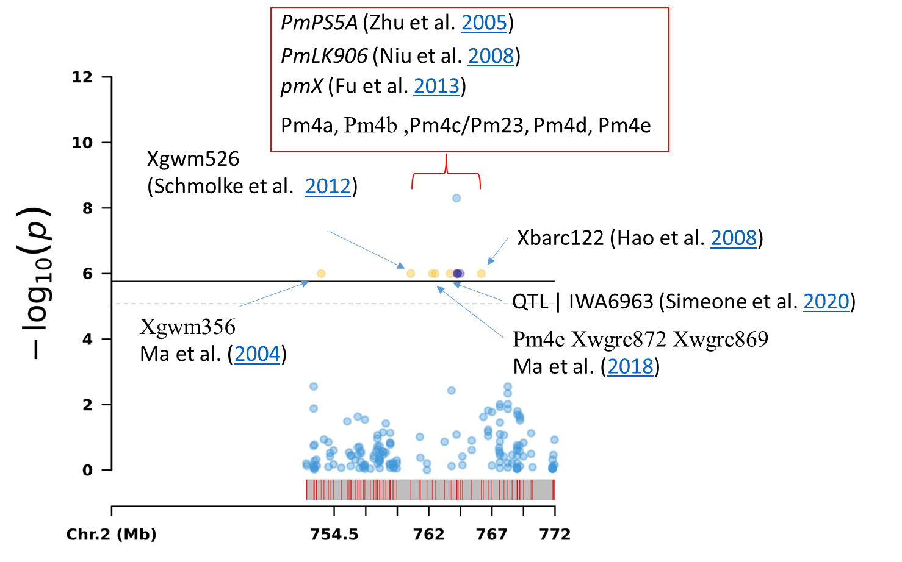

Figure S1: Published SSR-Marker reffering to published resistance gene in the MTA-5 Region

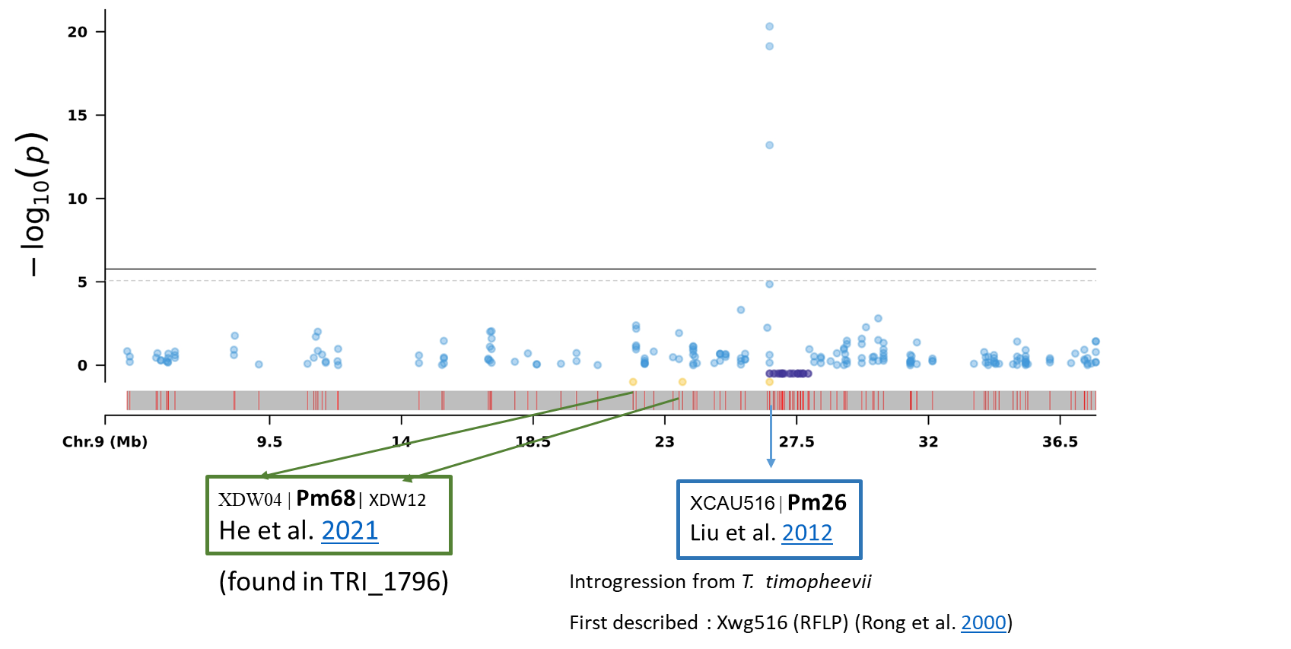

Figure S2: Published SSR-Marker reffering to published resistance gene (Pm26) in the MTA-30 Region