Supplementary Material

**Figure S1.** qRT-PCR curves at 85 °C [temperature, time, concentration]

**Figure S2.** qRT-PCR curves at 90 °C [temperature, time, concentration]

**Figure S3.** qRT-PCR curves at 95 °C [temperature, time, concentration]

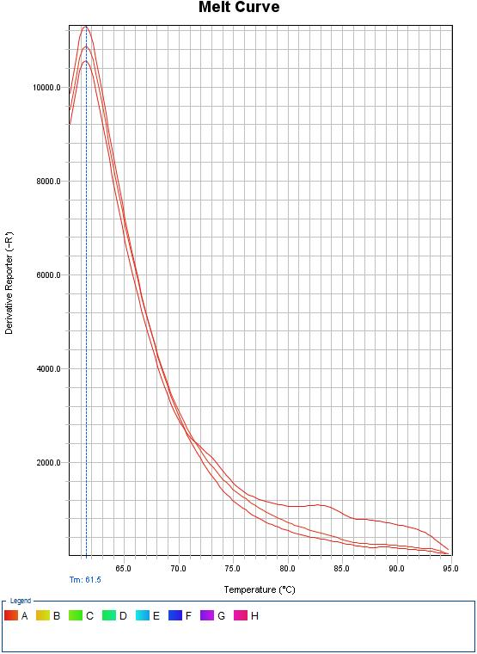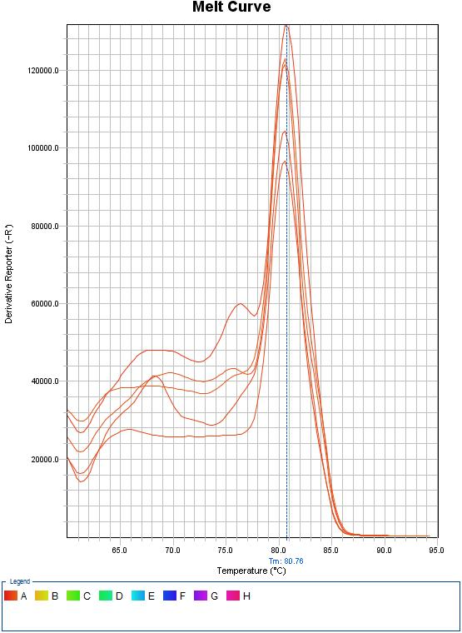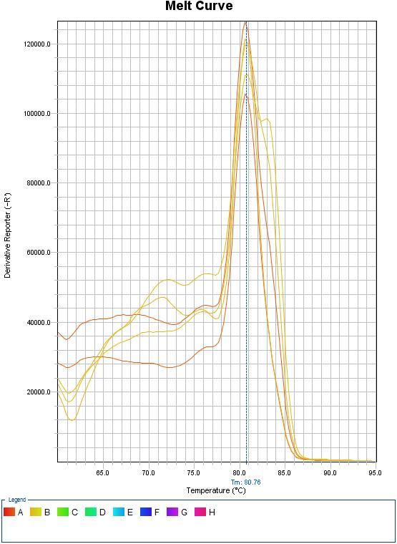 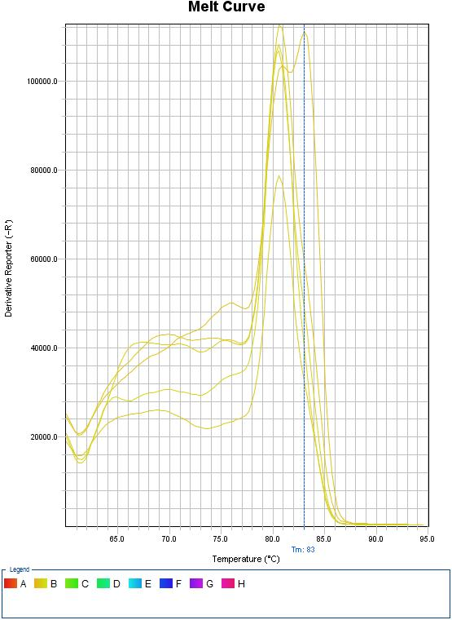 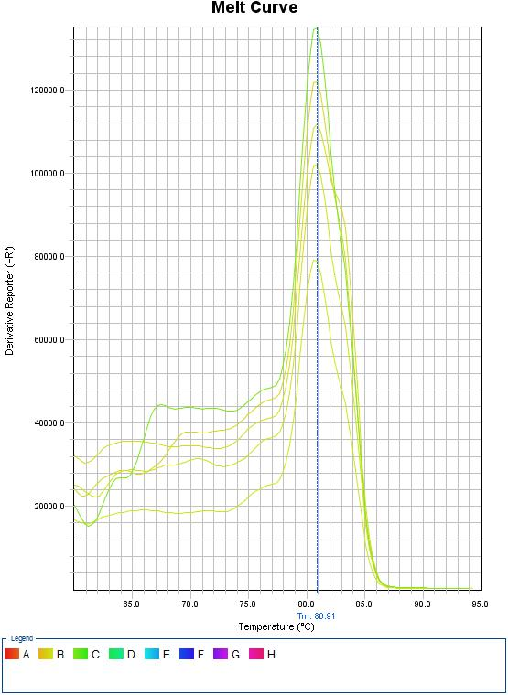 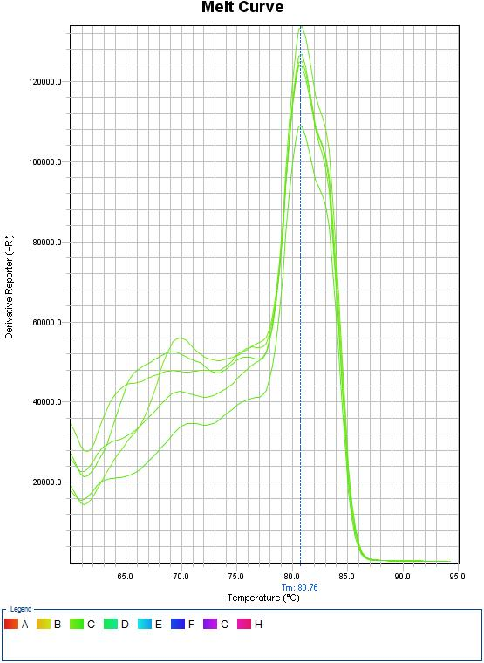

**Figure S4.** Melting curve analysis for RT-qPCR optimization. Melting curves at quantitative PCR against NCT and 0.1 μg/nL. 0.075 μg/nL, 0.05 μg/nL, 0.025 μg/nL, and 0.01 μg/nL of CMV template concentration.