Supplementary Material

Supplementary Figure 1. Effects of growth conditions on root twisting in abcb1/19.
Supplementary Figure 2. ABCB transporter protein sequence homology and conservation.
Supplementary Figure 3. Expression profiles of ABCB transporters and TWD1.
Supplementary Figure 4. Shoot phenotypes of abcb4 and abcb21 higher order mutants.
Supplementary Figure 5. Rosette leaves of abcb1, 19, 6, and 20 mutants.
Supplementary Figure 6. Cantil defects in abcb1/19 mutants.
Supplementary Figure 7. Phenotypes of abcb1/19/20 triple mutants.
Supplementary Figure 8. Genetic analysis of abcb11 mutants.
Supplementary Figure 9. Root waving phenotypes of abcb11-1.
Supplementary Figure 10. Competition of auxin transport with malate in abcb mutant seedlings.
Supplementary Table 1. Primers used in this study.
Supplementary Table 2. Mass transitions from LC-MS/MS quantitations.
Supplementary Table 3. Mutant alleles used by figure and table.

Supplementary Figure 1. Effects of growth conditions on root twisting in abcb1/19. (A) Typical and atypical twisting patterns observed in 7-day abcb1/19 and twd1 roots grown on ¼ MS medium containing 1 g L⁻¹ MES, 0.5% sucrose, and 0.8% agar (pH 5.6) under continuous 100 µmol m⁻² s⁻¹ light at 22°C. abcb1/19. Typical growth patterns in abcb1/19 consisted of increased root waving and skewing but lacked observable twd1-like twisting. Atypical patterns in abcb1/19 were identified as roots with segments of root twisting that continued for >500 µm (inset). Typical twd1 roots exhibited continuous cell file twisting while atypical patterns showed segments <500 µm with no twisting present. (B) Percentage of abcb1/19 roots showing typical and atypical growth with altered MS and sucrose concentrations. (C) Percentage of abcb1/19 roots showing typical and atypical growth with altered photoperiod and light fluence. Scale bars: 500 µm.

Supplementary Figure 2. ABCB transporter protein sequence homology and conservation. (A) Relatedness of Arabidopsis ABCB protein sequences by Maximum Likelihood method. The tree is drawn to scale, with branch lengths measured in the number of substitutions per site. Analysis involved 21 amino acid sequences, excluding the pseudogene ABCB8. Experimentally verified auxin and non-auxin transporters are indicated by green and red circles, respectively. ABCB14 is a malate transporter but differences in auxin transport have also been reported in abcb14 mutants. Experimentally determined TWD1 interactors and non-interactors are indicated by green and red squares, respectively. (B) AlphaFold2 predicted structure of ABCB19 with colors representing relative amino acid conservation amongst the 21 expressed ABCB proteins. Approximate position of the plasma membrane is indicated by black lines. Sequence variability is primarily associated with the transmembrane domains (TMDs), while the high sequence conservation is associated with the nucleotide binding domains (NBDs). (C) Pairwise protein sequence identity and similarity percentages (identity%/similarity%). Red indicates protein sequence conservation within paralogs and paralogous sets. ABCB19 shares the lowest conservation to any other transporter including its paralog ABCB1 (52%/70%). This likely contributes to its high auxin (indole-3-acetic acid) specificity while other ABCBs exhibit broader specificity or transport alternate substrates.
Supplementary Figure 3. Expression profiles of ABCB transporters and TWD1. Heat map showing expression of ABCBs and TWD1 in seedlings, roots, leaves, and inflorescence stems. Genes are presented in descending order based on overall expression (total read number of combined tissues). Data were acquired from the Trava RNAseq database (Klepikova et. al., 2016).
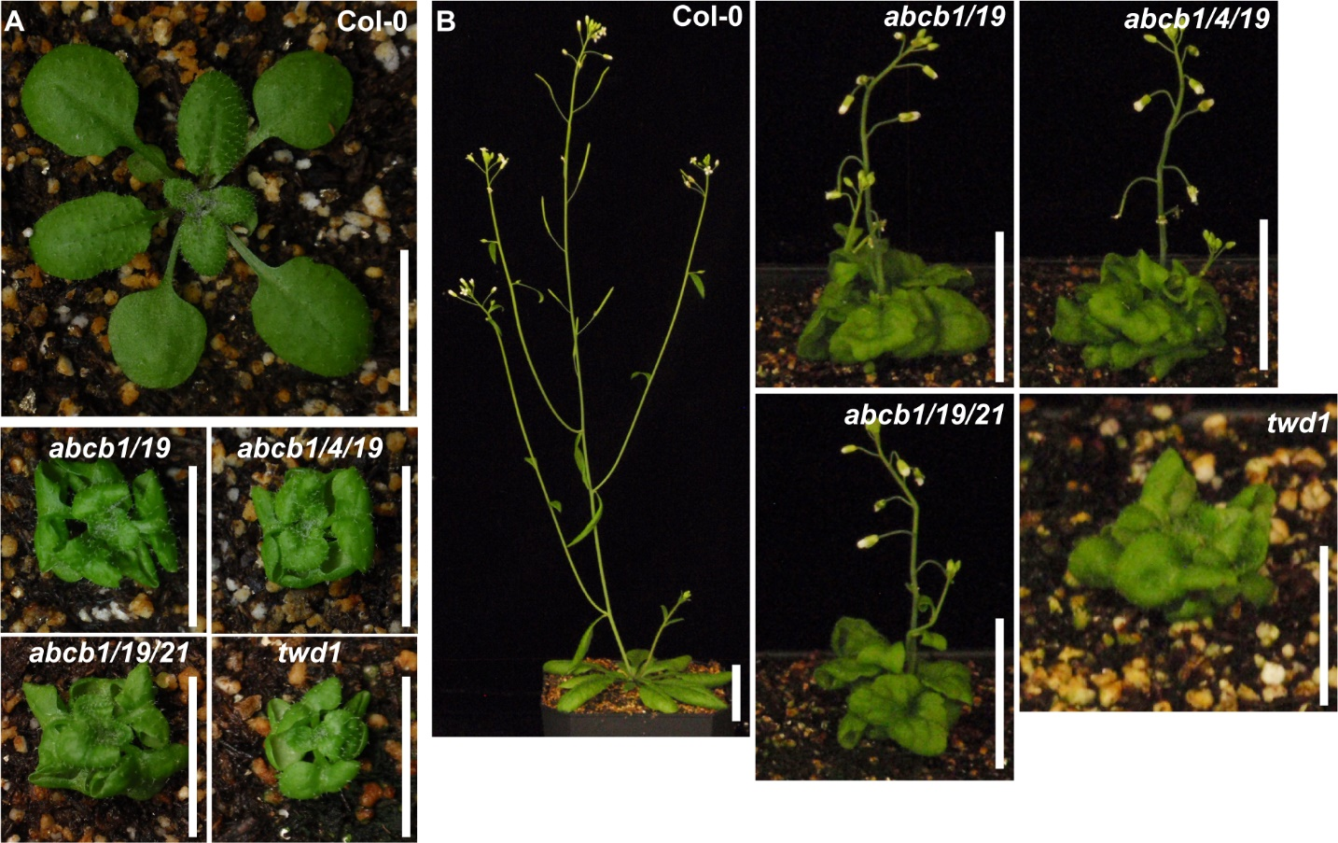
Supplementary Figure 4. Shoot phenotypes of abcb4 and abcb21 higher order mutants. (A) 18-d rosettes of Col-0, abcb1/19, abcb1/4/19, abcb1/19/21, and twd1. (B) 32-d rosettes and inflorescences of Col-0, abcb1/19, abcb1/4/19, abcb1/19/21, and twd1. Scale bars: (A) 1 cm; (B) Col-0: 5 cm, triple mutants: 2 cm, twd1: 1 cm.
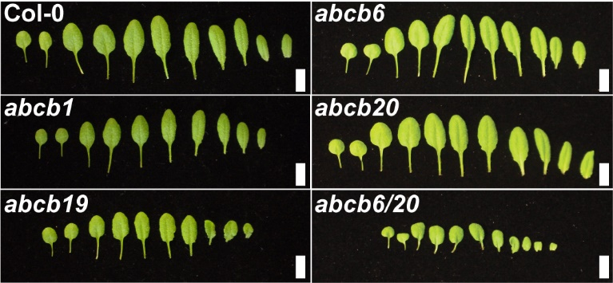
Supplementary Figure 5. Rosette leaves of abcb1, 19, 6, and 20 mutants. Leaves imaged 21 days after germination. Scale bars: 1 cm.
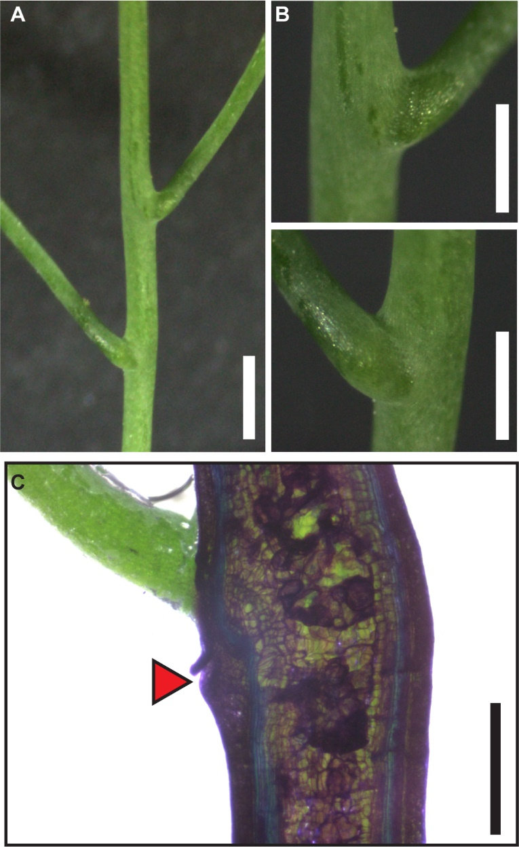
Supplementary Figure 6. Cantil defects in abcb1/19 mutants. (A) Cantil cuff formation in abcb1/19 grown under 100 µmol m⁻² s⁻¹, 16 h photoperiod. (B) Close ups of upper and lower cantils in (A). (C) Toluidine blue O staining of hand sectioned abcb1/19. Cuff outgrowth on the bottom side of the pedicel-stem junction is indicated with the red arrow. Scale bars: (A) 1 mm; (B,C) 0.5 cm.
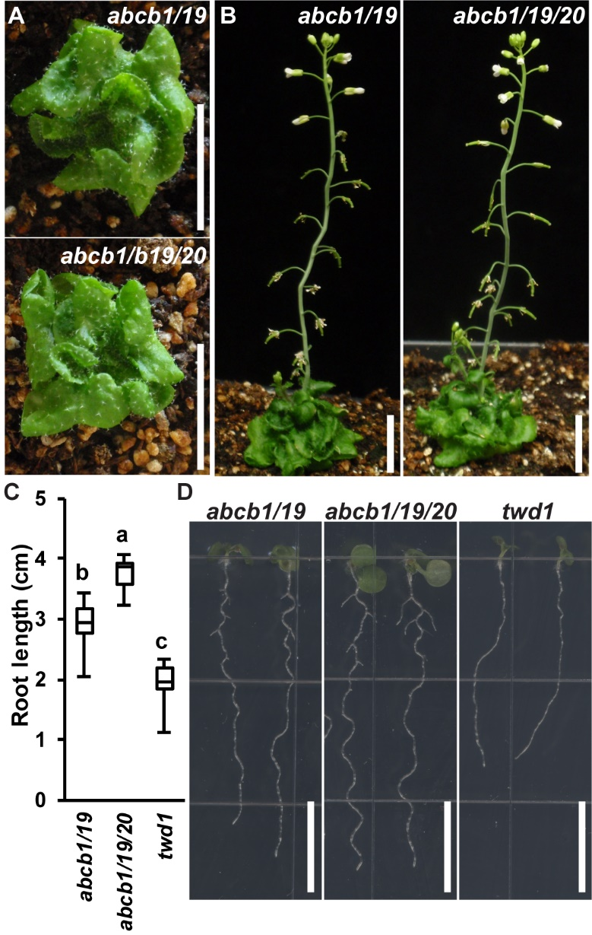
Supplementary Figure 7. Phenotypes of abcb1/19/20 triple mutants. (A) Pre-bolting rosettes of abcb1/19 and abcb1/19/20. (B) 35-d rosettes and inflorescences of abcb1/19 and abcb1/19/20. (C) Quantification of root growth in 7-d seedlings. (n=10-13). Asterisks indicate statistical differences by all pairwise Student’s t-test (*, P < 0.05). (D) Representative images of seedling roots in (C). Scale bars: 1 cm.
Supplementary Figure 8. Genetic analysis of abcb11 mutants. (A) Map of the ABCB11 locus. Approximate T-DNA insertion positions for abcb11-1 (SALK_057628) and abcb11-2 (SALK_037942) within exon 1 and exon 6, respectively, are indicated by white triangles. (B-C) Expression of (B) ABCB11 and (C) ABCB12 in abcb11-1. RNA was isolated from 5.5-d roots. Data shown are means ± SD (n = 3 biological replicates, 2 technical replicates).
Supplementary Figure 9. Root waving phenotypes of abcb11-1. (A) Primary root lengths of 5.5-d Col-0 and abcb11-1 seedlings grown on inclined plates. Angles are degrees from vertical. (n=12-15) (B) Quantification of root waving in seedlings from (A). Waves were defined as full oscillations across a vertical line drawn down the root axis. (n=12-15) (C) Representative images of Col-0 and abcb11-1 from (A) and (B). Asterisks indicate statistical difference from Col-0 by Student’s t-test (*, P < 0.05). Scale bar: 1 cm. All images in (C) are to scale.
Supplementary Figure 10. Competition of auxin transport with malate in abcb mutant seedlings. Competition of ³H-IAA from the shoot apex to the root-shoot transition zone (RSTZ) in 5.5-d seedlings with a 5:1 molar ratio cold malate. Values represent percent reduction compared to non-competed ³H-IAA transport in Figure 7C. Data shown are means ± SD (n = 3 pools of 10). Since ABCB19 is a primary mediator of polar auxin transport, the large error bars in abcb19 are due to changes in a severely reduced auxin transport background.

Supplementary Table 1. Primers used in this study.
Quantitative real-time PCR
Gene | 5’-Sequence-3’ | Sense
ABCB11 | CGCAGCTCATTCGATTACAAG  ACGAAGTTCCCTCCATTGAC | For.  Rev.
ABCB12 | TGCTTCCCTTGTTCAGCTTCA  GCTACATAAACTTGCATACAACAACATAA | For.  Rev.
PP2A | TCGTGGTGCAGGCTACACTTTC  TCAGAGAGAGTCCATTGGTGTGG | For.  Rev.
ACT2 | ACACTGTGCCAATCTACGAGGGTT  ACAATTTCCCGCTCTGCTGTTGTG | For.  Rev.
Promoter:GUS Constructs
Construct | 5’-Sequence-3’ | Sense
ABCB11 | CACCTGGACCCTCATGTTTTTCCTT  ATTTCGGCGCTGACAAAAATCAG | For.  Rev.
Expression in S.pombe
ABCB11 | ATCATATGATGAACGGTGACGGCGCCAGAGAAG  ATCCCGGGTCAATTAGAAGCAGTCATGTGAAGCTG | For.  Rev.
Genotyping
abcb11-1 | TGGCATCTTGAATAAGAACCG  ATTTTACGGGCAAGCAAAAAG | For.  Rev.
abcb11-2 | AACATCTCCATGTGTAACCGC  TCGGGTGAGTGATACTTTTGG | For.  Rev.
LBb1.3 | ATTTTGCCGATTTCGGAAC | T-DNA

Supplementary Table 2. Mass transitions from LC-MS/MS quantitations.
Molecule | Retention time (min) | Precursor ion (m/z) | Product ion (m/z)
oxIAA | 3.95 | 192 | 146
 |  |  | 128
IAA | 4.61 | 176 | 130
 |  |  | 77
¹³C-IAA | 4.61 | 182 | 136
 |  |  | 81

Supplementary Table 3. Mutant alleles used by figure and table.
 | Label in figure | Alleles
Figure 1 | abcb1/19  twd1 | abcb1-100 abcb19-101  twd1-3
Figure 2 | abcb1/19  abcb1/4/19  abcb1/19/21  twd1 | abcb1-100 abcb19-101  abcb1-100 abcb4-1 abcb19-101  abcb1-100 abcb19-101 abcb21-2  twd1-3
Figure 3 | abcb1  abcb6  abcb19  abcb20  abcb1/19  abcb6/20  twd1 | abcb1-100  abcb6-1  abcb19-101  abcb20-2  abcb1-100 abcb19-101  abcb6-1 abcb20-2  twd1-3
Figure 4 | abcb1/19  abcb6/20  amiRNA1334  b6-1 b20-1  twd1 | abcb1-100 abcb19-101  abcb6-1 abcb20-2  amiRNA1334  abcb6-1 abcb20-1  twd1-3
Figure 6 | abcb11-1  abcb11-2  abcb1/11-1/19  abcb1/19  twd1 | abcb11-1  abcb11-2  abcb1-100 abcb11-1 abcb19-101  abcb1-100 abcb19-101  twd1-3
Figure 7 | abcb1  abcb11-1  abcb14  abcb19  pin1 | abcb1-100  abcb11-1  abcb14-1  abcb19-101  pin1-7
Supplementary Figure 1 | abcb1/19  twd1 | abcb1-100 abcb19-101  twd1-3
Supplementary Figure 4 | abcb1/19  abcb1/4/19  abcb1/19/21  twd1 | abcb1-100 abcb19-101  abcb1-100 abcb4-1 abcb19-101  abcb1-100 abcb19-101 abcb21-2  twd1-3
Supplementary Figure 5 | abcb1  abcb6  abcb19  abcb20  abcb6/20 | abcb1-100  abcb6-1  abcb19-101  abcb20-2  abcb6-1 abcb20-2
Supplementary Figure 6 | abcb1/19 | abcb1-100 abcb19-101
Supplementary Figure 7 | abcb1/19  abcb1/19/20  twd1 | abcb1-100 abcb19-101  abcb1-100 abcb19-101 abcb20-2  twd1-3
Supplementary Figure 8 | abcb11-1  abcb11-2 | abcb11-1  abcb11-2
Supplementary Figure 9 | abcb11-1 | abcb11-1
Supplementary Figure 10 | abcb1  abcb11-1  abcb14  abcb19 | abcb1-100  abcb11-1  abcb14-2  abcb19-101
Table 1 | abcb1  abcb19  abcb1/19  abcb6  abcb20  abcb6/20 | abcb1-100  abcb19-101  abcb1-100 abcb19-101  abcb6-1  abcb20-2  abcb6-1 abcb20-2
Table 2 | abcb11-1  abcb11-2 | abcb11-1  abcb11-2

