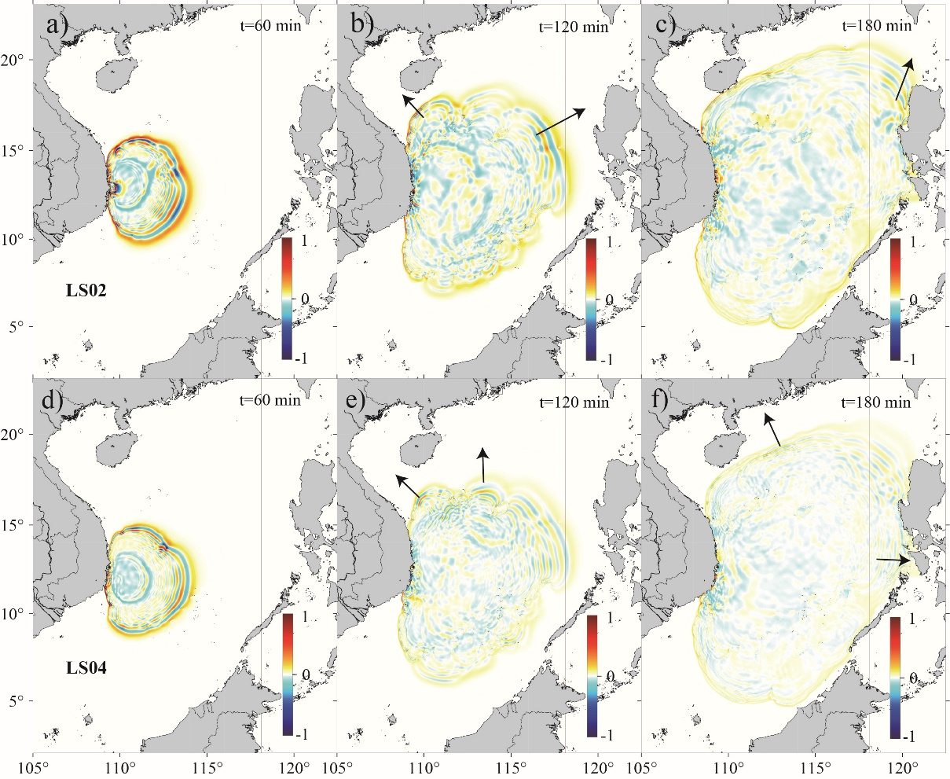

**Figure S1**: Snapshots of surface elevations simulated by FUNWAVE-TVD at time=60, 120, 180 min for (a-c) LS02 and (d-f) LS04 (deformable slide). **Black arrows**: the dominant direction of tsunami wave propagation.

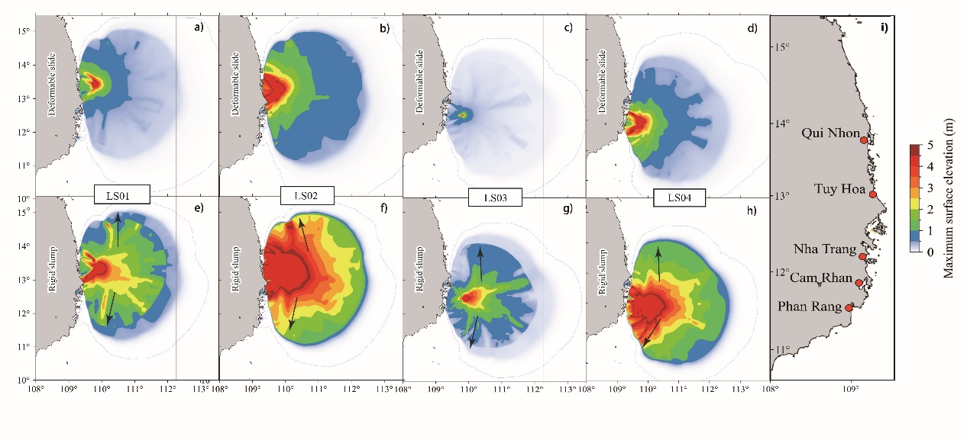**Figure S2**: The maximum surface elevation distribution within 30 min after failure. a)-d): deformable slide of LS01-LS04; e)-h): rigid slump of LS01-LS04.

Supplement 3

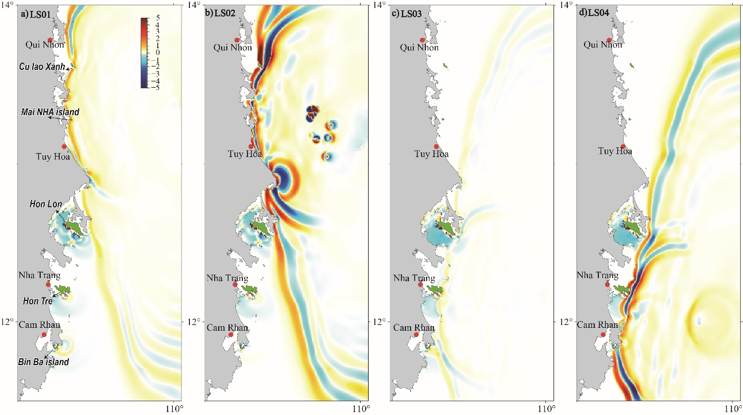

**Figure S3**: Nearshore propagation of tsunami waves generated by deformable slide of a) LS01; b) LS02; c) LS03; d) LS04. **Red dots**: large cities in east Vietnam coast. Green region (islands): possibility of affected by tsunami wave in the scenarios.



**Movie S1:** The tsunami wave generated by rigid slump of LS02 are propagating toward the Luzon island with a typically higher amplitude.

Table S1: Parameters of harbors and the calculated oscillation period.

|  |  |  |  |  |  |
| --- | --- | --- | --- | --- | --- |
| Name of Harbor | Depth (m) | L (m) | T0 (min) | T1 (min) | T2 (min) |
| Dam Thi Nai | 2.5 | 9700 | 130.5798 | 43.5266 | 26.1160 |
| Xuan Dai Bay | 4.4 | 6500 | 65.9571 | 21.9857 | 13.1914 |
| NHA Phu Bay | 37 | 16700 | 58.4373 | 19.4791 | 11.6875 |
| Vinh Cam Ranh | 1 | 4220 | 89.8228 | 29.9409 | 17.9646 |

*In section 5.2