Supplementary Material

## Supplementary Figures

D:\我的坚果云\实验室\合并一起发\投稿文件\Frontier in oncology\Figure\上传\Supplementary FigureS1.tif

**Supplementary Figure 1.** ORFV replicates in breast cancer cells

4T1 cells were infected with ORFV at MOI of 1 for 48 hours. Image was obtained by transmission electron microscopy (TEM). The virus particles are marked with black triangle.

**D:\我的坚果云\实验室\合并一起发\投稿文件\Frontier in oncology\Figure\上传\Supplementary FigureS2.tif**

**Supplementary Figure 2.** ORFV did not affect normal cells

(A). HUVEC infected with ORFV at different MOI (0, 1, 2 and 5), and the cell viability was measured by CCK8 assay. (B). Colony formation assay of HUVEC treated with ORFV for 7 days.

**D:\我的坚果云\实验室\合并一起发\投稿文件\Frontier in oncology\Figure\上传\Supplementary FigureS3.tif**

**Supplementary Figure 3.** Safety evaluation of ORFV in vivo treatment

(A). Body weight curve of nude mice after intratumoral injection of ORFV (n=5). There was no significant difference in body weight change between. (B). Representative image of tissue at the site of virus injection stained with HE. No pathological phenomena related to virus infection were found. The results are expressed as the means ± SEM. *, *p* < 0.05; **, *p* < 0.01; ***, *p* < 0.001

D:\我的坚果云\实验室\合并一起发\投稿文件\Frontier in oncology\Figure\上传\Supplementary FigureS4.tif

**Supplementary Figure 4.** Results of candidate kinases screening

(A) Schematic diagram of protein-protein interaction network in candidate kinases. (B) The enrichment result of the KO pathway in candidate kinases. D: The enrichment result of the Gene Ontology in candidate kinases.



**Supplementary Figure 5.** Results of relative expression of PAK4

After 24 hours of transfection with siPAK4 or mock, MCF-7 cells were infected with ORFV (MOI=5). After 72 hours of infection, the relative expression of PAK4 was detected by qPCR.

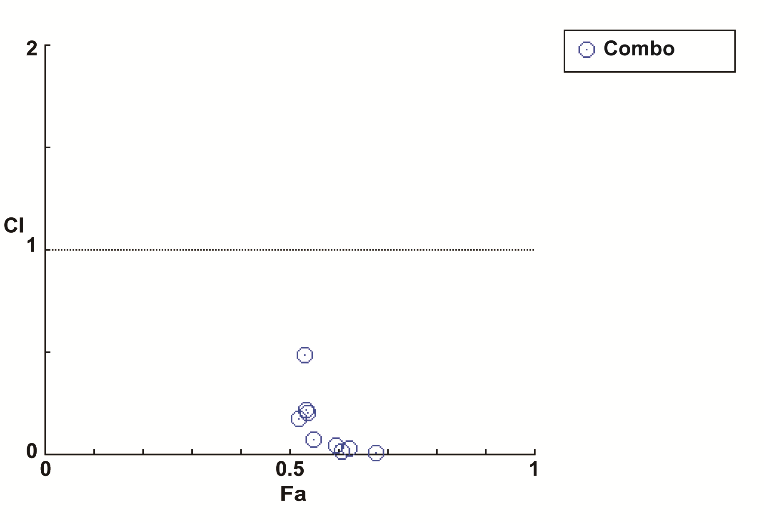

**Supplementary Figure 6.** The Combination index plot representations obtained for ORFV and PF3758309 combinations

MCF-7 cells treated with a series of combined treatments (ORFV, MOI=1/2/5; PAK4i, 10/20/40nM) for 72 hours. The Fractional Inhibition was obtained by CCK-8 assay. The graphic representations obtained from the CompuSyn Report.

D:\我的坚果云\实验室\合并一起发\投稿文件\Frontier in oncology\Figure\上传\Supplementary FigureS5.tif

**Supplementary Figure 7.** Cell scratch test

MCF-7 Cells were seeded in 6-well plates at a density of 106 cells per well and cultured for 24 hours. A wound was scratched in the cell lawn with a pipette tip and the cells were washed with serum-free DMEM three times to remove the debris. The cells were exposed to ORFV or PF-3758309 or combination treatment. Images of cell scratch test were captured at 24 hours. The results are expressed as the means ± SEM. *, *p* < 0.05; **, *p* < 0.01; ***, *p* < 0.001