Supplementary Information

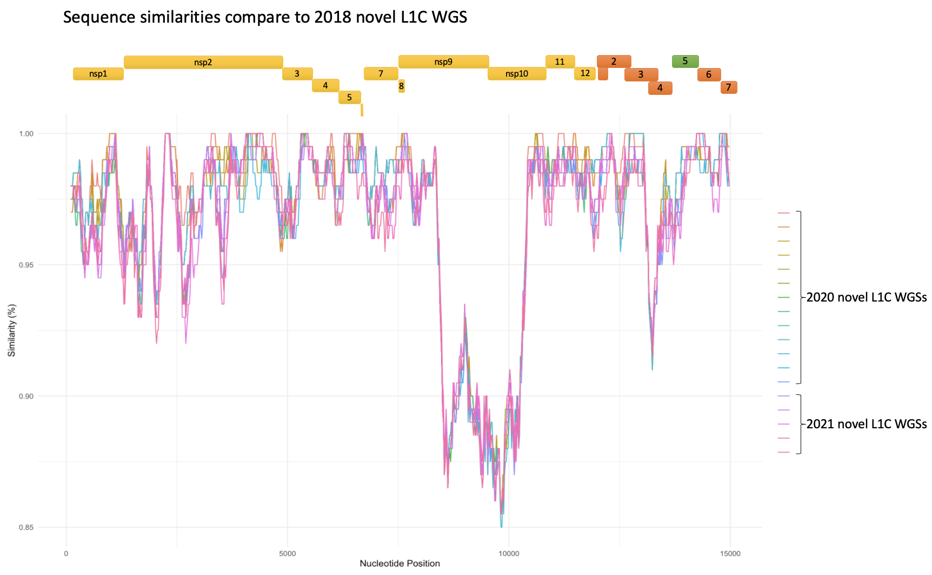
Supplementary figure 1. Similarity plot between the 2018 (reference) and the 2020-21 (queries) L1C 1-4-4 WGSs

Supplementary table 1. List of the U.S. PRRSV-2 WGSs with collection year information used in this study
NCBI accession no. | ORF5-based lineage | State | Collection year | Sequences used for timed-tree and DTA
OL963961 | novel L1C-1-4-4 | - | 2018 | 1
OL963962 | novel L1C-1-4-4 | - | 2020 | 1
OL963963 | novel L1C-1-4-4 | - | 2020 | 1
OL963964 | novel L1C-1-4-4 | - | 2020 | 1
OL963965 | novel L1C-1-4-4 | - | 2020 | 1
OL963966 | novel L1C-1-4-4 | - | 2020 | 1
OL963967 | novel L1C-1-4-4 | - | 2020 | 1
OL963968 | novel L1C-1-4-4 | - | 2020 | 1
OL963969 | novel L1C-1-4-4 | - | 2020 | 1
OL963970 | novel L1C-1-4-4 | - | 2020 | 1
OL963971 | novel L1C-1-4-4 | - | 2020 | 1
OL963972 | novel L1C-1-4-4 | - | 2020 | 1
OL963973 | novel L1C-1-4-4 | - | 2020 | 1
OL963974 | novel L1C-1-4-4 | - | 2020 | 1
OL963975 | novel L1C-1-4-4 | - | 2021 | 1
OL963976 | novel L1C-1-4-4 | - | 2021 | 1
OL963977 | novel L1C-1-4-4 | - | 2021 | 1
OL963979 | novel L1C-1-4-4 | - | 2021 | 1
OL963978 | novel L1C-1-4-4 | - | 2021 | 1
HQ699067.1 | L9 | - | 2006 | 0
JN654458.1 | L8 | - | 1996 | 0
JN654459.1 | L1C | - | 2008 | 1
JN660150.1 | L1B | - | 2008 | 0
JQ087873.1 | L5 | - | 2010 | 1
KC469618.1 | L5 | - | 1995 | 1
KF632717.1 | L1C | - | 2012 | 1
KF724397.1 | L1C | - | 2011 | 1
KF724398.1 | L1C | - | 2011 | 1
KF724399.1 | L9 | - | 2012 | 0
KF724401.1 | L1C | - | 2012 | 1
KF724402.1 | L1C | - | 2012 | 1
KF724403.1 | L9 | - | 2012 | 0
KF724404.1 | L8 | - | 2012 | 0
KF724405.1 | L9 | - | 2012 | 0
KF724406.1 | L9 | - | 2011 | 0
KF724407.1 | L6 | - | 2013 | 0
KF724409.1 | L1C | - | 2013 | 1
KF724410.1 | L1C | - | 2013 | 1
KF724411.1 | L1C | - | 2013 | 1
KF724412.1 | L1G | - | 2013 | 1
KF724413.1 | L5 | - | 2013 | 1
KP283399.1 | L1G | - | 2012 | 1
KP283400.1 | L1G | - | 2012 | 1
KP283401.1 | L1C | - | 2012 | 1
KP283402.1 | L1C | - | 2013 | 1
KP283403.1 | L1C | - | 2012 | 1
KP283404.1 | L1C | - | 2011 | 1
KP283405.1 | L1G | - | 2012 | 1
KP283406.1 | L1G | - | 2012 | 1
KP283407.1 | L1G | - | 2012 | 1
KP283408.1 | L1G | - | 2012 | 1
KP283409.1 | L1C | - | 2012 | 1
KP283410.1 | L1C | - | 2012 | 1
KP283411.1 | L1C | - | 2012 | 1
KP283412.1 | L1C | - | 2012 | 1
KP283413.1 | L1C | - | 2012 | 1
KP283414.1 | L1A | - | 2012 | 1
KP283415.1 | L1C | - | 2012 | 1
KP283416.1 | L1C | - | 2012 | 0
KR534893.1 | L1C | OH | 2013 | 0
KR534894.1 | L1A | OH | 2015 | 1
KT207837.1 | L9 | - | 2012 | 0
KT257944.1 | L5 | IA | 2014 | 0
KT257945.1 | L5 | IA | 2014 | 0
KT257946.1 | L5 | IA | 2014 | 0
KT257947.1 | L5 | IA | 2014 | 0
KT257948.1 | L8 | MN | 2014 | 0
KT257949.1 | L8 | MN | 2014 | 0
KT257950.1 | L8 | MN | 2014 | 0
KT257951.1 | L8 | MN | 2014 | 0
KT257952.1 | L8 | MN | 2014 | 0
KT257953.1 | L8 | MN | 2014 | 0
KT257954.1 | L1E | KS | 2014 | 1
KT257955.1 | L1E | CO | 2014 | 1
KT257956.1 | L1H | KS | 2014 | 0
KT257957.1 | L6 | KS | 2014 | 0
KT257958.1 | L1E | KS | 2014 | 1
KT257959.1 | L1B | - | 2014 | 1
KT257960.1 | L1B | - | 2014 | 1
KT257961.1 | L1B | - | 2014 | 1
KT257962.1 | L1B | - | 2014 | 1
KT257963.1 | L1B | - | 2014 | 1
KT257964.1 | L1B | - | 2014 | 1
KT257965.1 | L1B | - | 2014 | 1
KT257966.1 | L1A | NC | 2014 | 1
KT257967.1 | L1A | IA | 2014 | 1
KT257968.1 | L1A | IA | 2014 | 1
KT257969.2 | L1C | - | 2014 | 1
KT257970.1 | L1C | - | 2014 | 1
KT257971.1 | L1C | - | 2014 | 1
KT257972.1 | L1C | - | 2014 | 1
KT257973.1 | L1C | - | 2014 | 1
KT257974.1 | L1A | - | 2014 | 1
KT257975.1 | L1G | - | 2014 | 1
KT257976.1 | L1A | - | 2014 | 1
KT257977.1 | L1C | IA | 2014 | 1
KT257978.1 | L1D | - | 2014 | 0
KT257979.1 | L1C | - | 2014 | 0
KT257980.1 | L1C | - | 2014 | 0
KT257981.1 | L1C | - | 2014 | 0
KT257982.1 | L1C | - | 2014 | 0
KT257983.1 | L1C | IA | 2014 | 1
KT257984.1 | L1C | - | 2014 | 1
KT257985.1 | L1A | - | 2014 | 1
KT257986.1 | L1C | - | 2014 | 1
KT257987.1 | L1G | IA | 2014 | 1
KT257988.1 | L1A | - | 2014 | 1
KT257989.1 | L1A | - | 2014 | 1
KT257990.1 | L1A | - | 2014 | 1
KT257991.1 | L1A | - | 2014 | 1
KT257992.1 | L1G | MO | 2014 | 1
KT257993.1 | L1E | IA | 2014 | 0
KT257994.1 | L1D | NE | 2014 | 0
KT257995.1 | L1D | NE | 2014 | 0
KT257996.1 | L1D | NE | 2014 | 0
KT257997.1 | L1D | NE | 2014 | 0
KT257998.1 | L1D | NE | 2014 | 0
KT257999.1 | L1H | CO | 2014 | 0
KT258000.1 | L1H | CO | 2014 | 0
KT258001.1 | L1E | IA | 2014 | 0
KT258002.1 | L1E | IA | 2014 | 0
KT258003.1 | L1E | IA | 2014 | 0
KT258004.1 | L1E | IA | 2014 | 0
KT258005.1 | L1A | NE | 2014 | 1
KT258006.1 | L1G | NC | 2014 | 1
KT258007.1 | L1G | NE | 2014 | 1
KT258008.1 | L1G | MN | 2014 | 1
KT258009.1 | L1H | IA | 2014 | 0
KT581982.1 | L1C | - | 2014 | 1
KU131557.1 | L1D | - | 2011 | 0
KU131559.1 | L5 | - | 2004 | 0
KU131561.1 | L5 | - | 2002 | 0
KU131563.1 | L8 | - | 1998 | 0
KU131564.1 | L5 | - | 1995 | 0
KU131565.1 | L9 | - | 1995 | 0
KU131566.1 | L1D | - | 2011 | 0
KU131568.1 | L1D (Prevacent vaccine) | - | 2011 | 0
KU318406.1 | L5 | - | 2015 | 1
KX192112.1 | L1A | NE | 2016 | 1
KX192113.1 | L1A | NE | 2016 | 1
KX192114.1 | L1A | NE | 2016 | 1
KX192115.1 | L1A | NE | 2016 | 1
KX192116.1 | L1A | NE | 2016 | 1
KX192117.1 | L1A | NE | 2016 | 1
KX192118.1 | L1A | NE | 2016 | 1
KX192119.1 | L1A | NE | 2016 | 1
KX462792.1 | L5 | - | 2012 | 1
KY348847.1 | L9 | - | 1998 | 0
KY348848.1 | L1F | - | 2004 | 0
KY348849.1 | L1D | - | 2001 | 0
KY348850.1 | L9 | - | 2000 | 0
KY348851.1 | L5 | - | 2000 | 0
KY348852.1 | L8 | - | 2000 | 1
KY348853.1 | L5 | - | 2000 | 0
MF326985.1 | L1A | IA | 2014 | 1
MF326986.1 | L1A | IA | 2015 | 1
MF326987.1 | L1A | IA | 2015 | 1
MF326988.1 | L1A | IA | 2013 | 1
MF326989.1 | L1A | IA | 2014 | 1
MF326990.1 | L1A | NC | 2014 | 1
MF326991.1 | L1A | NC | 2014 | 1
MF326992.1 | L1A | IN | 2014 | 1
MF326993.1 | L1A | OH | 2014 | 1
MF326994.1 | L1A | OH | 2014 | 1
MF326995.1 | L1A | IA | 2014 | 1
MF326996.1 | L1A | IA | 2015 | 1
MF326997.1 | L1A | IA | 2015 | 1
MF326998.1 | L1A | NC | 2015 | 1
MF326999.1 | L1A | NC | 2015 | 1
MF327000.1 | L1A | IA | 2015 | 1
MF327001.1 | L1A | IA | 2015 | 1
MF526964.1 | L1A | IN | 2017 | 1
MF526965.1 | L1C | IN | 2017 | 1
MK796164.1 | L1C | - | 2018 | 0
MK796165.1 | L8 | - | 2018 | 0
MK837936.1 | L8 | - | 1996 | 0
MK860181.1 | L1A | NC | 2015 | 1
MN073081.1 | L1A | - | 2018 | 1
MN073082.1 | L1A | - | 2018 | 1
MN073083.1 | L1A | - | 2018 | 1
MN073084.1 | L1A | - | 2018 | 1
MN073086.1 | L1A | - | 2017 | 1
MN073088.1 | L1A | - | 2017 | 1
MN073089.1 | L1A | - | 2017 | 1
MN073092.1 | L1A | - | 2017 | 1
MN073095.1 | L1A | - | 2017 | 1
MN073097.1 | L1A | - | 2017 | 1
MN073098.1 | L1A | - | 2017 | 1
MN073099.1 | L1A | - | 2017 | 1
MN073100.1 | L1A | - | 2017 | 1
MN073102.1 | L1A | - | 2018 | 1
MN073111.1 | L1C | - | 2017 | 1
MN073112.1 | L1C | - | 2017 | 1
MN073113.1 | L1C | - | 2017 | 1
MN073114.1 | L1C | - | 2016 | 1
MN073115.1 | L1C | - | 2016 | 1
MN073116.1 | L1C | - | 2017 | 1
MN073117.1 | L1C | - | 2017 | 1
MN073118.1 | L1C | - | 2017 | 1
MN073119.1 | L1C | - | 2017 | 0
MN073120.1 | L1C | - | 2017 | 0
MN073121.1 | L1C | - | 2017 | 0
MN073122.1 | L1C | - | 2018 | 0
MN073123.1 | L1B | - | 2017 | 1
MN073124.1 | L1B | - | 2017 | 1
MN073127.1 | L1F | - | 2018 | 0
MN073129.1 | L7 | - | 2018 | 0
MN073130.1 | L5 | - | 2018 | 1
MN073131.1 | L5 | - | 2018 | 1
MN073132.1 | L5 | - | 2018 | 1
MN073133.1 | L5 | - | 2016 | 1
MN073136.1 | L5 | - | 2017 | 1
MN073137.1 | L5 | - | 2017 | 1
MN073138.1 | L5 | - | 2016 | 1
MN073139.1 | L5 | - | 2016 | 1
MN073140.1 | L5 | - | 2017 | 1
MN073141.1 | L5 | - | 2017 | 0
MN073142.1 | L5 | - | 2017 | 0
MN073143.1 | L5 | - | 2017 | 0
MN073144.1 | L5 | - | 2017 | 0
MN073145.1 | L5 | - | 2017 | 0
MN073146.1 | L5 | - | 2017 | 0
MN073147.1 | L5 | - | 2017 | 1
MN073148.1 | L5 | - | 2017 | 0
MN073149.1 | L5 | - | 2017 | 0
MN073150.1 | L5 | - | 2017 | 1
MN073151.1 | L5 | - | 2017 | 1
MN073155.1 | L8 | - | 2016 | 0
MN073157.1 | L8 | - | 2018 | 0
MN073158.1 | L8 | - | 2017 | 1
MN073159.1 | L8 | - | 2017 | 1
MN073160.1 | L8 | - | 2017 | 1
MN073161.1 | L8 | - | 2017 | 0
MN073162.1 | L8 | - | 2017 | 0
MN073164.1 | L8 | - | 2017 | 0
MN073165.1 | L8 | - | 2017 | 0
MN073168.1 | L8 | - | 2016 | 0
MN073169.1 | L8 | - | 2017 | 0
MN073170.1 | L8 | - | 2017 | 0
MN073171.1 | L8 | - | 2017 | 0
MN073172.1 | L1D | - | 2018 | 0
MN073173.1 | L1E | - | 2018 | 0
MN073177.1 | L1H | - | 2017 | 0
MN073178.1 | L1H | - | 2017 | 0
MN073180.1 | L1H | - | 2018 | 0
MN175677.1 | L1A | - | 2016 | 1
MT269876.1 | L5 | - | 2009 | 0
MT269877.1 | L1F | - | 2006 | 0
MT269878.1 | L1C | - | 2016 | 1
MT269879.1 | L1A | - | 2016 | 1
MT376723.1 | L1A | OH | 2016 | 1

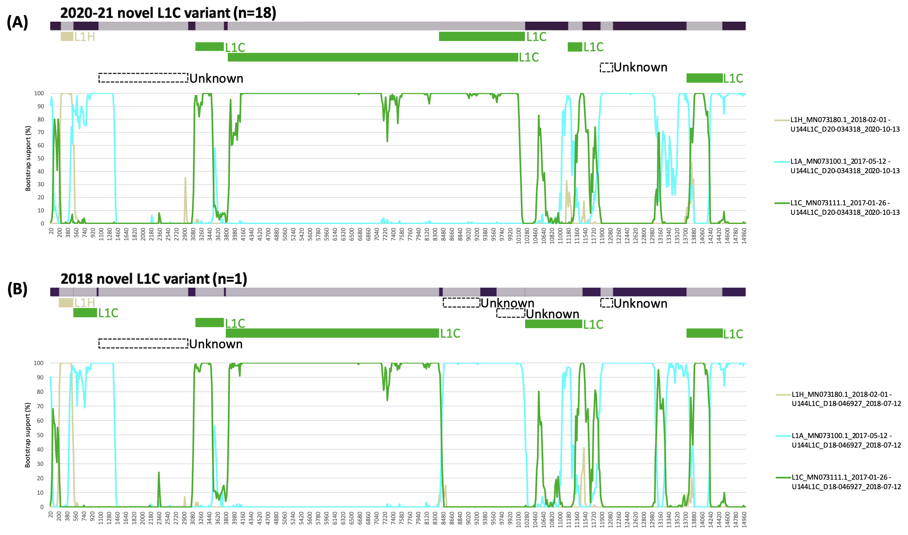
Supplementary figure 2. BOOTSCAN plots showing putative recombination parents of the 2020-21 (A) and the 2018 L1C 1-4-4 WGSs (B) across genomic position compared to the full recombination plots summarized from the 7 detection methods. The bootstrap value (%) supporting the clustering of the novel L1C 1-4-4 recombinants – each parent was shown on the y-axis. Each putative parent was colored based on ORF5 gene-based classification; L1C (green), L1A (blue), and L1H (beige).
position in alignment  Supplementary table 2. Putative recombination profile of the novel L1C 1-4-4 WGSs detected by the 7 methods in RDP5 | gene | number of the novel L1C recombinants | Minor Parental Sequence(s) | Major Parental Sequence(s) | Detection Methods
 |  |  |  |  | RDP | GENECONV | Bootscan | Maxchi | Chimaera | SiSscan | 3Seq
188-506 | nsp1 | 19/19(all novel L1C) | L1H_MN073180.1 | L1A_MN073102.1 | 2.3632 𝗑 10⁻¹⁹ | 2.744 𝗑 10⁻¹³ | 1.2804 𝗑 10⁻¹⁹ | 4.6843 𝗑 10⁻⁶ | 1.6803 𝗑 10⁻⁶ | 3.554 𝗑 10⁻⁵ | 3.2907 𝗑 10⁻¹³
507-1022 | nsp1 | 1/19(only 2018 sequence) | L1C_MF526965.1 | Unknown*(L1A_KT257966.1,L1A_MF326990.1,L1A_MF326998.1,L1A_MN073084.1,L1A_MN073086.1,L1A_MN073088.1,L1A_MN073095.1) | 0.00039217 | NS** | 0.00164049 | 1.1918 𝗑 10⁻⁵ | 0.01518259 | NS | 5.6588 𝗑 10⁻⁷
1038-3010 | nsp1-2 | 19/19(all novel L1C) | Unknown(L1C_KP283416.1,L1A_MF326993.1,L1C_KR534893.1,L1C_KT257979.1,L1C_KT257980.1,L1C_KT257981.1,L1C_KT257982.1,L1C_KT581982.1,L1C_MN073119.1,L1C_MN073120.1,L1C_MN073121.1) | L1A_KP283414.1,L1C_JN654459.1,L1C_KF724409.1,L1C_KF724410.1,L1C_KP283401.1,L1C_KP283402.1,L1C_KP283403.1,L1C_KP283404.1,L1C_KP283410.1,L1C_MN073116.1,L1C_MN073117.1,L1C_MN073118.1 | 1.1591 𝗑 10⁻⁸⁵ | 3.3651 𝗑 10⁻⁸⁷ | 3.388 𝗑 10⁻⁵⁴ | 2.6093 𝗑 10⁻³¹ | 1.7083 𝗑 10⁻³¹ | 5.8983 𝗑 10⁻⁵⁵ | 1.4449 𝗑 10⁻³⁸
3135-3780 | nsp2 | 19/19(all novel L1C) | L1C_KT581982.1 | L1A_KT257988.1,L1A_KT257989.1,L1A_KT257990.1,L1A_KT257991.1 | 8.7186 𝗑 10⁻²⁸ | 3.3644 𝗑 10⁻³¹ | 1.6693 𝗑 10⁻⁴¹ | 1.961 𝗑 10⁻¹⁶ | 3.5081 𝗑 10⁻¹⁸ | 2.7754 𝗑 10⁻¹⁹ | 3.1557 𝗑 10⁻³⁸
3802-8442 | nsp2-9 | 19/19(all novel L1C) | L1C_MN073111.1,L1C_MN073112.1 | L1A_MN073100.1 | 6.667 𝗑 10⁻¹⁴⁸ | 1.821 𝗑 10⁻¹⁴⁸ | 1.152 𝗑 10⁻¹²⁶ | 2.0972 𝗑 10⁻⁴³ | 3.2853 𝗑 10⁻⁴⁴ | 3.0092 𝗑 10⁻⁶⁷ | 2.958 𝗑 10⁻¹¹²
8443-11554 | nsp9-12 | 18/19(all except 2018 sequences) | L1C_MN073114.1,L1C_MN073115.1 | L1A_MN073097.1 | 6.6777 𝗑 10⁻¹³ | 1.2441 𝗑 10⁻⁸ | 1.2762 𝗑 10⁻¹² | 6.0304 𝗑 10⁻⁷ | 4.3242 𝗑 10⁻⁵ | 1.7739 𝗑 10⁻⁶ | 5.2322 𝗑 10⁻¹⁰
8452-11230 | nsp9-11 | 18/19(all except 2018 sequences) | L1C_MN073114.1,L1C_MN073115.1 | U144L1C_D18-046927 | 2.083 𝗑 10⁻¹⁰⁸ | 2.5278 𝗑 10⁻⁸⁶ | 2.807 𝗑 10⁻¹⁰³ | 3.0471 𝗑 10⁻²⁸ | 3.0869 𝗑 10⁻²⁸ | 5.2367 𝗑 10⁻³² | 2.724 𝗑 10⁻⁹¹
8522-9358 | nsp9 | 1/19(only 2018 sequence) | Unknown(L1G_KP283400.1,L1G_KP283399.1,L1G_KP283408.1,L1G_KT258008.1) | L1A_MF326994.1,L1A_KR534894.1,L1A_KT257966.1,L1A_KT257967.1,L1A_KT257968.1,L1A_KT257976.1,L1A_KT258005.1,L1A_KX192112.1,L1A_KX192113.1,L1A_KX192114.1,L1A_KX192115.1,L1A_KX192116.1,L1A_KX192117.1,L1A_KX192118.1,L1A_KX192119.1,L1A_MF326985.1,L1A_MF326986.1,L1A_MF326987.1,L1A_MF326990.1,L1A_MF326991.1,L1A_MF326995.1,L1A_MF326996.1,L1A_MF326997.1,L1A_MF326998.1,L1A_MF326999.1,L1A_MF327000.1,L1A_MF327001.1,L1A_MK860181.1,L1A_MN073084.1,L1A_MN073086.1,L1A_MN073088.1,L1A_MN073089.1,L1A_MN073092.1,L1A_MN073095.1,L1A_MN073098.1,L1A_MN073099.1,L1A_MN175677.1,L1A_MT269879.1,L1A_MT376723.1,L1C_MF526965.1 | 2.6157 𝗑 10⁻¹¹ | NS | 2.2984 𝗑 10⁻¹¹ | 3.0108 𝗑 10⁻⁵ | 1.0899 𝗑 10⁻⁶ | 4.4837 𝗑 10⁻⁵ | 1.6454 𝗑 10⁻¹³
9684-10313 | nsp10 | 1/19(only 2018 sequence) | Unknown(L1F_MT269877.1,L1F_KY348848.1) | L1C_KF632717.1 | 5.5983 𝗑 10⁻⁹ | 2.7539 𝗑 10⁻⁵ | 2.0963 𝗑 10⁻¹¹ | 2.7359 𝗑 10⁻⁶ | 4.3888 𝗑 10⁻⁷ | 1.2764 𝗑 10⁻¹⁰ | 1.4716 𝗑 10⁻⁷
10314-11554 | nsp10-12 | 1/19(only 2018 sequence) | L1C_MN073114.1,L1C_MN073115.1 | L1A_KT257990.1,L1A_KT257988.1,L1A_KT257989.1,L1A_KT257991.1 | 2.1769 𝗑 10⁻²⁹ | 1.4218 𝗑 10⁻¹⁹ | 1.1251 𝗑 10⁻²⁹ | 6.5286 𝗑 10⁻¹⁶ | 2.5242 𝗑 10⁻⁹ | 2.0791 𝗑 10⁻¹⁷ | 6.493 𝗑 10⁻²¹
11968-12217 | ORF2 | 19/19(all novel L1C) | Unknown(L8_MN073165.1,L5_KU131561.1,L5_KY348853.1,L6_KF724407.1,L8_JN654458.1,L8_KU131563.1,L8_KY348852.1,L8_MK796165.1,L8_MK837936.1,L8_MN073157.1,L8_MN073158.1,L8_MN073159.1,L8_MN073160.1,L8_MN073161.1,L8_MN073162.1,L8_MN073164.1,L8_MN073168.1,L8_MN073169.1,L8_MN073170.1,L8_MN073171.1,L9_KT207837.1,L9_KU131565.1,L9_KY348847.1) | L1C_KP283401.1,L1C_KF632717.1,L1C_KF724409.1,L1C_KF724410.1,L1C_KF724411.1,L1C_KP283402.1,L1C_KP283403.1,L1C_KP283404.1,L1C_KP283409.1,L1C_KP283410.1,L1C_KP283413.1,L1C_MN073121.1,L1C_MT269878.1 | 1.3832 𝗑 10⁻⁵ | NS | 1.8005 𝗑 10⁻⁵ | 0.00030582 | 0.00011315 | 2.5529 𝗑 10⁻⁵ | 8.3087 𝗑 10⁻⁹
13802-14582 | ORF5-6 | 19/19(all novel L1C) | L1C_KF724410.1,L1C_KF724409.1,L1C_KF724411.1,L1C_KP283401.1,L1C_KP283409.1,L1C_KP283410.1,L1C_MN073116.1,L1C_MN073117.1,L1C_MN073118.1 | L1A_MF326985.1 | 2.0973 𝗑 10⁻²⁷ | 1.7438 𝗑 10⁻²² | 6.3121 𝗑 10⁻²⁷ | 6.2024 𝗑 10⁻¹² | 1.5666 𝗑 10⁻¹³ | 5.2422 𝗑 10⁻¹⁴ | 8.433 𝗑 10⁻²⁵

*Unknown = The sequence listed as unknown was used to infer the existence of a missing parental sequence. (Only one parent and a recombinant need be in the alignment for a recombination event to be detectable.)
**NS = No significant P-value was recorded for this recombination event using the particular method.
Supplementary table 3. Temporal signal of PRRSV-2 WGS fragment trees
WGS  fragment | Best-fitting root method
 | Heuristic residual mean squared |  | Residual mean squared |  | Correlation |  | R-squared
 | r* | R² | r | R² | r | R² | r | R²
ORF1a-1 | 0.3817 | 0.1457 | 0.3817 | 0.1457 | 0.3875 | 0.1502 | 0.3875 | 0.1502
ORF1a-2 | -0.0256 | 6.56 𝗑 10⁻⁴ | -0.0256 | 6.56 𝗑 10⁻⁴ | 0.2677 | 7.17 𝗑 10⁻² | 0.2677 | 7.17 𝗑 10⁻²
ORF1b | 0.3438 | 0.1182 | 0.3722 | 0.1385 | 0.4447 | 0.1978 | 0.4447 | 0.1978
3'ORFs | 0.06546 | 4.29 𝗑 10⁻³ | 0.06546 | 4.29 𝗑 10⁻³ | 0.3411 | 0.1164 | -0.3905 | 0.1525

*r = Pearson’s correlation coefficient between root-to-tip divergence and time

