Supplementary material

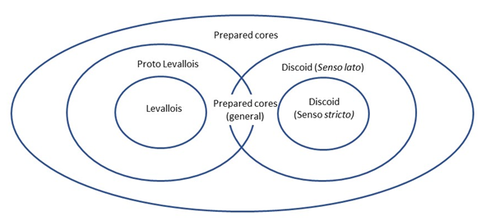

**Figure S.1.** A schematic illustration of the prepared core assemblage, including all three core types: proto Levallois, discoid and prepared cores (general).

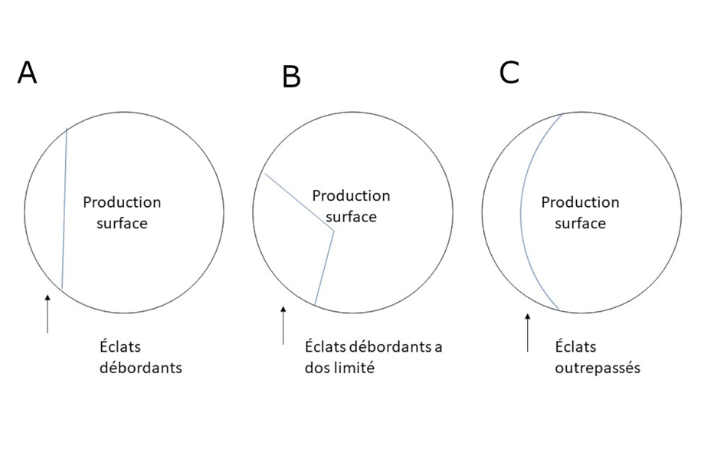

**Figure S.2.** Schematic description of *éclats débordants* scars on the core

production surface. A: *Éclats débordants*, B: *éclats débordants a dos limité*, C: *éclats outrepassés*.

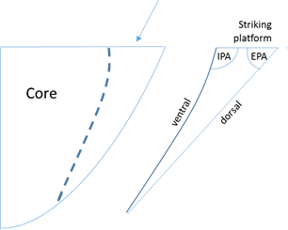

**Figure S.3**. Schematic illustration of the angles between the striking platform and the dorsal\ventral face of CTEs and end products. IPA: internal platform angle, EPA: external platform angle.

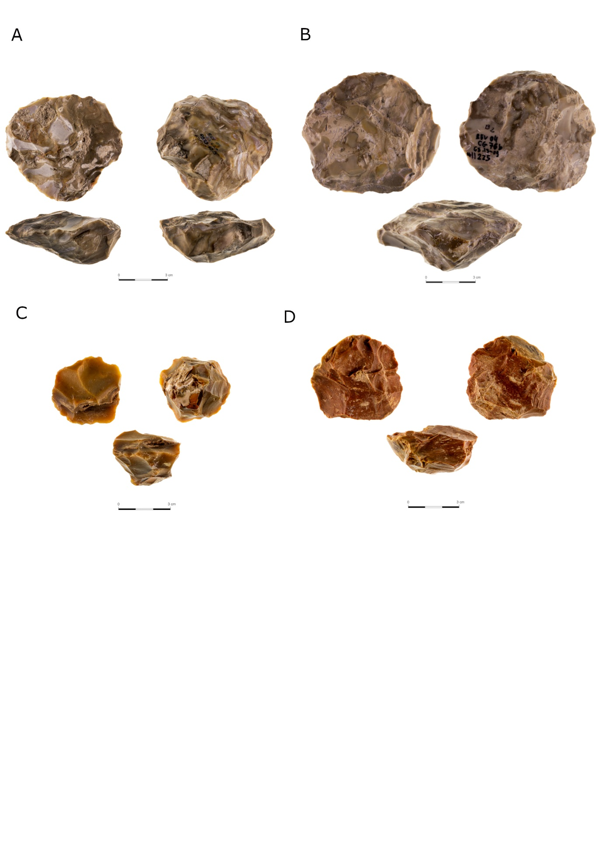

Figure S.4. Proto-Levallois cores from Revadim (**A**,**B**) and Jaljulia (**C**,**D**). The striking platform is shown in the left part of each figure.

Figure S.5. Discoid core from Revadim exhibiting two stages of use, most probably both as cores, indicated by patina differences. The blue dots represent the old patinated surfaces.

Table S.1: Assemblage composition at Revadim Area B and Area C (Agam and Barkai, 2018a; Rosenberg-Yefet and Barkai, 2019; Solodenko, 2010).

|  |  |  |  |  |  |  |  |  |  |  |  |  |
| --- | --- | --- | --- | --- | --- | --- | --- | --- | --- | --- | --- | --- |
| **Layer** | **B1** | | | **B2** | | | **C3** | | | **C5** | | |
|  | **No.** | **% of débitage and shaped items** | **% of total assemblage** | **No.** | **% of débitage and shaped items** | **% of total assemblage** | **No.** | **% of débitage and shaped items** | **% of total assemblage** | **No.** | **% of débitage and shaped items** | **% of total assemblage** |
| Primary Element Flake | 23 | 3.4% | 0.4% | 109 | 3.5% | 0.8% | 2397 | 13.4% | 8.4% | 57 | 11% | 3% |
| Primary Element Blade |  | 0.0% | 0.0% | 3 | 0.1% | 0.0% | 40 | 0.2% | 0.1% |  | 0% | 0% |
| Flake | 119 | 17.8% | 2.1% | 471 | 15.3% | 3.3% | 3734 | 20.9% | 13.1% | 81 | 15% | 5% |
| Broken flake | 173 | 25.9% | 3.0% | 782 | 25.3% | 5.4% | 4717 | 26.4% | 16.6% |  | 0% | 0% |
| Blade | 1 | 0.1% | 0.0% | 15 | 0.5% | 0.1% | 87 | 0.5% | 0.3% | 4 | 1% | 0% |
| Core | 21 | 3.1% | 0.4% | 151 | 4.9% | 1.0% | 1323 | 7.4% | 4.7% | 28 | 5% | 2% |
| Core Trimming Elements (CTE) | 27 | 4.0% | 0.5% | 125 | 4.1% | 0.9% | 1104 | 6.2% | 3.9% | 62 | 12% | 4% |
| Core on flake | 9 | 1.3% | 0.2% | 49 | 1.6% | 0.3% | 944 | 5.3% | 3.3% | 31 | 6% | 2% |
| Recycled items |  | 0.0% | 0.0% |  | 0.0% | 0.0% | 708 | 4.0% | 2.5% | 34 | 6% | 2% |
| Tool | 280 | 41.9% | 4.9% | 1321 | 42.8% | 9.2% | 2541 | 14.2% | 8.9% | 224 | 42% | 13% |
| Special Spall | 15 | 2.2% | 0.3% | 59 | 1.9% | 0.4% | 301 | 1.7% | 1.1% | 17 | 3% | 1% |
| Sum of Débitage and Shaped Items | 668 | 100.0% | 11.7% | 3085 | 100.0% | 21.4% | 17896 | 100.0% | 63.0% | 538 | 100% | 31% |
| Micro flake | 257 |  | 4.5% | 678 |  | 4.7% | 1721 |  | 6.1% | 145 |  | 8% |
| Chip | 4640 |  | 81.3% | 9795 |  | 68.0% | 7252 |  | 25.5% | 721 |  | 41% |
| Chunk | 107 |  | 1.9% | 645 |  | 4.5% | 1211 |  | 4.3% | 330 |  | 19% |
| Flaked pebble | 22 |  | 0.4% | 131 |  | 0.9% | 127 |  | 0.4% | 5 |  | 0% |
| Raw material | 13 |  | 0.2% | 66 |  | 0.5% | 202 |  | 0.7% |  |  | 0% |
| Total | **5707** |  | **100.0%** | **14400** |  | **100.0%** | **28409** |  | **100.0%** | **1739** |  | 100% |

Table S.2: A general breakdown of the Jaljulia Area B assemblage

|  |  |  |  |
| --- | --- | --- | --- |
| **Area** | **B** | | |
|  | **No.** | **% of débitage and shaped items** | **% of total assemblage** |
| Primary element flake (PE flake) | 1055 | 15% | 6.41% |
| Primary element blade (PE blade) | 44 | 1% | 0.27% |
| Non-modified base flake | 1320 | 19% | 8.02% |
| Modified base flake | 724 | 10% | 4.40% |
| Blade | 38 | 1% | 0.23% |
| Lip flake | 127 | 2% | 0.77% |
| Prepared core flake | 99 | 1% | 0.60% |
| Core trimming element (CTE) | 355 | 5% | 2.16% |
| Core | 629 | 9% | 3.82% |
| Core on flake | 195 | 3% | 1.19% |
| Recycled products | 206 | 3% | 1.25% |
| Shaped items | 2032 | 29% | 12.35% |
| Special waste | 229 | 3% | 1.39% |
| **Sum of débitage and shaped items** | **7053** | **100%** | **42.86%** |
| Chunk flake | **3735** |  | 22.70% |
| Chunk | 3094 |  | 18.80% |
| Chip | 1820 |  | 11.06% |
| Micro flake | 745 |  | 4.53% |
| Raw material | 7 |  | 0.04% |
| **Total** | **16454** |  | **100.00%** |

Table S.3: Number of prepared cores and their products (CTEs and blanks) for each of the Revadim layers included in this study and Jaljulia area B.

|  |  |  |  |  |  |  |  |  |  |  |
| --- | --- | --- | --- | --- | --- | --- | --- | --- | --- | --- |
| **Jaljulia** | | **Revadim** | | | | | | | | **Site** |
| **Area B** | | **Layer B1** | | **Layer C3** | | **Layer B2** | | **Layer C5** | |  |
| % out of  total | No. | % out of  total | No. | % out of  total | No. | % out of  total | No. | % out of  total | No. | **Cores** |
| 82.6% | 497 | 60% | 9 | 96% | 1257 | 80% | 49 | 78% | 21 | **"Simple" flake cores** |
| 17.4% | 105 | 40% | 6 | 4% | 49 | 20% | 12 | 22% | 6 | **Prepared cores** |
| 3.0% | 18 | 13% | 2 | 1% | 9 | 2% | 1 | 4% | 1 | Prepared cores (general) |
| 8.3% | 50 | 20% | 3 | 1% | 18 | 18% | 11 | 15% | 4 | Proto Levallois cores |
| 6.1% | 37 | 7% | 1 | 2% | 22 |  | - | 4% | 1 | Discoid cores |
| 100.0% | 602 | 100% | 15 | 100% | 1306 | 100% | 61 | 100% | 27 | **Total** |
| % out of  total | No. | % out of  total | No. | % out of  total | No. | % out of  total | No. | % out of  total | No. | **CTEs** |
| 87.7% | 429 | - | - | 98% | 770 | - | - | 95% | 59 | Non prepared cores  CTEs |
| 12.3% | 60 | - | - | 2% | 18 | - | - | 5% | 3 | **CTEs of prepared cores** |
| 100.0% | 489 | - | - | 100% | 788 | - | - | 100% | 62 | **Total** |
| % out of  total | No. | % out of  total | No. | % out of  total | No. | % out of  total | No. | % out of  total | No. | **Blanks** |
| 97.1% | 3291 | - | - | 99.9% | 2194 | - | - | 96% | 142 | Falkes |
| 2.9% | 99 | - | - | 0.1% | 2 | - | - | 4% | 6 | **Prepared cores products** |
| 100.0% | 3390 | - | - | 100.0% | 2196 | - | - | 100% | 148 | **Total** |

Note: The numbers include broken items that were not considered in the detailed analysis.

Table S.4. Metric data for the three core types from both sites. The SD is given in parentheses. Production surface (produc. Sur.).

|  |  |  |  |  |  |  |  |  |  |
| --- | --- | --- | --- | --- | --- | --- | --- | --- | --- |
| **Core type** | **Revadim** | | | | **Core type** | **Jaljulia** | | | |
|  | Length  (produc. Sur.) | Width (produc. Sur.) | Length (largest scar) | Width (largest scar) |  | Length (produc. Sur.) | Width (produc. Sur.) | Length (largest scar) | Width (largest scar) |
| **Proto-**  **Levallois**  **(n = 36)** | 4.5 (1.6) | 4.3 (1.2) | 2.8 (1) | 2.5 (0.8) | **Proto- Levallois**  **(n = 44)** | 5.6 (2.9) | 5.4 (1.3) | 3.7 (1.3) | 3.2 (1.3) |
| **Discoid**  **(n = 24)** | 4.8 (1.8) | 4.8 (1.8) | 2.6 (1) | 2.7 (1) | **Discoid**  **(n = 35)** | 5.2 (1.2) | 5.2 (1.3) | 2.9 (0.7) | 2.8 (0.7) |
| **Prepared**  **cores**  **(general)**  **(n = 9)** | 4.07 (1.2) | 4.03 (1.1) | 2.8 (1) | 2.2 (0.4) | **Prepared cores (general) (n = 13)** | 4.3 (1) | 4.2 (0.7) | 2.5 (0.9) | 2 (0.6) |

Table S.5. Metric data for the two CTE types from both sites. The SD is given in parentheses.

|  |  |  |  |  |  |
| --- | --- | --- | --- | --- | --- |
| **CTE type** | **Revadim** | | **CTE type** | **Jaljulia** | |
|  | **Length** | **Width** |  | **Length** | **Width** |
| *Éclats débordants* (n=11) | 4.05 (1.4) | 3.7 (1.1) | *Éclats débordants* (n=20) | 3.5 (1) | 3.05 (0.9) |
| Prepared core CTEs (n=10) | 3.5 (0.9) | 2.9 (0.9) | Prepared core CTEs (n=40) | 3.4 (1.4) | 3.1 (1.1) |

Table S.6. Metric measurements for the prepared core blanks from Jaljulia.

|  |  |  |  |  |  |
| --- | --- | --- | --- | --- | --- |
|  | **Length** | **Width** | **Thickness (bulb)** | **Thickness (middle)** | **Thickness (end)** |
| **Prepared core flakes (n=99)** | 3.8 | 3.8 | 0.7 | 0.8 | 0.4 |