Frontiers in Forests and Global Change

**Supplementary Materials**

Table S1. Categories of variables assessed by the Built Environment Domain analysis for the Santa Barbara Regional Wildfire Mitigation Program (RWMP).

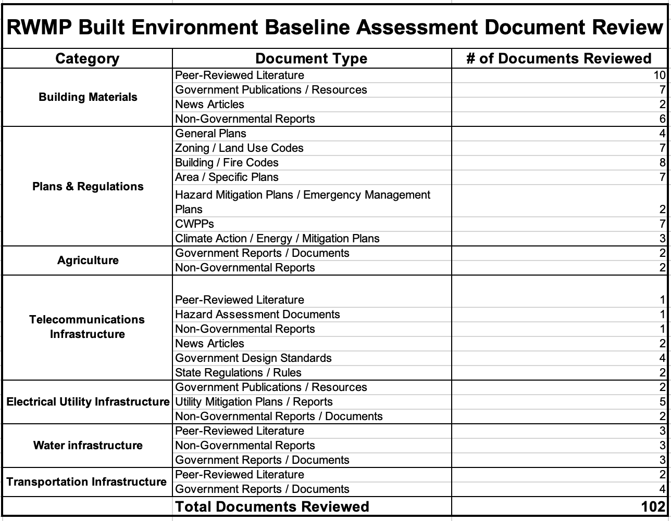

Table S2. Wildfire Hazards and Resilience Indicators by Community K-Means Cluster Analysis Groups. Comparison of wildfire hazard, built environment and landscape indicators for sets of communities by cluster group (and other assessments) will enable prioritization of wildfire hazard and risk mitigation programs to regions most needing them.  By column, group means not sharing letters differed significantly in Tukey Honest Significant Difference comparisons (ɑ < 0.05).

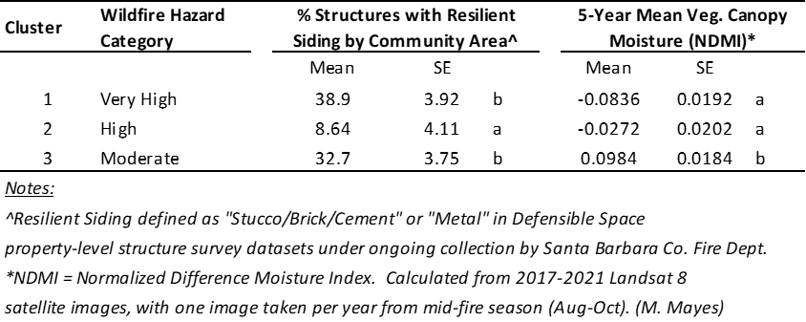

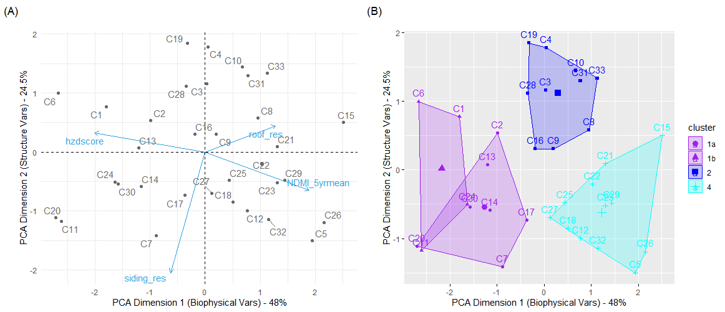

Figure S1. Biophysical and built environment characteristics across communities in the Santa Barbara RWMP Area.  (A) Principal Components Analysis visualization. X- and y-axes represent PCA dimensions, blue arrows depicting input variable loading vectors, and grey labeled dots indicate rotated data cloud values for community areas. (B) K-Means Cluster Analysis.  Overlapping clusters were grouped together for means’ comparison analyses (Table S2).

Further Explanation of Methods for K-Means Cluster Analysis (Table S2 and Figure S1):

K-means cluster analyses were conducted using three primary data inputs. The first was field survey data on built structures’ roofing and siding materials, collected during property-level defensible space assessments by the Santa Barbara County Fire Department. The survey data analyzed constituted a total of 2101 individual structure assessments across 33 Santa Barbara community areas, with community areas roughly delineated by management structure for readiness-response planning of the Santa Barbara County Fire Department. The second data input was an original wildfire hazard layer modeled with the FlamMap software package (Finney, 2006; Finney *et al.*, 2011), one of a series of hazard modeling projects conducted by the Santa Barbara RWMP, Spatial Informatics Group (SIG) and Spatial Informatics Group-Natural Assets Laboratory (SIG-NAL) and UCSB researchers. Data inputs for the wildfire hazard model included high-resolution, spatial climate data downscaled from the WRF weather model that representing severe fire weather conditions coinciding with past wildfires in Santa Barbara (Jones *et al.*, 2021) , and fuels models from the California Forest Observatory (<https://forestobservatory.com/>). The third data input was a satellite remote sensing indicator of vegetation canopy moisture, specifically Normalized Difference Moisture Index (NDMI), which was extracted and averaged for community area spatial polygons from fire season Landsat 8 satellite imagery during the last five years (2017-2021 inclusively).

K-Means analyses were conducted using the R package [factoextra](https://rpkgs.datanovia.com/factoextra/index.html) (Kassambara and Mundt, 2020) and we acknowledge the contributions of developers of all other dependent packages therein. The optimal cluster number (4) was identified via the Gap Statistic method (clusGap function; (Tibshirani, Walther and Hastie, 2001). One-way analysis of variance was used to assess the effect of cluster membership on percentage of structures with resilient siding and vegetation canopy moisture index values, with the unit of observation being individual community areas (N=33). Two overlapping clusters in the K-means analyses (1a, 1b) were combined as one group for analysis. Means comparison tests across cluster groups was conducted using Tukey Honest Significant Difference tests. Additional to factoextra, R packages used for analyses included cluster, rcompanion, lsmeans, multcomp, multcompView, emmeans, and the tidyverse. All analyses were conducted using R (4.1.2) and R Studio (2022.02.0 Build 443).

**References**

Finney, M.A. (2006) “An Overview of FlamMap Fire Modeling Capabilities,” in Andrews, P.L. and Butler, B.W. (eds). Portland: USDA Forest Service Proceedings RMRS-P-41, pp. 213–220.

Finney, M.A. *et al.* (2011) “A simulation of probabilistic wildfire risk components for the continental United States,” *Stochastic Environmental Research and Risk Assessment*, 25(7), pp. 973–1000. doi:10.1007/s00477-011-0462-z.

Jones, C. *et al.* (2021) “Climatology of Sundowner winds in coastal Santa Barbara, California, based on 30 yr high resolution WRF downscaling,” *Atmospheric Research*, 249. doi:10.1016/j.atmosres.2020.105305.

Kassambara, A. and Mundt, F. (2020) “factoextra.” Available at: https://rpkgs.datanovia.com/factoextra/index.html (Accessed: April 28, 2022).

Tibshirani, R., Walther, G. and Hastie, T. (2001) “Estimating the number of clusters in a data set via the gap statistic,” *Journal of the Royal Statistical Society: Series B (Statistical Methodology)*, 63(2), pp. 411–423. doi:10.1111/1467-9868.00293.