# Supplementary Figures and Tables

## Supplementary Figures

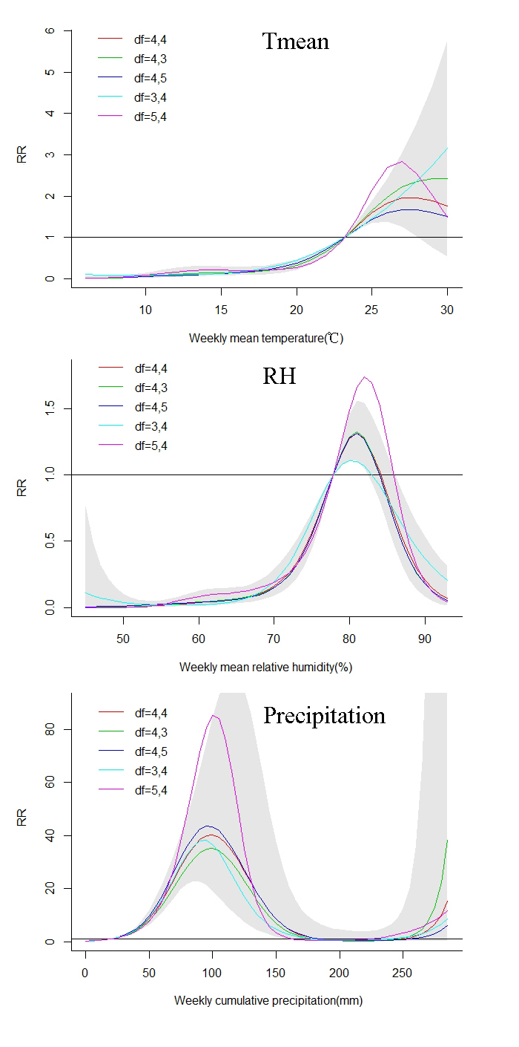

**Supplementary Figure 1.** Results of sensitive analysis by changing the degree of freedom of long-term trend and seasonality and changing the degrees of freedom of meteorological factors and corresponding lags.

## Supplementary tables

**Supplementary Table 1.** Spearman’s correlation analysis of ST cases and meteorological factors

|  |  |  |  |  |
| --- | --- | --- | --- | --- |
|  | Case | Mean relative humidity(%) | Precipitation(mm) | Mean temperature(℃) |
| Case | 1.00 |  |  |  |
| Mean relative humidity(%) | 0.21* | 1.00 |  |  |
| Precipitation(mm) | 0.23* | 0.73* | 1.00 |  |
| Mean temperature(℃) | 0.64* | 0.23* | 0.34* | 1.00 |
| * P < 0.05 | | | | |

|  |  |  |  |  |  |  |  |  |  |  |  |  |  |  |
| --- | --- | --- | --- | --- | --- | --- | --- | --- | --- | --- | --- | --- | --- | --- |
| **Supplementary Table 2.** The relative risks of different factors at different lag weeks | | | | | | | | | | | | | | |
|  | Lag 0 | Lag 2 | Lag 4 | Lag 5 | Lag 7 | Lag 9 | Lag 11 | Lag 13 | Lag 15 | Lag 17 | Lag 19 | Lag 21 | Lag 23 | Lag 25 |
| *P5* t | 0.86(0.69-1.08) | 0.71(0.67-0.76) | 0.71(0.65-0.77) | 0.74(0.69-0.80) | 0.82(0.78-0.86) | 0.89(0.85-0.93) | 0.95(0.91-0.98) | 0.99(0.94-1.03) | 1.01(0.97-1.05) | 1.02(0.99-1.06) | 1.03(0.99-1.06) | 1.02(0.98-1.06) | 1.01(0.96-1.06) | 1.00(0.93-1.07) |
| *P25* t | 0.73(0.64-0.84) | 0.73(0.70-0.76) | 0.78(0.74-0.82) | 0.82(0.78-0.86) | 0.90(0.97-0.93) | 0.97(0.94-0.99) | 1.01(0.98-1.04) | 1.04(1.01-1.07) | 1.05(1.02-1.08) | 1.04(1.01-1.07) | 1.02(1.00-1.06) | 1.00(0.97-1.03) | 0.97(0.93-1.01) | 0.94(0.89-0.99) |
| *P75* t | 1.18(1.10-1.27) | 1.09(1.05-1.12) | 1.04(1.01-1.08) | 1.03(1.00-1.06) | 1.02(1.00-1.04) | 1.01(0.99-1.03) | 1.01(0.98-1.03) | 1.00(0.98-1.03) | 1.00(0.98-1.03) | 1.00(0.98-1.02) | 1.01(0.98-1.03) | 1.01(0.98-1.04) | 1.01(0.98-1.05) | 1.02(0.97-1.07) |
| *P95* t | 1.18(1.06-1.32) | 1.05(1.00-1.11) | 1.01(0.95-1.07) | 1.01(0.96-1.06) | 1.01(0.97-1.05) | 1.02(0.98-1.06) | 1.02(0.98-1.06) | 1.02(0.98-1.07) | 1.02(0.98-1.06) | 1.02(0.98-1.06) | 1.01(0.97-1.06) | 1.01(0.96-1.06) | 1.00(0.94-1.07) | 1.00(0.92-1.09) |
| *P5* rh | 1.45(1.25-1.69) | 1.16(1.06-1.27) | 0.96(0.87-1.06) | 0.89(0.81-0.98) | 0.79(0.73-0.85) | 0.73(0.68-0.78) | 0.70(0.66-0.76) | 0.71(0.66-0.76) | 0.73(0.68-0.78) | 0.78(0.73-0.82) | 0.84(0.80-0.89) | 0.93(0.88-0.98) | 1.03(0.97-1.09) | 1.15(1.07-1.24) |
| *P25* rh | 1.09(1.02-1.16) | 0.90(0.87-0.93) | 0.85(0.82-0.88) | 0.86(0.83-0.89) | 0.89(0.86-0.91) | 0.91(0.89-0.94) | 0.94(0.91-0.96) | 0.95(0.93-0.98) | 0.96(0.94-0.99) | 0.97(0.95-1.00) | 0.98(0.96-1.00) | 0.98(0.96-1.00) | 0.98(0.96-1.01) | 0.98(0.95-1.02) |
| *P75* rh | 0.95(0.91-0.99) | 1.03(1.02-1.05) | 1.06(1.04-1.08) | 1.05(1.03-1.07) | 1.03(1.02-1.04) | 1.01(1.00-1.02) | 1.00(0.99-1.02) | 0.99(0.98-1.01) | 0.99(0.98-1.00) | 0.99(0.98-1.00) | 0.99(0.98-1.00) | 0.99(0.98-1.00) | 1.00(0.98-1.01) | 1.00(0.98-1.02) |
| *P95* rh | 0.89(0.82-0.97) | 0.94(0.90-0.98) | 0.96(0.92-1.00) | 0.96(0.92-1.00) | 0.96(0.93-1.00) | 0.96(0.93-1.00) | 0.96(0.93-1.00) | 0.96(0.92-1.00) | 0.96(0.92-1.00) | 0.96(0.93-1.00) | 0.96(0.93-1.00) | 0.96(0.92-1.00) | 0.96(0.92-1.00) | 0.96(0.91-1.00) |
| *P5*p | 0.94(0.90-0.97) | 0.88(0.86-0.90) | 0.87(0.85-0.89) | 0.88(0.86-0.90) | 0.90(0.88-0.92) | 0.92(0.90-0.93) | 0.93(0.92-0.95) | 0.95(0.93-0.96) | 0.96(0.94-0.97) | 0.97(0.95-0.98) | 0.98(0.96-0.99) | 0.98(0.97-1.00) | 0.99(0.97-1.01) | 1.00(0.97-1.02) |
| *P25* p | 0.95(0.92-0.98) | 0.90(0.89-0.92) | 0.89(0.88-0.91) | 0.90(0.88-0.92) | 0.92(0.90-0.93) | 0.93(0.92-0.95) | 0.95(0.93-0.96) | 0.96(0.94-0.97) | 0.97(0.95-0.98) | 0.97(0.96-0.99) | 0.98(0.97-0.99) | 0.99(0.97-1.00) | 0.99(0.98-1.01) | 1.00(0.98-1.01) |
| *P75* p | 1.10(1.04-1.15) | 1.19(1.16-1.22) | 1.21(1.17-1.24) | 1.19(1.16-1.22) | 1.15(1.13-1.17) | 1.12(1.10-1.14) | 1.09(1.07-1.11) | 1.07(1.06-1.09) | 1.06(1.04-1.07) | 1.05(1.04-1.06) | 1.04(1.03-1.06) | 1.04(1.02-1.05) | 1.04(1.02-1.06) | 1.04(1.01-1.06) |
| *P95* p | 1.14(1.03-1.28) | 1.22(1.14-1.30) | 1.19(1.11-1.28) | 1.16(1.09-1.24) | 1.09(1.03-1.17) | 1.05(0.99-1.13) | 1.04(0.97-1.11) | 1.04(0.97-1.11) | 1.05(0.99-1.12) | 1.08(1.02-1.15) | 1.13(1.07-1.19) | 1.18(1.12-1.25) | 1.25(1.17-1.33) | 1.32(1.22-1.43) |