**Chromosome-level Genome Assembly of *Acer pseudosieboldianum* Highlights the Mechanisms for Leaf Color and Shape Change**

**Supplementary Figures**

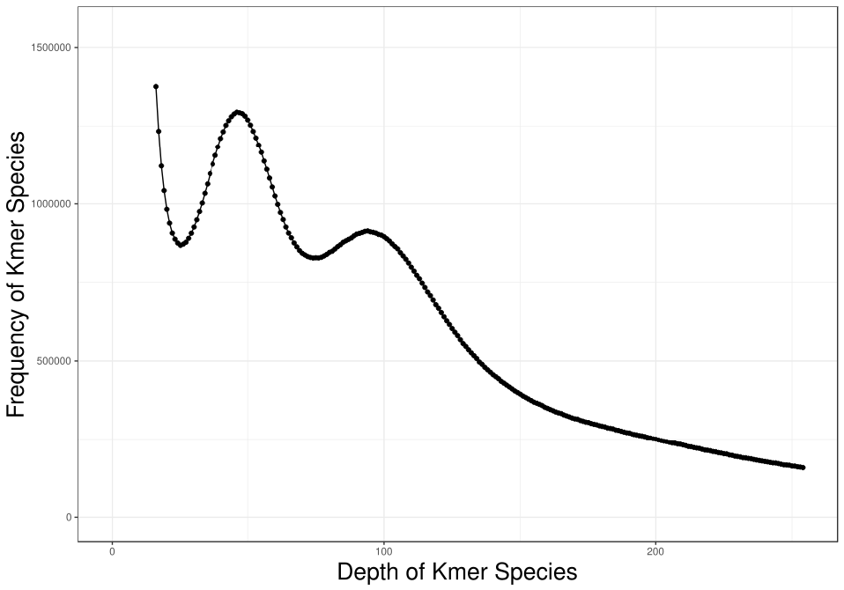

**Figure S1.** 15-mer analysis to estimate the [*A. pseudosieboldianum*](http://db.kib.ac.cn/CNFlora/SearchResult.aspx?CPNI=CPNI-111-20623) genome size. The x-axis and y-axis indicate the 15-mer number and frequency of kmer, respectively.

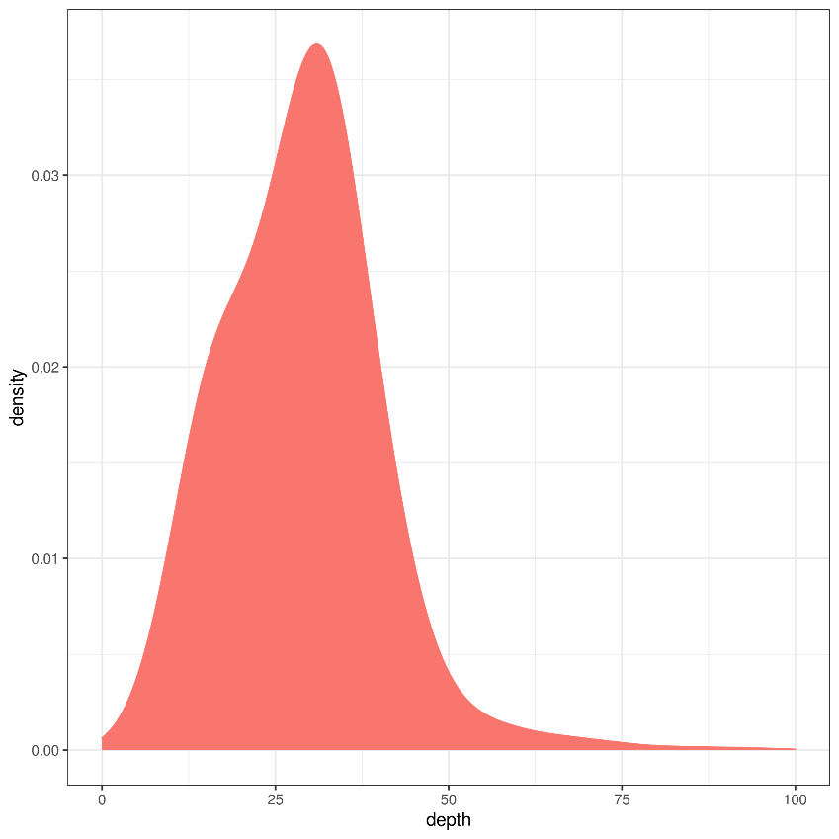

**Figure S2.** Sequencing depth distribution of the assembled *A. pseudosieboldianum* genome.

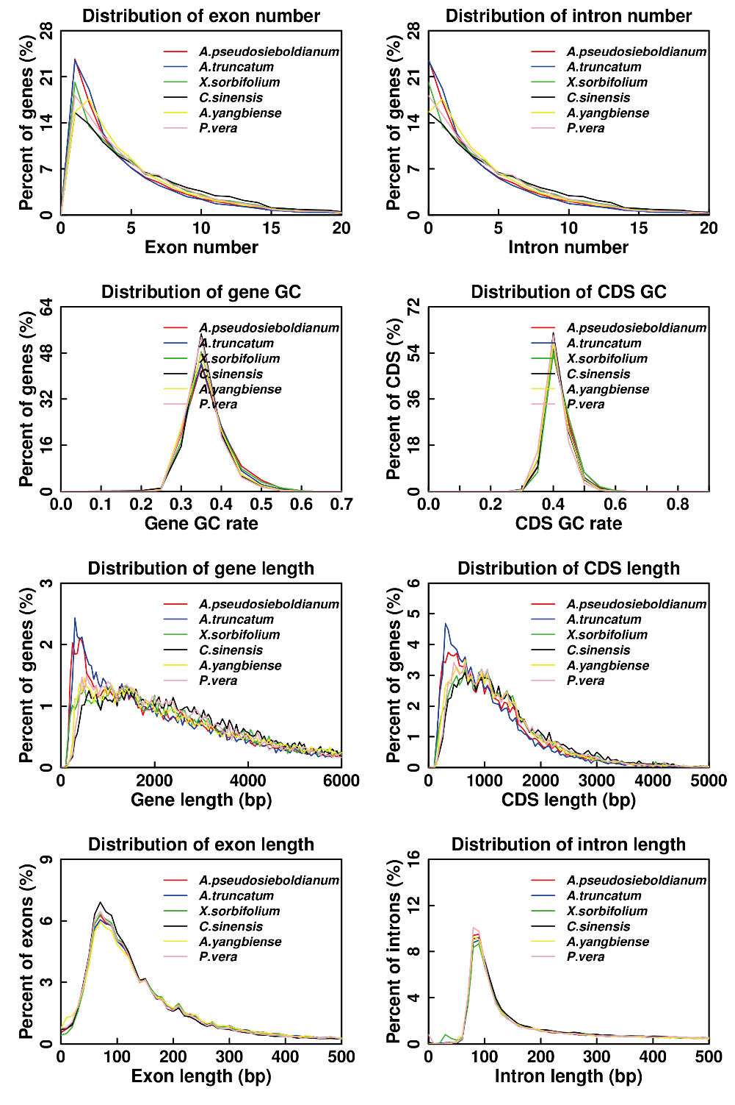

**Figure S3.** Cross-species comparisons of exon number, intron number, gene GC, CDS GC, gene length, CDS length, exon length and intron length distribution in six species.

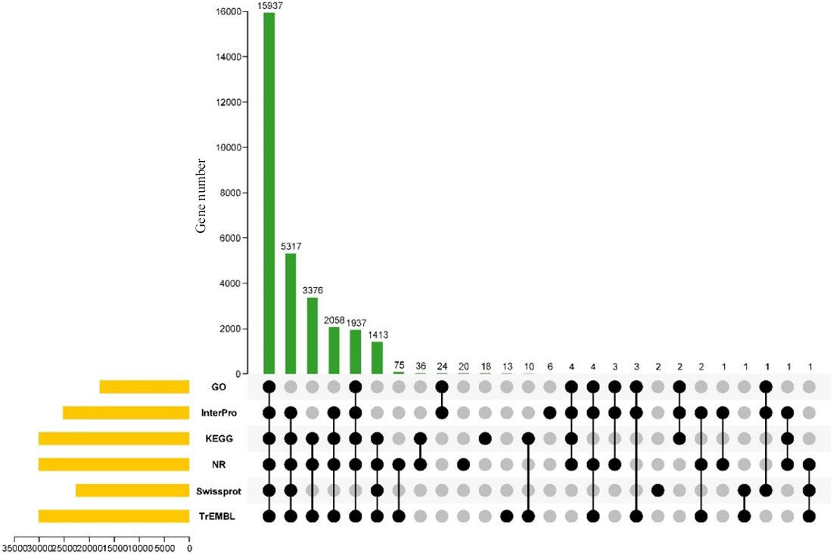

**Figure S4.** Upset plot of genes annotated in GO, InterPro, KEGG, NR, Swissprot and TrEMBL database in *A. pseudosieboldianum.*

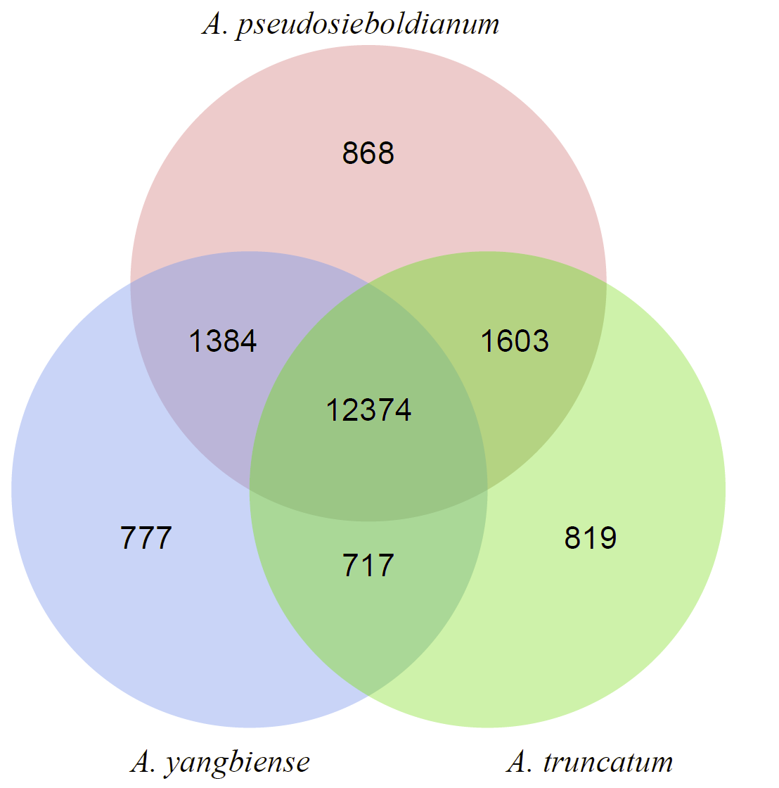

**Figure S5.** Venn diagrams of differentially expression gene family in *A. pseudosieboldianum*, *A. yangbiense* and *A. truncatum.*

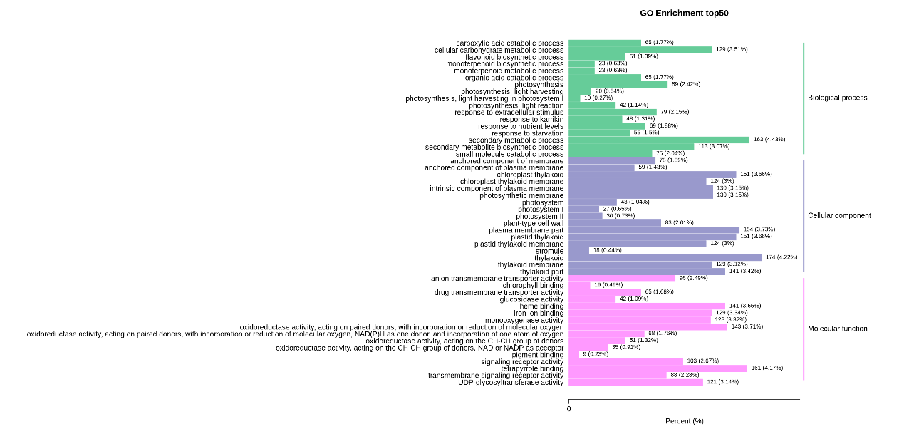

**Figure S6.** The GO enrichment analysis of GL vs RL during developmental fruit in *A. pseudosieboldianum*.

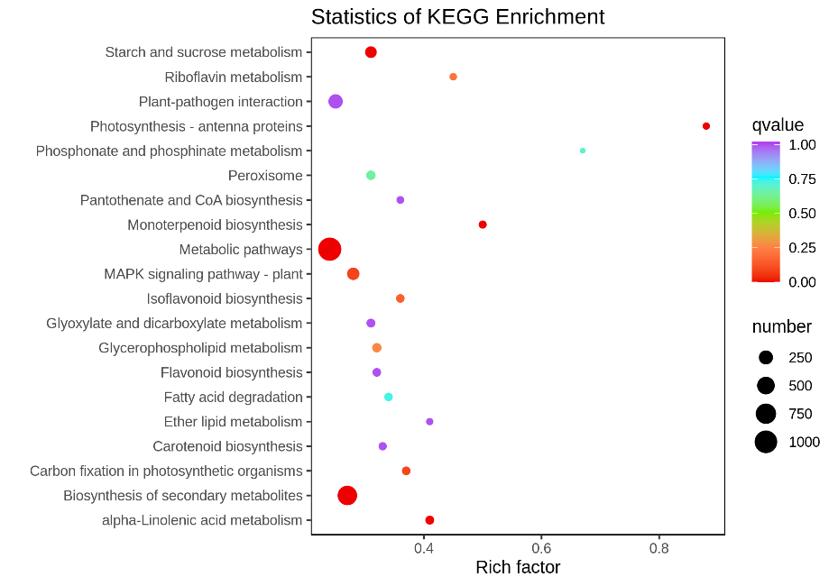

**Figure S7.** The KEGG enrichment analysis of GL vs RL during developmental fruit in *A. pseudosieboldianum.*

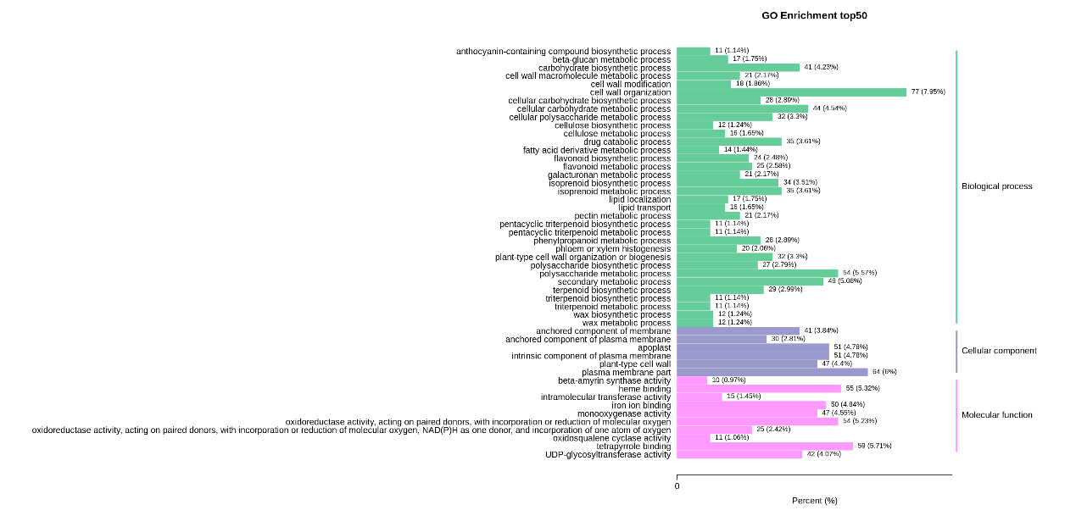

**Figure S8.** The GO enrichment analysis of GL vs HRL during developmental fruit in *A. pseudosieboldianum.*

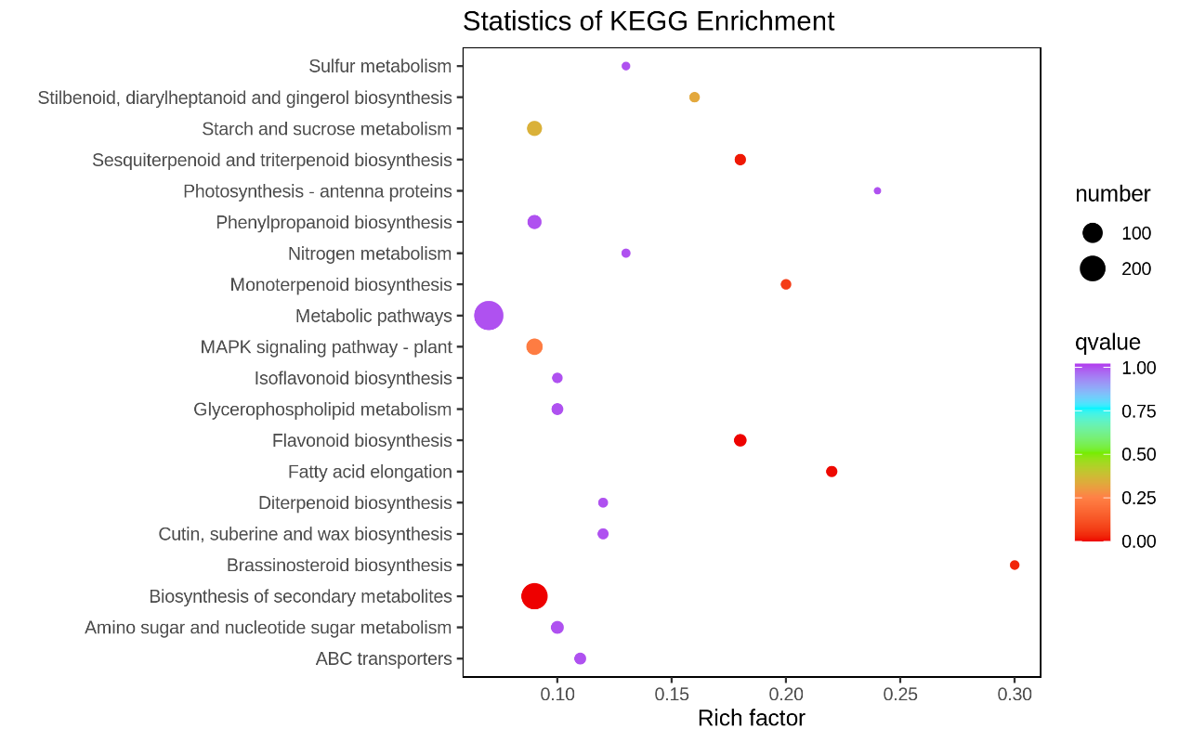

**Figure S9.** The KEGG enrichment analysis of GL vs HRL during developmental fruit in *A. pseudosieboldianum*.

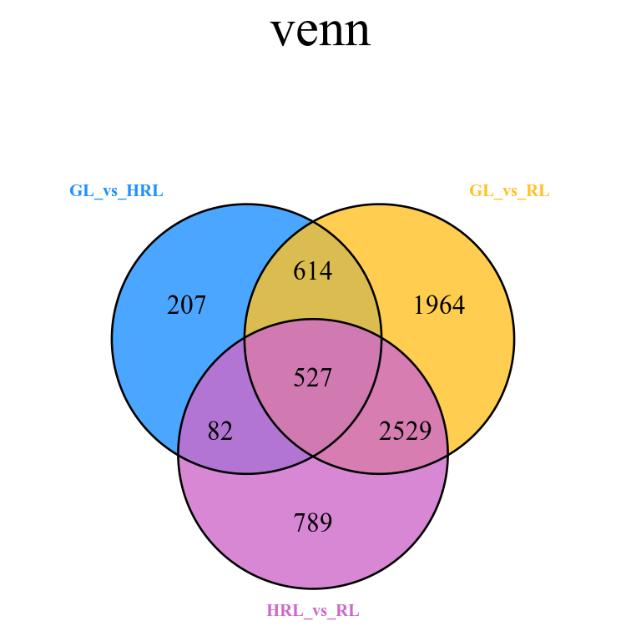

**Figure S10.** Venn diagrams of differentially expression genes in GL vs HRL, GL vs RL and HRL and RL

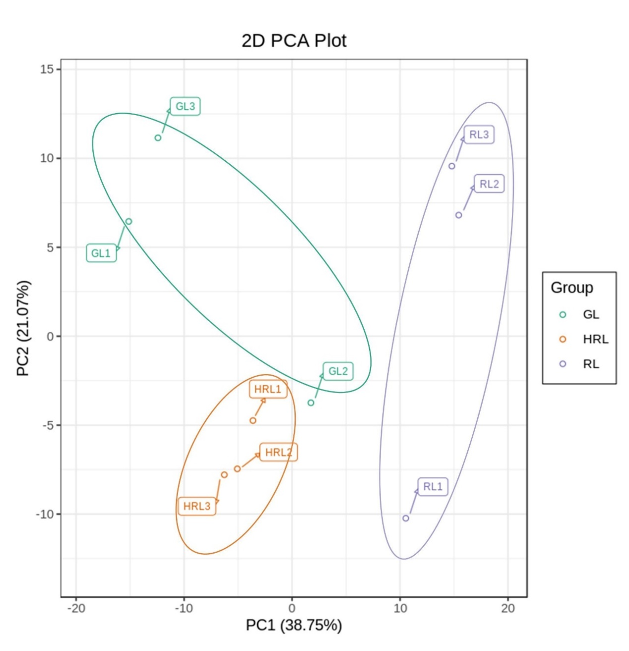

**Figure S11** PCA score plot metabolite profiles from different sample groups