Optimize the Preparation of Novel Pyrite Tailings Based Non-Sintered Ceramsite (PTNC) by Plackett-Burman Design Combined with Response Surface Method For Phosphorus Removal
Ruihuan Chen^{1,2}, Zhenlin Pan¹, Shuyi Chu³, Jibo Xiao^{1*}, Rengui Weng⁴, Da Ouyang⁵, Yunlong Yang¹, Xiangting Wu¹ and Zhida Huang^{6*}
¹College of Life and Environmental Science, Wenzhou University, Wenzhou, China
²Zhejiang Provincial Key Laboratory for Water Environment and Marine Biological Resources Protection, Wenzhou University, Wenzhou, China
³Wenzhou Academy of Agricultural Sciences, Wenzhou, China
⁴Indoor Environment Engineering Research Center of Fujian Province, Fujian University of Technology, Fuzhou, China
⁵Key Laboratory of Soil Contamination Bioremediation of Zhejiang Province, School of Environmental and Resource Sciences, Zhejiang Agriculture and Forestry University, Hangzhou, China
⁶Wenzhou Institute of Industry and Science, Wenzhou, China

*Co-corresponding authors:
Jibo Xiao (jbxiao@wzu.edu.cn);
Zhida Huang (40098008@qq.com)

Acknowledgments: The authors appreciate all the participants.

Text S1 Adsorption kinetic models
Nonlinear form pseudo fist-order:
${\text{q}}_{\text{t}}\text{=}{\text{q}}_{\text{e}}\text{(1-}{\text{e}}^{\text{-kt}}\text{)}$ (S1)
where q_{t} is the adsorption amount at time t (mg/g), q_{e} is the equilibrium adsorption amount (mg/g), and k₁ is the equilibrium rate constant of the model (min⁻¹).
Nonlinear formula of pseudo second-order model:
${\text{q}}_{\text{t}}\text{=}\frac{{\text{q}}_{\text{e}}^{\text{2}}{\text{k}}_{\text{2}}\text{t}}{\text{1+}{\text{q}}_{\text{e}}{\text{k}}_{\text{2}}\text{t}}$ (S2)
where k₂ is the pseudo second-order rate constant (mg/g/min).

Text S2 Adsorption isotherm models
Langmuir empirical model:
${\text{q}}_{\text{e}}\text{=}\frac{{\text{q}}_{\text{m}}{\text{k}}_{\text{L}}{\text{C}}_{\text{e}}}{\text{1+}{\text{k}}_{\text{L}}{\text{C}}_{\text{e}}}$ (S3)
where C_{e} (mg/L) is the equilibrium adsorbate concentration in liquid, q_{m} and k_{L} are the Langmuir maximum adsorption capacity and the energy related constant respectively.
The Freundlich isotherm is described as the following equation:
${\text{q}}_{\text{e}}\text{=}{\text{k}}_{\text{F}}{\text{C}}_{\text{e}}^{{\text{1}}/{\text{n}}}$ (S4)
where k_{F} is the Freundlich constant and n is the heterogeneity factor (Freundlich coefficient).
Text S3 Thermodynamic parameters calculation method
The free energy of adsorption (∆G), enthalpy of adsorption (∆H), and entropy of adsorption (∆S) during the adsorption process by PTNC was be calculated as with following equations:
$\text{∆G=-RT}\text{ln}{\text{K}}$ (S5)
$\text{ln}{\text{K}}\text{=}\frac{\text{∆S}}{\text{R}}\text{-}\frac{\text{∆H}}{\text{RT}}$ (S6)
Where R is the universal gas constant, 8.314 (J/mol/K); T (K) is the absolute solution temperature; K is the dimensionless thermodynamic equilibrium constant. The ΔH and ΔS values are calculated from the slope and intercept of the plot with the plot of lnK versus 1/T. Before the calculation process, the K gained from the best fitted model (Langmuir isotherm) need to be recalculated by multiplying it by 10⁶ to become dimensionless, due to its unit was L/mg.

Table S1 Chemical composition of original pyrite tailings
Composition | S | Fe | Si | P | C | Mn
Percent (%) | 45.32 | 50 | 2.2 | 0.23 | 0.26 | 0.4

Table S2 Chemical composition of dehydrated sludge
Composition | SiO₂ | Al₂O₃ | Fe₂O₃ | CaO | MgO | Na₂O | K₂O
Percent (%) | 63.51 | 17.21 | 6.53 | 0.96 | 3.65 | 1.71 | 2.89

Table S3 List of levels and factors of Plackett-Burman experiment
Factors | Code | Levels
Factors | Code | -1 | +1
Cement | A | 10 | 30
Calcium lime | B | 1 | 3
Anhydrous gypsum | C | 1 | 3
Dehydrated sludge | D | 2 | 6
Sodium bicarbonate | E | 0.5 | 1.5

Table S4 Variables and levels in Box-Behnken design response surface method
Levels | Factors
Levels | X₁  Dehydrated sludge (g) | X₂  Sodium bicarbonate (g) | X₃  Cement (g)
-1 | 2 | 0.5 | 10
0 | 4 | 1 | 20
+1 | 6 | 1.5 | 30

Table S5 Analysis results of specific surface area and pore size with BET method
Parameters | Units | Original PTNC | PTNC after adsorption
Specific surface area | m²·g⁻¹ | 7.21 | 11.39
Average pore volume | cm³·g⁻¹ | 0.024 | 0.029
Average pore aperture | nm | 13.42 | 10.08

Table S6 Physical characteristics of PTNC
Indicators | Standard value | PTNC performance
Water adsorption (%) | 22 | 25.08
Cylinder compressive strength (MPa) | 1.0 | 1.80
Porosity (%) | ≥40 | 53.90
Solubility in hydrochloric acid (%) | ≤2 | 5.36
Specific surface area (m²/g) | 0.5 | 7.21
Wear rate (%) | ≤6 | 2.08
Silt content (%) | ≤1 | 0.54

Table S7 The concentrations of heavy metals in the PTNC leachate
 | Cu | Pb | Cr | Zn | Ni | Cd
Detected value (mg/L) | 0.096 | 0.003 | 0.007 | 0.258 | 0.002 | 0.012
Standard limitation （mg/L） | 100 | 5 | 5 | 100 | 5 | 1

Table S8 The fitted parameters of two adsorption dynamic models
Pseudo first order |  |  | Pseudo second order
q_{e1} (mg/g) | k₁ (1/h) | R² | q_{e2} (mg/g) | k₂ (g/mg/h) | R²
0.2995 | 0.1661 | 0.9155 | 0.3527 | 0.4691 | 0.9100

Table S9 The isothermal adsorption model parameters of TP adsorption
T (K) | Langmuir |  |  | Freundlich
T (K) | q_{m} (mg/g) | K_{L} (L/mg) | R² | K_{F} (L/mg) | n (L/g) | R²
293 | 6.9603 | 0.8543 | 0.9421 | 3.0483 | 0.2487 | 0.8348
303 | 6.9824 | 0.8678 | 0.9574 | 3.0880 | 0.2495 | 0.8382
313 | 6.9978 | 1.1648 | 0.8530 | 3.2436 | 0.2353 | 0.7875

Table S10 Thermodynamic parameters for TP adsorption by PTNC
T (K) | ∆G (kJ/mol) | ∆H (kJ/mol) | ∆S (J/mol/K)
293 | -33.27 | -11.69 | 153.09
303 | -34.45
313 | -36.35

Fig. S1 XRD pattern of pyrite tailings

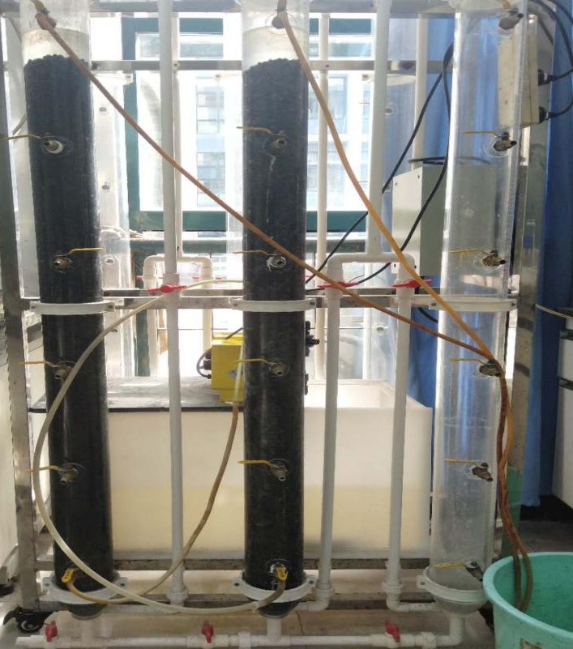
Fig. S2 Experimental device for dynamic adsorption experiment

Fig.S3 Comparison analysis of experimental and predicted TP removal rates

Fig. S4 Comparison XRD analysis of pyrite tailings, PTNC before and after adsorption of TP.

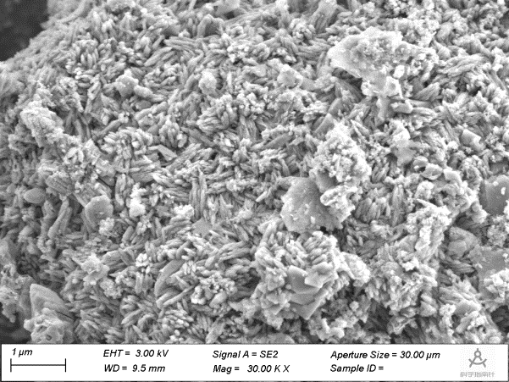

Fig. S5 SEM image of PTNC after adsorption

