## Supplementary Figures

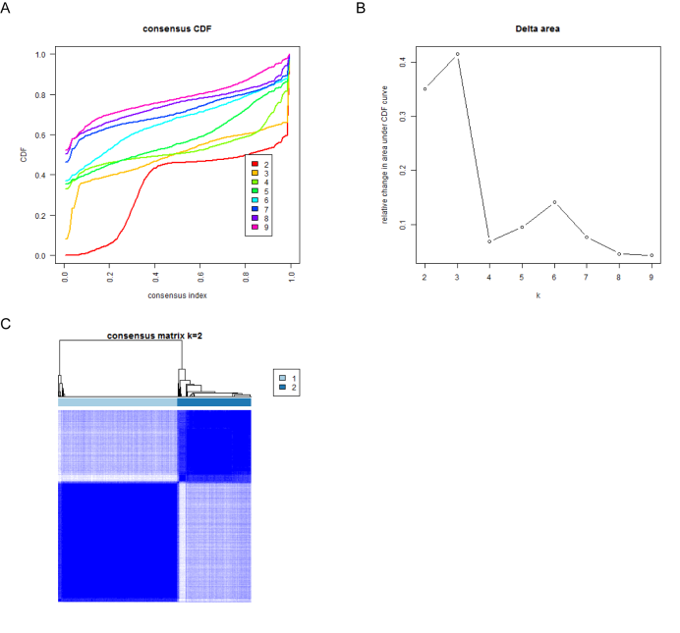

**Supplementary Figure S1.**Consensus clustering analysis based on the mRNA expression profiles of 52 pyroptosis-related genes. (**A, B**) Consensus clustering model with cumulative distribution function by k from 2 to 9. (**C**) Consensus matrix when k=2.

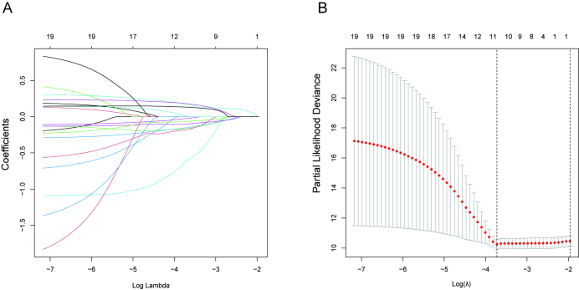

**Supplementary Figure S2.** LASSO Cox regression analysis was applied to model construction. **(A, B)** Screening the optimal parameter (lambda), which is represented by the vertical black line in the plot.