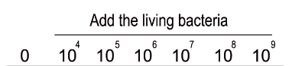
Figure 5A

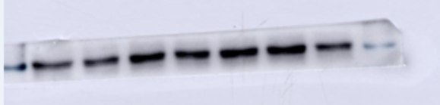
p-mTOR

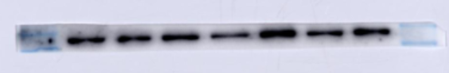
PIK3CB

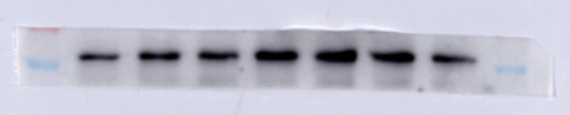

p-P70S6K

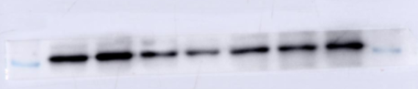

p-PDCD4

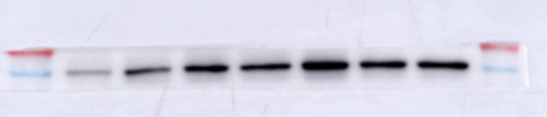
p-AKT

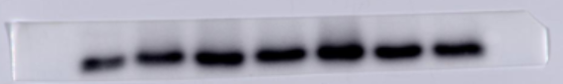
p-4EBP1

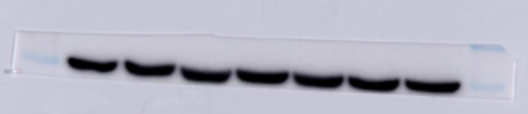
β-Actin

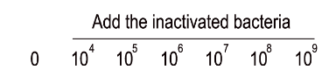
Figure 5B

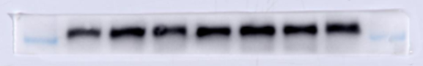
p-mTOR

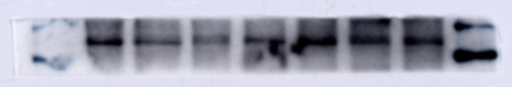

PIK3CB

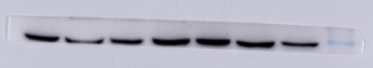
p-P70S6K

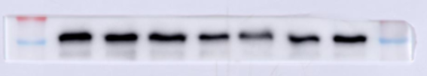

p-PDCD4

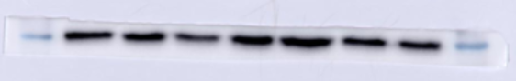
p-AKT

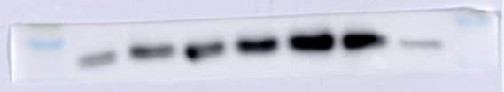
p-4EBP1

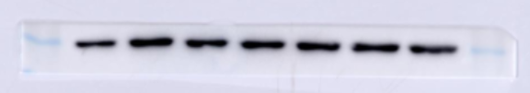
β-Actin

Figure 6
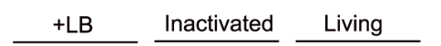

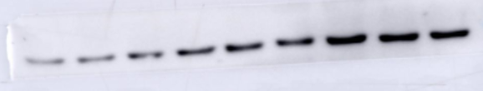
p-mTOR

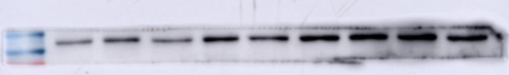
PIK3CB

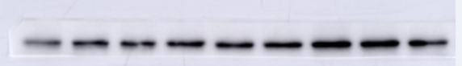
p-P70S6K

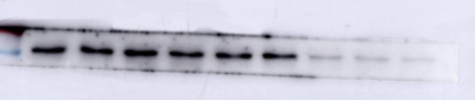

p-PDCD4

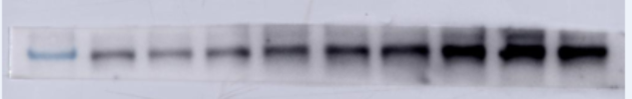
p-AKT

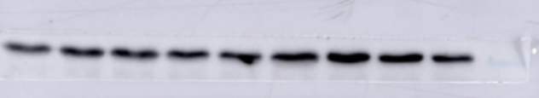

p-4EBP1

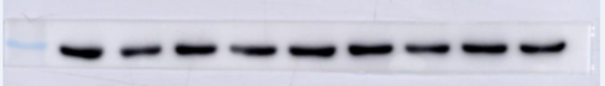
β-Actin


Figure 8

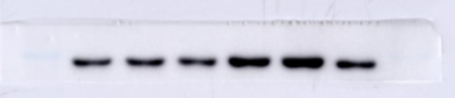
p-mTOR

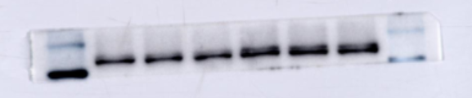

PIK3CB

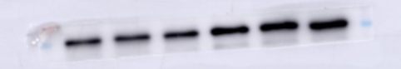
p-P70S6K

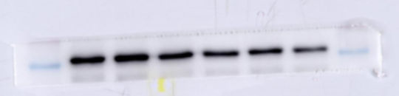

p-PDCD4

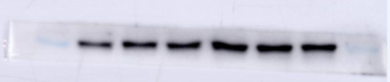
p-AKT

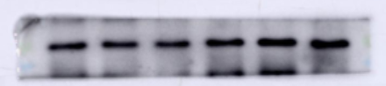
p-4EBP1

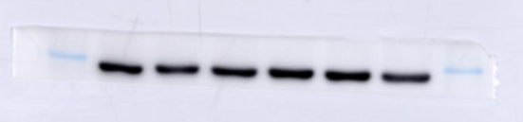
β-Actin


Figure 9A
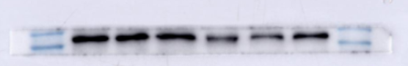
PIK3CB

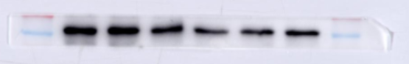
p-AKT

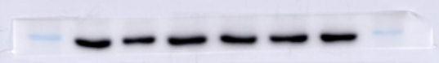

β-Actin

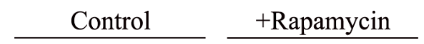
Figure 9B
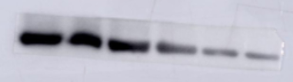
p-mTOR

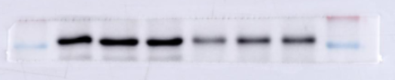
p-P70S6K

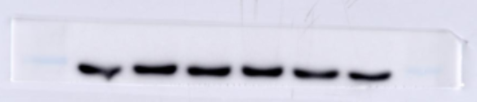
β-Actin

