**Supplemental materials**

**Figure supplemental materials**

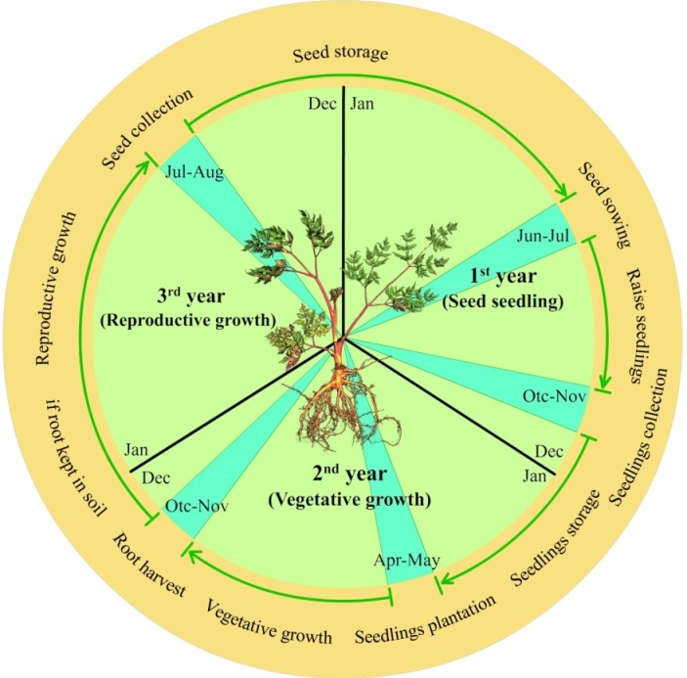

**Fig. S1.** Process of growth and development of *Angelica sinensis*.

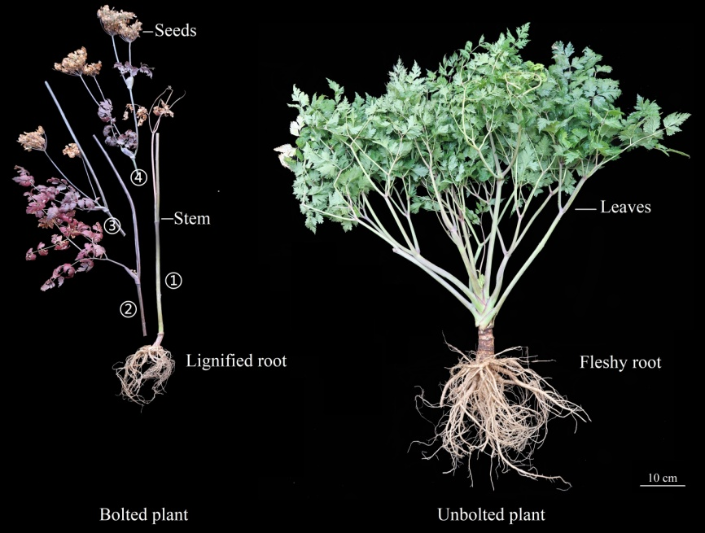

**Fig. S2.** Morphological characteristics of lignified (bolted) and fleshy (unbolted) of *Angelica sinensis*. The ①, ②, ③ and ④ in the image refer to the order of organs that are cut and separated from root to aerial parts.

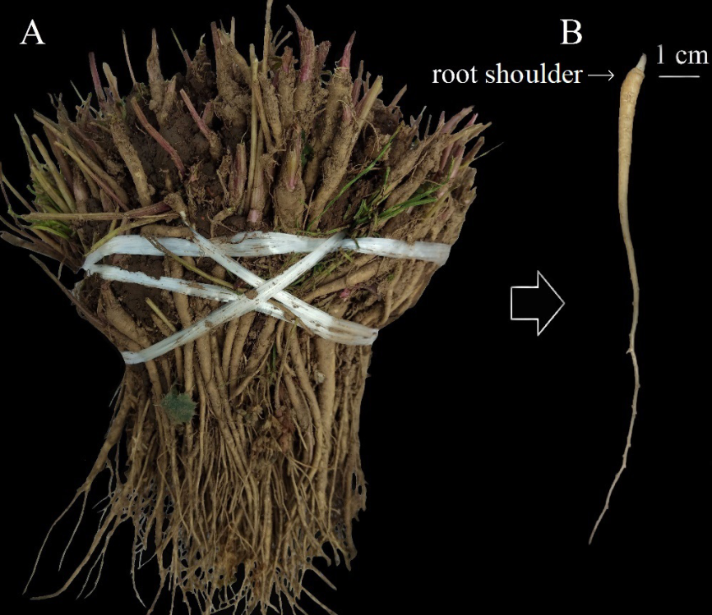

**Fig. S3**. The tied seedlings (A) and single seedling (B) of *Angelica sinensis*.

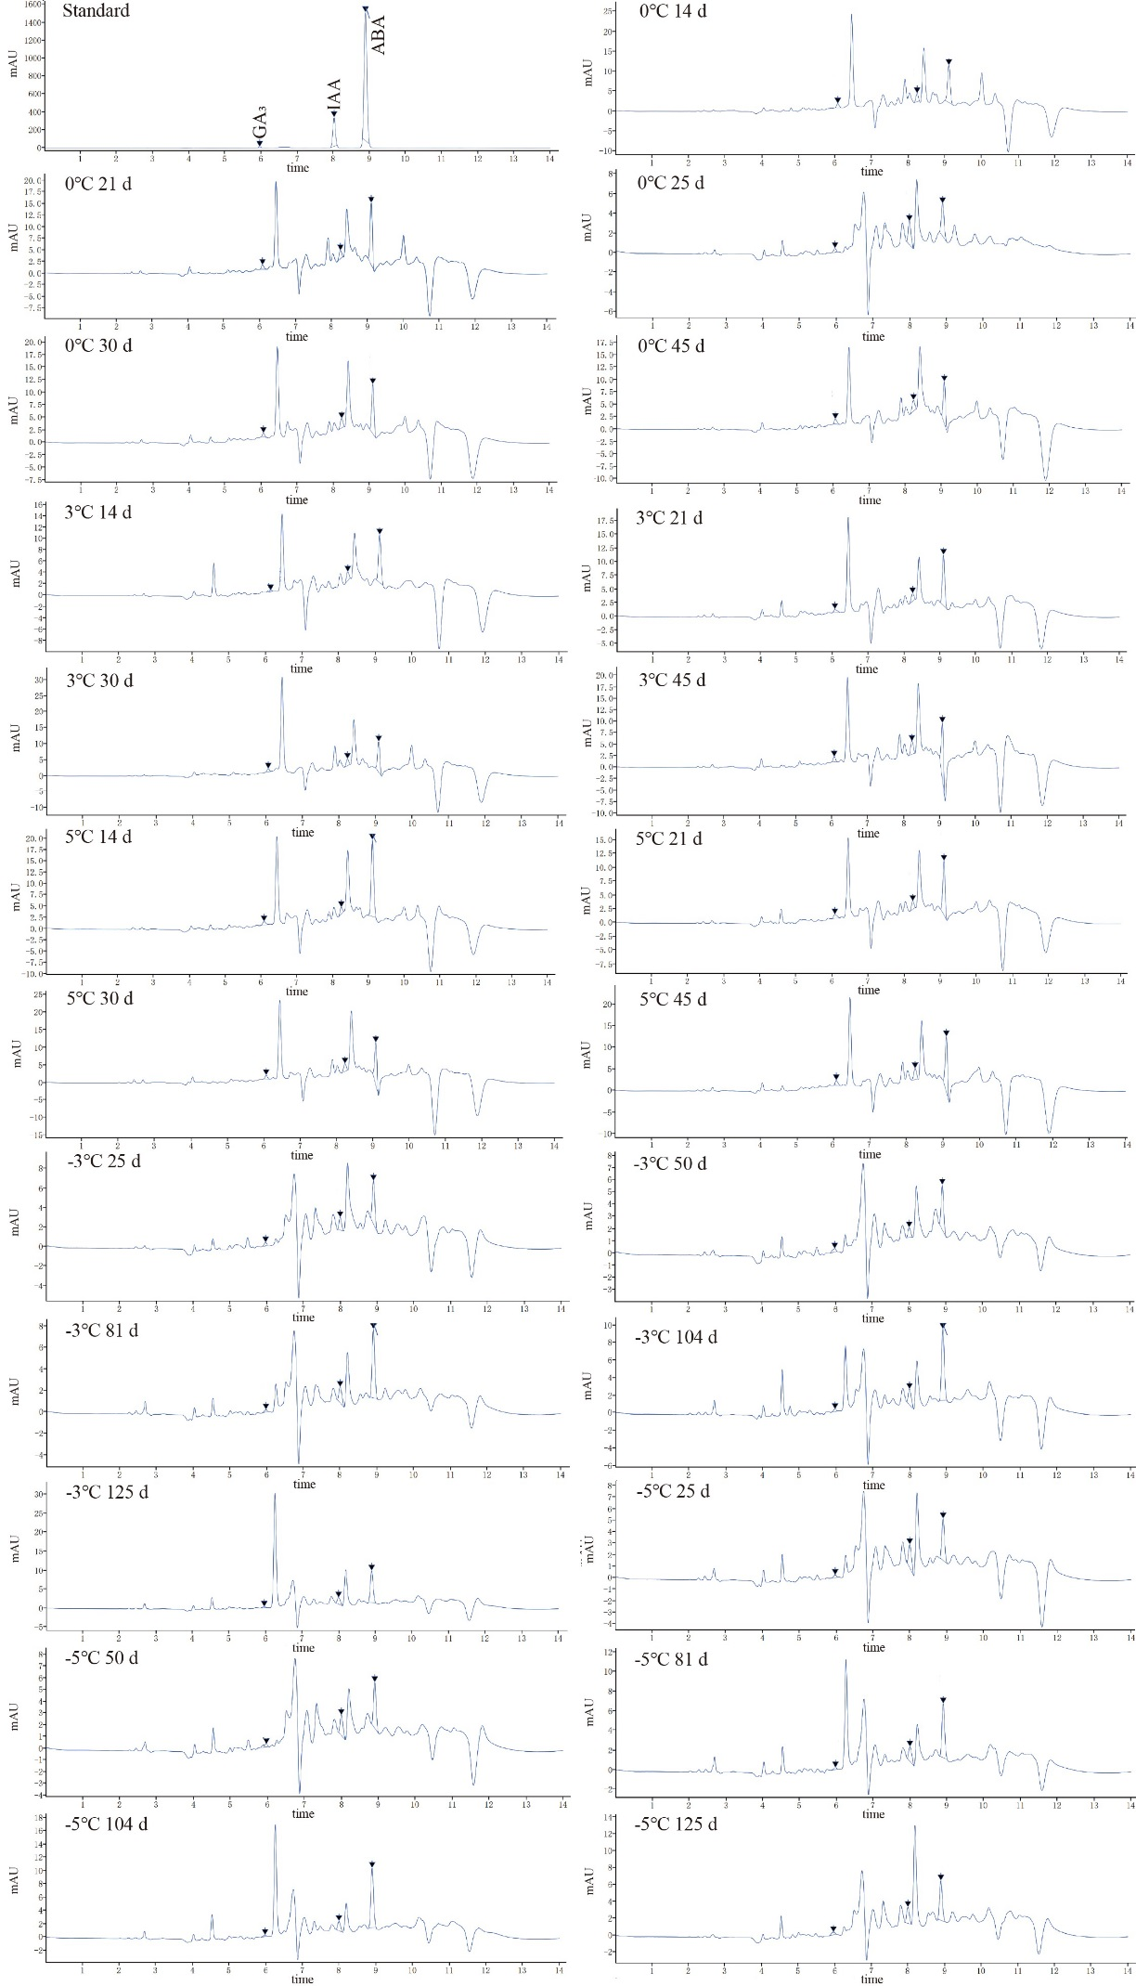

**Fig. S4.** Representative chromatograms of standard references and samples at different temperatures and durations.

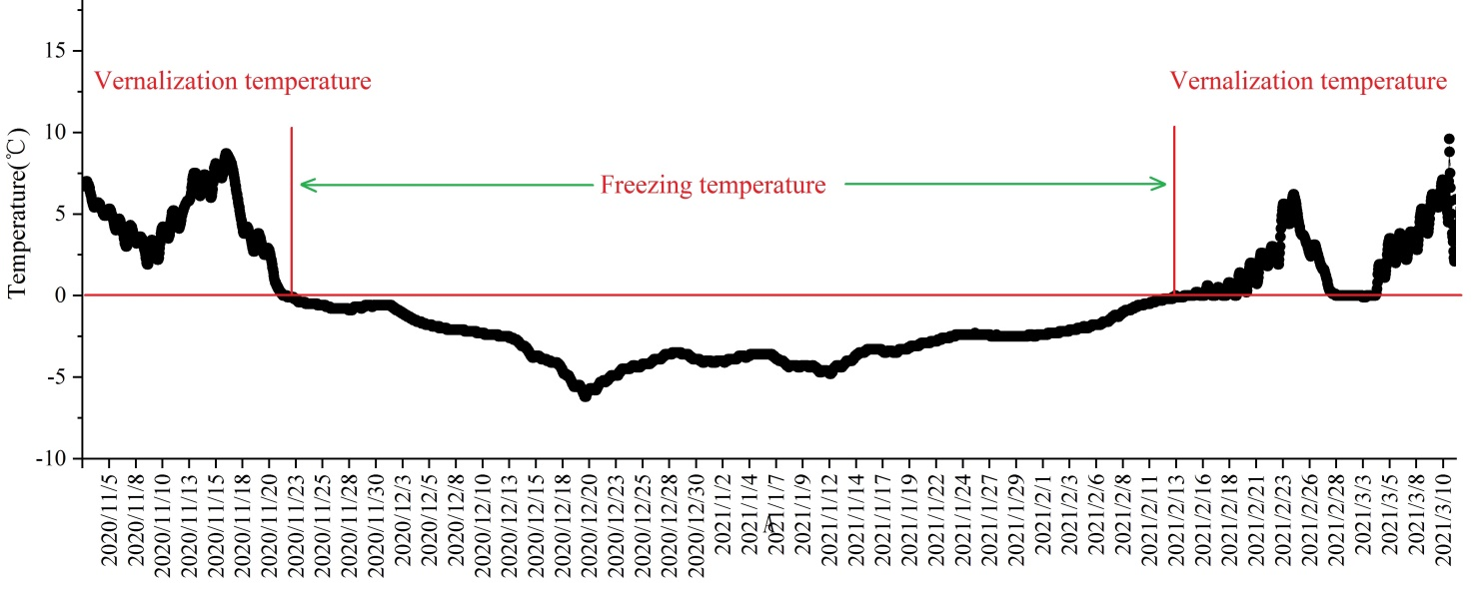

**Fig. S5.** Changes in temperature during the practical overwinter storage.

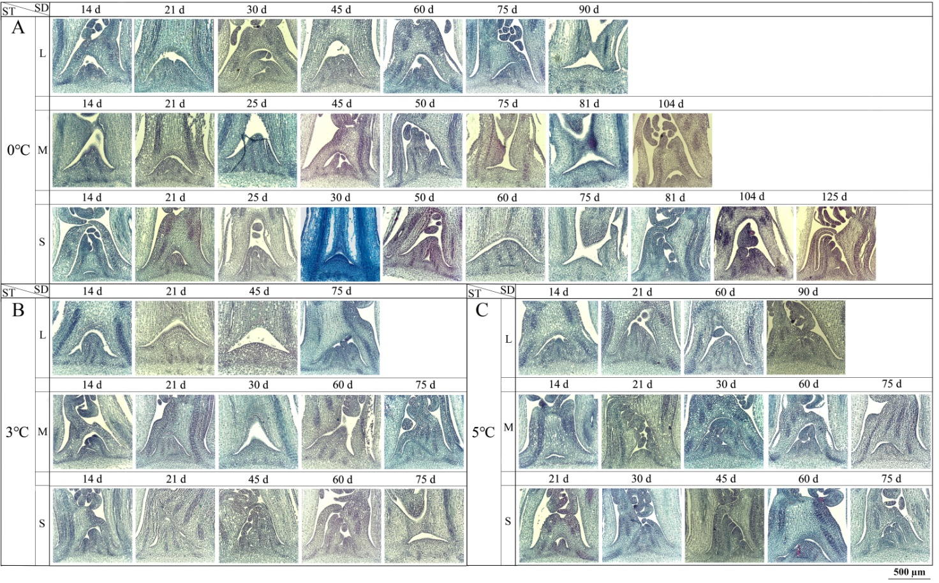

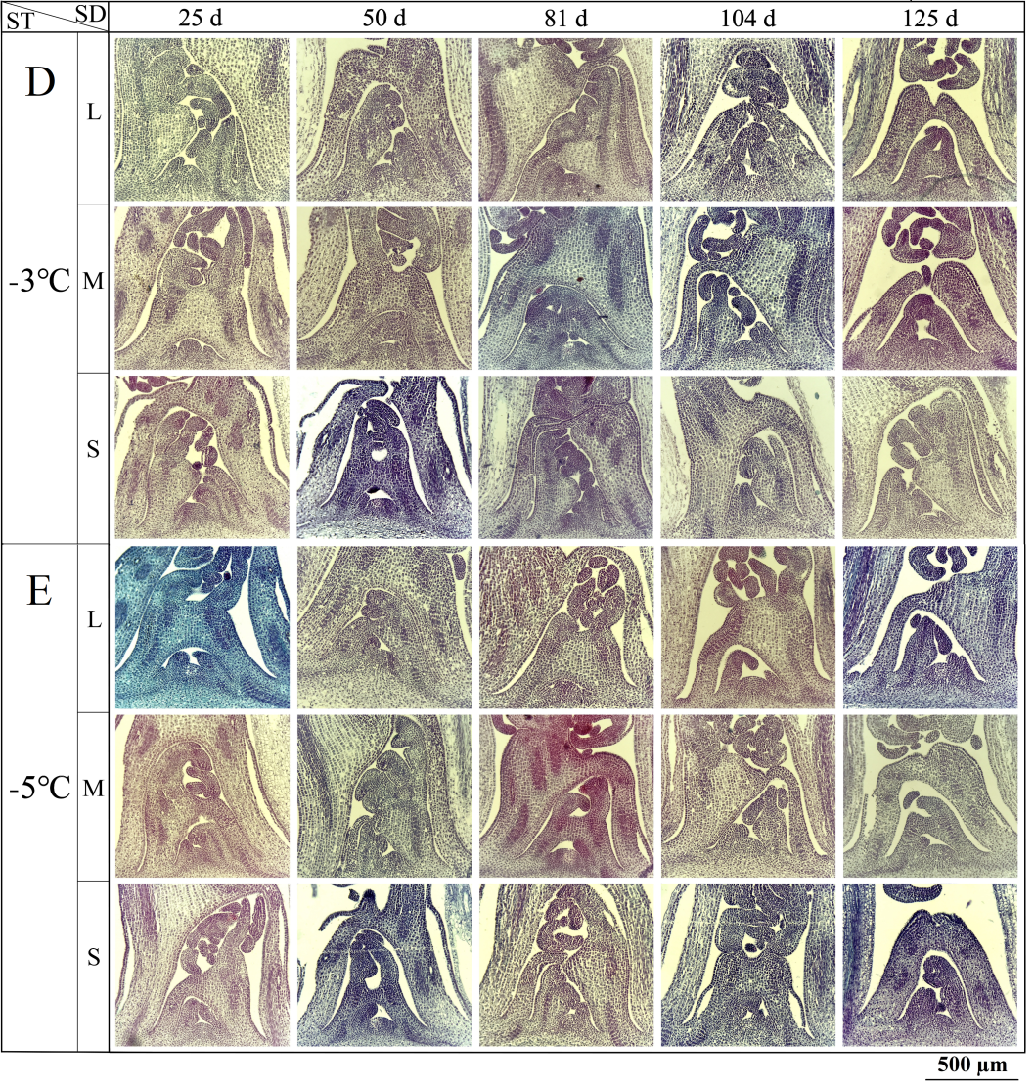

**Fig. S6.** Specific anatomical structures of different size seedlings at different storage temperatures.

**Table supplemental legends**

**Table S1.** Standard curves of TTC, soluble sugar, starch, protein and amino acid.

|  |  |  |
| --- | --- | --- |
| **Reference** | **Standard curve** | ***R2*** |
| TTC | *C* = 23.32*A* + 0.84 | 0.9997 |
| Soluble sugar | *C* = 72.99*A* - 1.47 | 0.9968 |
| Starch | *C* = 238.10*A* - 9.60 | 0.9914 |
| Protein | *C* = 142.86*A* - 12.60 | 0.9951 |
| Amino acid | *C* = 71.94*A* + 0.54 | 0.9986 |

“*C*” represents the compound amount (µg), and “*A*” represents the absorbance.

**Table S2.** Standard curves of GA3, IAA and ABA.

|  |  |  |
| --- | --- | --- |
| **Reference** | **Standard curve** | ***R2*** |
| GA3 (B20187) | *X*=6.7431*Y*+1.8166 | 0.9993 |
| IAA (B21810) | *X*=0.3019*Y*-0.2167 | 0.9996 |
| ABA (B27484) | *X*=0.0448*Y*+1.5521 | 0.9988 |

“*X*” represents the compound concentration (µg/mL), and “*Y*” represents the peak area (AU). The agents GA3, IAA and ABA were purchased from Shanghai yuanye Bio-Technology Co., Ltd, China.

**Table S3.** The data of storage temperatures and durations as well as EBF rate in the practical large-scale cultivation.

|  |  |  |  |
| --- | --- | --- | --- |
| **Actual temperature (**°C**)** | **Average temperature (**°C**)** | **Duration days (d)** | **EBF rates (%)** |
| 0-5 | 2.13 | 33 | >40 |
| 0-10 | 3.22 | 44 | >40 |