Supplementary Material

Supplementary Figures and Tables

Supplementary Figures

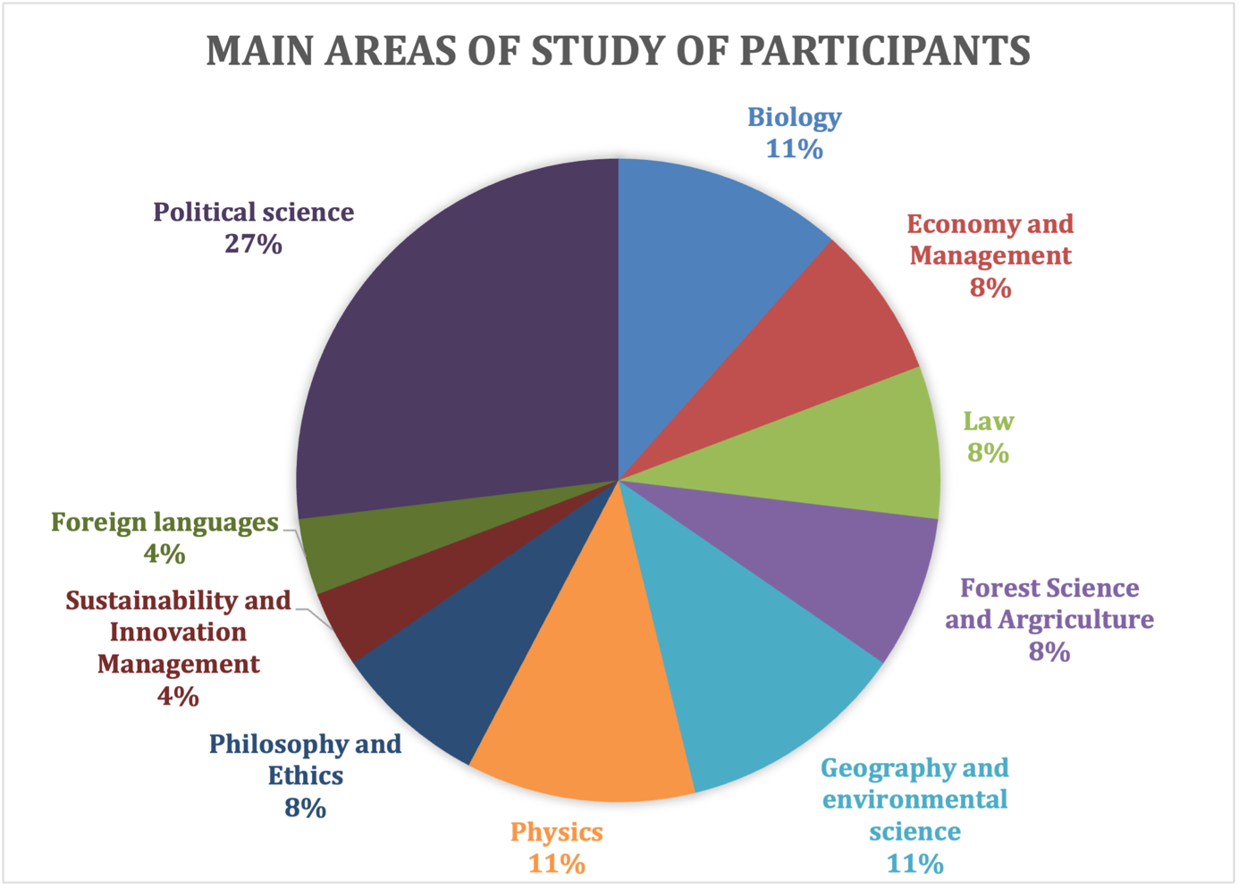
Figure 1. Composition of students (n=26).

Supplementary Tables
Table 1 Students responses (N=26)
Items/statements | Disagree* | Neutral** | Agree***
1. I increased substantive and methodological knowledge in my main field of study. | 6 | 9 | 11
2. I increased my ability to formulate complex problems in a critical and independent way. | 6 | 6 | 14
3. I increased my ability in planning, conducting and finalising a research project. | 6 | 1 | 19
4. I appreciated that we could address grand challenges of concern for the global society. | 1 | 1 | 24
5. I found my main field of study allowed me to fully grasp the topics addressed in lectures and workshops I attended. | 5 | 5 | 16
6. Lectures, workshops, and our research project mostly used tools and knowledge from fields different from my main area of study. | 7 | 6 | 13
7. I think my field of study does address current societal and environmental problems | 4 | 2 | 20
8. The research/project I worked on can actually have an impact in a real-world scenario. | 2 | 5 | 19
9. Information and ideas provided by non-academics (experts, speakers, stakeholders, etc) were important for the development of our research project. | 3 | 6 | 17
10. The findings of our research pushed me to question some attitudes/ideas I had prior to starting the project. | 7 | 5 | 14
11. The most relevant feature in this learning experience was lectures and related discussions. | 11 | 7 | 7
12. The most relevant feature in this learning experience was applying and developing research and development tools – software and apps, internet-based tools, etc. | 5 | 9 | 11
13. The most relevant feature in this learning experience was interacting with my peers from other universities’ research groups. | 6 | 7 | 13
14. What I most appreciated was learning and applying research methods and procedures. | 3 | 7 | 16
15. Our research project could not have been realised without input from all team members. | 8 | 3 | 15
16. I enjoyed working with colleagues in my group. | 2 | 5 | 19
17. I enjoyed working in English in most activities. | 1 | 2 | 22
18. I enjoyed drafting and editing the final research output. | 5 | 6 | 15
19. I have greater confidence in doing scientific research. | 6 | 4 | 16
20. I feel I could lead a team in similar situations. | 1 | 4 | 21
21. I feel complex issues like climate change and environmental degradation can be tackled in a constructive way. | 1 | 0 | 25
*Disagree = the number of respondents who selected 1 (I totally disagree) and 2 (I disagree).
**Neutral = the number of respondents who selected 3 (I am neutral).
***Agree = the number of respondents who selected 4 (I agree) and 5 (I totally agree).
Table 2 Measuring the reception of CBL features in the 2021 Arqus Collaboratory Programme (max=26)
CBL characteristics | Negative score | Positive score
1. Tackling societal challenges | 2.3 | 21.9
2. Inter-disciplinarity | 9.9 | 11
3. Engaging stakeholders | 3 | 17
4. Internationalisation | 4 | 16.6
5. Applying research skills | 4.5 | 16.8
6. Teamworking and interpersonal skills | 4.6 | 16.2
7. Active learning approach | 6.3 | 12.9
8. Technology | 5 | 12.6

