**Supporting Information for**

**The seasonality** **of mesoscale eddy intensity in the southeastern tropical Indian Ocean**

**Supplementary methods**

1. **Data verification**

In present study, the AIPOcean2.0 dataset will be used for the analysis but needs to be verified if it can capture the basic seasonal features and structures of the eddies in the SETIO. We identified and tracked all the eddies in the AIPOcean2.0 dataset in the region with the algorithm in Nencioli et al., (2010), then did the same statistics and calculation as done for the Mesoscale Eddy Trajectory Atlas product, and the results are shown in **Figure S1**. One can see that the location of the area where the eddy exhibits the most remarkable seasonal variability (**Figure S1A-L**) is in good agreement with the SSA in **Figure 2**. And the variation of eddy intensity in SSA (**Figure S1M**) shows a similar seasonality to the one in **Figure 2M**. The consistence on eddy variability between the AIPOcean2.0 and AVISO datasets is also reflected by the spatial patterns of the standard deviation of 30-120 days band-pass filtered SLA in the two datasets, which is mainly induced by eddy activities (**Figure S2**). Although the magnitude of eddies in AIPOcean2.0 is relatively smaller, this kind of discrepancy is quite common in ocean models and will not affect the reliability of our analysis on the processes and dynamics that are related to the seasonal variability of eddies.

**Supplementary figures**

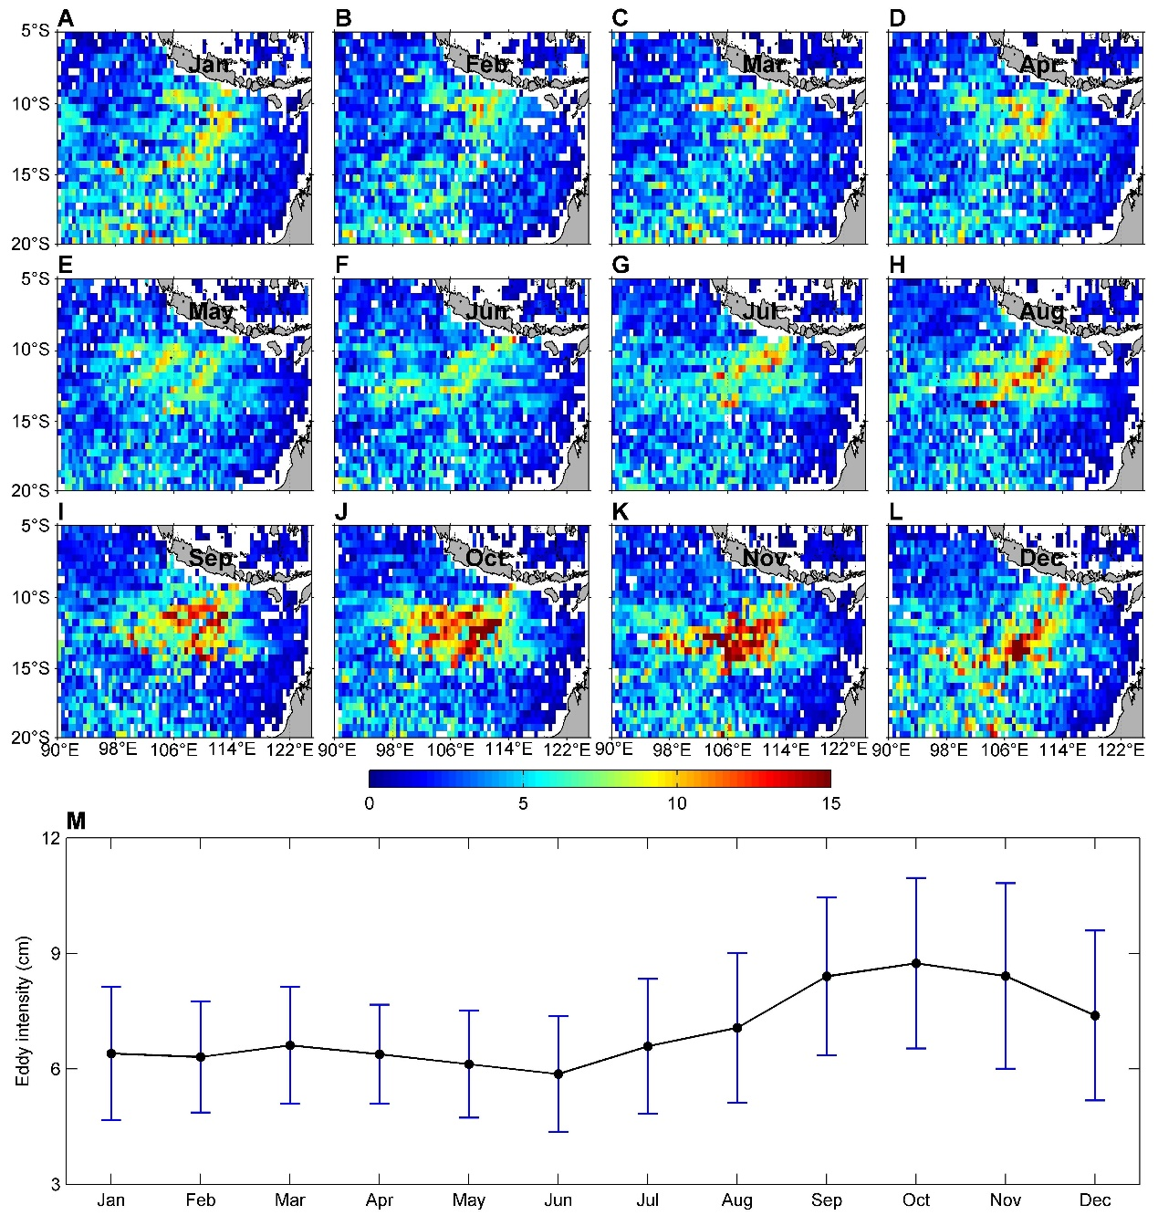

**FIGURE S1 |** Same as **Figure 2** but for eddies in the AIPOcean2.0 dataset.

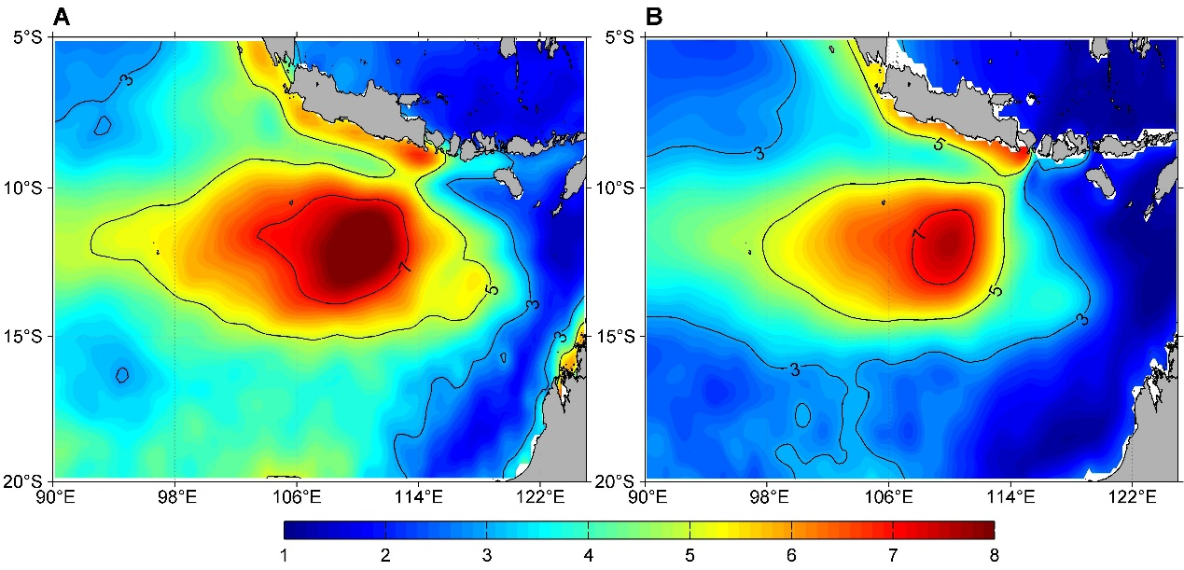

**FIGURE S2 |** Standard deviation of 30-120 days band-pass filtered SLA (unit: cm) derived from AVISO **(A)** and AIPOcean2.0 **(B)**.

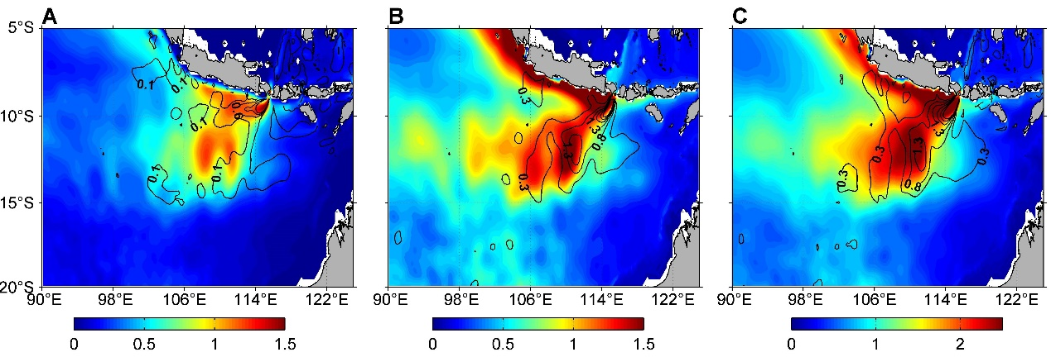

**FIGURE S3 |** Annual mean vertically integrated **(A)** EKE (color) and BTR (×10-6, contours), **(B)** EPE (color) and BCR (×10-6, contours), **(C)** TEE (color) and the sum of BTR and BCR (×10-6, contours) in upper 300 m. Units for EKE, EPE and TEE are m2/s2. Units for BTR and BCR are m2/s3. The contour interval is 0.5×10-6 m2/s3 except for 3×10-6 m2/s3 where the BTR larger than 3×10-6 m2/s3 in **(A)**.

**References**

Nencioli, F., Dong, C., Dickey, T., Washburn, L., and McWilliams, J. (2010). A vector geometry-based eddy detection algorithm and its application to high-resolution numerical model products and high-frequency radar surface velocities in the Southern California Bight. J. Atmos. Oceanic Technol. 27(3), 564-579. doi:10.1175/2009JTECHO725.1