Supplementary Material

## Supplementary Tables

**Table S1.** Positive detection per virus species in the time of the active prevention

| Virus species | Treatment group (N=59) | Control group (N=60) |
| --- | --- | --- |
| Rhinovirus | 10 (16.95%) | 9 (15.00%) |
| SARS-CoV2 | 5 ( 8.47%) | 14 (23.33%) |
| Coronavirus NL63 | 2 ( 3.39%) | 1 ( 1.67%) |
| Coronavirus OC43 | 3 ( 5.08%) | 5 ( 8.33%) |
| Metapneumovirus | 1 ( 1.69%) | 0 ( 0.00%) |
|  | | | |

**Table S2.** Cycle threshold values (Ct) according to qPCR during EF treated (Echinaforce) and untreated (control) viral symptomatic RTI episodes overall and COVID-19 episodes (A). Comparison of virus load reduction between time points per study group (B).

|  |  |  |  |  |  |  |  |  |
| --- | --- | --- | --- | --- | --- | --- | --- | --- |
| **(A)** |  | Viruses overall | | | SARS-CoV-2 viruses | | | |
|  |  | day 1 | day 5 | day10 | day 1 | day 5 | day10 |
|  |  |  |  |  |  |  |  |
| EF treatment | n | 9 | 11 | 11 | 6 | 8 | 8 |
|  | Mean (Ct)1 | 21.60(3.07) | 27.82(4.97) | 36.24(7.39) | 21.34(3.28) | 27.06(3.99) | 32.96(5.73) |
|  | Median (Ct) | 21.4 | 26.79 | 36.19 | 21.48 | 26 | 32.29 |
|  | 95%CI of Mean | 19.23/23.96 | 24.48/31.16 | 31.28/41.21 | 17.90/24.78 | 23.72/30.40 | 28.17/37.75 |
|  |  |  |  |  |  |  |  |
| No treatment (control) | n | 11 | 10 | 9 | 9 | 8 | 7 |
|  | Mean (Ct) 1 | 21.52(4.99) | 23.15(4.09) | 29.15(6.31) | 22.22(4.98) | 23.98(4.17) | 29.75(6.82) |
|  | Median (Ct) | 21.9 | 24.82 | 30.11 | 22.5 | 25.93 | 30.11 |
|  | 95%CI of Mean | 18.16/24.87 | 20.22/26.07 | 24.30/34.00 | 18.39/26.05 | 20.5/27.47 | 23.45/36.06 |
|  |  |  |  |  |  |  |  |
| Difference | Mean2 (∆Ct) | -0.08 | -4.67 | -7.09 | 0.88 | -3.08 | -3.21 |
|  | 95%CI of Mean | -3.92/3.76 | -8.82/-0.53 | -13.5/-0.65 | -3.73/5.49 | -7.45/1.30 | -10.4/3.95 |
|  |  |  |  |  |  |  |  |
|  | p-value4 | 0.965 | 0.0292 | 0.0327 | 0.687 | 0.154 | 0.348 |
| **(B)** |  |  |  |  |  |  |  |
|  |  | Viruses overall | | | SARS-CoV-2 viruses | | | |
|  |  | day 1 vs. day 5 | day 1 vs day 10 | Day 5 vs day 10 | day 1 vs. day 5 | day 1 vs day 10 | Day 5 vs day 10 |
| EF treatment | Mean (log∆Ct) 3 | -2.19 | -4.73 | -2.54 | -2.14 | -3.91 | -1.77 |
|  | 95%CI of Mean | -3.08/-1.30 | -6.01/-3.45 | -3.82/-1.25 | -3.21/-1.06 | -5.14/-2.68 | -2.71/-0.83 |
|  |  |  |  |  |  |  |  |
|  | p-value2 | 0.0003 | <0.0001 | 0.0013 | 0.0022 | 0.0001 | 0.0029 |
|  |  |  |  |  |  |  |  |
| Control | Mean (log∆Ct) 3 | -0.07 | -1.91 | -1.84 | 0.03 | -1.71 | -1.74 |
|  | 95%CI of Mean | -1.04/0.90 | -3.33/-0.49 | -3.58/-0.10 | -1.10/1.18 | -3.63/0.21 | -4.04/0.56 |
|  |  |  |  |  |  |  |  |
|  | p-value2 | 0.8706 | 0.0144 | 0.0403 | 0.9427 | 0.0724 | 0.1130 |

Data are 1mean Ct values(SD) resp. 2Mean ∆Ct, resp. 3mean log∆Ct values. 4Student’s t-test with Satterthwaite modification comparing EF treatment vs control. 2Student’s t-test with Satterthwaite modification comparing sampling time points.

**Table S3.** Virus loads (Ct values) during EF treatment/prevention (EF) vs non-treatment (control) as per qPCR.

|  |  |  |  |  |  |  |
| --- | --- | --- | --- | --- | --- | --- |
|  |  |  |  |  |  |  |
|  | **all viral detections2** | | | **SARS-CoV-2 detections2** | | |
| **Viral load (Ct):** | EF | Reference (Control) | p-value | EF | Reference (Control) | p-value |
| n | 55 | 84 |  | 31 | 56 |  |
| Mean (Ct) | 30.0(7.6) | 27.8(7.1) | 0.094 | 30.3(7.8) | 29.1(7.5) | 0.4591 |
| Median | 29.97 | 27.26 |  | 31.3 | 27.95 |  |
| 95%CI for Mean | 27.94/32.07 | 26.29/29.38 |  | 27.44/33.17 | 27.05/31.05 |  |

Data are mean(SD). Analyzable sample sets per day and study groups (n) are indicated.1Student’s t-test.

**Table S4**. Course ofbody temperatures (°C)/fever days (>37.8 °C) during EF treated (Echinaforce) and untreated (control) viral symptomatic RTI episodes overall.

|  |  |  |  |  |  |  |  |  |  |  |  |
| --- | --- | --- | --- | --- | --- | --- | --- | --- | --- | --- | --- |
|  |  |  |  |  |  |  |  |  |  |  |  |
| EF treatment | day | 1 | 2 | 3 | 4 | 5 | 6 | 7 | 8 | 9 | 10 |
|  | Mean (°C) | 36.4 (0.5) | 36.4 (0.3) | 36.6 (0.5) | 36.4 (0.4) | 36.4 (0.5) | 36.3 (0.4) | 36.2 (0.5) | 36.2 (0.4) | 36.3 (0.4) | 36.3 (0.5) |
|  | Median | 36.5 | 36.4 | 36.4 | 36.5 | 36.4 | 36.4 | 36.5 | 36.4 | 36.4 | 36.5 |
|  | Fever days (N)2 | 0 | 0 | 1 | 0 | 0 | 0 | 0 | 0 | 0 | 0 |
|  |  |  |  |  |  |  |  |  |  |  |  |
| No treatment (control) | day | 1 | 2 | 3 | 4 | 5 | 6 | 7 | 8 | 9 | 10 |
|  | Mean (°C) | 37.4(0.9) | 37.2(0.7) | 36.9(1.0) | 36.7(0.8) | 36.8(0.6) | 36.7(0.4) | 36.6(0.5) | 36.6(0.3) | 36.5(0.4) | 36.5(0.3) |
|  | Median | 37.3 | 37.2 | 36.6 | 36.5 | 36.6 | 36.6 | 36.5 | 36.7 | 36.5 | 36.4 |
|  | Fever days (N) 2 | 4 | 3 | 1 | 1 | 2 | 0 | 0 | 0 | 0 | 0 |
|  |  |  |  |  |  |  |  |  |  |  |  |
|  | p-value1 | 0.002 | 0.003 | 0.326 | 0.128 | 0.039 | 0.033 | 0.034 | 0.013 | 0.22 | 0.174 |

Data are mean(SD). 1Student’s t-test with Satterthwaite modification, 2Data are N=fever days (≥37.8 °C).

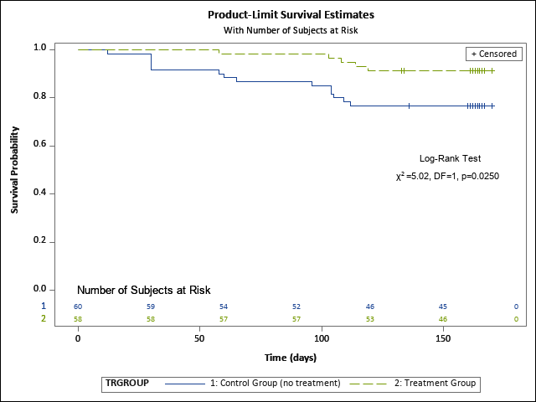

Figure S1. Kaplan-Meier estimate curves showing the subjects at risk rates for SARS-CoV-2 infection during prevention.