**Supplemental Materials**

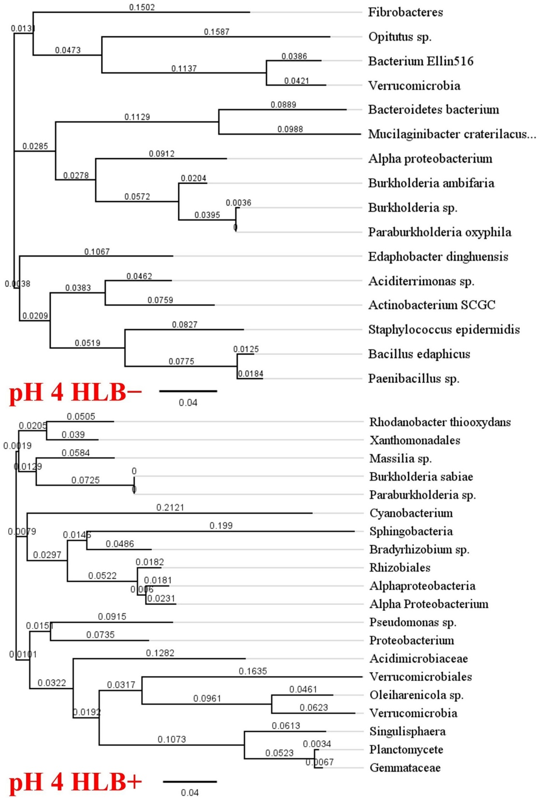

**Figure S1**. Bacteria phylogenetic analysis of soilless substrate under treatment pH 4 based on root microbe 16S rRNA sequencing of HLB− (top) and HLB+ (bottom) plants of ‘Ray Ruby’ grapefruit (*Citrus paradisi*) on Sour orange (*Citrus aurantium*) rootstock. The phylogenetic tree was built utilizing the neighbor-joining analysis method with bootstrap support at the nodes (Saitou & Nei, 1987).

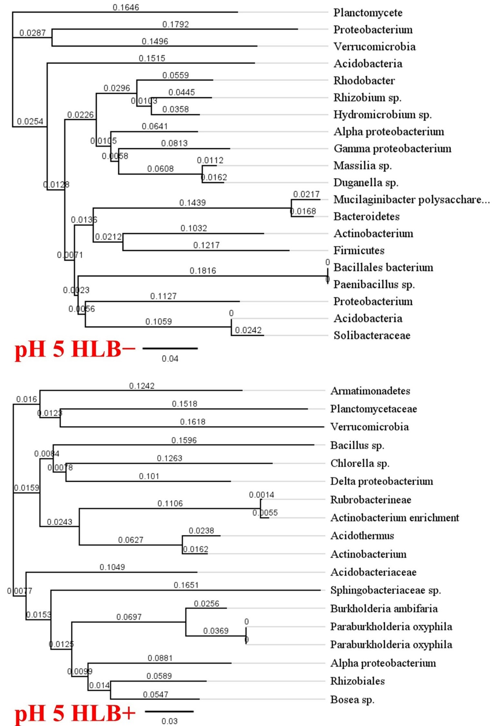

**Figure S2**. Bacteria phylogenetic analysis of soilless substrate under treatment pH 5 based on root microbe 16S rRNA sequencing of HLB− (top) and HLB+ (bottom) plants of ‘Ray Ruby’ grapefruit (*Citrus paradisi*) on Sour orange (*Citrus aurantium*) rootstock. The phylogenetic tree was built utilizing the neighbor-joining analysis method with bootstrap support at the nodes (Saitou & Nei, 1987).

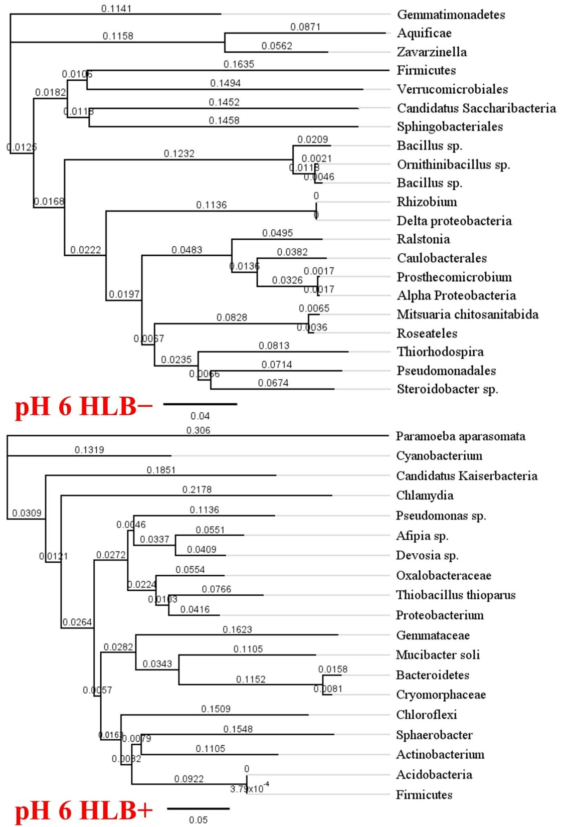

**Figure S3**. Bacteria phylogenetic analysis of soilless substrate under treatment pH 6 based on root microbe 16S rRNA sequencing of HLB− (top) and HLB+ (bottom) plants of ‘Ray Ruby’ grapefruit (*Citrus paradisi*) on Sour orange (*Citrus aurantium*) rootstock. The phylogenetic tree was built utilizing the neighbor-joining analysis method with bootstrap support at the nodes (Saitou & Nei, 1987).

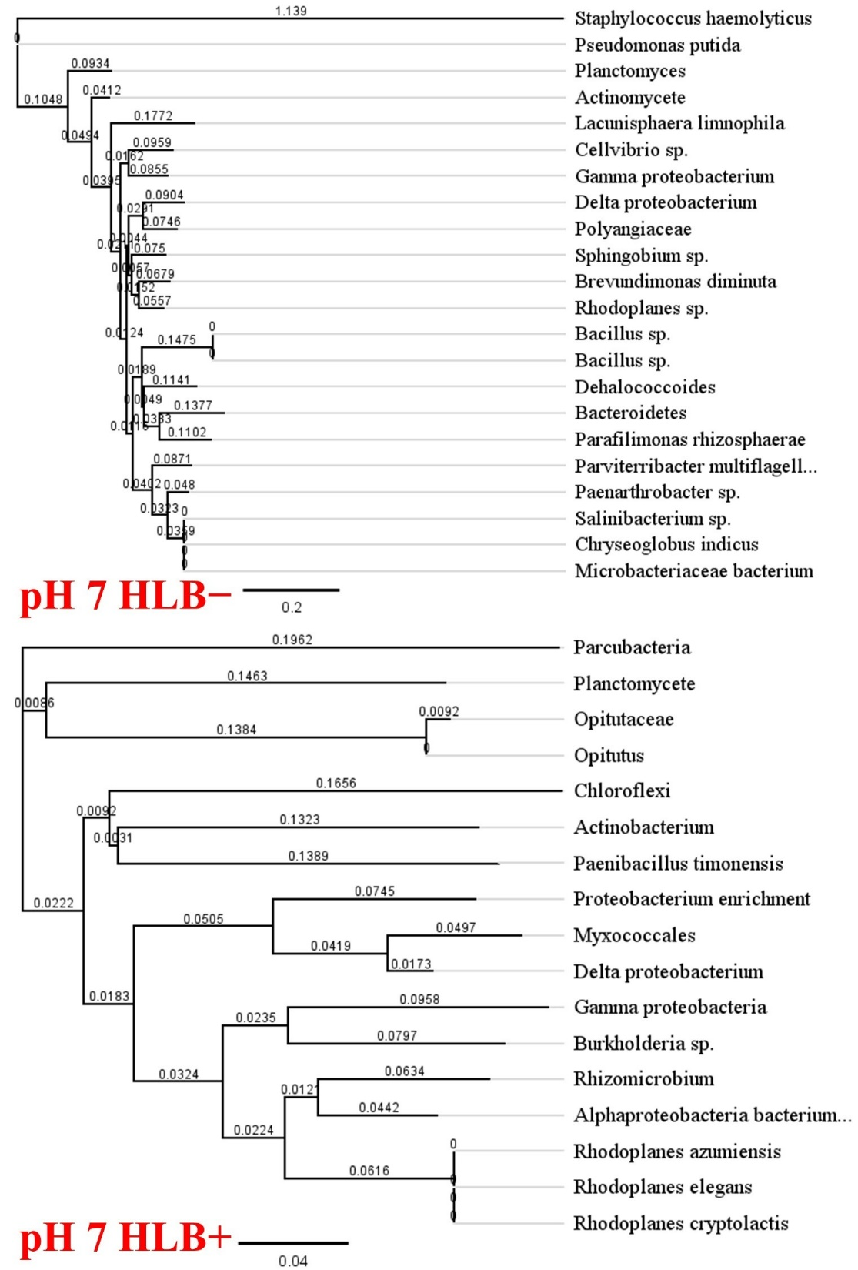

**Figure S4**. Bacteria phylogenetic analysis of soilless substrate under treatment pH 7 based on root microbe 16S rRNA sequencing of HLB− (top) and HLB+ (bottom) plants of ‘Ray Ruby’ grapefruit (*Citrus paradisi*) on Sour orange (*Citrus aurantium*) rootstock. The phylogenetic tree was built utilizing the neighbor-joining analysis method with bootstrap support at the nodes (Saitou & Nei, 1987).

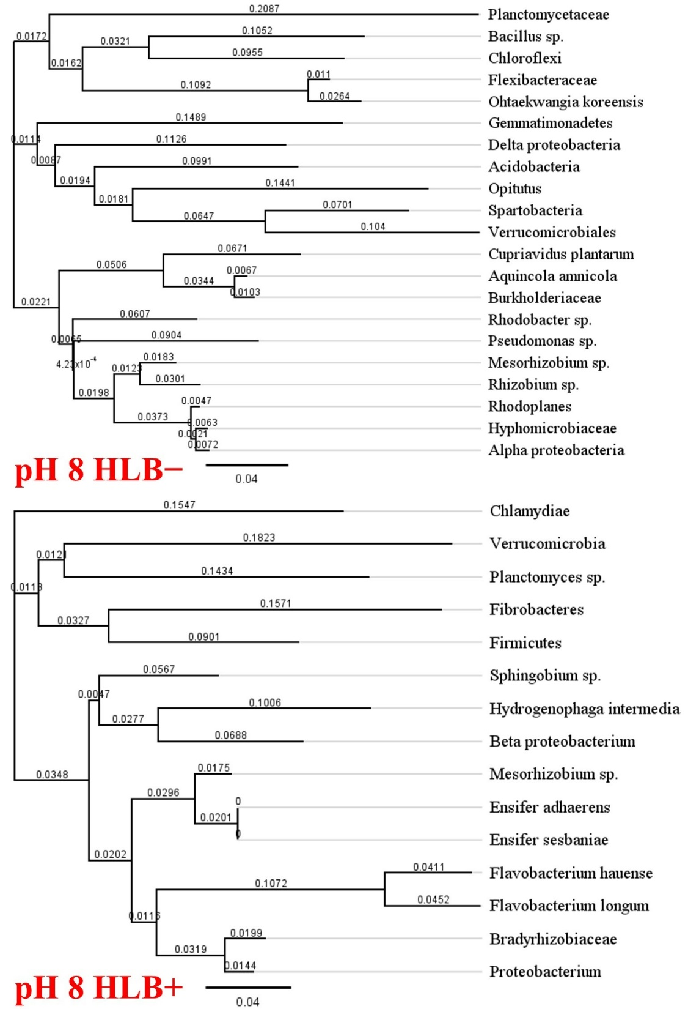

**Figure S5**. Bacteria phylogenetic analysis of soilless substrate under treatment pH 8 based on root microbe 16S rRNA sequencing of HLB− (top) and HLB+ (bottom) plants of ‘Ray Ruby’ grapefruit (*Citrus paradisi*) on Sour orange (*Citrus aurantium*) rootstock. The phylogenetic tree was built utilizing the neighbor-joining analysis method with bootstrap support at the nodes (Saitou & Nei, 1987).

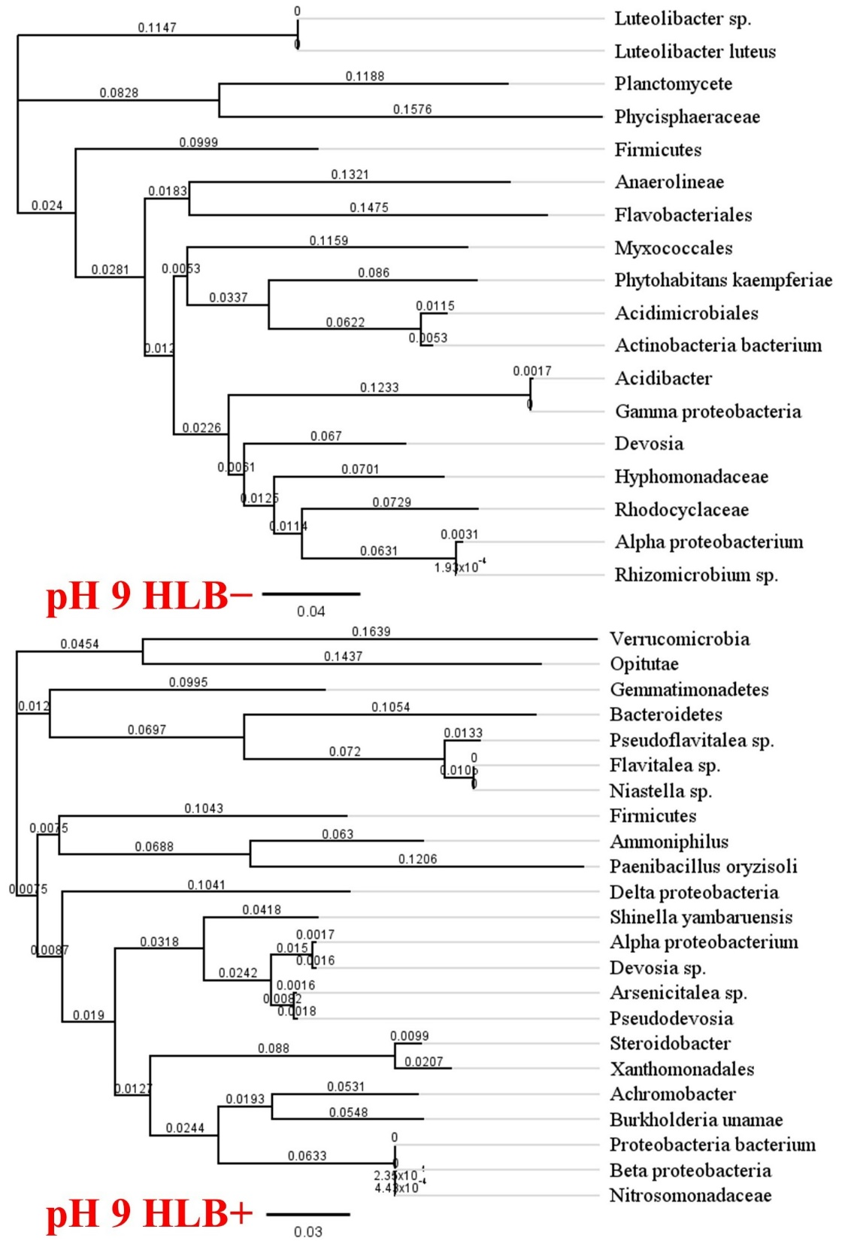

**Figure S6**. Bacteria phylogenetic analysis of soilless substrate under treatment pH 9 based on root microbe 16S rRNA sequencing of HLB− (top) and HLB+ (bottom) plants of ‘Ray Ruby’ grapefruit (*Citrus paradisi*) on Sour orange (*Citrus aurantium*) rootstock. The phylogenetic tree was built utilizing the neighbor-joining analysis method with bootstrap support at the nodes (Saitou & Nei, 1987).