Trophic ecology of deep-sea megafauna in the ultra-oligotrophic Southeastern Mediterranean Sea

Tamar Guy-Haim1*, Nir Stern1, Guy Sisma-Ventura1*

1 Israel Oceanographic and Limnological Research, National Institute of Oceanography, Haifa, 3108000, Israel

**\* Correspondence:**Tamar Guy-Haim  
[tamar.guy-haim@ocean.org.il](mailto:tamar.guy-haim@ocean.org.il)  
Guy Sisma-Ventura  
[guy.siv@ocean.org.il](mailto:guy.siv@ocean.org.il)

Supplementary Material

# Supplementary Tables and Figures

## Supplementary Tables

**Table 1**: Metrics for estimating isotopic niche size in eight fish and four decapod crustaceans from the Levantine deep-sea (*n*≥5). SEA, standardized ellipse area (‰2); SEAC, size-corrected standardized ellipse area; SEAB, Bayesian standardized ellipse area.

|  |  |  |  |
| --- | --- | --- | --- |
| Sample type / Species | SEA | SEAC | SEAB |

|  |
| --- |
| **Fish** |

|  |  |  |  |
| --- | --- | --- | --- |
| *Coelorinchus caelorhincus* | 1.84 | 2.04 | 1.81 |
| *Dentex macrophthalmus* | 0.85 | 0.94 | 0.81 |
| *Helicolenus dactylopterus* | 0.21 | 0.22 | 0.19 |
| *Hoplostethus mediterraneus* | 0.25 | 0.31 | 0.28 |
| *Lepidotrigla cavillone* | 0.27 | 0.34 | 0.25 |
| *Macroramphosus scolopax* | 0.49 | 0.66 | 0.40 |
| *Nezumia* sp. | 0.37 | 0.41 | 0.35 |
| *Scorpaena elongata* | 0.24 | 0.32 | 0.25 |

|  |  |  |  |
| --- | --- | --- | --- |
| **Crustaceans** | | | |
| *Acanthephyra eximia* | 0.50 | 0.56 | 0.47 |
| *Aristeus antennatus* | 0.59 | 0.63 | 0.55 |
| *Parapenaeus longirostris* | 0.06 | 0.07 | 0.06 |
| *Plesionika edwardsii* | 0.16 | 0.20 | 0.14 |

## Supplementary Figures

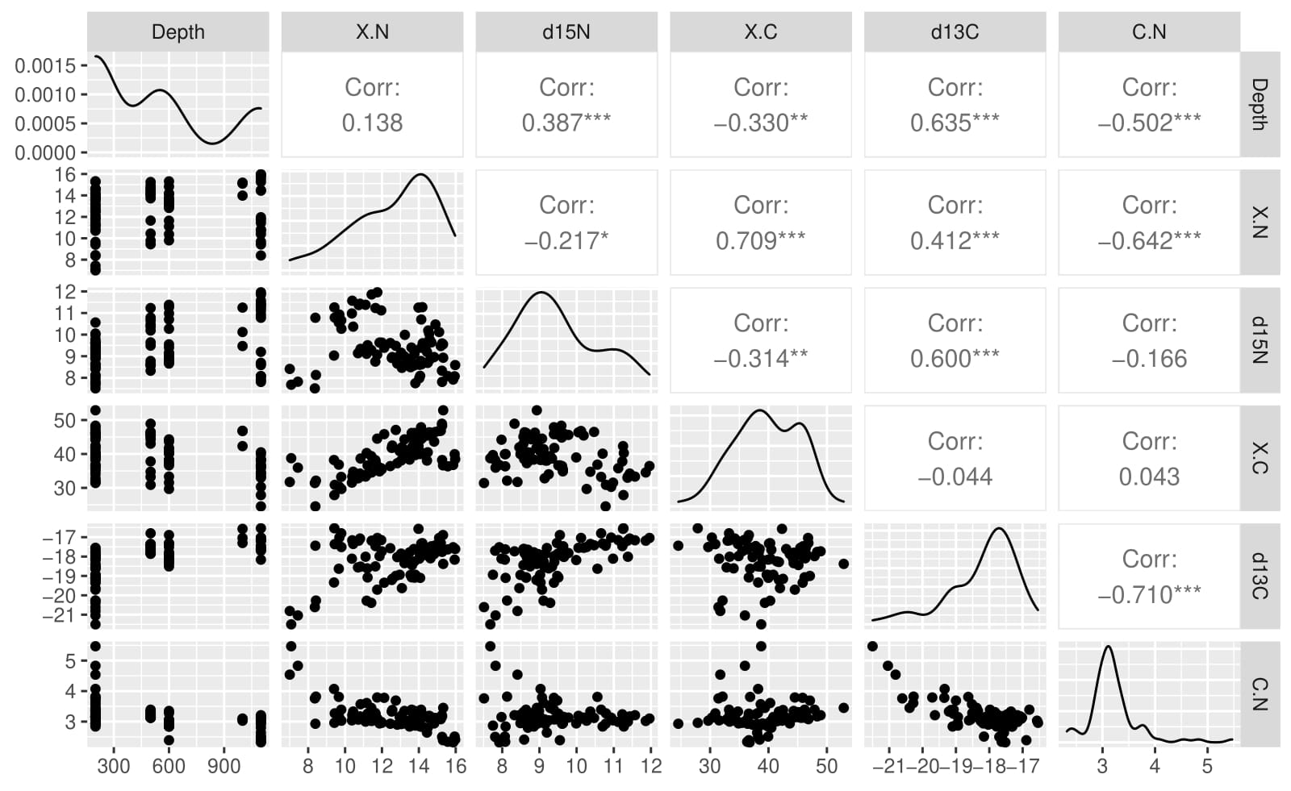

**Supplementary Figure 1**. Pairwise correlation matrix between depth, %C, δ13C, %N, δ15N and C/N ratio in bathypelagic fish (n=86) collected from the Southeastern Mediterranean Sea. Data points are shown in the scatterplots below the diagonal. Variable distributions are presented on the diagonal. Pearson correlation coefficients are presented in the cells above the diagonal, asterisk denotes significance level.

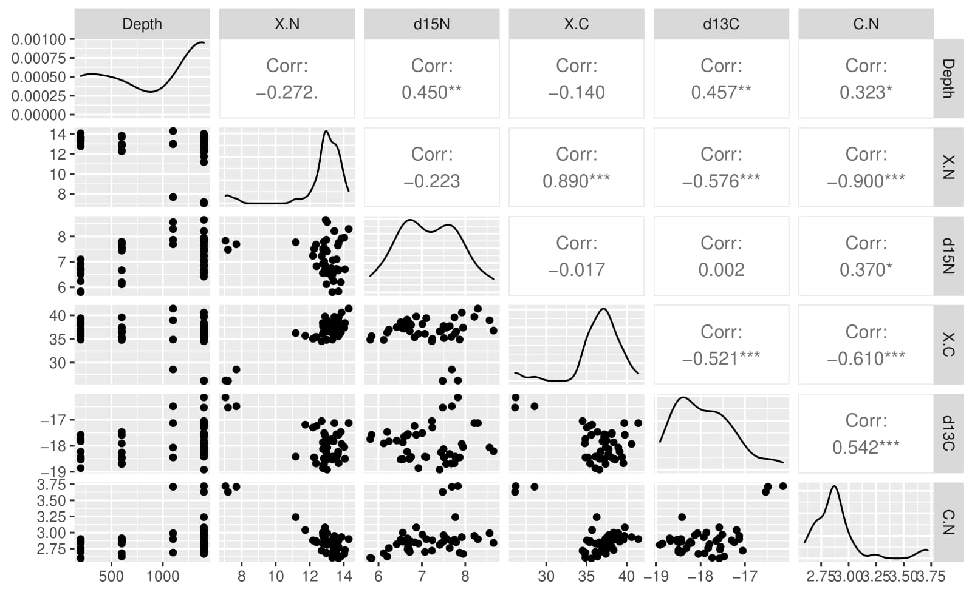

**Supplementary Figure 2**. Pairwise correlation matrix between depth, %C, δ13C, %N, δ15N and C/N ratio in bathybenthic crustaceans (n=46) collected from the Southeastern Mediterranean Sea. Data points are shown in the scatterplots below the diagonal. Variable distributions are presented on the diagonal. Pearson correlation coefficients are presented in the cells above the diagonal, asterisk denotes significance level.

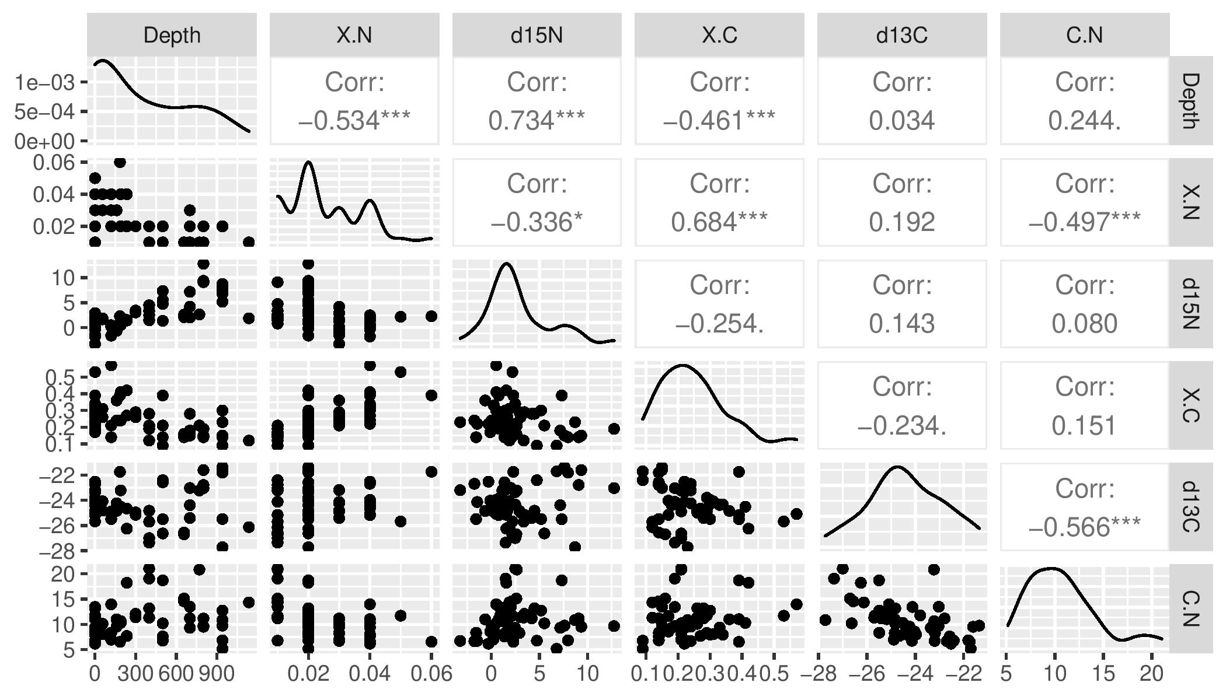

**Supplementary Figure 3**. Pairwise correlation matrix between depth, %C, δ13C, %N, δ15N and C/N ratio in POM samples (n=55) collected from the Southeastern Mediterranean Sea. Data points are shown in the scatterplots below the diagonal. Variable distributions are presented on the diagonal. Pearson correlation coefficients are presented in the cells above the diagonal, asterisk denotes significance level.